Module 1.
Topic APPEARANCE.
1. Physical appearance
Warm-up Questions
1. Who’s your favourite movie star?
2. What does he/she look like?
3. How do you describe yourself?
4. Do you look like your brother/sister?
5. Who do you look like, your mum or your dad?

Look at the words below.
lanky stocky chubby well-built skinny petite slim overweight wiry curvy shapely slender

Which of the following people could they be used to describe?
a. a strong, thin man
b. a small, thin woman
c. a tall, thin man
d. a small, fat, strong man
e. an attractive woman with broad hips and a big bust
f. a tall, thin woman

Which of the phrases below suggest
a. a slim, strong man
b. a big, fat man
c. an attractive man (in your opinion)

He’s got a double chin He’s got a pot belly
He’s got a beard and moustache He’s bald
He’s got sideburns He’s got slim hips and a narrow waist
He’s broad-shouldered He’s got high cheekbones
He’s got a six pack He’s long-legged

Antonyms. Match the adjectives below to the word which means the opposite:
tall | ugly
weak | mean
young | small
fat | short
beautiful | thin
generous | old
big | strong

Match the adjectives in A below to the adjectives in B.
Example: middle-aged is closest in meaning to old/young
A | B
Overweight elderly middle-aged chubby  Handsome well-built petite good-looking slim of medium height skinny attractive gorgeous plain | short fat tall young strong generous thin beautiful big mean ugly old small

Which of the words above have a negative, critical meaning?
Which of the words in list A can be used to describe the people below?
a. a man
b. a woman
c. a person over 50
d. a person over 70
e. a bodybuilder
f. a supermodel
g. you

Put the adverbs in order from the weakest to the strongest:

weakest |  |  |  |  |  | strongest

Really fairly not very very extremely absolutely quite

Match an adverb from the list above to one of the adjectives in exercises 1 and 2, then write a sentence to rephrase the sentences below.

Example: She is 97 years old: She’s extremely old OR she is very elderly.
1 She’s the most beautiful woman in the world.
2 He is an Olympic weightlifter.
3 She will only eat one piece of fruit a day, and nothing else.
4 Since I stopped cycling to work, I’ve put on a bit of weight.
5 Frank is the best-looking man in the world.

Absolutely only goes with one adjective from exercises 1 and 2. Which adjective? Why?

Match the parts of the face with the list of adjectives that can be used to describe them:
ears | nose | eyes | lips

big snub pointed thin full sexy big bright blue big cauliflower sticky-out

What’s the difference between the following?
a. a ponytail a pigtail a goatee
b. flat-chested pigeon-chested broad-chested
c. bony big-boned skin and bones
d. handsome gorgeous attractive
e. hunky cute charming

Read the descriptions of different people. Then complete the final
sentence in the most appropriate way.

a. When I last saw my brother, he was a long, lanky eighteen-year-old with scruffy, long hair and a thin moustache that looked silly. He was skinny and shy. But now, I’ve just returned from two years in America, and he’s absolutely gorgeous. He’s
___________________________________.

b. When he was young my dad was short, slim and wiry. He played rugby, and he was very fast and strong.But now, well, he’s put on a bit of weight, and he would best be described as
________________________________.

c. My friend Sara has always been a bit chubby, and over Christmas she ate lots of good food, and got depressed because she was really overweight. So she went on a crash diet, lost loads of weight, and started working out at the gym. She’s transformed. Now, she’s
________________________________.

Structures for describing appearance.
What does he/she look like?
Age | He/She is young / middle-aged / elderly / old.  a baby/ toddler / teenager.  in his/her 20s / 30s …  in his/her early / late 20s.
Height | He/She is 165cm tall.  of average / medium height.  tall / very tall / rather tall.  short.
Build | He/She is fat / overweight / plump /chubby  skinny /thin / slim / plump. well-built. muscular.
Hair/face | He/She has (got)black, straight hair.  a round / long / square face
Clothes | He/She wears a hat / earrings.  is in black.
Distinguishing features | He/She wears glasses / contacts / braces.  has (got)a tattoo / a piercing.

Prepare to discuss these questions.
1 How would you describe your own appearance?
2 Who do you take after in your family?
3 What physical characteristics do you find attractive?
4 How would you describe the physical appearance of your ideal man/woman?
5 Do you think the way we look is important?
a. when finding a partner
b. when making friends
c. at work

Description Order. Study the descriptions in Vocabulary 3 and work out the order information is given.
1) General characteristics: age, height, build and gender.
2) Details such as hair and any other distinguishing features, like the eyes or the nose, a beard, a moustache, glasses, etc.
For example,
Anna is quite young, she is in her twenties. She’s very tall and thin. She has long brown and curly hair and beautiful blue eyes.

Look at the pictures and descriptions. Match the descriptions with the pictures. Use the information to describe the people, first orally, then in written.

around 20 / tall / slim / beautiful /  long straight  hair | in his 40s  /short /  stocky /  mustache | really cute /wavy hair /big beautiful  eyes | around 60  years old /  short curly  hair/ glasses | a wide face  / darkskinned / muscular | young / of  medium  height / a  ponytail
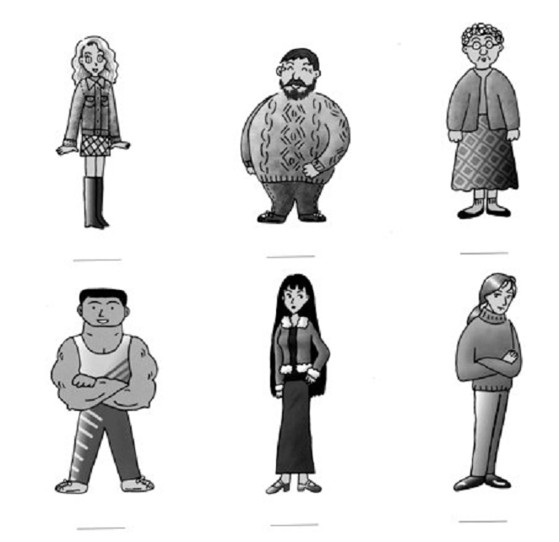

Write a description of someone you know well, a friend or a relative, whose appearance has changed. What did they look like before, and what do they look like now? Why and how did they change?

Read the text
Appearance
By Tricia Muller

Does your appearance mean more than your personality? This is a debate that has raged throughout time without a definitive answer. It's one of the most important questions in a teens life, and among many adults as well.
While it is important that you be a caring, responsible, likable person, not many people are going to notice that about you when meeting you. Unfortunately, humans are very visually oriented and what we see of people leaves a lasting impression. When we go into a restaurant we don't care if our chef donates to Toys for Tots, we care that he is clean, dressed well, and professional looking. When shopping for a new dress we are more likely to ask for help from the well dressed, attractive employee than the girl who showed up to work looking as if she slept in her clothes and has never brushed her hair.
In our personal lives the importance of appearance is much the same. It's a cruel fact of life, but people who are sloppy, dirty and poorly groomed don't get dates. Most of us are "instinctively" attracted to good looking, well dressed people. When marriages were arranged by family this wasn't such an issue, but today it most certainly is. No one wants to date the guy who doesn't shower or the girl who wears clothing three sizes too small.
Even in the workplace appearance is seen as an indicator of ability. A job applicant with a master's degree isn't likely to be hired if s/he is missing teeth, no matter how qualified they are. Very few people would choose a surgeon who has dirt under their fingernails. A stylist with a lousy hair style isn't likely to have very many clients.
Unfortunately, appearance is even important to children. Many small children, especially, can take an instant dislike to someone based solely on what they look like. As children get older appearance becomes an integral part in who is popular and who isn't. The child who doesn't have designer clothing is more likely to be left out of things than the child who wears all of the right brands. With teenagers attractiveness seems to denote popularity more than anywhere else. Teens don't care if the overweight girl is a math genius who has a way with animals, they don't care if the geeky boy writes the most beautiful poetry ever read, they just care what s/he looks like.
Right or wrong, in our society appearance is just too important to be ignored. While personality is a better indicator of a person's value in the long run, when it comes to first impressions what we look like will always win out over who we are.

