Module 4.
Topic FOOD.
I. FOOD.
Read the texts on the topic Food. Study the topical vocabulary in bold type.
Eating Culture.
Text 1. Do we live to eat or eat to live? That is the question.
I remember as a child growing up in Britain having fish and chips or baked beans on toast at least twice a week on my lap while watching my favourite cartoon. Of course I enjoyed my food but it wasn’t something I often talked about. Now, I’m not blaming my culture for my lack of interest in food at an early age. Perhaps my silence was due to the fact that I didn’t know anything about food. How many children know that prawns only turn pink when they are cooked and that tuna does not come from a can? Now after having lived in Southern Europe, Asia and Australia I find myself talking about food all the time. The world has seduced my taste buds and opened my mouth.
Food that’s plain and simple is often the best but not always so. For many of us food is a need. For others, food is a friend. Yet to some others food is an enemy. Cravings grip us at all the wrong times while we struggle to follow a strict diet that turned all our favourite desserts into mortal sins. There are others who regard food as an investment. To them, food has some kind of special powers that can control their lives, for better or for worse. If that’s the case, it’s time to change and make food work for us.
Does this mean snacking is a bad idea when you’re feeling down? Not at all. You just have to do it wisely. In place of a chocolate bar, have a slice of toast with chunky marmalade. Then instead of fat and caffeine you’ve just given yourself a dose of vitamin C that has been shown to fight depression. In addition, marmalade is loaded with the type of sugar that spurs the release of mood-lifting chemicals in the brain.
In fact you can manage your mood and boost your brainpower, metabolism, even your sex life, by eating the right food. Whatever your goals, you can custom-design a diet to help you meet them. Here’s how taking control of your food can help you take control of your life.
The next time you have an important meeting that requires mental processing, try some brain processing food that looks like this: tuna salad on whole wheat bread, green salad with tomatoes, a handful of nuts, bananas, a glass of skimmed milk. Tuna, bananas, nuts and whole wheat bread are high in vitamin B6, which has been scientifically proven to help preserve cognitive skills. Protein-rich food contains a nutrient called Tyrosine, which studies have shown, are linked to clear thinking and alertness. Greens such as broccoli and spinach naturally contain loads of vitamins and iron. Lack of these nutrients can lead to fatigue and difficulty in concentrating.
Having said all that, let’s not be too stressed about what we eat. Many scientists these days believe that indulging in life’s little pleasures may actually help improve your health because of the psychological lift it gives you. There is a lot of truth in the old saying that ‘a little of what you fancy does you good.
II. Recipes.

Text 2. Five sandwiches that will take hunger away
Mar 8 at 21:31 | Olga Rudenko
Sandwiches are the new meals of the office world. And, although there is nothing particularly wrong with the good old bacon-lettuce-tomato sandwich, or even occasional hot dogs and hamburgers, the world’s cooking tradition offers a universe of sandwiches that you might like instead.

The Kyiv Post has picked out five tasty alternatives to your regular boring sub. Please note that the calories and prices are calculated approximately, based on prices of foods bought from Auchan, with hamburger-style imported rolls used as a base – unless the recipe says otherwise.

Pan-bagnat

This piece of Mediterranean cuisine is known as a usual snack that fishermen from Nice, France, used to take when departing to the sea. It’s basically a Nicoise salad packed into a roll to make a tasty and healthy takeaway food.
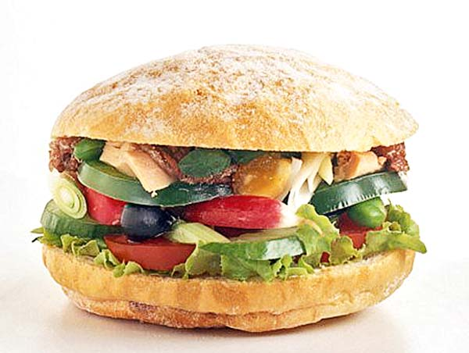
Recipe. Split a roll in half lengthwise. Sprinkle both pieces with olive oil. Arrange some tuna fish (canned tuna is fine, as long as it’s drained), black olives and pieces of boiled egg in layers on one half. Add vegetables to taste – lettuce, bell peppers or tomatoes will do nicely. Replace the top part of the roll.

The combination of tuna fish and olives is peculiar, not everyone will like it. Despite the fact that I do, the pan-bagnat will not become an everyday meal for me. This sandwich is meant to diversify your menu and tame your hunger slowly and lightly.
What I like best in the pan-bagnat is the light taste of olive oil. And the fact that this sandwich tastes better the next day.

Taco
Taco comes in a myriad of shapes and tastes. The stuffing can be made out of anything, and the only rule is to wrap it up into a tortilla, a Mexican corn flatbread.
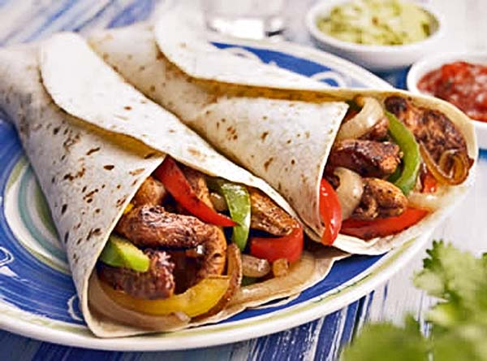
Recipe. Mince or chop beef very finely and pan roast it. Just before the meat is ready, add some onions and bell pepper to it. Spread the mixture on the tortilla (mine was locally made), and add fresh lettuce and tomatoes. You can add spice at any stage, by throwing chili or Tabasco into the mix. Roll up carefully.

Taco’s best feature is nutritiousness. Making it on your own means that you will be able to find the perfect proportion of meat to vegetables. But the most essential part is bread. I used a Ukrainian-made bread called Mexican tortilla bread, but it was too dry and stiff, and broke when I rolled it. Real tacos are hard to find and expensive, but the local flat bread, lavash, is a ubiquitous alternative.

III. Restaurants
Text 3.
Concord, on of the oldest luxury restaurants in Kyiv, received Best of Kyiv award. It has gained a steady reputation for its pleasant service, relaxing atmosphere spiced up with quality live music and, of course, food. Concord defines itself as “a restaurant of creative cuisine” blending French haute cuisine with oriental elements and latest culinary techniques. The restaurant’s chef keeps inventing new dishes and coming up with surprising new combinations, which helps to preserve Concord’s reputation as the international cuisine trendsetter of the capital.
But the creative side of Concord is obvious not only on the menu. Its design is also remarkable. The classical sofas, easy chairs and table covered in immaculate white cloth, contrast with eclectic ethnic-themed decor elements – photographs of Indians, tribal masks and Persian rugs. Plenty of green plants further liven up the spacious airy restaurant. Finally, the special attraction of Concord is the magnificent view of central Kyiv opening from its terrace. You can hardly think of a better option for a romantic candle-lit dinner, a business meeting or family celebration.

Dialogue.
At the Reastaurant.
Waiter: Hi. Welcome to Heavenly Pies. May I take your order?
Woman: Uh . . . yes. I'd like the chicken fried steak.
Waiter: Okay. Would you like fries, bread, or rice with your meal?
Woman: Umm. I'll take the rice.
Waiter: Would you care for anything to drink?
Woman: Yeah. I'll take a medium Sprite.
Waiter: I'm sorry. We only have large or small.
Woman: Well, in that case, uh, I'll have a small Sprite.
Waiter: Okay. A small Sprite. And what kind of dressing would you like with your salad. It comes with the fried steak.
Woman: What dressings do you have?
Waiter: We have French, Italian, blue cheese, and ranch.
Woman: Oh! Ranch, please.
Waiter: Would you like anything else?
Woman: Well, I'd like to see you pie menu. That's the main reason why I like to dine here.
Waiter: Oh, I'm so sorry, but we aren't serving pies today.
Woman: Huh?
Waiter: Well, you see, Dave, our baker, slipped on a banana peel back in our kitchen two days ago, and injured his back. [Oh] He'll be out for at least two weeks. In the meantime, we're serving ice cream sundaes instead. Sorry.
Woman: Wow. I'm sorry to hear that. I hope he gets better soon.

Vocabulary notes
meal (noun): a portion of food served and eaten at one time
e.g. This restaurant serves delicious meals at a reasonable price.
care for (verb): informal, to want or wish for something
e.g. Would you care for another drink?
dine (verb): to eat dinner
e.g. How about dining at my house tonight?
injure (verb): to cause physical damage to someone
e.g. He injured his back when he tried to lift those heavy boxes.

IV. Crockery and Cutlery.
Study the words.

