Module 3.
Topic HOUSE
Part I.
Task1 Describing houses
People live in lots of different places. Sometimes the type of house tells us about the people who live there and sometimes it doesn’t. Different countries have different types of houses.
A. Which of these features do you think are an essential part of a home? Which are not essential?
a garden  a balcony  a swimming pool  a garage  a patio / terrace  more than one bathroom  a kitchen  a fireplace | central heating  carpeted floors  a dining room  lots of space  shutters  a beautiful view  a basement  family room

B. Can you match these words describing types of house to their definition?
apartment flat penthouse bungalow loft apartment detached castle semi-detached studio cottage palace terraced

- a small house in the country _________________
- a house with no stairs, on one level. _______________
- a house which is part of a bigger building - Am. English: ____________
- a house which is part of a bigger building -Brit .English: ___________
- a house which is not joined to another house_______________
- a house which is joined to another house on one side _______________
- a house which is joined to other houses on two sides______________
- a house which is part of a line of houses ______________
- a house which was built to keep the inhabitants safe ______________
- a house which was built for rich or grand people _________________
- a house which is on the top of a tall building _________________
- a house which was an industrial building _________________
- a small one-roomed flat_________________

Task 2. Describe your home
Ask and answer questions about your home.
- Number of rooms?
- Type of house?
- Features?
- Location?

Task 3. Read the text and answer these questions

- What type of house is being described?
- What are the key features of this type of house?
- Where can you find these homes?

Look at a house from the outside, and you can guess what type of people live in it. Well, perhaps this is not always true. Some people can live in unusual houses. Some people live on boats, in tree houses or in tents.
For example, imagine you are in an old part of an industrial city in the UK. Cities like London, Manchester, Liverpool or Newcastle. There is a river, or a canal, which was important for transport in the past, before the railways were built. There are a lot of enormous buildings near the water. They were built in the 19th century. They must be industrial places to store things for import or export.
But…look more closely! There are expensive cars parked outside some of these buildings. And on the corner of the street there is a French restaurant, with a wine bar opposite. And just round the corner there is a shop with beautiful furniture. And here are more shops…Who buys these things?
Answer: the people who now live in these old buildings. Old warehouses like these offer two things that are difficult to find in modern houses: space, and a view.
Over the past 10 years, more and more architects have converted buildings like this into apartments, which have big rooms, high ceilings… and often a terrace which looks onto the water.
So, the old parts of many of Britain’s industrial cities now have a new life. They are not dead anymore, with empty warehouses and disused factories. You can buy factory space and make yourself a home in it. And the people who live in them can walk or cycle to work.
Or…with so much space. They work from home with a computer and a modem! Buildings don’t always tell us about lifestyles immediately. So, next time you see an old station, a deserted church or a village school in Britain, look carefully for the clues. You may get a surprise. Is this true in your town too?

Are these sentences true or false?
• These buildings were built recently.
• They are very spacious.
• Britain’s city centres do not have people living in them.
• Some people in Britain live and work in the same place.
• Some people in Britain live in churches.

Task 4 Houses in your country
Describe the types of housing available in your country/area.
• What are the main features?
• Do people live in the centre of cities or towns?
• Are there any unusual houses?
• Historic houses?
• Have the types of houses changed in the last 50 years?

Task 5 Your ideal home. Describe your ideal place to live.
• Would you rather live alone or with lots of people?
• In a town or a rural area?
• In a flat, a house or something more unusual like a boat?
• Do you like old buildings or modern ones?
• Is there anyone in the class with the same taste as you?

Task 6 Changing rooms: Your taste.
In the UK there are a lot of very popular TV programmes about houses. One programme, called ‘Changing rooms’ is very popular. One family or couple take a room in another family’s house and they change the look of the room. Sometimes they change it completely, changing the furniture and the style. Sometimes the people who live there are very happy with the new room, sometimes it does not suit their taste and they don’t like the changes at all. Sometimes you can guess a person’s taste, their interests and even their job from looking at a photo of their living room.
• What type of taste have you got?
• What other types of things can show a person’s taste?
• Describe 4 or 5 things in your bedroom which can help explain your taste.

Task 7 Discussion: Flying the nest
Discuss these questions with your partner
- At what age do people usually leave home in your country?
- What are the main reasons?
- Do young people share flats or houses?
- Do you think this is a good idea?
- What might be the advantages of leaving home at 18 to share a flat with friends?
- What are the possible disadvantages?
- If you had an opportunity to buy or rent a house or a flat what factors would be the most important for you?
- Imagine, you are married, you have a family and three children. In what kind of house or flat would you like to live with your family?
- What factors are important when you are looking for a place to live?
- All young people prefer to live in the city. But in what place would you like to live when you get married and have children?
- Imagine, you want to sell the house. What will you start with?
- What does it mean to be a good neighbour?
13. You want to buy the house and you have some amount of money but it is not enough. What will you do?

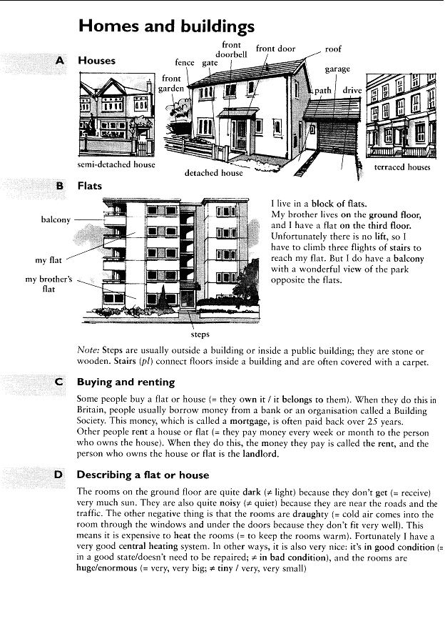
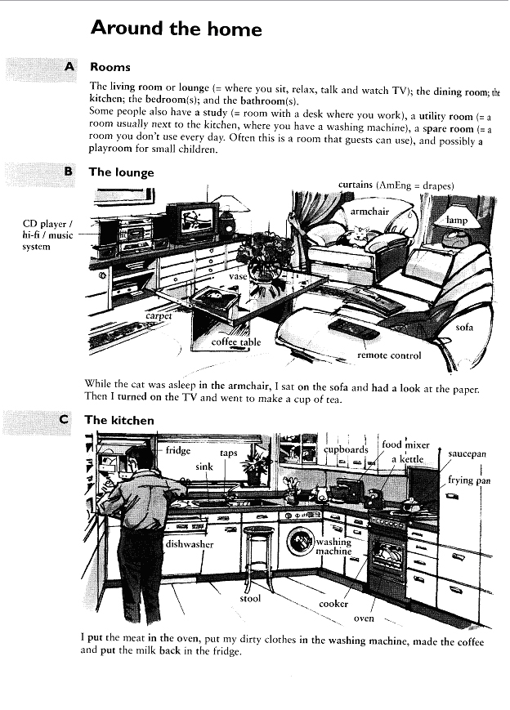
Part II.
Text 1.
It’s a pretty common discussion amongst us environmentalists – which is more eco-friendly, living in the city or living in the country? While there are points for both locations, I was giving this some thought the other day now that I live in a small mountain town of only 6,500 people, which is about 2 hours away from the closest city. While most of the population crams itself into our cities, there are still millions of people who live outside of the cities, living an entirely different kind of lifestyle – and that’s me now. From my perspective, living here is more eco-friendly for several reasons, but there are certainly some advantages of living in a big city as well, so let’s take a look at all of them. Comment on the points that you may not agree.

Eco-Friendly Advantages To City Living
More public transportation
Might not need to own a car at all
Walkable neighborhoods
Better selection of goods
Most people live in co-housing of some sort
Probably more energy-efficient, even if cities use more energy than the country
Less lawn maintenance/pesticides

Eco-Friendly Advantages To Country Living
No idling cars sitting in traffic
No pollution
Plenty of land to grow your own food
The ability in some climates to live off-grid (many people do that here where I live)
Distances might be further, but there are more bike-friendly roads
More access to fresh fruits & veggies due to more local farmers
Much less opportunity for consumerism, meaning you buy what you need and not much more
Easier to set up composting of your old food
Ability to have your own animals for food (eggs, milk, etc)

Of course, not all cities are the same nor are all places in the country the same. I can only compare where I used to live, Los Angeles, to where I live now in Northern New Mexico. The house we are renting is only a few block from the town center, meaning we are still able to get by with one car and my bicycle. All shopping, from groceries to the hardware store, are only a few miles away at most – but a lot of country towns are different than that. In Los Angeles I could not leave my house by car at almost any time of day – it was always rush hour. To go the 20 miles to the airport one day a long time ago took 3 hours. 3 hours to go 20 miles; it was that bad. Just the other day I drove 120 miles to the airport here in 2 hours – there isn’t any traffic at all. Many homes and buildings here are powered by solar power, our radio station is 100% solar-powered, and there are a lot of people who catch their own water from the sky. In the city, not many people can have the option of using solar power, as most of them live in condos or apartments. Out here in the country we have our own water-treatment plant that recycles all of our waste water into water used for watering, while in big cities a lot of the dirty water just gets pumped into any nearby body of water. But again, not every person living in the country lives in such a progressive place as this, so it really depends on what community you live in. It is not as simple as comparing apples to oranges; there are many different kinds of both and its not easy to say one is inherently better than the other. What do you think? Do you think one is more eco-friendly than the other?

Text 2.
City or Country (http://www.englishbaby.com/lessons/4889/real_life/city_or_country)

When you think of life in a big city, do you picture crowds, traffic, noise, and pollution? Or do you imagine soaring skyscrapers, an exciting mix of cultures, and endless restaurants, nightclubs, museums, and shops to visit?
Cities usually offer plenty of entertainment and excitement. But country life has its attractions as well. In the country, everything moves a bit slower. You can relax, lead a simpler life, and feel closer to nature.
Jason is sick of the city and thinking about moving to the country. But Ella grew up in the country. Find out if she thinks moving there is a good idea.

Jason: I just moved in to a new apartment downtown to save on my commute time. But I’ve been feeling so claustrophobic that I almost just want to leave the city altogether, get out of the rat race, go out to the country.
Ella: I don’t know. I grew up kind of in the countryside, in Florida. There was one bus stop, we had a sheriff, you know, less than 5,000…Everyone basically knew each other, there was like one grocery store…
Jason: Did you like growing up like that?
Ella: It was a good childhood. But it took forever to get to the mall. I mean, the beach was only a couple miles away, so that’s all we did, was like play tag or go to the beach or go to school. But everything was pretty far away to get to.
Jason: It must have been easy to go camping and stuff. You don’t have to go far to get back to basics.
Ella: Yeah, exactly.
Jason: I mean, but do you think it was simpler? Did you feel calmer?
Ella: It was nice to know everyone. You felt safe. I feel like if you live in the city you always have to watch your back and you’re not sure who’s out to get you. You get this kind of paranoid like, “Someone’s gonna rob me, someone’s gonna try to kill me!” You didn’t have that in the country. What do you think?
Jason: That’s interesting. It seems to me like the country’s almost more dangerous. Like if you’re in the middle of nowhere there’s crazies out there…
Ella: Well we’ve got that one sheriff.
Text 3. Buying a Property

Buying a home can be stressful and confusing if you do not have the tools to help you make informed decisions. Whether you are looking for an investment property or a place to call home Kiev International Realty will be glad to guide you through the complex and daunting process of doing so in Kiev / Ukraine. Kiev International Realty will be glad to not only steer you through the notoriously intricate Ukrainian bureaucracy but to also provide you with expert objective advice and representation during the process of property purchase.

If you are thinking of buying a property in Kiev, the first step would be to schedule a free consultation with one of our sales brokers. After the consultation, upon mutual agreement, we can then establish a representation agreement in which your wants and desires are formalized on paper. This step is essential in to narrow down your requirements and to prevent any mutual misunderstanding in the future.

Next step is for your agents to conduct property search on your behalf and keep you updated as new properties are being listed. When you encounter a listing which strikes your attention, your broker contacts their counterpart and schedules a viewing which he attends on his own. After the first viewing your agent will provide you with a summary, photographs and a video of the property. At this point if you are satisfied with the information presented, the second viewing requiring your participation is then scheduled.

Once we have located a property that suits your needs, we will then conduct negotiations with the selling party, title search and an independent appraisal. Upon successful completion of these steps we will then assist you in the closing process and post sale property registration with the governmental agencies.

Buying a property is a complicated, serious decision thus it is essential to have an objective reliable local partner. If you are thinking of investing in Kiev’s real estate market please do not hesitate to contact us by phone at +380 44 209 3266, leave us an inquiry below, or email us at info@kievintlrealty.com
Task 1. Renting an apartment or taking out a home mortgage loan to buy a house are major decisions in one's life. In other cases, students might live in dormitories on campus or even stay with a homestay family which can give them opportunities to interact with native speakers. Study the words below and consult a dictionary if you need a definition. Write a sample sentence for each word to learn how it is used in context. You can use the Internet to find such sentences or related information.
- apartment
- apartment manager
- carport
- condominium
- dormitory
- down payment
- duplex
- furnished / unfurnished
- gas / light / water bill
- housing
- landlord
- mortgage payment
- parking space
- rent
- roommate
- security deposit
- tenant
- townhouse
- utilities
- yard
Task 2. Now, complete the sentences below with the best answer:

1. You have to pay a __________________ when you rent an apartment, and this money is often used to cover any damages you cause.
A. down payment B. mortgage payment C. security deposit
2. Many international students live in a ________________ on campus when they study abroad. It often doesn't have its own kitchen, but it often is furnished with a bed and desk.
A. dormitory B. townhouse C. condominium
3. According to housing rules, __________________ are not allowed to smoke or have pets in their apartments.
A. apartment managersB. tenants C. landlords
Part III.
Examples of essays on the topic.

Essay 1. “Home Sweet Home”
Home... to me, it is my nest, my cave, my comfort zone for heart and soul, my safe haven. Home is also the place where I design my environment to reflect my personality, turning my surroundings into an extension of myself and making them part of me visually as well as ideologically. Home is where I come back to after an outing, and it awaits me with my worn slippers, my comfy recliner and my happy pets. Home is where I know every nook and cranny, every creak and groan, every smell and every patch of light and shadow. My home is my castle... I have the right to make it almost inaccessible to unwelcome intruders and welcoming to those I love and respect. It is my retreat from the world, the showcase for my treasures, and the stronghold of my values. Home... it is my second skin, my soil in which I am rooted, the roof over my head and the blanket for my soul. Sometimes I wonder how a professionally decorated house or apartment can be a real home to the people who live in it. To me, it seems as if that was the same as wearing a stranger's clothes or somebody else’s prescription glasses. Sure, it may serve the basic purpose and it may look better than if you used your own things and ideas, but it's just not you. Isn't hiring somebody to create your living space, your home, a lot like having the secretary choose your friend’s birthday present flowers and put a birthday card in front of you to sign while making your dinner reservations? The birthday is remembered and observed, the employee quite possibly has impeccable taste and chooses well, yet the whole setup misses the original idea by miles.
What about adding one's own personal touches to a professionally created environment then? Would this fix the problem? It might – but usually, such a professionally designed environment is finely balanced, and changes or additions as small as a misfit picture frame in the wrong place or a chair pulled closer to the coffee table for comfort mar the professional's composition and, in a way, defeat the purpose behind hiring a decorator in the first place. I personally believe that a home should grow over time and be cultivated by those who live in it, rather than be served like a classy but prefabricated dinner by a stranger. Strangers just never put the right amount of salt in it, if you ask me. Have you ever watched a dog turn 'round and 'round before finally lying down for a cozy nap? Some animals in the wild do the same thing, and I think the purpose of this is to create a sort of molded dip in the ground cover for added comfort. As for me, I like my slippers molded to my feet, my chair molded to my body and, generally, my home molded to my mind and soul. These things do add a lot of comfort to the dog bed part of life. Comfort is not the only reason for having things "just so", though. If you have a runaway brain cell (singular) like I do, you probably live pretty much on instinct at least some of the time. Living on instinct means, in part, that you don't notice much of what you’re used to, but anything out of the ordinary makes you perk up your ears and squirt some adrenaline through your system just in case it's needed. For me, any unfamiliar noise, smell or sight does it, and I get flighty without meaning to.
At the same time, being in my familiar, second-skin surroundings at home gives me peace of mind and a feeling of security which is as intense as that nervousness is. I suppose you could say that there is a lot of mental and emotional security in old slippers and the faint buzzing of your refrigerator. Security. Have you ever noticed that your home is the only place in the world where your level of security is entirely up to you? You have choices ranging from unlocked doors to barred windows, both in the physical and the figurative sense. You have the option to keep out the unwelcome by way of locks, caller ID and the "off" button on the TV. Although there are exceptions such as determined criminals or junk e-mail over which we can't always have control, the home is where we make the rules, where we decide what or who may be part of our personal lives. Whether we entertain friends, have a family get-together, take in stray animals or people, or post "No Trespassing" signs around our property and refuse the traveling salesman or missionary, it's our choice.

Essay 2. There is no place like home
The charms and pleasures of domestic life are known to everyone. Just go out to another town to see your relative, and there you will be secretly pining for your home, sweet home. You will remember the delightful evenings you passed around the fireside. It will be delightful to recall the scene of your father returning home after his day’s work, the children climbing on his knee; the mother preparing the evening meal and your sisters, talking of sweet innocent things; The kindly neighbors drop in helping to pass the evening hours merrily with their pleasant and cheerful conversation.
These homely joys may at first sight seem to be somewhat commonplace. But as we grow older we find that they are the true sources of happiness. The joys given by wealth, rank, position and fortune, are short lived; they soon pass away. But the joys of domestic life are of a permanent nature. They always remain with us. A kind father, an affectionate mother, a sympathetic brother, a loving wife, a dutiful son, a devoted, obedient daughter fill our life with cheerfulness. Rank; wealth and fame are not within the reach of all, thy come only to those who are fortunate. But these domestic joys can be enjoyed even by the poorest laborer. While the pleasures given by wealth, position and fame are of an exciting nature and make our soul weary of the world, the serene joys of domestic happiness soothe our very soul and bring us peace, contentment, and cheer fullness.
But it is not for these joys alone that our home is to be valued. A home is often-the best school for acquiring the noble virtues of honesty, truthfulness, faithfulness, sincerity, obedience, sympathy, self-sacrifice, and self-denial. We imitate the actions of our parents and relatives. From them we learn to be sympathetic, obedient and true to others. The unselfish devotion with which the mother serves her husband and children and the wonderful self-denial which the father displays in daily life are noble examples of the highest virtues. Self-control, the noblest of all virtues, is largely a result of home influences.
Most of our pleasant associations are often connected with our homes. For it was there that most of us spent the happy days of our childhood and youth. Imagination clothes these scenes with loveliness and throws a charm of romance over them. So it is that, wherever we may roam, there is no place like home.
Tasks for translation.
  - Черноватий – Unit 1. Lesson 1.
A.
- Він хоче продати котедж із солом‘яною стріхою, розташований у живописному передмісті Лондона.
- Я б ніколи не хотіла жити у висотному будинку в центрі міста або у новому житловому районі з однотипними будинками.
- Мрією мого дитинства завжди був житловий автопричеп, тому що ми б могли подрожувати усією родиною і зупинятися там, де захочемо.
- Вона дуже скоро вийде заміж за Джека і тоді вони житимуть разом у його окремому будинку з чудовим садом.
- Я більше не живу у двоповерховому будинку, ми переїхали у нову квартиру.
- Ти коли-небудь думав про те, щоб переїхати до будинку терасного типу?
- Їй завжди хотілося втекти з великого міста і оселетися у невеличкому бунгало на березі моря.
- На горищі старого будинку завжди можна знайти безліч цікавих речей.
- Тепер я живу у хмарочосі в центрі Нью-Йорка, і ввечері дуже полюбляю сидіти біля вікна і дивитися на місто.
- Найважливішим для нього було якнайшвидше купити ранчо і почати нове щасливе життя.

B.
1. Якби він мав достатньо грошей, то придбав би собі дачу.
2. Хмарочоси нічного міста вражали туристів.
3. На горищі ранчо поліція знайшла вкрадені гроші.
4. Він вже майже забув про своє життя у автопричепі.
5. Напівокремі будинки можна побачити у багатьох європейських країнах.
6. Цей багатоквартирний будинок буде продано, а його мешканці переїдуть в інший.
7. Особняк містера Соммерса виглядає розкішно.
8. Нещодавно Сара переїхала у новий житловий район з розташованими поруч однотипними будинками.
9. Ця квартира в двох рівнях належить його матері.
10. Котеджі зі солом’яною стріхою можна зустріти навіть у сучасних селах.
11. Цей будинок побудовано у вікторіанському стилі.
12.Стоянка житлових автопричепів знаходилася біля лісу.
13. Анна вже 10 років мешкає у кондомініумі.
14. Кімнати, перебудовані з інших приміщень, є популярними серед творчих людей.
15. Чорний хід допоміг йому втекти.

Collocations
- Він завжди пишався власним родовим будинком, що був великим та просторим.
- Вікна будинку виходили на великий магазин.
- Наша фірма може забезпечити тимчасовим чи постійним житлом , або житлом на час відпустки.
- У столиці зросли ціни на житло, тому я буду купувати комфортабельну, простору, умебльовану квартиру в Одесі.
- Розташований у центрі міста, будинок коштував величезні гроші.
- Це приватне житло, а я його власник.
- Я тебе виселю з квартири, якщо ти не заплатиш.
- Я шукаю в Миколаєві тимчасове житло, але не можу знайти.
- Хоча цей незаселений десятикімнатний будинок досить дорогий, він безладно збудований і давно не ремонтований.
- Ми вже переїхали до скромної затишної квартири на останньому поверсі.

II. Черноватий – Unit 1. Lesson 2.
- Родини, фінансове становище яких поліпшується, хочуть мати модні, елегантні і навіть розкішні оселі, де житло планується переважно без міжкімнатних перегородок, принаймні на першому поверсі
- Замість кімнат є зони, наприклад, зона харчування, в якій розрізняють зону легкого харчування( наприклад, для сніданку) та зону для більш офіційних заходів.
- Є також зони наведення туалету та перевдягання з трельяжем та гардеробом, крізь який можна проходити, відпочинку( або відпочинку і занять спортом), прання та інших занять.
- Ванні кімнати в таких будинках мають комірчини ( одинарні або подвійні), в які можна навіть заходити , а найбільша ванна кімната є зазвичай класу «люкс» і пишається окремим душем , туалетом і джакузі.
- Просторий коридор , передпокій, досить велика, але затишна кухня у формі літери L, оснащена легкодоступними вбудованими меблями та коморою для провізії, з столом посередині приміщення та суміжною комірчиною для пральної машини.
- Тут є досить місця і для куточку для сніданка.
- У правому кутку є зручно розташована простора кімната для відпочинку, яку можна перетворити на комфортабельну їдальню або на затишну додаткову кімнату, а може й найкращу в кімнаті спальню
- На першому поверсі , у передпокої, що розширюється і перетворюється на вітальню, яку деякі називають просто «великою» або « родиною кімнатою», є ще одна кімната , з входом через передпокій
- Ще дві кімнати для гостей мають комірчини для білизни, ванну кімнату та вікна, які виходять на сад.
- Цей будинок вартий власної ціни
- Ми всі на намагаємося зробити свій дім затишним, привабливим і зручним.
- Цей двоповерховий привабливий будинок з чіткими лініями є ідеальним для тих, хто купує житло вперше, або для подружжя без житла.
- В будинку є зони наведення туалету та перевдягання з трельяжем та гардеробом, крізь який можна проходити, відпочинку( або відпочинку і занять спортом), прання та інших занять.

III. Черноватий - Unit 1. Leson 3, cтор.354-369

- Хазяйка призначила орендну плату вище, ніж у минулому місці, тому що замінила килимове покриття та купила нові м’які стільці, нові портьєри та кушетку.
- Прозора завіса відділяла ліжко з балдахіном від зони перевдягання з шафою, туалетним столиком з дзеркалом, пуфиком та комодом, в якому зберігалися постільні речі.
- В вітальні було небагато предметів умеблювання, тільки секційний диван, стерео установка та скриня з подушками, пледами та простирадлами. Стінку прикрашала картина (мистецький вироб) у позолоченій рамці.
- Відсотки за позику, комісійні для агента з нерухомості, податок на нерухомість, додаткові витрати на юридичну реєстрацію визначають кінцеву вартість житла, яка досить часто є недоступною для народу.

IV. Unit 1. Leson 4.
  - Після того, як підлогу в кімнаті помили шваброю, вона стала виглядати чистою і затишною.
  - Помий, будь ласка, посуд, а я попилосошу в кімнаті.
  - Не бери кухонний рушник, краще використай серветки.
  - Коли будеш мити цей фарфоровий посуд, будь дуже обережним, він дорого коштує.
  - Ці портьєри роблять кімнату світлішою.
  - Том вирішив оселитися у напівокремому будинкові з великою вітальнею, їдальнею, світлою спальнею та зручним робочим кабінетом.
  - У Британії вважається незаконним встановлення таких високовольтних електричних приладів, як пральна машина та сушарка у ванні. Для них існує окрема підсобка, в якій також можуть поміщатися посудомийна машина та морозильна камера.
  - Моя мрія – це велика вілла з багатьма оранжереями та квітниками.

Letter.
Доброго дня, пане Литвиненко!
Я знаю, Ви допомогли моїй подрузі винайняти в оренду простору квартиру за прийнятну ціну.
Я хотіла б Вас попросити знайти житло для мене. Мені потрібно винайняти маленьку, але затишну однокімнатну квартирку. Я буду мешкати в цій квартирі разом з зі своєю сестрою. Квартира повинна бути умебльованою. Я навчаюся в НАУ, тому хотіла б, щоб квартира знаходилася десь неподалік. Сестра хотіла б, щоб там був домофон або хоча б конс’єрж. Ми можемо дозволити собі знімати житло, місячна оплата за яке не перевищувала б 2300 грн.
Заздалегідь вдячна,
З повагою,
Марина

