Vladimir A.Egorchenkov, the Donbas National Academy of Civil Engineering and Architecture, Makeevka, the Donetsk region, Ukraine

THE INFLUENCE OF THE LIGHTING PARAMETERS ON VISUAL ENSATIONS IN INDUSTRIAL PREMISES

The administration of the electric lamp plant in Maily-Saisk (Kirghizia) made a request to the specialists responsible for the lighting conditions to study the lighting environment in the electrode-spiral shop and to make recommendations for a rational lighting system arrangement. The matter is that in the spiralization department the artificial lighting system was doubly reconstructed but has met no positive result. When examining the shop the adjusters of the coiling machines pointed to some working places where one could not look at the spiral because it looked like a sparkling body. When working the workers suffered from unpleasant visual sensations, and afterward they felt dark spots in the eyes for some time. It’s natural that the plant administration was anxious with this negative fact removal of which was important first of all from the standpoint of preventing a professional disease.

As known, a lighting environment in the industrial premises makes a great effect on labor productivity and on how a man feels. A high intensity of the visual labor and bad lighting conditions not only decreases the labor productivity, but causes professional diseases of both the organs of sight and other systems of the organism, namely a decrease of the visual analyzer efficiency, a partial loss of sight, headache etc. So, the health of a human being working in the industry will greatly depend on how the lighting systems in the shops will be done.
Light possesses both quantitative and qualitative characteristics. When designing the lighting systems, the main significance, as a rule, is attached to the account of quantitative characteristics, and qualitative characteristics are usually given as general recommendations, although they can be of crucial importance in accepting this or that system of lighting the premises. Thus, when analyzing the situation mentioned above it has been proposed that the qualitative characteristics of the light field are not adequately accounted.
The purpose of this work is to study a complex influence of quantitative and qualitative characteristics of the light field in the spiralization shops of the electric lamp plants on visual sensations.
At the electric lamp plants, one of the most crucial production bays both from the standpoint of the quality the output (electric incandescent lamps) and the lighting conditions is the spiralization bay (the first category of visual operations [1]).
Analysis of the spiral coiling technology shows that if a defect occurs, an operator controlling the spiral coiling must immediately determine its type (there are more than 20 types of a defect) and, according to it, adjust the coiling machine operation.
Thus, the labor productivity and the quality of the spirals coiled will depend on how quickly and correctly an operator will detect a defect and determine its type, and that, in its turn, depends on the quality of lighting both on his working place and in the premises. The object of visual observation in this case is a spiral coiled, and the object of distinguishing is a clearance between a spiral coils.
To study the influence of the lighting parameters on the state of the organs of sight, there has been developed a test-object which comprises 12 lots of 24 spirals of a definite type with the ratio of good and defective spirals 1:1, and their alternation was random to avoid guessing. The type of a defect included into the test-object is a chop, the most typical for this kind of production.
Analysis of the psycho-physical methods [2] has shown that in this case the most acceptable method is the method of permanent irritants. The idea of this method is that creating different parameters of the lighting environment on the experimental working place approaching a real production, an examinee (there were chosen 12 persons of the workers of this plant) was suggested a test-object in the form of a definite lot of spirals. The lighting environment parameters and the examinees’ answers (if a spiral is good or defective) were registered in a special card of the psycho-physical investigations.
To study the influence of the light characteristics on visual sensations, there was used a visual working capacity η [3]. This criterion is most universal and sensitive to the qualitative indices of lighting. Its use is also efficient when inspecting the moving objects.
A visual working capacity in the experiment was determined by the formulae:
$η=\frac{N}{T}⋅\frac{n^{'}}{n}$,
where N – a common number of the test-object elements viewed by an examinee, pieces;
Т – a full time of the visual working capacity determination, sec;
n – a number of the defective elements in a test-object, pieces;
$n^{'}$- a number of the correctly identified elements, pieces.
To compare the influence of different parameters of the lighting environment on a visual working capacity, there was used a relative working capacity η_{rel:}
$η_{\text{отн}}=\frac{η}{η_{\text{max}}}\text{10}0$, %,
where η_{max} – a maximum value of the visual working capacity determined by the most favorable value of this or that lighting parameter for the given test-object.
The control and adjustment of the experimental results were carried out with the help of the examinees’ subjective evaluation.
A relative working capacity was determined according to the following lighting parameters:
- an average spherical illuminance Е_{4π} – a quantitative characteristic;
- angular parameters of the light vector – an azimuth β and an angular height θ – the qualitative characteristics;
- the lighting contrast range m, numerically equal to the relation of the value of the light modulus of a vector$\overset{→}{|ε|}$ to the value of an average spherical illuminance – a qualitative characteristic.
A measurement of the value of an average spherical illuminance was taken with the help of a spherical probe 120 mm in diameter made of a stifled methylmetacrilate with a selenium photocell 25 mm in diameter in a metallic holder attached to the probe surface. The angular parameters of the light vector and the value of its modulus were measured by a vector scope consisting of six selenium photocells SPh-44 44 mm in diameter in a plastic holder arranged on the faces of a metallic box with each side equal to 70 mm. All photocells were provided with the corresponding correlation light filters.
The investigations were conducted at a natural (side windows and II-shaped lamps) and artificial (a general lighting in the form of fluorescent luminaires and a local lighting in the form of a luminaire with an incandescent lamp which can have different spatial arrangement) lighting. For brevity sake, there are presented the results obtained at a natural lighting. At an artificial lighting the character of the parameter change is the same as at a natural lighting, and the absolute levels were slightly higher.
Psycho-physical measurements were taken in two stages. At the first stage there were determined the ranges which could enclose favorable levels of lighting conditions. At the second stage there were determined the exact values of the favorable levels of lighting.
On the evidence of the preliminary investigations, it has been found that the most acceptable levels of spherical illuminance are within 200-300 lx, the value of the modulus of a light vector is 400-750 lx, and the lighting contrast range is 1.6-2.3. These values have been adopted as constant when determining the angular parameters.

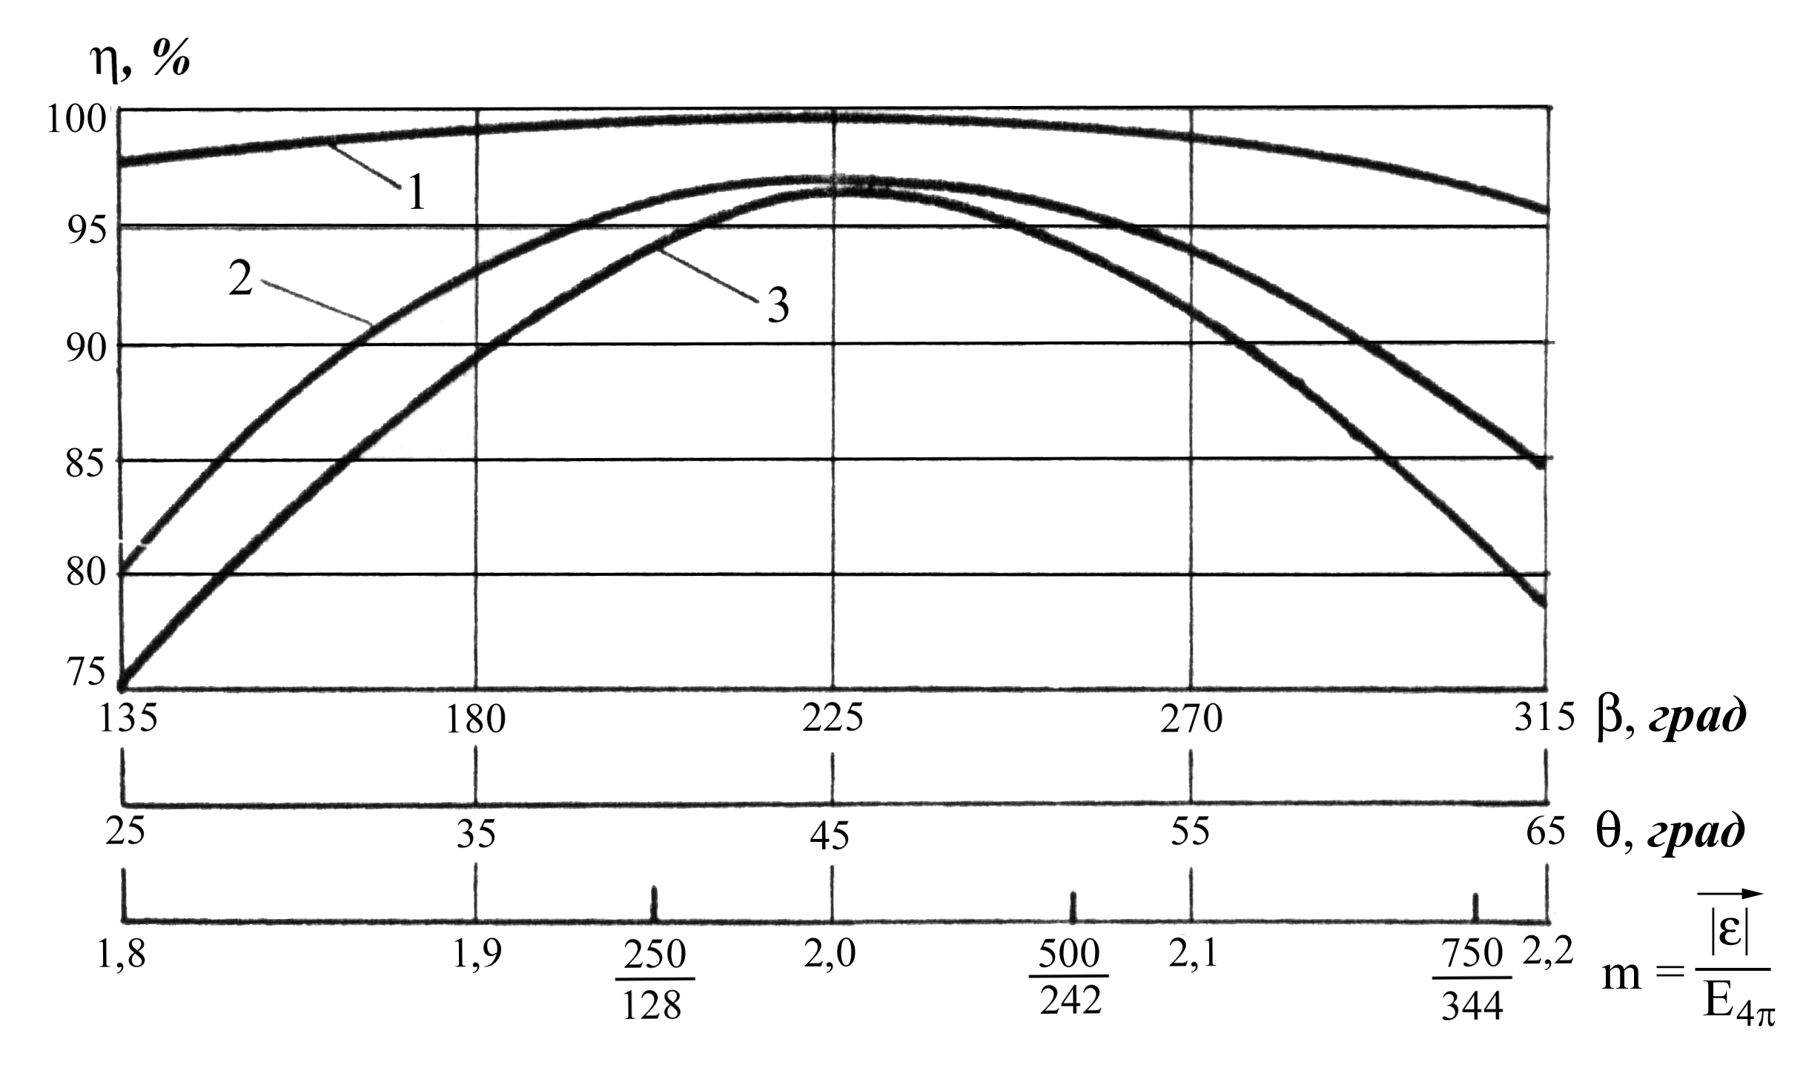
At first, there was determined a favorable value of the light vector azimuth at three values of the angle of elevation: 30°, 45° and 70°. The best results were obtained at θ = 45°. As a consequence, the highest labor productivity was fixed at the value of the light vector azimuth equal to 228 ± 12° (see Figure, curve 2) from the sight line clockwise around the subject of observation. This value remained constant at an accurate determination of the angle of elevation which eventually proved to be equal to 47 ± 2° (see Figure, curve 3) from a horizontal plane around the subject of observation.
When determining the favor-
able values of the light vector
A relative visual working capacity as a function of the natural lighting parameters: 1 – the lighting contrast range; 2 - the light vector azimuth; 3 – the light vector angle of elevation

azimuth and the average spherical
illuminance, the azimuth and light
vector angle of elevation were
adopted as constant and their

values were within the found favorable ranges.
This part of the investigation was also taken in two stages. At the first stage there was being solved the task of determining the best value of the lighting contrast range, and was being determined an approximate range of the values for absolute levels at which the maximum sight labor productivity was observed. At the second stage there were determined the exact values of the modulus of a light vector and an average spherical illuminance which corresponded to the favorable conditions of the visual perception.
The investigation results are presented in the figure from which it follows that the most favorable values must be taken the following values (see Figure, curve 1):
- lighting contrast range – m = 2,0 ± 0,1;
- an average spherical illuminance Е_{4π} = 280 ± 44лк (it is correlated in terms of a subjective estimation).
We emphasize that when searching the favorable values of the light field parameters; there have been found an explanation to the occurrence of a sparkling spiral which was mentioned about in the preamble to the article. The point is that the pivot (the base a spiral is coiled on) is a molybdenum wire, and the spiral itself is dark tungsten coils. At a definite unfavorable combination of the light parameters, the light fluxes reflected from the pivot and passing through the spiral coils produce lots of the smallest glares in the observers’ eyes and that’s why the observers perceive the spiral as a sparkling body. But if the system of lighting is accomplished in such a way that the found favorable parameters of the light field or close to them will be obeyed, then such an unfavorable phenomenon will not take place.
To make an estimate of a comparative influence of the parameters on the visual sensations, lets bring into coincidence the plots of each parameter in one figure (see Figure) by some transformations and calculations we’ll determine an averaged value of the degree of the parameter influence to one another. As a result we’ll get the following picture:
- on an average spherical illuminance …………………………к_{е} = 0,2;
- on the lighting contrast range ………………………………..к_{m} = 1,0;
- on the light vector angle of elevation…………………………k_{θ} = 9,7;
- on the light vector azimuth ………………………………….к_{β} = 6,4.
It means that if the parameter deviated from its normative value, a relative visual working capacity decreases K times in relation to the lighting contrast range.

Conclusions

1. As evident from the results obtained, for this production operation not the absolute levels but the angular parameters of a light vector are of a crucial importance for visual sensations.
2. The use of the experimental results will make it possible to determine the most efficient system of lighting which will be favorable not only for a high labor productivity, but will minimize professional diseases of the organs of sight.
3. The use of the obtained results will allow an accomplishment of a light-technical estimate of different variants of the system of lighting when designing buildings [4].
4. On the results of these investigations when designing the system of an artificial lighting on the pilot bay, the number of lamps was cut in half, and their power was decreased in half too. As this took place, the arrangement of lamps was changed, and the parameters of lighting were brought to the found favorable ranges. As a result, the lighting conditions improved, the phenomenon of a sparkling spiral was not observed at the working places and the labor productivity increased by 12%.
The experimental procedure has been tested at the electric lamp plant in Maily-Saisk (Kirghizia) and at some enterprises in the Donetsk region.

References

- Natural and artificial lighting. The design codes. SNIP ІІ-4-79 [Changed]//Svetotehknika, 1991, №6.- P.1-31.
- Bardin K.V. The Problem of the Threshold Sensitivity.- M.: Nauka, 1076.- 395 p.
3. Weston H. The relation between illumination and visual performance. – London, 1953.
4. Egorchenkov V.A. A Light-Technical Estimate of Fenestrations in Buildings by Some Criteria on the Base of Computer Technologies. – In: Architectura i technika a zdrowie. Materialy II sympozjum. At-z. – Gliwice, 2004.- С. 65-72.

Resume. There are presented the results of the psycho-physical investigations to determine the influence of the lighting parameters on a visual working capacity in the spiralization shops of the electric-lamp industry. There has been developed an experimental procedure, determined the favorable values of the lighting parameters for specific visual operations (spiral coiling): an average spherical illuminance, a lighting contrast range, the azimuth and angle of elevation of a light vector. The use of the obtained results will allow the determination of the most efficient system of lighting.

