UDC 621.391
B.P. Ivanov
(Central Reserch of Armament of Armed Forces of Ukraine, Ukraine, Kiev)
D.P. Kucherov, doctor of science
(National aviation university, Ukraine, Kiev)
THE TASK OF TRACKING A MOBILE ROBOTIC SYSTEMS ON A ROUTE
The report considers the problem of delivery a cargo by remotely controlled a robotic systems wheel type. It is assumed that the movement of vehicles along the route takes place column, which are arranged at the start of the machine, the route consists of straight and curved portions movement. Determined to motion parameters column machines and the law of motion control for movement along a predetermined path.
The report considers the problem of ensuring the delivery of goods from one point to another in a minimum time. Consignment cannot be delivered by one vehicle, but it is possible to redistribute evenly between vehicles of a one class. Delivery is carried out by vehicles that allow remote control, for example, that can occur in cases associated with increased risk for life staff. As vehicles are selected the wheeled vehicles that can be moving on a dry, inviscid coating.
This problem relates to the problems of group control (control collective behavior) mobile robots, that is enough actual direction of the modern robotics.
Solution of the problem tend to select the travel route of a vehicles and tracking the movement of a group (for example, see [1-5]).
We assume that the load shedding associated only with a reduction of group elements, and the reasons leading to a reduction in the number of group elements are absent. In this case, the main task of collective management will considered the minimum time of delivery.
This problem is sufficiently popular among researchers engaged in remote controlled moving transport platform. The main attention is paid to the definition of a mathematical model for remote control and the construction of this model for the optimal control for a single platform. The task could be complicated by the introduction of additional rigid mechanical links. While in areas curved path of motion of this principle is similar to the movement of the tow snakes. Recently, however, there are increasing development-oriented collective (group) management, does not imply the presence of rigid connections between individual members of the group. Such works include work such as [1, 3], which offers the possibility of a tree view in the form of a "master-slave" and the division of the system into subsystems management software and positional control. The "master" (leader) defines the objectives of motion and sequence, "slave" follows the "master".
To determine the design requirements for the system management is needed of information on the potential possibilities of the system, which will ensure the safety of traffic on the route.
We assume key performance indicators of this problem are the delivery time and no loss of cargo during movement.
Thus, the main aim of the paper is to provide a minimum time of delivery a group that consists of n - robotic vehicles.
The problem of delivery is stated as that allowed its distribution between individual vehicles in equal portions. Thus, the choice of the number of vehicles depends on the volume of cargo. A load on a separate vehicle is completely determined of dimensions of robotic agents.
Movement group performed on the track of arbitrary shape with a constant adhesion to the road surface. The track consists of portions of rectilinear and curvilinear motion. Vehicles are moving in the column of the n-machines. At the same time lead car takes leadership group, it has complete information about the ultimate task of following groups and also has navigation and communication tools, as members of the group and the operator in a position to suggest certain actions in the process of solving the problem. Generalized scheme of robotic movement means shown in Figure 1.

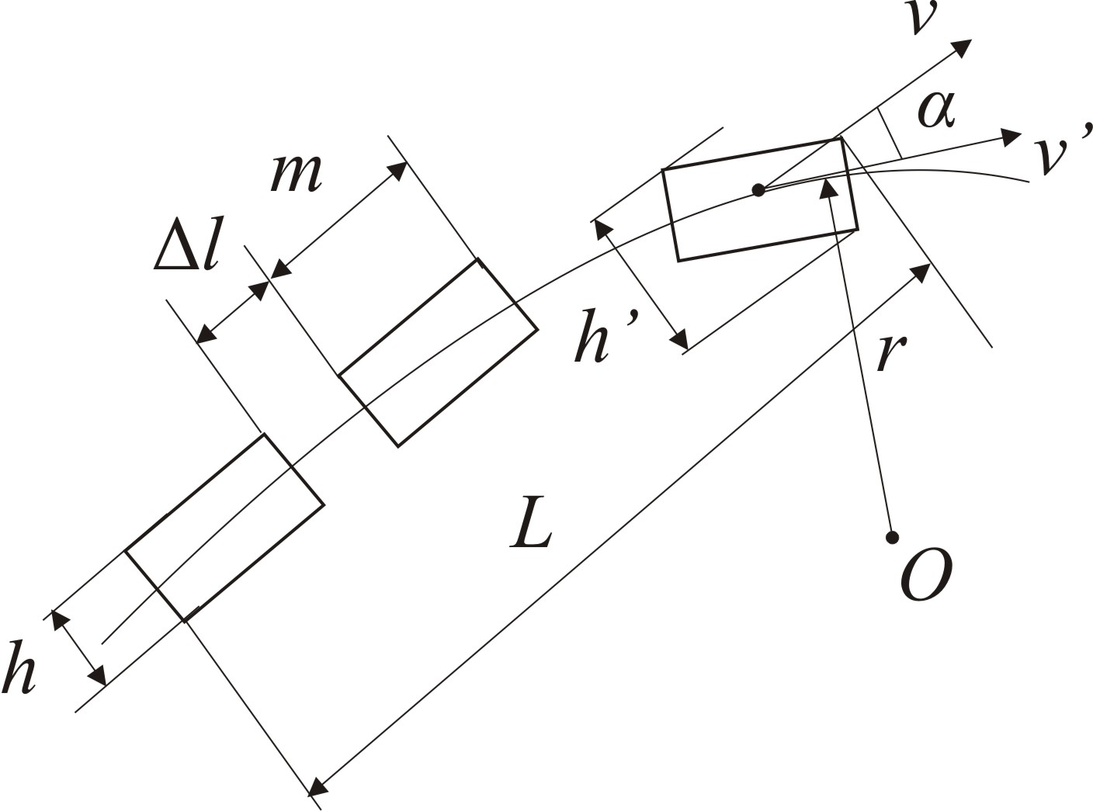
Fig. 1. A scheme of movement of the mobile robotic systems

On Fig. 1 introduced the notation h '- width of the corridor, O - the center of rotation, r - turning radius, v, v' - velocity vectors and its tangential component.
Required to determine the maximum parameters follow a group of n-vehicles into account the curved trajectory.
In order to ensure group's safety on the route are assigned a constant distance Δl between the cars and transverse interval Δh, during which cars do not come out. The route consists of a section start, plot movement on the track and finish area. The sections of start and finish are not point. It is assumed that the areas start / finish line, turning movement is performed with an acceleration, on the straight portion of is uniform motion performed. Size L column on the route agreed with the number of machines in the group, the size of individual vehicle and the value m distance Δl
$L=(n−1)Δl+\text{nm}$ (1)
and cannot go beyond a certain value Δδ, the maximum value of which will be determined by the geometry of the rotation, the motion parameters and the number of vehicles.
We assume that the movement of a group of vehicles in the absence of a rigid connection between the elements of the group, allowing the group to consider each element separately and setting its average values for the corridor and a maximum average speed.
We will seek the average vehicle speed on a section of curvilinear motion of radius r under the conditions that the average speed on a uniform plot v, car deviates from the normal when turning no more than an angle α and gravity during movement of the car does not change. Then the speed of the vehicle is determined by the formula
$v=\sqrt{\frac{\text{gr}}{\text{tg}β}}$, (2)
where g = 9.8 m/s² - acceleration of gravity, and the maximum speed in the curved section of track with a radius r_{max} and the angle of deviation from the normal β_{max} is
$v_{\text{max}}=\sqrt{\frac{{\text{gr}}_{\text{max}}}{\text{tg}β_{\text{max}}}}$. (3)
The maximum width of the corridor is determined as the difference between the radii of the two points of the machine - the most distant from the rotation center and closest thereto. Consequently, at the curved portion of the movement to the dimensions of the vehicle horizontally m and h the vertical the corridor is value
$\frac{m^{2}}{r}+h\text{cos}α≤h_{\text{доп}}$. (4)
In (4), the maximum width of the corridor is defined at the minimum r and at the maximum α.
The repetition interval should provide time for slowing down to a complete stop if the vehicle in front applies the emergency brake. From course physics we know that the braking distance S_{m} determined vehicle speed v at the beginning of braking and friction coefficient μ
$S_{т}=\frac{v^{2}}{μg}$. (5)
Obviously, the choice of the distance in the group, based on the terms of traffic safety, to exceed this distance in 2 .. 3 times, namely
Δl=(2…3)S_{т}. (6)
Thus, formulas (1) - (5), taking into account the comments (6) fully define the requirements for the movement of the group on the route.
Dynamics of the route described by differential equations of the form, in accordance with [1, 3]
${\overset{˙}{x}}_{i}=y_{i},{\overset{˙}{y}}_{i}=u_{i}(x,y,z)$, (7)
where x={x₁,…, x_{n}}, y={y₁,…, y_{n}}, z={z₁,…, z_{n}} – position, velocity and acceleration of the center of mass n machines in Cartesian coordinates, and u_{i}(x, y, z) - the control action that is meaningful acceleration the i-th machine.
We assume that the system has the exchange of information and every machine available information about parameters of the motion the neighboring machine, namely j-th means have the information about j-1 and j +1 machines, n-th has information about (n-1)-th machine.
Then, the control law that provides the tracking on a trajectory can be described as
$u_{i}=c_{k}V_{i}$, (8)
where с_{k}≠0, k=1, 2, 3,
$V_{i}=(x_{i}−x_{i−1},y_{i}−y_{i−1},z_{i}−z_{i−1})$. (9)
аnd i=1…n.
Control law (8), (9) is smooth in the coordinates x, y, z function, it is allows to realize a system with feedback control, its effectiveness is determined by an appropriate choice of c_{k}. When the law (8), (9) is performed, each machine should be strictly on a route determined by the master.
Conclusions
In the article the requirements to parameters for mobile robotic systems motion as a column machines, conditions for performing motion based representations of the physical laws of motion of vehicles. The actual dynamics of the route is determined by a mathematical model of the system, representing a system of differential equations of second order. Further research should focus on optimizing the control law.
LITERATURE
- Кунцевич В.М. Некоторые задачи управления групповым движением подвижных роботов / Кунцевич В.М. // Проблемы управления и автоматики. - № 1. – 2012. – с. 5-18.
- Ларин В.Б. Об отслеживании программной траектории колесным транспортным роботом / Ларин В.Б. // Проблемы управления и автоматики. - № 1. – 2013. – с. 139-146.
- Морозов Ю.В. Модификация и сравнительный анализ гладких законов управления группой агентов / Морозов Ю.В. // Автоматика и телемеханика. - № 11. – 2012. – с. 96-113.
- Кучеров Д.П. Интеграционный подход к задаче выбора маршрута группы БПЛА / Кучеров Д.П., Козуб А.Н. // Искусственный интеллект. - № 4 (62). – 2013. – С. 333-343.
- Кучеров Д.П. Планирование маршрута БПЛА / Кучеров Д.П., Козуб А.Н. // Вісник східноукраїнського національного університету імені Володимира Даля. - № 5. – 2013. – С. 189-192.

