V.V. Perederii,
Ph.D., associate professor of the Management of foreign economic activity of enterprises department, National Aviation University
V.O. Novak,
Ph.D., professor, Head of the Management of foreign economic activity of enterprises department, National Aviation University
A.O. Sobkova,
student, National Aviation University

Change management in the EU enterprises as a key in building
international competitiveness

У статті визначено сучасні тенденції менеджменту змін у розвинених країнах світу, досліджено особливості та основні типи управління змінами, здійснено аналіз рейтингу конкурентоспроможності країн і стан бізнес-середовища ЄС, науково обґрунтовано фактори ефективності впровадження програм менеджменту змін на європейських підприємствах.
Ключові слова: управління змінами, конкурентоспроможність, організаційні зміни, європейські організації, бізнес-середовище.
В статье определены современные тенденции менеджмента изменений в развитых странах мира, исследованы особенности и основные типы управления изменениями, осуществлен анализ рейтинга конкурентоспособности стран и состояние бизнес-среды ЕС, научно обоснованы факторы эффективности внедрения программ менеджмента изменений на европейских предприятиях.
Ключевые слова: управление изменениями, конкурентоспособность, организационные изменения, европейские организации, бизнес-среда.
In the article the authors have outlined current trends of change management in the developed countries, have studied peculiarities of the main types of change management, have analyzed state competitiveness ranking and EU business environment, and have scientifically justified the effectiveness factors of change management program implementation in EU enterprises.
Key words: change management, competitiveness, organizational changes, European companies, business environment.
Statement of the problem. Analyzing the competitiveness of European enterprises considering the dynamic development of the national economies, one can observed a situation that almost 80% of the leading enterprises are companies implementing organizational changes in the business processes and developing change management strategies to adapt to the environment. Organizational changes allow surviving in conditions of constant progress and being a leader among competitors. Change management provides many advantages for both companies and countries, increasing their economic growth.
Analysis of the latest researches and publications. The analysis of competitiveness and its connection and dependence with change management was conducted by scientists, well-known top managers, companies providing outsourcing services and outstaffing exactly for such purposes – the provision of change management in organizations. This issue directly was considered by scientists such as A. Boyd, T. Cabrey, N. Chlapak, A. Haughey, A. Mar, D. Myron, M. Smith, V. Tsukanova, S. Ulfelder, J. Williams and others. In particular, many studies were conducted by leading specialists and experts of companies like “Prosci”, “Bain Consulting Group”, “Boston Consulting Group”, “Forrester Group”, “Hitachi Consulting”, etc.
The main objective of the article. The purpose of this study is to analyze the need of implementing of organizational changes by European enterprises as well as to show the relationship of change management with the competitiveness of companies, its advantages by analyzing the business environment in European Union.
Exposition of the basic material. Today's question about the changes is facing all organizations regardless of its ownership or specialization. Most scientists believe that any organization should carry out reorganization every 3-4 years and make changes within it as some response to changes in the dynamic and changeable environment. Organizational changes allow surviving under conditions of constant progress and being a leader among competitors.
It should be noted that it is quite difficult to define the main sphere of organizational changes because of its complexity. And it is also troublesome to define time or period of implementing the changes. Changes can be caused incidentally or advisedly. And both of them should be analyzed and implemented in the company, otherwise a business will not have a chance to compete with its rivals and occupy leading positions in the market.
In the case of EU market, there are more than 20 million businesses of different sizes, ownerships, industry, etc. Due to rising competition among them and enterprises from Asia, USA, Canada, Australia companies every day collide with questions of how to make better use of knowledge, technologies and human resources so as not only to stay competitive on the global market but to become better and take leading place on it. Consequently such enterprises need to implement organizational change to maximize the benefits from new technologies, particularly information and communications technology in order to realize productivity increases from investments in both tangible (plant, equipment) and intangible (research, training) assets.
Moreover, organizational change should be implemented fast. It is one of the main clues to get benefit from the change. The new research from the Economist Intelligence Unit has shown that 92% of powerful companies consider speed as an integral element of their corporate culture, but only 24% of them are able to rapidly involve new possibilities or adapt effectively to unexpected changes [6]. These fast adapters build a necessary base to become more competitive and profitable. Nevertheless there are a lot of other different aspects that should be taken into account while providing change such as in-depth analysis of external environment change, conducting SWOT analysis financial capacity analysis of the company, etc. So change should be implemented quickly but with increased attention as sometimes rapid change can lead not only to success but to failure.
There are four main fundamental drivers to company success: cost competitiveness, quality, speed and innovation. These four sources of sustainable competitive advantage are really the goals that every manager should constantly try to achieve and improve upon implementing changes (Fig. 1).

Fig. 1. Four sources of competitive advantage determining the need for
change management

Over the past few years stable change management trends have formed, particularly: increasing in the scale and depth of change management, understanding the need to use productive relationship between effective change management and project management, formation of stable core company competencies using change management, provision of leadership support for optimal change management, improving communications, information systems and human capital to ensure the implementation of productive changes, use of new change management business practices with their adaptation to enterprise development conditions.
A lot of companies are aware of the need to provide organizational change to support the conditions of the surrounding business environment. According to the study carried out by the world's second largest professional services network “PricewaterhouseCoopers”, operating in such services lines as assurance, advisory and tax, among European enterprises’ managers almost 76% said that their ability to adapt to changes will be a key source to build sustainable competitive advantage in their business activity. One of the world's largest consulting, outsourcing and professional services companies “Cap Gemini” in its research detected that 82 % of all European leading companies admitted that it is vital important to them to be able at any time to transform, reorganize and restructure the organization. Such result is quite predictable and can be explained by looking at the surrounding European business environment.
The European Commission periodically carries out the analysis of market conditions and the business environment in EU. The Commission is committed to improving the regulatory environment for business. The main instrument using by Commission is EU Business Climate Indicator (Common factor in industry). As can be seen in Fig. 2, changes in business economic environment annually occur quite rapidly [4].

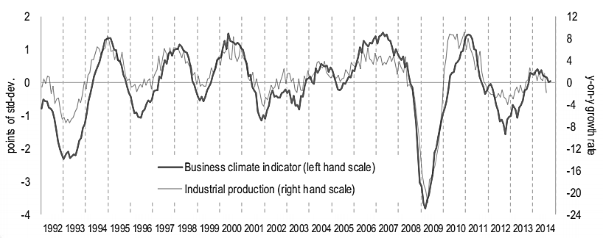
Fig. 2. Business Climate Indicator dynamics for the Euro Area in 1992-2014
Source: European Commission Services [4]

For EU companies to stay on the same positions on the market and even more – to keep leading positions and go up further, it is very important to adapt to changes. So they have to be capable of reorganizing their tangible and intangible assets at the same speed. From previous experience, companies that are able to forecast and analyze future changes, and then adapt quickly to these external changes, have a competitive advantage and as a result become more profitable without losing their market position.
In the technical system Bloomberg the more detailed information can be found as indicator is shown in the monthly term (Fig. 3). In October, after four months of stagnation or decline, the European Commission Euro Area Business Climate Indicator increased from 0.02 points to 0.05 points [5].

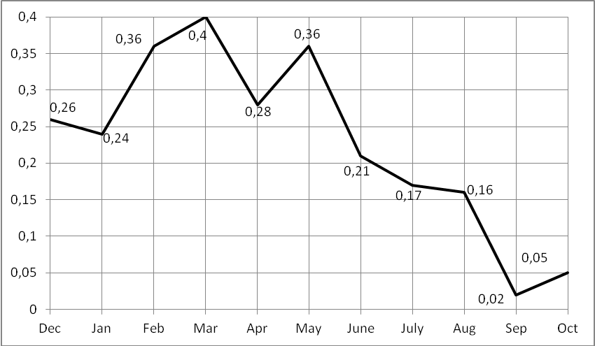
Fig. 3. Business Climate Indicator dynamics for the Euro Area in 2014
Source: Bloomberg [5]

There are three main interrelated aspects in EU business reflecting the fastest and the most intensive implementing of changes – product and service innovation, new technology introduction and business processes adaptation. Only 30% of EU companies can proactively implement these processes to support organizational changes.
Organizational change affects not only company’s activity but national economic as well. The activity of organizations creates an appropriate income which is evaluated by well-known index – GDP (Gross Domestic Product). Thus it can be said that the changes in the company’s activity influencing the economic environment.
Change affects the country competitiveness level according to economic conditions. As to the World Competitiveness Report, eight out of twenty most competitive business environments are situated in the EU (Table 1).

Table 1. The Global Competitiveness Index in 2014
Rank | Country/Economy | Score
1 | Switzerland | 5.70
2 | Singapore | 5.65
3 | United States | 5.54
4 | Finland | 5.50
5 | Germany | 5.49
6 | Japan | 5.47
7 | Hong Kong SAR | 5.46
8 | Netherlands | 5.45
9 | United Kingdom | 5.41
10 | Sweden | 5.41
11 | Norway | 5.35
12 | United Arab Emirates | 5.33
13 | Denmark | 5.29
14 | Taiwan, China | 5.25
15 | Canada | 5.24
16 | Qatar | 5.24
17 | New Zealand | 5.20
18 | Belgium | 5.18
19 | Luxemburg | 5.17
20 | Malaysia | 5.16
Source: compiled by authors based on The Global Competitiveness Report [2]

It can be a significant problem to arrange the different types of change management across an organization. There are a lot of types of change management and different sources provide different types. The most common four types of change management, determining by the level, are presented in [8] and are as following:
1. General organizational (culture changes, focused on human resource factors).
2. Program (program level changes involves the development of a detailed change management program needed to conduct change management in a certain way; it provides a balance between the need of change and the actions that need to be done to implement specific change).
3. Project (providing scheduling and control of every change on all project stages).
4. Department and team (implementing of changes intended to improve activities in the defined department or group but not in the whole organization).
Different researches have shown that about 70-80% of attempts to provide change are failing. It is appropriate to consider the following organizational changes: company merger/acquisition (using integration advantages); business expansion (geographic expansion, network development or launching new product lines); corporate culture change (the use of cross-cultural management, multinational staff involvement); introduction of new information system; re-engineering or process optimization; re-structuring; technological change; changes through use of total quality management (TQM); development of new strategies (Table 2). Using these indicators M. Smith conducted research devoted to the analysis the success rate of change comparing among 40,000 American, European and Japanese companies [9].

Table 2. Median success rate of organizational change efforts
Type of changes | Median success rate, %
Strategy deployment | 58
Restructuring/ reducing the size | 46
Technology changes | 40
Mixed collection of change efforts | 39
TQM-driven change | 37
Mergers/acquisitions | 33
Re-engineering and process design | 30
Software development and introduction | 26
Business expansion | 20
Culture change | 19
Source: compiled by authors based on [9]

From Table 2, we can see that the main place is given to strategy deployment – 58% which due to research is the most success among other organizational change efforts. The first type of changes is followed by restructuring and reducing the size – 46%, technology changes – 40%, mixed collection of change efforts – 39%, TQM-driven change – 37%, mergers/acquisitions – 33%, re-engineering and process design – 30%, software development and installation – 26%, business expansion – 20% and the last one is culture change – 19% [9]. The most successful changes represent well-known practices, involving the use of accumulated experience and key company competencies.
It is worth to say that any organizational change can include not only type of change but several of them. For example, a merger can include strategy implementation, corporate culture changes, integrating IT-systems, business processes re-engineering and new technology introduction [9]. In general, almost a half of organizational changes involved more than one category of changes.
In modern conditions successfully operate organizations helping other business actors to provide organizational change, built its internal environment, implementing the change management program. Among companies with such specialization is American company Prosci – the world leader in benchmarking research and change management products, serving 14% of EU companies. Its task is to provide organization with appropriate tool and training necessary to provide effective change management. Annually, since 1998, Prosci carries out research on the change management programs’ effectiveness (Fig. 4).

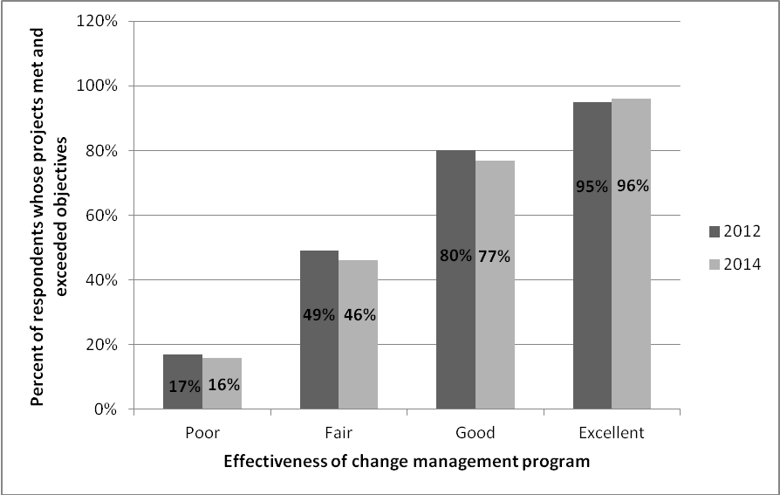
Fig. 4. Comparison of enterprises’ change management programs effectiveness in 2012 and 2014
Source: compiled by authors based on Prosci data [10]

The latest research has shown that projects effectively applying change management meet project objectives and optimally use budget more often.
Conclusions and suggestions. Analyzing the fundamental role of change management in the enterprise and its impact on the competitiveness of not only the company but also the national economy as a whole, we can conclude that with every year changes become more necessary for implementing in organizations to support their functioning and competitiveness both in the domestic and international markets. Indeed changes play an important role in reinforcements of the company’s competitiveness and economy of the country. It is necessary periodically examine need for changes, implement them and exercise ongoing control. However, changes should be implemented only if they are needed. At present, organizations develop dynamically enough and changes sooner or later will catch them. However, changes may be a failure, so there is a need to develop detailed plan for change implementation.

References
1. Cabrey T. PMI’s Pulse of the Profession In-Depth Report: Enabling Organizational Change Through Strategic Initiatives / T. Cabrey, A. Haughey. – Washington: Project Management Institute, Inc., 2014. – 16 р.
2. Schwab K. The Global Competitiveness Report 2014-2015 / K. Schwab. – Geneva: World Economic Forum, 2014. – 548 р.
3. Boyd A. Top trends in change management [Electronic resource] / A. Boyd. – Mode of access: http://www.change-management.com/Prosci-Top-Trends-Webinar-Slides.pdf
4. Business Climate Indicator for the Euro Area. European Commission [Electronic resource]. – Mode of access: http://ec.europa.eu/
5. European Commission Euro Area Business Climate Indicator [Electronic resource]. – Mode of access: http://www.bloomberg.com/
6. European companies behind in building economic competitiveness [Electronic resource]. – Mode of access: http://www.exact-software.co.uk/about-exact/the-biz-box/financials/590-european-companies-behind-in-building-economic-competitiveness
7. Future of Change Management. Best Practices in Change Management 2014 [Electronic resource]. – Mode of access: http://www.change-management.com/tutorial-2014-report-future-of-cm.htm
8. Mar A. 4 Types of Change Management (Levels) [Electronic resource] / A. Mar. – Mode of access: http://management.simplicable.com/management/new/4-types-of-change-management
9. Smith M. Success rates for different types of organizational change [Electronic resource]. / M. Smith. – Mode of access: http://www.ispi.org/pdf/Vol41_01_26.pdf
10. Williams J. Change management for the build environment: making the case for change [Electronic resource] / J. Williams. – Mode of access: http://www.rtkl.com/you-are-here/change-management-built-environment-making-case-change/

