
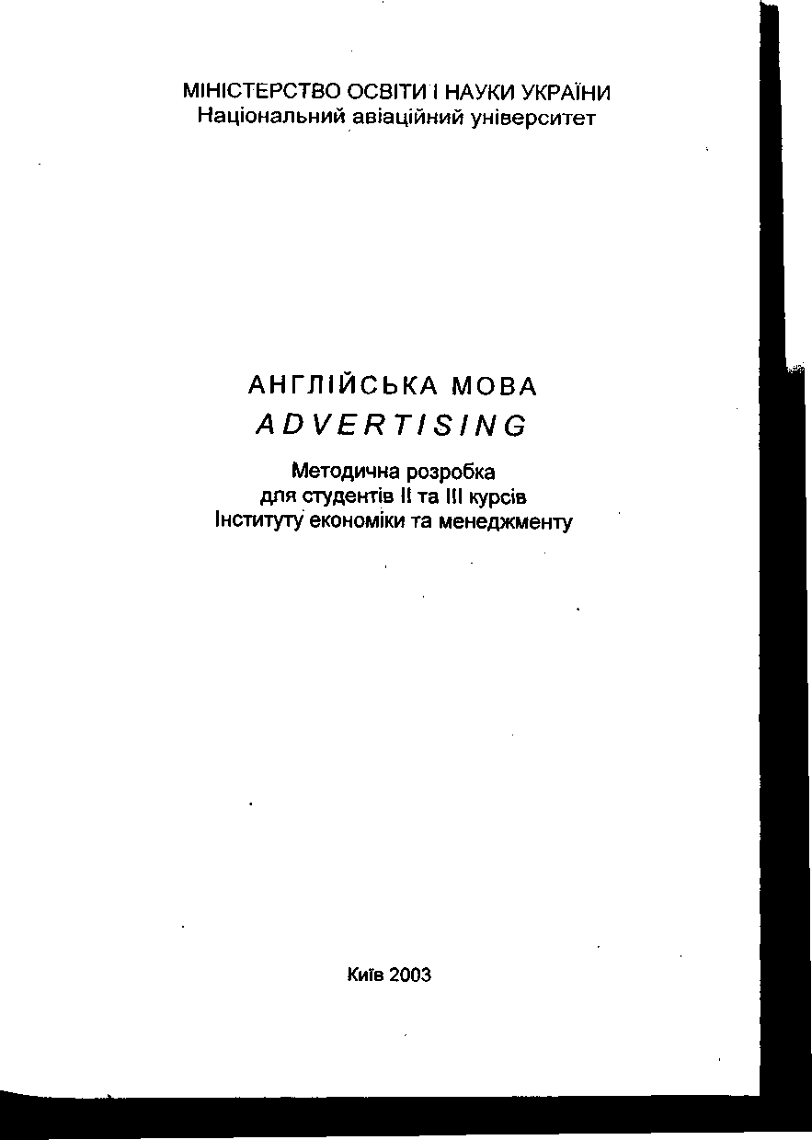
УДК 811.111 (076.5)
ББКШ 143.21-913 А-647
Укладач І.С. Козелецька Рецензент 0.0. Письменна
Затверджено на засіданні науково-методичної редакційної ради Гуманітарного інституту НАУ 26 червня 2003 року.
Англійська мова. ADVERTISING: Методична розробка А 647/Уклад. І.С. Козелецька - К.'.НАУ, 2003.- 48 с.
Містить тексти для самостійного та аудиторного опрацювання, лексичні вправи, глосарій.
Призначена для студентів другого та третього курсів Інституту економіки та менеджменту.
INTRODUCTION
This book is addressed to the students of Economics who study English at the intermediate or advanced levels.
It contains 12 units which include texts, exercises and a glossary of basic terms or unfamiliar words. Each reading passage is followed by questions for comprehension and discussion. They give the students the opportunity to use in a communicative situation both the vocabulary items and structural patterns occurred in reading. Some tasks include communicative learning and pose problems that might occur if the students were working in a particular job.
The book has been designed for the work in class and for unsupervised and self-instructional use as well.
The students for whom this book is intended should be acquainted with most of the structural patterns of English. The learners’ principal goal should be mastering vocabulary, using various structural patterns in a normal mixture, and improving his or her ability to communicate in English.

UNIT І. ROLE OF ADVERTISING
Advertising plays a unique and central role in any economic system. Along with other forms of marketing communication, it helps to sell ideas, goods, and services. As a large part of the environment in which we live, advertising both reflects and affects our very lifestyles and thus plays a substantial social role. And, particularly since the advent of television, advertising figures prominently in our political decisions.
Advertising is defined as any paid form of nonpersonal presentation and promotion of ideas, goods, or services through the mass media by an identified sponsor. Sponsors may be a nonprofit organization, a political candidate, a company, or an individual. Advertising differs from news and publicity in that an identified sponsor pays for placing the message in the media.
Advertising has become a workhorse that serves many communication needs of society, including needs other than goods and services. Business firms, labour unions, government agencies, and political leaders, among others, are successfully employing advertising to inform and persuade preselected audiences about major issues. Advertising is used when sponsors want to communicate with a number of people who cannot be reached economically and effectively through personal means.
For decades, economists generally ignored advertising and its influence on economy. Yet, the proponents of advertising would like to have economists agree on at least four points:
First, because of advertising, the country's gross national product is greater and the standard of living is higher than they would otherwise be. Advertising* creates general demand as well as demand for individual brands and thus assists in the marketing of more and better products. So advertising creates jobs, the argument runs, and provides us with a greater variety of products, while die quality of goods is improved over time in part because of advertising.
A second argument put forth by advertisers is that advertising plays a mayor role in informing the consumer so that more intelligent choices are made in the marketplace. Thus advertising aids the competitive process.
A third rationale for advertising is that the firm's cost of production per unit of output is lower because advertising increases
demand for the firm's output. Thus substantial plant economies or economies of scale are achieved; fixed costs are spread over a larger number of units of output. So advertising leads to a more efficient use of resources in the economy.
Finally, because of advertising, new firms have an easier time entering the market than would be true if advertising were restricted or prohibited. Advertising helps the new firm, or the firm with a new product, take on the giants in the industry and carve out a niche in the marketplace. Thus, advertising, again, is pro-competitive.

WORDS
lifestyle | спосіб життя
since the advent of television | 3 появою телебачення
to figure prominently | грати дуже важливу роль
identified sponsor | встановлений рекламодавець
nonprofit organization | громадська організація
individual | фізична особа
workhorse | основний компонент, “робочий кінь”
to employ advertising | використовувати рекламу
to persuade | переконувати
preselected audience | попередньо обрана аудиторія
proponent | прибічник
gross national product | валовий національний продукт
standard of living | життєвий рівень, рівень,життя
otherwise | інакше
generic demand | загальні вимоги
in part | частково
to put forth | тут - пропонувати
rationale | логічне обґрунтування
cost of production | витрати виробництва
unit of output | одиниця продукції
substantial | суттєвий, значний

підвищення ефективності від зростання масштабу виробництва
постійні (фіксовані) витрати
economy of scale
fixed costs to take on to carve out a niche pro-competitive
ставати заповнювати нішу позитивний фактор конкуренції

Assignments

І. Match each of the following terms with the correct definition:
- lifestyle
- sponsor
- nonprofit
- individual
- advertise
- mass media
- gross national product
- standard of living
- output
- fixed costs m.demand
- To tell people publicly about a product or service in order to
persuade them to buy it.
- ^Not intending or intended to earn a profit
- ^The way someone lives including the place they live, the things they
own, the kind of job they do, and the activities they enjoy.
- Any of certain charges, as taxes, rent, interest, etc., which must be
paid, usually at regular intervals, without being changed and without reference to the amount of business done.
- A business firm or other agency that alone or with others pays the
costs of a radio or television program on which it advertises or promotes something.
- The level of comfort and wealth which people have in a particular
society or country.

- The amount of something they make or produce.
- Various ways by which information and news is given to large
number of people, especially television, radio, newspapers, and magazines.
- People’s need or desire to buy or use particular goods or services.
- ^The total value of all goods and services produced in a country,
in one year, except for income received from abroad.
- single being or organism, esp. when regarded as a member of a
class, species, group etc.
- Translate the following word combinations into English*:
спосіб життя, рівень життя, загальні вимоги, прибічник, використовувати рекламу, фізична особа, з появою телебачення, валовий національний продукт, грати дуже важливу роль, громадська організація, рекламодавець, логічне обгрунтування, витрати виробництва, одиниця продукції, постійні витрати, позитивний фактор конкуренції, підвищення ефективності від зростання масштабу виробництва, попередньо обрана аудиторія.
- Translate the following sentences into English*:
- Реклама відіграє унікальну і центральну роль у будь-якій економічній системі.
- Поряд з іншими формами маркетингового зв’язку, реклама допомагає продавати ідеї, товари та послуги.
- Рекламування відрізняється від новин та гласності утому, що рекламодавець вкладає гроші, щоб розмістити повідомлення в ЗМІ.
- Протягом десятиріч економісти в основному ігнорувати рекламування і його, вплив на економіку.
- Реклама розробляє загальні вимоги, а також вимоги для окремих торгових марок, таким чином допомагаючи розміщенню на ринку більшої кількості хороших товарів.
- Answer the questions.
- What is advertising?
- What role does it play in any economic system?
- Why is it called a “workhorse”?
- How have advertisers proved ad’s value?

V. Sum up the information about:
- The role of advertising in an economic system.
- Arguments for ad’s value.

UNIT 2

HOW ADVERTISING DEVELOPED
Advertising is as old as civilization itself. In the ruins of ancient Egypt, explorers have found papyrus posters offering rewards for the return of runaway slaves. In the ruins of the Roman city of Pompeii, archaeologists have discovered political ads painted on walls along streets bearing such entreaties as, “Vote for Cicero, the friend of the people”.
However, until the advent of mass selling in the nineteenth centuiy, advertising played only a minor role in the conducting of business. In early Greek and Roman days, signboards were placed above the doors of business establishments, and town criers proclaimed that merchants had certain wares for sale. These were merely means to attract customers to a shop.
There is jot doubt that advertising flourished in this period, but with the fall of the Roman Empire and the onset of the Dark Ages, advertising temporarily declined in importance to Western civilizations.
However; in contrast with modern advertising and sales techniques, the* display of merchandise and personal selling were depended on to make the sale.
Early English advertising
Perhaps the oldest relic of advertising among English-speaking people is family names referring to the various specialized crafts. The earliest of these designations was Smith. Names like Miller, Weaver, Wright, Tailor and Carpenter were the earliest means of product identification - the forerunner of the brand name so essential to modern advertising.
Beginning of printed advertisements
One of the most significant events in the development of advertising was the invention of a system of casting movable type of the German, Johann Gutenberg, in 1438. Paper had been invented more than a thousand years earlier by the Chinese and was introduced to Europe by the Turks in the twelfth century. Now all the necessary components were available for mass printing. At the same time, literacy was increasing. William Caxton, an early English printer, made advertising history in 1478 when he printed a handbill now regarded as the first known printed English advertisement. It advertised a book he had printed, the Salisburi Pye, ruled for the clergy at Easter.

WORDS
papyrus posters | оголошення, написане на папірусі
reward | винагорода
runaway slave | раб, що втік
entreaty | прохання
Cicero | Цицерон
conducting of business | ведення бізнесу
signboard | вивіска
town criers | глашатай
merchants | купець, торговець
wares | товари, вироби
jot doubt | невеликий сумнів
to flourish | процвітати
onset of the Dark Ages | раннє середньовіччя
craft | ремесло
forerunner | попередник
casting movable type | лиття рухливої літери
literacy | грамотність
handbill | рекламний листок

- Find in the text the synonyms to the words:
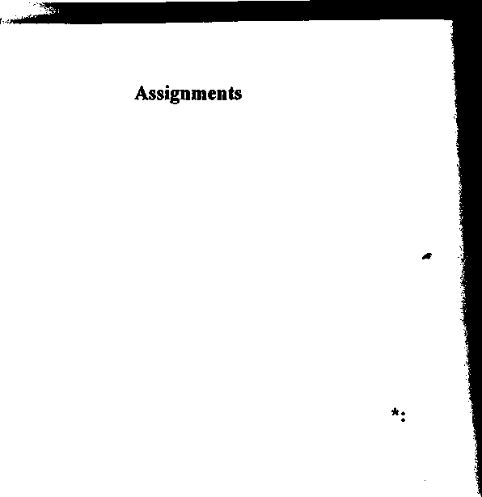
- announcement, placard
- Translate the following word combinations into English
- prize
- appeal
- billboard
- seller, supplier
- goods T.succeed
- predecessor
- MiddleAges
- cducation 11 .flyer
оголошення, написане на папірусі, винагорода, раб, що втік, прохання, ведення бізнесу, вивіска, глашатай, купець, вироби, невеликий сумнів, процвітати, раннє середньовіччя, ремесло, попередник, грамотність, рекламний листок
Ш. Translate the following sentences into English'^:
- До появи масового продажу в дев’ятнадцятому столітті, реклама відігравала незначну роль у веденні бізнесу.
- У давньогрецькі та римські часи вивіски розміщували над дверима комерційних підприємств, а міські глащатаї оголошували, що купці мають товар для продажу.
- Це було просто засобом заохочення клієнтів до магазину.
- Викликає сумнів те, що рекламування процвітало у цей період, але з падінням Римської імперії і на початку середніх віків реклама тимчасово втратила свою важливість для західних цивілізацій.
- Найстарішою реліквією реклами серед англомовних народів є прізвища, що отримали свою назву від різних ремесел.
б.Однією з найважливіших подій розвитку реклами було винайдення системи лиття рухливої літери.

- Answer the questions:
1 .What evidences of advertising were found in ancient times?
- What did the advertising serve for in that period?
- When did it lose its significance?
- What is the oldest relic of advertising among English-speaking people?
- What helps to develop a new stage of advertising?
- Who made advertising history? When?
- Render the text as if you were:
- a merchant
- a descendant of an English oldest family name
- Johann Gutenberg

UNIT3

ADVERTISING PLAN
The foundation of an effective advertising campaign is a sound advertising plan. The plan includes three groups of objectives and strategies: those for marketing, advertising, and copy. Each group is narrower and more specific in scope than the one before. Each plan helps to determine the next. The three are interrelated and interdependent
Marketing objectives can be either short-term (one year) or longterm (three or five years). They should be expressed quantitatively, so as to be measurable, for example, “To increase vnit sales from this year’s 9,000,000 to 10,000,000 in the next fiscal year, etc. Marketing strategies aim at reaching the stated goals. Possible strategies include increasing the sales force, changing the product, and increasing advertising. Marketing strategies might mention advertising, but they do not tell, for instance, how advertising will be increased. This comes under advertising strategies.
Advertising is communication, so advertising objectives are expressed as communication goals. They are also measurable and limited
to a certain length of time, usually one year. An example of an advertising objective is, “if they are asked to name every brand they can think of in the product category, 40% of consumers in the target market will name our brand. This can be checked by survey one year after an advertising campaign has begun. Notice that the objective is not stated in terms of sales. Traditionally, sales have been the only measurement gif advertising effectiveness. But in recent years marketers have realized that sales are a result of many factors, not of advertising alone. The emphasis has therefore shifted to communication goals, quantifiably expressed.
This shift is due largely to the work of Russell Colley, who provided a theoretical framework for setting advertising objectives. In the early 1960’s, Colley developed his DAGMAR approach (Defining Advertising Goals for Measured Advertising Results). Colley said that the only function of advertising was to communicate to a target audience. It should communicate information about the company and the product. It should create an attitude - readiness to buy the product - that would lead to purchase. Colley used six principles in his approach to advertising goals;
Advertising goals state the communication components of the total marketing effort.
1.
2.
3.
They are stated in writing, in measurable terms.
Both planners and creative people (copywriters, designers) agree upon them. They agree on the nature of the message and of the target audience before they agree on exactly how to deliver the message.
They are based on real problems and opportunities. These are discovered by careful research, not by intuition or guess.
4.
They establish a basis for later evaluation. For instance, consumer awareness of the brand is tested both before and after the advertising campaign.
5.
At the same time they are stated, the specific means of later evaluation are also stated {survey, questionnaire, redemption of C0up(ms, etc.)
6.

WORDS
чіткий план масштаб
sound plan scope interrelated interdependent fiscal year stated goal target audience sales force
to communicate information
planner
guess
copywriter
evaluation
survey
questionnaire redemption of coupons copy
взаємопов’язаний взаємозалежний фінансовий (бюджетний) рік сформульована мета потенційні клієнти торговий агент передавати інформацію плановик припущення
укладач рекламного повідомлення
оцінка
опитування
анкета
викуп купонів
текст рекламного оголошення

Assignments

І. Match each of the following terms with the correct definition:
- marketing
- copy
- sales
- questionnaire
- survey
- evaluation
- copywriter
- measurable
- objective
- campaign
- A writer of copy for advertisements or promotional material.
- Something that can be measured.
- А decision about the significance, value, or quality of something,
based on a careful study of its good and bad features..
- The quantity that a particular company sells, or the quantity that is
sold generally throughout a country.
- A written or printed form used in gathering information on some
subject or subjects, consisting of a set of questions to be submitted to one or more persons.
- ^A detailed study or inspection, as by gathering information through
observations, questionnaires, etc. and analyzing it.
- The words of an advertisement, as distinct from the layout,
pictures, music, etc.
- All business activity involved in the moving of goods from the
producer to the consumer, including selling, advertising, packaging, etc.
- A planned act of activities that people deliberately cany out over a
period of time to produce a particular result.
- Something you are trying to achieve by a particular course of
action.
- Define the following terms in English:
Marketing, copy, copywriter, questionnaire, objective, survey, campaign, sales.

Ш. Translate the following word combinations into English*:
чіткий план, масштаб, взаємопов’язаний, взаємозалежний, фінансовий рік, торговий агент, передавати інформацію, припущення,укладач рекламного повідомлення, оцінка, опитування, анкета, текст рекламного оголошення.
- Translate the following sentences into English*:
- Такі концепції ймовірно включають збільшення числа торгових агентів, зміну продукту і збільшення реклами.
- Реклама - це інформація, отже завдання реклами виражені як комунікативні цілі.
- Традиційно, об’єм продажу був єдиним показником ефективності реклами.
- Єдиною функцією реклами було підтримувати зв’язок з потенційними клієнтами.
- Answer the questions:
- What are the three groups of objectives and strategies in an advertising plan?
- What is the relationship among the three groups?
- What is the difference between an objective and a strategy?
- The advertising plan usually contains two kinds of marketing objective. What are they?
- How should marketing objectives be expressed?
- Give the examples of marketing strategies.
- How are advertising objectives expressed? Why?
- Why are sale no longer the only measurement of advertising effectiveness?
- What other factors besides advertising do you consider responsible for decreasing sales?
- Whose work was instrumental in the shift to communication goals? What was his contribution?
11 .What did he say advertising should do?
- Briefly enumerate six principles underlying advertising goals?
- Make up short dialogues using the following expressions:
Marketing objectives, advertising objectives, copy objectives, to communicate information, DAGMAR approach, principles, to develop, to agree.

UNIT 4


HIERARCHY OF EFFECTS
The final goal of all advertising is to have consumers use the goods or the service. Russell Colley’s model for attaining that goal names three stages that precede action. First is awareness that the product exists. Second is understanding of what the product is and what benefits it offers. Third is the decision to use the product. Then comes the actual purchase of the product or use the service.
This is a model of the "hierarchy of effects ”. These are steps that a consumer takes toward purchase. They also delineate the effects of advertising at the various stages.
In 1961, Robert J. Lavidge and Gary A. Steiner refined Colley’s model. In their theoretical model they named five steps in the movement toward purchase. They also outlined how the emphasis of advertising changed to expedite the process. They said that a consumer moves from awareness to knowledge, then liking. During this time advertising gives actual information. Next the consumer reaches the level of preference, then conviction. At this point, consumers prefer the brand over all others, they want to buy it, and they are convinced that the purchase would be a wise one. Advertising in this period aims to change feelings and attitudes. It appeals to the emotions. As the consumer draws closer to purchase, advertising is directed at motives. It seeks to stimulate action.
A third model of the hierarchy of effects is AIDA. Like DAGMAR, AIDA is an acronym. It stands for Attention, Interest, Desire, and Action. This familiar formula suggests that one good advertisement can move consumers through all four steps. First, it captures the attention; something in it catches the eye or the ear. Then there must be something that holds the interest of the reader, watcher, or listener. The advertisement should stimulate the consumer’s desire to have the product. Finally, it should stir him or her to action.
The buyer behavior model uses the language of computers to summarize the decision process. It begins with recognition by the consumer of an unsatisfied need. The need motivated action, the search for ways to satisfy that need. The search narrows to a specific product. The consumer is aware of its existence, but lacks - and looks for - information about it. Next, he or she evaluates the information and
considers the risks of purchase. “Will this product satisfy my need? Will it be worth the cost in time and money? What if I make the wrong decision?” At this point, the consumer decides whether to buy thte product. If the consumer buys it, he or she decides whether he or she is satisfied or dissatisfied with it. If dissatisfied, the consumer begins the search again. If satisfied, he or she may decide to use it regularly.

WOIU)S
to precede | передувати
hierarchy of effects | ієрархія впливу (засобів)
to delineate | визначати
to refine | удосконалювати, покращувати
to outline | розробляти
to expedite | прискорювати
preference | перевага :
conviction | переконання
to draw closer | підходити (наближатися) ближче
acronym | акронім (слово, сформоване з перших літ словосполучення, яке воно замінює)
to capture attention | привертати увагу
to catch one’s eye | спіймати, перехопити погляд
to stir to action | спонукати до дії

Assignments

I. Find in the text the synonyms to the words:
to draft, to accelerate, to head (come first), advantage, to catch, confidence, interest, to improve.

II. Give the English Equivalents for*:
передувати, ієрархія впливу (засобів), визначати, покращувати, розробляти, прискорювати, перевага, переконання, наближатися ближче, привертати увагу, залучити погляд, спонукати до дії.

Ш. Answer the questions:
- Name, in order, the steps in Colley’s hierarchy of effects model.
- Name five steps in Lavidge and Steiner’s model.
- Go through the five steps and describe how the emphasis of advertising changes during the process.
- How are the two models different? How are thy similar?
- Name and describe the four steps in AIDA.
- Why is the language of computers used for the buyer behavior model?
- How can purchase be a risk? What may result from consumer’s satisfaction with the product? His dissatisfaction?

IV. Work in pairs and discuss your opinions on the following:
- The model of the "hierarchy of effects ”.
- Colley’s model.
- Compare all four models.

UNITS

ADVERTISING STRATEGIES
All four models mentioned above illustrate a process that happens in the minds of consumers as they move toward purchase. The models provide a theoretical foundation for establishing advertising objectives. In the advertising plan, these lead to advertising strategy. Objectives always tell what will be done, and strategy tells how. The advertising strategy is the main idea of the message that goes to consumers.
Probably the most prominent advertising strategy is the Unique Selling Proposition (USP). The USP may be the unique product feature or benefit. Today’s market is highly competitive. Products in the same category are likely to be very similar. In order to sell the product, it may be necessary to “create” a difference. This does not mean to invent one where none exists. To do so may be against the law. Besides, consumers will quickly discover dishonesty in advertising, and sales will stop.
To “create” a difference, or a benefit, simply means to capitalize on a feature that will sell the product. Discovering the USP is a matter of discovering the product’s consumer strength. Research should reveal why people like a particular brand, or what they look for in that product category. Then advertising can be built around that idea. Advertising built around the USP must show benefit to the consumer. It should make a promise: “Here is what makes our product special, and here is how it will help you”. It should also be a benefit that competitors cannot offer, or that they have failed to advertise. And it must be a very strong, persuasive idea.
The USP is not the only possible advertising strategy. Some advertisers use motivation as a strategy. They look for the “real reasons”, conscious or unconscious, that consumers buy certain products. Others stress image. Still others believe it is the form of the advertisement itself, its execution, that provides the best strategy. In his book, Madison Avenue U.S.A., Martin Mayer proposed his value-added theory. It is consistent with all of these strategies. Mayer said that advertising doesn’t just inform and persuade. Advertising itself adds value to the product. Mayer saw that a new package or a new brand name changed the product in consumers’ view. Advertising, he said, did the same. Whether the advertising strategy is based on USP, motivation, image, or execution, it translates the product concept into a consumer benefit. It supports the advertising objective of turning potential consumers into actual purchasers.
Advertising objectives and strategies define what will be done by advertising, and how. Their foundation is in research. Market research tells what competitors are doing. Along with product research, it leads to the discovery of product features and benefits. Consumer research underlies the models of the hierarchy of effects and the value-added theory. Effective advertising depends on thorough research. It also depends on the creative aspects - the visible part of advertising.
виявляти нечесність отримувати вигоду з показувати - переконливий мотивація свідомий виконання додаткова вартість бути послідовним покупець лежати в основі ретельне дослідження

- Give the antonyms to the words:
to discover
dishonesty
to capitalize on
to reveal
persuasive
motivation
conscious
execution
value-added
to be consistent
purchaser
to underlie
thorough research
Assignments
Dishonesty, discover, persuasive, conscious, consistent, purchaser, difference, thorough, benefit.

- Read the text again and write the words (at least 10) related to the topic into appropriate columns
Expression
- Give the English equivalents for*:
Noun
Verb
ретельне дослідження, виконання, переконливий, свідомий, додаткова вартість, лежати в основі, показувати, отримувати вигоду з, нечесність, бути послідовним, покупець.
- Make up short dialogues using the words from the vocabulary.
20
- Answer the questions:
- What is advertising strategy?
- What is the difference between an objective and a strategy?
- Find examples of USP’s in advertising.
- What can a marketing communicator do if there is no USP?
- Study the respective benefit claims that are made for several products in a single product category, e.g., several brands of cigarettes. Which claims are not truly unique, but can apply to other brands in the same category?
- Name three other advertising strategies.
- Elaborate on the value-added theory. How is it consistent with the theories behind USP, motivation, image, and execution as advertising strategies?
- Sum up the information about:
- The Unique Selling Production.
- Value-added theory.

UNIT 6
COPY OBJECTIVES AND STRATEGY
Along with ma.rketing and advertising objectives, the advertising plan contains the copy objective, also known as the creative objective. It focuses upon a copy problem, e.g. “How can our product best be positioned against the competition and in consumers’ minds?”, “Find the USP”, or “Change the brand image”, or “Think of a new name”, etc. Those are not advertising strategies, not solutions. They don’t supply the words or the pictures, or the music that will solve the problem. What is needed is the “big idea”.
The big idea gives the product concept in capsule form. It ties together all of the elements in an advertising campaign. It is often summarized in a slogan. Slogans need to say something ateut product
uniqueness or value. They should command attention, be memorable and be brief. Slogans frequently use a play on words.
The big idea is generally the result of working through hundreds of lesser ideas, of brainstorming and testing. This, again, is where all of the early research pays off. Information supports analysis, and analysis supports ideas. Still, all of the available methods of scientific research cannot replace creative observation. Marketing communicators need to use their own experience, too. They need to handle the product, talk to consumers, and study competitors’ advertisements themselves. Creative people describe the creative process in various ways. In the end, though, big ideas spring from an indefinable inspiration.
Inspiration must be checked, however. To be successful, an idea has to be practical for execution. Copy strategy should clearly tell what the product is and how it is used. It should describe what the product does, and how that benefits consumers. An excellent copy strategy positions the product clearly in consumers’ minds. Finally, it illuminates the character of the product, which will be reflected in the atmosphere and tone of the advertising.
WOIIDS
to contain
to position
solution
in capsule form
uniqueness
to command attention
play on words
brainstorming
to pay off
to spring off
вміщувати розміщувати рішення у стислій формі унікальність заволодіти увагою гра слів
пошук творчих ідей окупитися раптово виникати

Assignments
І. Match each of the following terms with the correct definition:
- brainstorming
- uniqueness

- solution
- spring off
- available
- illuminate
- competitor
- research
- memorable
- inspiration
- pay off
- ^To make something easier to understand by explaining it carefully
or giving examples.
- Someone who is trying to sell goods or services to the same people
as you are.
- To yield full recompense or return.
- The process of finding the answer to a question or a satisfactory way
of dealing with the problem.
- Something is worth remembering or likely to be remembered,
because it is special or unusual.
- sudden good idea of what you should do or say .
- Detailed study of a subject or an aspect of subject.
- Highly unusual, extraordinary, rare.
- Unrestrained offering of ideas or suggestions by all members of a
conference to seek solutions to problems.
- Something that is able to be used or can easily be bought and found.
- Suddenly appear or start to exist.
II. Define the following terms in English:
brainstorming, competitor, research, solution, pay off.
- Give the English equivalents for:
пошук творчих ідей, вміщувати, у стислій формі, рішення, заволодіти увагою, раптово виникати, окупитися, унікальність, розміщувати, гра слів,

- Make up sentences with these words related to the topic.
- Answer the questions:
- Why does an advertising plan contain a copy objective?
- What is the big idea?
- Where does it come from?
- How do people recognize it?
- What restrictions are there on its use?
- Fill in the blanks with appropriate words front the texts.
- Objectives tell what will be done. tell how objectives will
be reached.
- “By increasing advertising” is an example of a marketing
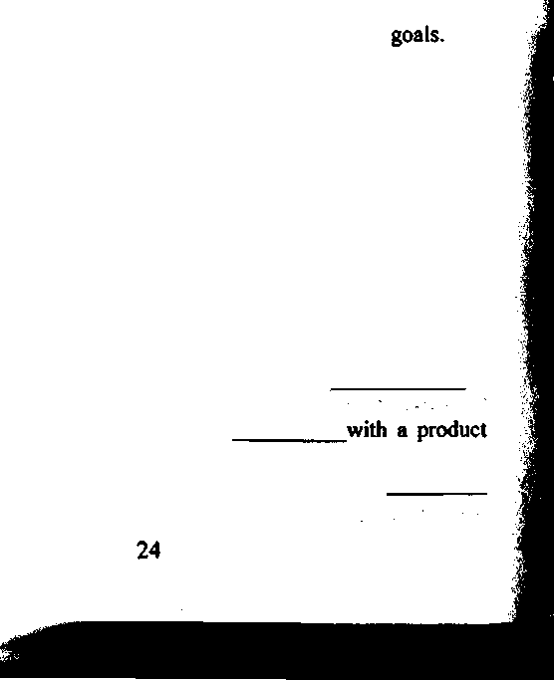
- Advertising objectives are now expressed as
- Traditionally, have been the only measurement of
advertising effectiveness.
- Russell Colley developed his approach in the early 1960’s.
- He said that ^e only function of advertising was to communicate with
a ; .
T.Colley said that advertising objectives should be stated in writing, in ^terms.
- He set up a model of the hierarchy of .
- His model has three steps that precede action: awareness, understanding
and .
- Lavidge and Steiner’s model has five steps. They said that a consumer moves from awareness to knowledge, then
- Next comes preference, and finally^
- Advertising in this period appeals to the
- AIDA stands for , Interest, Desire and
M.Consumer motivates action. .
- According to the buyer behavior model, may lead to adoption or non-adoption.
- РгоЬаЬІу the most prominent advertising strategy is the
IT.Products in the same category are likely to be very similar. In order to sell a product, it may be necessary to “ a difference.
- Martin Mayer’s theory is called the theory.
- The ^objective is also called the creative objective. ^
- Copy strategy should clearly tell what and how
VI. Render the text as if you were:
- an advertising manager
- a marketing communicator

UNIT?

MEDIA ADVERTISING
The execution of an advertising idea depends upon the medium that will be used. The major media are magazines and newspapers (print media) and radio and television (broadcast media). Minor media include outdoor advertising, point-of-purchase advertising, and direct mail. The media mix is manipulation of these variables: which media will be used, how, and to what extent. The media planners’ task is to match the product concept and its market requirements with appropriate media, so that the right message will reach consumers in the most effective and efficient way. There is no formula for the ideal media mix. The mix selected depends on a number of factors.
The first consideration might be how much money is available for advertising and merchandising. While television, for example, might be ideal for the message, TV advertising is very expensive. The cost may be prohibitive. Another consideration is the product’s stage in the life cycle. The aim of advertising in the introductory stage is brand recognition. Wide media coverage, though expensive, may be necessary at that point. Price of the product influences the media mix. New products are often introduced at a premium price, in the hope of quickly recovering the expenses of introducing them. When the price is hi^, prestige is part of the product concept. The use of more prestigious media supports the message.
Market segmentation is another important factor. Based upon demographic, psychographic, or geographic data, an effective media effort concentrates on the target market. Some media are more appropriate than others for certain products. For example, quality magazines are best suited to expressing the concept of a grand piano, Mass circulation magazines are better suited for products of general use.
A final consideration is distribution. If the product is not distributed in a certain part of the country, there may be no point in advertising there. On the other hand, the product may be advertised there to encourage new distributors.
WORDS
medium major media minor media outdoor advertising point-of-purchase advertising
direct mail media mix
manipulation consideration merchandising prohibitive cost premium price
miarket segmentation distribution to encourage
носій інформації основні засоби інформації другорядні засоби інформації вулична реклама реклама в місцях продажу
реклама товарів поштою план комплексного використання різних засобів поширення реклами управління операціями судження, точка зору товарознавство надто висока вартість ціна вища номіналу, ціна з надбавкою сегментування ринку збут, розподіл заохочувати

Assignments
- Arrange the following words according to the type of media (major, minor). Explain why they belong to this or that group.
direct mail, magazines and newspapers, radio and television, point-of- purchase advertising, outdoor advertising.
- Match English equivalents to the following words:
- носій інформації
- to encourage
- outdoor advertising
- distribution
- manipulation
- premium price
- minor media
- medium
- market segmentation
- prohibitive cost
- merchandising
- media mix
- direct mail
- major media
- point-of-purchase advertising 0. consideration
- другорядні засоби інформації
- вулична реклама 4.0СН0ВНІ засоби інформації
- реклама в місцях продажу
- реклама товарів поштою
- план комплексного використання різних засобів поширення реклами З.управління операціями
- судження, точка зору
- товарознавство
11 .надто висока вартість
- ціна вище номіналу
- сегментування ринку 14.збут, розподіл
15. заохочувати
- Give the English equivalents for:
носій інформації, реклама в місцях продажу .управління операціями, ціна вища номіналу, судження, основні засоби інформації, план комплексного використання різних засобів поширення реклами, вулична реклама, надто висока вартість, товарознавство, другорядні засоби інформації, реклама товарів поштою.
- Answer the questions:
1 .What determines the type of execution an advertising idea will have?
2. What is the principal object of media planning?
S.What factors does the selection of a media mix depend on?
- What media in your country are the more prestigious ones?
- Give additional examples of how some media are more appropriate than others for certain products.
- What are arguments for and against advertising in an area where a product isn’t distributed?
- Work in groups of 4 and discuss your opinions from the viewpoint of:
- a major media manager
- a minor media manager
- a marketer
UNIT 8

PRINT MEDIA
Print advertising deals with the use of space. A printed advertisement has four elements: illustration, headline, eopy block (body copy or text) and logotype.
Illustrations
In a printed ad, the illustration usually dominates the space; most effectively, 60 to 70% of it. Effective illustrations vary in form and content, but mpst have several characteristics in common. They capture the a.ttention of the target audience. They arouse interest in the product and often illustrate a product benefit. Good illustrations are relevant to the basic idea of tlie advertisement and to the words in headlines and body copy. They convey a tone or create an atmosphere and express feelings more directly and dramatically than words.
Photographs are by far more effective than any other illustration technique. They have practical advantages as well. They are faster and
less expensive to complete? And they are more adaptable to a variety of uses. In any technique, color is more effective than black and white. Thus, for example, in women’s magazines, the advantage of color over' black and white is 68-70%, in newspapers - 45-70%. Advertisements in color may cost 30% more.
Headlines should draw attention; 80 to 90% of readers never read beyond them. If the headline fails to draw their interest immediately and forcefully, they won’t read the text. The appearance of the headline alone is often the attention-getting device. By definition, it is printed in larger type than the rest of the advertisement. Headlines are usually short, one to six words on a single line, or event more than two lines to deliver the essential message to the right readers. However, brevity should not be more important than meaning.
Body copy
According to research, the optimal amount of body copy uses less than 20% of the total advertising space. The major function of the body copy is to satisfy the curiosity of readers. In general, the most effective copy tells buyers how to satisfy their needs and solve their problems. It does this in a clear, concise, and personal way. Finally, it suggests action: where to finds the product and, often, its price.
Logo
The fourth major element of print advertising is the logotype, or logo. The logo is the name or symbol of a company, store, or brand. It is often a design, and it is usually recognizable in print, e.g., the distinctive lettering of Coca-Cola is both a brand mark and a logo. The logo often appears in the lower right-hand corner of an advertisement. The slogan and a picture of the package often accompany it. They use little space, usually no more than 5%.
Besides the four major elements, many advertisements also use subheads and captions. Subheads are in smaller type than headlines. Captions are sentences of one or two lines under or next to the illustrations. They are in still smaller type. Captions explain illustrations.
Most print advertising is designed for newspapers and magazines. The choice of one medium above the other depends first upon the
location of the target audience. Newspapers have certain advantages over magazines. Usually within a narrow geographical range, they provide very high reach. Newspapers offer more options in size of space and time of appearance for ads.
On the other hand, magazines are printed on paper of higher quality, so print looks better and color reproduction is better. Advertising in magazines carries more prestige. Special interest magazines make it easier to reach a specific audience. People read newspapers quickly and throw them away; newspaper advertisements are short-lived. Magazines advertisements are long-lived. People take more time to read a magazine. They may look at it again and again, then give it to someone else.
In general, the choice of print medium depends upon such major factors as the product concept, advertising objectives, and the advertising budget.

WORDS
заголовок газети основний текст реклами логотип підзаголовок
headline
copy block (body copy)
logotype
subhead
caption
to convey a tone forcefully concise short-lived
надпис, заголовок (статті, розділу)
передавати стиль
переконливо
лаконічний
недовговічний, скороминущий

Assignments

І. Match each of the following terms with the correct definition:
- concise
- headline
- caption
- subhead
- illustration
- photograph
e. copy body 1
- logo
- The special design or way of writing the name of a company or
organization that is put on all its products, notepaper, advertisements, etc.
- Short and clear, with no unnecessary words.
- The title of a subdivision of a chapter, article, etc.
- The title of a newspaper story, printed in large letters at the top of
the story, especially on the front page.
- ^All the words printed above or below a picture in a book or a
newspaper, or on a television screen to explain what the picture is about.
- A picture in a book, article etc. which is used to explain the point
or make it clear.
- Main context of advertising.
- A picture made by using a camera containing film which changes
when light falls on it and then printed on a special paper.

II. Define the following terms in English:
headline, subhead, caption, copy body, illustration, logo, photograph.

Ш. Translate the following word combinations into English*:
основний текст реклами, підзаголовок, логотип, надпис, передавати стиль, переконливо, лаконічний, недовговічний, заголовок газети.

IV. Answer the questions:
- Name the four major elements of print advertising.
- Why does the illustration usually dominate the space?
- Why is one large illustration better than several smaller ones?
- What practical advantages do photographs offer?
- Why is color more effective than black and white?
- Why is necessary for a headline to draw attention?
- What are some ways it does this?
- Why are headlines usually short?
- What are some characteristics of effective body copy?

31
lO.Find an advertisement that you think is well-designed. Analyze is, using the concepts in the text.

11 .Name several comparative advantages and disadvantages of newspapers and magazines.
V. Fill in the blanks with appropriate words from the text.
1 .The copy block is also called the body copy or the
- In a print advertisement, the illustration dominates the
- A good illustration must capture the attention of the
- ^are more effective than any other technique of
illustration.
- The headline is printed in larger than the rest of the
advertisement.
- Because of space and for the convenience of readers, headlines are
usually .
- But brevity shouldn’t be more important than .
- are sentences of one or two lines that explain
illustrations.
- The four major elements of print advertising are illustration, headline,
copy block, and .
- Most print advertising is for and
carried more prestige.
11 .Advertising in

VI. Work in groups of 4 pointing out advantages and disadvantages of each type of print media.

UNIT 9

BROADCAST MEDIA
Time versus space. This is the essential difference between the broadcast media and the print media. Newspapers and magazines exit in space. Their pages are tangible. Advertising in print media occupies
space. Radio and television exist in time. Their broadcasts are intangible. Advertising on TV and radio occupies time. A consumer can pick up a newspaper, or more likely a magazine, and look at its messages again an^ again. Once a message is broadcast, it is gone forever. Another difference between the two types of media is a difference of purpose. The major function of print media is to provide news and information; of the broadcast media, to provide entertainment. The reach of newspapers and magazines is limited only by how far their publishers care to send them. The reach of radio and television is limited by the strength of station (channel) transmitters. The number of copies of newspaper or magazine that go to consumers represents its circulation. A radio or TV station’s number of potential listeners or viewers is its coverage. Its “circulation” is measured by exposure.
Radio time is classified by dayparts: drive time, housewife time, weekend time, and evening time. There are two drive times: morning and . afternoon. The audience for both periods consists of people driving to and from work, preparing meals and working; children not in school; and teenagers, e.g. housewife time is 10 a.m. to 3 p.m.
On radio advertising interrupts. From the advertiser’s point of view, this is both a strength and a weakness. The interruption itself can be an attention-getting device. It can prepare people to listen to the message. But the interruptions are also/a source of irritation. They can cause people not to listen; in fact, to resent the advertisement and the advertiser. This dual effect of interruptions places a burden on anyone who writes advertising copy for radio. So do two other characteristics of the medium. First, it is purely aural; sound effects must do all of the work. Second, few people just sit and listen to the radio. Most are doing something else at the same time. The advertisement has to seize their attention immediately, preferably within eight seconds. Then the remaining content of the ad has to hold their attention.
Listeners expect radio to bring them news, information, and entertainment. Effective radio advertising is in harmony with their expectations. A new product or »a. special price can be news. The commercial can inform consumers about the product and its benefits; Through music, sound effects, and humor, advertising can entertain. Repetition of the brand name and the advertisement’s basic idea helps listeners to remember them. As in print advertising, natural, conversational language works best.
Advantages of radio as an advertising medium are its cost, its specialized nature and its flexibility. Radio is the least expensive major medium. It can be very selective in reaching target markets. It is flexible geographically and in the variety of time slots it can offer.
Television is probably the most potent of all advertising media. Unlike any other, it combines sight and sound. It shows real action, it is personal, and it is true to life. In many countries, the television audience is larger than that for any other form of mass communication.
While television is not so selective as radio, TV advertisers do have a degree of selectivity. One tool is the time of day. For example, tfae time to reach men is Saturday and Sunday afternoons; children- Saturday mornings; teenagers - the late fringe period on Friday and Saturday nights. A second tool is type of program. More men watch sports, more women watch dramas. Special programming such as sports championships and multi-episode dramas offers opportunities to advertisers. Such programming may supply a captive audience for several hours. Special programs of unusually high quality attract affluent, educated viewers and lend prestige to the sponsors or participating advertisers.

WORDS
порівняно 3, проти помітний, реальний, матеріальний передавач
versus
tangible
transmitter drive time
attention-getting device irritation • to resent
to place a burden on smb.
aural
time slot
affluent
час радіослухачів в дорозі прилад, що отримує сигнал роздратування, ображатися
перекладати тягар на чиїсь плечі акустичний,слуховий часовий інтервал багатий

Assignments
- Match English equivalents to the following words
- прилад, що отримує сигнал а. affluent
- багатий b. time slot
- перекладати тягар на чиїсь плечі с. aural
- часовий інтервал d. to resent
- помітний, реальний, матеріальний е. irritation
- передавач
- attention-getting device
- drive time
- transmitter
- tangible
- versus
- to place a burden on smb
- порівняно з, проти
- ображатися
- час радіослухачів в дорозі
- роздратування
- акустичний,слуховий

II. Give synonyms to the words:
affluent, essential, tangible, purpose, circulation, aural, benefit, teenager, irritation, versus, time slot.
- Give the English equivalents for:
проти, ображатися, передавач, перекладати тягар на чиїсь плечі, акустичний, роздратування, помітний, час радіослухачів в дорозі, прилад, що отримує сигнал, часовий інтервал,багатий
- Answer the questions:
1 .What are the two principal broadcast media?
- What are advantages of radio as an advertising medium?
- What are advantages of television as an advertising medium?
4.On radio advertising interrupts. How is this fact both a strength and a weakness?
5.What is the essential difference between print and broadcast media?

V. Render the text as if you were:

1 .a housewife
UNIT 10
- a driver
- a TV-lover.

CURRENT PROBLEMS AND TRENDS IN ADVERTISING
The advertising industry is seeking to cope with a number of problems and trends affecting the field. Among them are the following:
- Audience fragmentation. To a large extent the mass market is splintering into hundreds of smaller markets, requiring new ways to communicate with them. In television the growth of cable and the number of independent stations, coupled with the heavy use of videocassette recorders, has reduced the impact of conventional TV programming and commercials.
- Clutter. Hundreds of new products crowding supermarket shelves and aisles have greatly increased advertising clutter, making creative breakthroughs difficult to achieve. Fifteen-second TV spots, rare a few years ago, now constitute about 25 percent of all television advertising.
- Trapping. Millions of viewers are zappers, switching channels repeatedly to avoid commercials or to shop for a more inviting program. Fortunately, zapping is not widespread.
- Loss of advertising revenues. Sales promotion firms, such as those that devise the 25-cents-off coupons for supermarkets and invent games enabling customers to win prizes, have become permanent fixtures in the marketing budgets of large companies, draining money from advertising budgets. The use of bar-code scanning devices has enabled retailers to determine customer preferences and put pressure on manufacturers to shift money from advertising into discounting, shelf-space fees, and other promotions. Studies show that promotions now constitute two- thirds of marketing expenditures and advertising one-third, the reverse of the traditional percentage. At the same tine, many
companies have learned the art of “value added” advertising, insisting that print and broadcast media offer flexible rates pr marketing incentives to increase the impact of their advertising. More sophisticated targeting of market segments. Advertisers are increasingly supporting innovative methods to reach only those consumers most likely to buy their products and services. Examples include the identification of clusters of like-minded consumers through psychographic and demographic studies, as previously mentioned, and through controlled circulation and controlled -television-audience techniques.
“One-stop shopping" problems. To combat the growth of “in- house” agencies within corporations as well as competition from boutique specialty shops, many agencies have become “communications supermarkets”. In so doing they have acquired firms specializing in direct marketing (including mail operations on which almost half of all advertising dollars are spent), public relations, sales promotions, package design, dealer aids and sales- meeting operations. Many advertisers, however, remain unconvinced that one-stop shopping provides the high quality of services they desire.
Global advertising. The expansion of business has spawned giant transnational advertising agencies and forced them to become international in their operations.
7.
8.
Convinced that network TV has become too lenient in its treatment of sex, alcohol, tobacco and violence, individuals and organized pressure groups have boycotted or threatened to boycott advertisers who buy time on these programs.

WORDS
розщеплення, поділ, фрагментація
fragmentation to splinter conventional clutter aisle
breakthroughs TV spot
розколюватися, розбиватися
традиційний
безладдя, суєта
прохід між рядами
прорив в науці
рекламна пауза на телебаченні
to shop for

primetime
придивлятися, підшукувати кращий час для телепередач' старожил, постійний член викачувати гроші група людей
fixture
to drain money cluster
one-stop shopping купівля всіх необхідних товарів в одному магазині direct marketing збут товару без посередників
lenient поблажливий
Assignments
І, Match English equivalents to the following words
1. | прохід між рядами | a. lenient
2. | старожил, постійний член | b. primetime
3. | кращий час для телепередач | c. direct marketing
4. | рекламна пауза на телебаченні | d. to drain money
5. | викачувати гроші | e. to shop for
6. | купівля всіх необхідних товарів в одному магазині | f. breakthroughs
7. | безладдя, суєта | g. one-stop shopping
8. | придивлятися, підшукувати | h. conventional
9. | розколюватися, розбиватися | i.. fixture
10. | прорив в науці | j. aisle
11. | поблалсливий | k. TV spot
12. | група людей | 1. clutter
13. | традиційний | m. fragmentation
14. | розщеплення, поділ, фрагментація | n. cluster
15. | збут товару без посередників | o. splinter
II. | Give the English equivalents for:

купівля всіх необхідних товарів в одному магазині, безладдя, суєта, придивлятися, розколюватися, прорив в науці, поблажливий, група людей, традиційний, поділ, прохід між рядами, старожил, кращий час для телепередач, рекламна пауза на телебаченні, викачувати гроші, збут товару без посередників

- Answer the questions:
I
1 .What are the problems the advertising industry is seeking to cope with?
- What reduced the impact of conventional TV programming and commercials?
- Why did advertising clutter increase?
- What is zapping?
- How are sales promotion firms draining money from advertising budgets?
- What innovative methods are advertisers increasingly supporting?
- What is a “one-stop shopping problem?
- Why are certain advertisers boycotted?
- Render the text as if you were:
- a reporter
- a consumer

UNIT 11

CRITICISM OF ADVERTISING
Because advertising is so much a part of our lives, criticisms are rampant. Some of the more common complaints and the replies that have been made to each of them are;
- Advertising persuades us to buy goods and services we cannot afford. Persuasion is present, but never coercion; it is up to each of us to exercise self-control and sound judgment in our purchases.
- Advertising appeals primarily to our emotions, rather than to our intellect. Since all of us are motivated by emotional drives, it is only natural that advertisers should make such appeals. Again, a cautious buyer will avoid obvious appeals to the emotions.
- Advertising is biased. Thus, too, is natural; all persons put their best foot forward in whatever they say or do. Being aware of this bias, we can discount some of the superlatives used in advertising.
- Advertising involves conflicting competitive claims. But advertising is “out in the open”, never hidden as are some forms of propaganda, and we can decide for ourselves.
Advertising is unduly repetitious. This is because the public is essentially a passing parade, nor a mass gathering; there are always new users whom the appeal has never reached. Slogans such as “It Floats” have sold goods successfully for generations. Much advertising is vulgar, obtrusive, irritating. Actually, only a handful advertisers employ poor taste in their appeals; their excesses damage the higher standards of many other advertisers. The very nature of radio and television, whose commercials cannot easily be turned off, accounts for much irritation; this complaint is seldom voiced in relation to printed advertising, which may be ignored.
5.
6.
Yet, businesspeople and consumers alike agree that advertising should provide information, on which the public can rely - that it not be false or deceptive.

WORDS
той, що лютує; нестримним примушення
rampant coercion to motivate emotional drive cautious buyer obvious appeal bias
to put one’s best foot forward
unduly
repetitious
vulgar
handful
obtrusive
irritating
deceptive
спонукати, примушувати емоційний стимул, поштовх обережний, передбачливий покупець очевидний звернення
необ’єктивність, упередженість братися за справу серйозно надзвичайно
той, що без кінця повторюється вульгарний, непристойний невелика кількість нав’язливий, безцеремонний той, що дратує шахрайський

Assignments
)
- Match each of the following terms with the correct deflnition:
rampant
coercion
cautious
obvious
appeal
bias
unduly
repetitious
vulgar
handful
obtrusive
deceptive
- A tendency to show prejudice against one group and favoritism
towards another, or to be influenced so much by something that you do not judge things fairy.
- To extreme, or too much.
- Saying the same thing several times.
- A very small number of people or things.
- ^The use of threats or orders to make someone do something they
do not want to do.
- It encourages you to believe something which is not true.
- Very careful to avoid possible danger.
- Impolite or showing bad manners.
- Easy to see and understand, evident.
- Something that is growing, spreading or continuing to exist in an
uncontrolled way.
- A quality that makes you like something or someone, be interested
in them, or like them.
- A tendency to consider one person, group, idea etc. more
favorably than others.
- Give synonyms to the words:
intrusive, unrestrained, fraudulent, compulsion, small number, careful, apparent, request, prejudice, excessively, tasteless.
- Give the English equivalents for*:
невелика кількість, нав’язливий, очевидний, спонукати, звернення, вульгарний, братися за справу серйозно, передбачливий покупець, поштовх, надзвичайно, той, що лютує, , упередженість, той, що без кінця повторюється, примушення, той, що дратує, шахрайська реклама, непристойний.
- Answer the questions:
- What are the more common complaints and claims related to the advertising?
- What does advertising persuade?
- What does advertising primarily appeal to?
- Why is advertising considered to be biased?
- What is “out in the open” advertising?
- Do you believe much advertising is vulgar and irritating?
- What sort of advertising would businesspeople and consumers like to see?
- Speak on the topic:
What would I change in ad if I were an advertiser?
UNIT 12
і
I

CAREERS IN ADVERTISING
People in the advertising field warn others not to enter it, although they themselves stay in it. Their ambivalent attitude reflects the excitement, the frustration, the satisfactions, the difficulties, and the rewards of work in advertising.
Most people in the field would probably give this advice: “Don’t go into advertising if you’re afraid of conflict, competition, deadlines, and hard work”.
A full-service advertising agency began a hundred years ago. Agents, or space brokers, brought print space from publishers in bulk and sold it to individual retailers. Gradually, in order to satisfy customers and to help their own growth, they added other services. As competition increased, they added still more. Today’s advertising agency will arrange for its clients virtually every aspect of promotion except personal selling. The typical full-service agency has these departments: account service, research, creative, production, media, and traffic.
Account Service
Account service, or account management, is the link between the client and the agency. Account managers therefore have responsibilities to both. They work closely with clients to find out their needs and interpret them to the people in the agency working on the account. They carry information and instructions from the client to the various departments. They work with agency personnel to develop plans and suggestions, then take them to the client for approval. Account executives have to be diplomats and good leaders - well organized, ambitious, and decisive. Becoming an account executive is usually along climb up to the ladder, staring from account service trainee.
Research
The job of tlie research department is to gather marketing data and provide them to other departments. Researchers study and analyze the general market situation and, specifically, the position of competitors. They estimate current marketing potential and forecast future demand. Through questionnaires, surveys, and interviews, they study consumers’ values, attitudes, and opinion. A primary purpose of research is to isolate the product benefit, which will trigger the basic idea fro the ad campaign. Researchers analyze the product by itself and in comparison to other brands. They compute the likely psychological and financial results of a price or a change in price; the effectiveness of packaging; consumers; feelings about the client company and brand. Media research indicates which media will be most efficient in cost and delivery.
Communications research evaluates the effectiveness of advertising both before and after it is used, through tests that measure brand recognition, awareness, and recall. Not all of this will be done at the agency. The client company may have its own research and development department, or the work may be given to an outside commercial research group.
Researches should be cooperative, well organized, analytical, observant, and intellectually curious. A background in mathematics and statistics, sociology, or psychology - or, better yet, a combination of these - is helpful. Entry-level jobs are as research trainee or research assistant.
Creative
The creative department generally comprises the art staff and copy staff. Although “business people” may not like to think so, the creative staff is the center of agency’s entire operation, and is central to the advertising campaign. They are the hub of the agency wheel, and the voice of the client that speaks to the public. Everyone else in the agency supports their work. The creative services department is responsible for all print advertising and broadcast commercials, and often for package design and merchandising materials as well.
двоякий
ambivalent
frustration
deadline
observant
staff
hub
II
розчарування
кінцевий термін
спостережливий, уважний
персонал
центр, “серце”

Production
Production may be part of the creative department. There is an increasing tendency to unite the two, since they must work so closely together. Production is responsible for the mechanical execution of the creative work. The production staff supervises the manufacture of advertising, both words and pictures, for all print media. The work itself is given to outside suppliers who take a mechanical, shoot it with a camera, and make an engraving, or metal plate. From engraving they print proofs. Proofs are given to copywriters or proofreaders for checking. Final proofs are shown to clients for approval. Print production specialists work with artists and copywriters, advertising them about the characteristics of various graphic art techniques.
Media
ТЪе job of the media department is to choose the media for the client. This means having ail available information about the media, analyzing it, planning the media mix, making recommendations to the agency and the client, and contracting .with the media. The essence of the job is to deliver the right package to the client; a plan for hoW and where to reach the appropriate audience, in the most cost-efficient manner. Fortunately, in a large agency the media director doesn’t work alone. Media planners organize data and write plans. Media buyers negotiate purchases of space or time with publishers or broadcasters. Media estimators make charts that show purchases, dates, and costs. In a small

agency, all of these jobs will be combined. Media people should be thorough, dependable, organized, and able to negotiate. Previous work in media, research or sales is excellent background, as is a degree in marketing, economics, statistics, or business administration.

The traffic department keeps everything moving. It is responsible for the coordination of all activities. The traffic department handles all necessary approvals. Traffic people move from one department to another, making sure that everyone is working harmoniously and on schedule. They see that closing dates, deadlines for sending advertisements and commercials to the media, are met. If the creative department is the hub of the agency wheel, the traffic department is the lubricant. No particular background is necessary, but accumulated knowledge of all agency working is imperative.
Traffic
WORDS
Yet, in a small advertising agency, positions are not so narrowly classified, and one person will have a greater variety of duties. There are even one-person agencies. For any job in advertising, the best broad experience is gained through working in a retail store, in any capacity. Retailing gives the ambitious, observant, enthusiastic, and interested person constant opportunities to see how consumers behave and how products work.
керувати, контролювати кліше {полігр.) пробний відбиток металева пластина прибутковий, рентабельний обов’язкове для виконання
Assignments
- Answer the questions:
- .Why do many people in advertising have an ambivalent attitude toward it?
- Why would anyone say “Don’t go into advertising”?
3 -Name the department of the typical large agency.
- What is the function of account service?
5 .How do account managers carry it out?
6. What are desirable characteristics for account managers?
T.Describe specific duties of researchers in these areas; market, consumer, product, media and communications research.
- Name desirable qualities for researchers.
- Why are the creative people “the hub of the agency wheel”?
- What are their general responsibilities?
- .Give reasons for combining the creative and production departments.
- What is the production department responsible for?
- Explain proofs. What are they?
M.What is the major job of the media department?
15.In a large agency media work may be divided among media planners, buyers and estimators. What are their respective tasks?
- Describe the nature and duties of the traffic department.
- Why is work in retail stores the best preparation for work in advertising?
- FHl in the blanks with appropriate words from the text.
1 .The agency that handles a wide range of advertising and merchandising services is a agency.
2.ТІ1Є company, organization, or individual that uses and agency is a
- Market researchers analyze the general market situation and,
specifically, the position of .
- They estimate current market potential and future
demand.
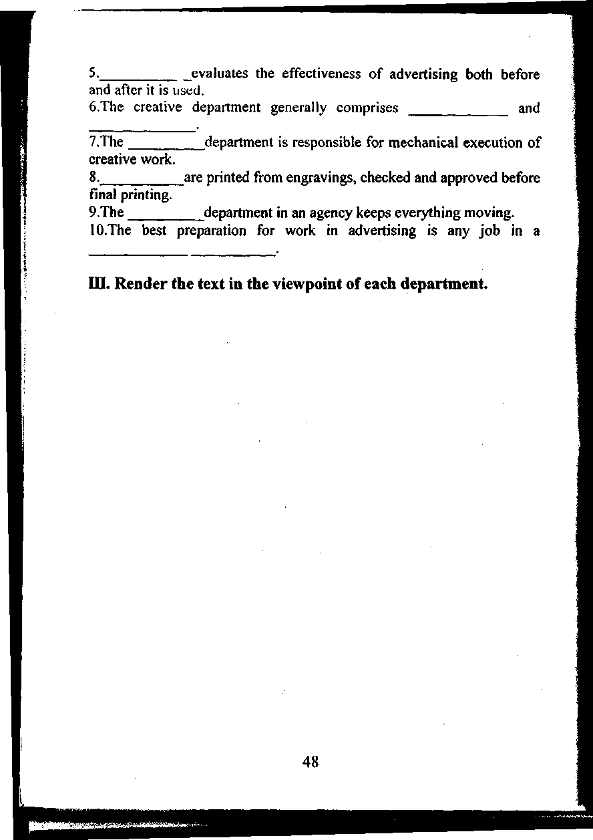
Навчально-методичне видання

АНГЛІЙСЬКА МОВА
ADVERTISING

Методична розробка
для студентів II та III курсів
Інституту економіки та менеджменту
Укладач КОЗЕЛЕЦЬКА Ірина Степанівна
Технічний редактор А.І. Лаврінович
Підписано до друку 24.11.03. Формат 60x84/16. Папір офсетний. Офсетний друк. Ум. фарбовідб. 13. Ум. друк. арк. 2,79. Обл.-вид. арк.3,0. Тираж 130 прим. Замовлення № 293-1. Вид. Ns 18/ III.
Видавництво НАУ
03058. Київ-58, проспект Космонавта Комарова, 1.
Свідоцтво про внесення до Державного реєстру ДК № 977 від 05.07.2002

