UDC 629.735.072.8.08:004(043.2)

N.O. Solomina, assistant,

I.V. Ostroumov, associate professor,
(National Aviation University, Kiev)
TCAS MODELING SOFTWARE FOR SUPPORT EDUCATION PROCESS
Analysis of modern TCAS e-learning software has been represented. Optimal structure of modeling software has discussed. As a consequence of the work was obtained visual representation of an interactive simulator.
Warning of dangerous convergence of aircrafts in the air is one of the most important tasks of safety flights, especially in relentless with busy air routes and airports. The main function of traffic collision and avoidance system (TCAS) is to solve conflicts. There is a requirement for the presence of such system in the aircraft in many countries. It doesn’t depend on any air traffic controlling systems. TCAS analyzes the airspace around the aircraft, during the flight. Flight crew must quickly perceive and respond to commands of TCAS. The TCAS training system is very useful in the aviation branch as it provides better instruction for the personnel. Training is conducted on the basis of their knowledge about the subject. The disadvantage is subject orientation, i.e., binding to a particular subject area. One of the main functions of the training program is to control cognitive activity of user. This program should obtain information about the process of training, learning about the test results and carry out practical tasks. It’s so called distance learning. This is the possibility that links teacher with the students and sources of information located in different geographical regions, with the help of special technology. [3, 7].
Today, users are offered several training facilities. The vast majority of existing training programs based on the principles of electronic book. They contain details of explaining the principles of the audio and video materials that reflect the work of the TCAS in specific circumstances.
The main educational systems are:
1. ARINC TCAS Training
TCAS Training - training complex of ARINC, designed for training pilots, Chief Inspector, Federal Aviation Agency personnel (USA) and others [2]. This complex is represented on compact disc (CD), which costs $ 150. Interface shows the actual scenario of TCAS, to provide "practical" experience. This complex provides performance statistics upon completion.
2. Sun flight avionics TCAS training
Complex Sun flight avionics TCAS training submitted on CD training is based on the work of consulting TCAS [4]. Training set contains information from the pilots and the general theory that is used for general purpose aircraft. Study explains the methods used in sensing and control plane. There are used demonstrations, graphics that move, for better navigation and display the same kind of TCAS in this complex.
3. ASDL and KC TCAS 2000
The automated system of distance learning and knowledge control TCAS 2000 (ASDL and KC TCAS 2000) – is a set of tools for studying the functioning of onboard collision avoidance systems in the air in 2000 TCAS (TCAS II) with the ability to control knowledge and practicing skills of interaction with this system in various conflict situations [5]. This educational complex is used in aviation schools and airlines to train pilots of civil aviation. Training complex can be installed as a standalone workstation or on a dedicated server inside the corporate network. The complex also has conservation reports on the results of passing benchmark users.
4. ACSS Training
Aviation Communication and Surveillance Systems (ACSS) presents a training course, which is described in detail and depicted system TCAS [1]. Training courses offered ACSS adopted the Federal Office of Civil Aviation.
After the considering of those systems was decided to create own training system.
Our E-training complex consists of:
- graphical interface of user;
- resource support as necessary databases and knowledge bases;
- calculation module.
E-learning complex was built by using Adobe Flash technology and programming languages: Action Script, PHP, MySQL. Multimedia interfaces implemented by Action Script, database organized on a dedicated server Database , MySQL. With the help of the Flash technology it modelled the electronic flight instrument system (EFIS) software. This program is an industry standard for creating dynamic, interactive applications with the ability to output to a variety of medium to another: personal computers, mobile devices and screens of almost any size and resolution. The main advantages of Adobe Flash are creating interactive content with an expressive typography, flexible templates, and dynamic animation - the opportunity to highlight their creativity and attention to detail.
E-training software written on the principle of building a Web-interface using standard Internet browser system [6]. Source of E-learning complex is located on a dedicated server, which provides many users access to resources E-learning complex. The necessary modules can be loaded on the client laptop by the request.
User should complete the electronic registration procedure for the access to the interactive media training.
After the registration goes the main content (fig.1). It dives quick access to the next items:
- electronic book
- simulator of TCAS;
- useful links;
- testing;
- questions for self checking;
- glossary (dictionary of aviation terms);
- information on authors;
- information about the Air navigation systems Department;
- application settings;
- presentations;
- exit the program.
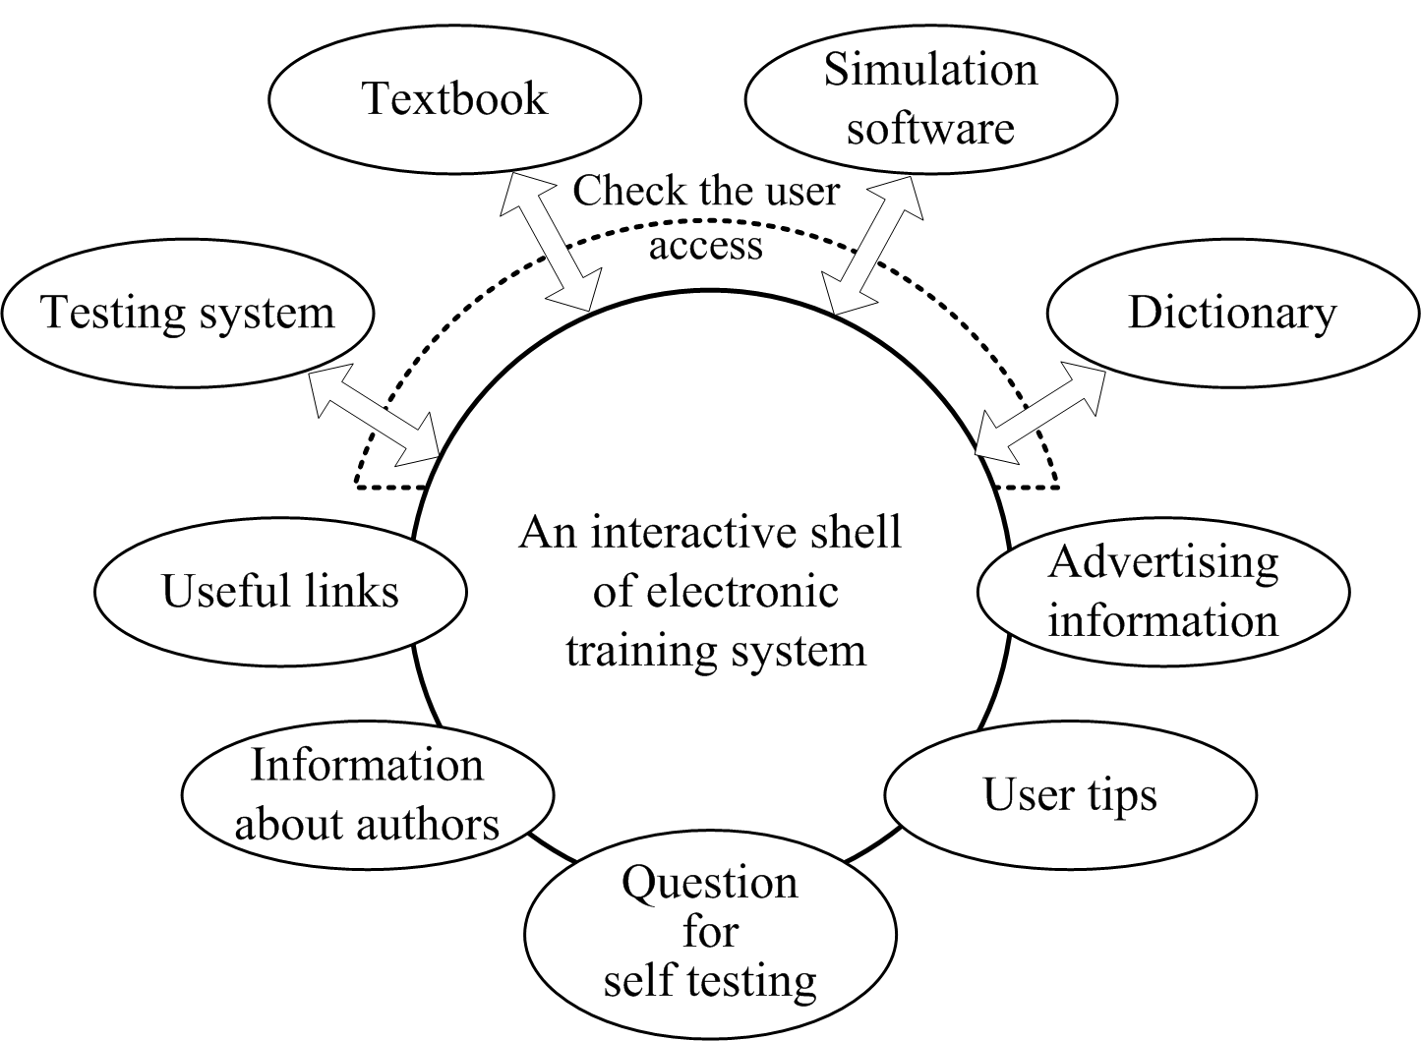

Fig.1. Structure of E-learning software

Transition to any of the elements of E-learning complex is provided by clicking on the title of this item. Clicking on the word simulator, the user goes directly to the "Simulators TCAS"
E-learning complex shows a special symbolic notation of all navigation elements. The information in symbolic form allows the user to remember it very. However, cursor tip appears with the name in the symbol.
Each user can test their knowledge with the help of questions for self-testing, after studying the material about the TCAS. Clicking on the main menu of E-learning complex appropriate symbol, as a result, the user gets to the "questions for self testing”. Here the user can answer various questions, of a high and low level about TCAS and to analyse its degree of learned material, during the course.
Content of glossary of E-learning complex is standardized. It contains the following elements:
- go to the main menu;
- history of search queries (contains previous user requests for the current work session);
- search in Wikipedia (to more information on the current dictionary entry in the online encyclopaedia Wikipedia);
- search the Internet (to get more information at the current dictionary entry on the Internet);
- quit.
As for the interactive simulator the main idea of it is to investigate the principle of work of the electronic flight instrument system. Simulation of air traffic requires addressing the motion and generate the trajectory of their own aircraft and others aircraft, where can be a conflict situation. In order to calculate the speed of convergence and flight time to the point of greatest convergence, the system uses a mathematical formula.
There are exists three variants of interface displays of electronic simulator. The method of displaying depends on the type of installation, by displaying a TCAS. Configuration of the flat indicator VSI / TDA (Vertical Speed / Traffic - vertical speed) shows how objects in the air, and information about the change of vertical speed (fig.2).
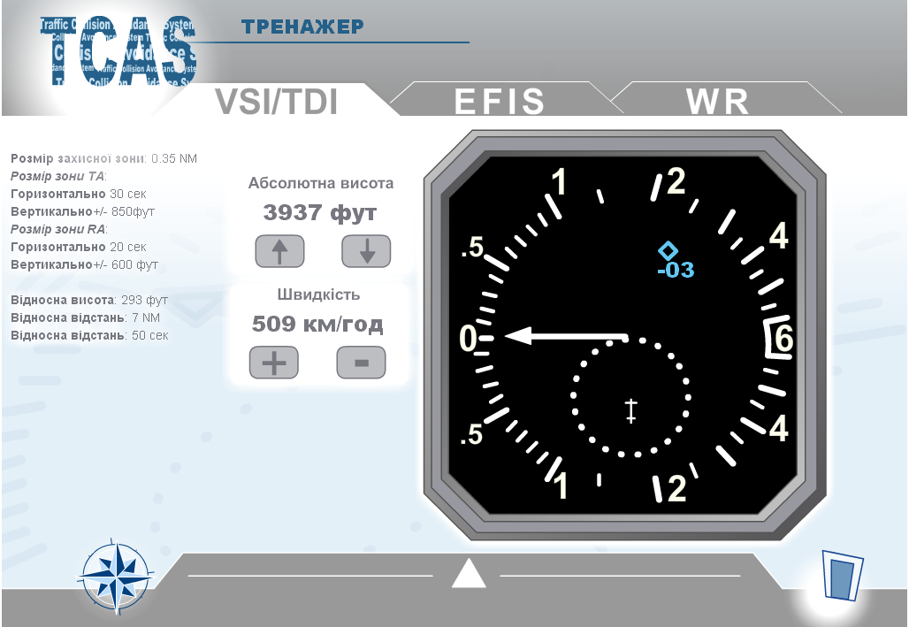
Fig.2. Simulation of VSI / TDA indicator
Configuration in the system of electronic flight instrument displays information on the objects to air traffic and navigation display EFIS displays information about changing the vertical speed in resolution advisory (RA) on the scale of the main flight indicator (fig.3).
The third configuration includes a special indicator to show the objects of air traffic using the modified weather indicator. Depending on the manufacturer's equipment, there are differences in the devices.
TCAS system management is realized by using the control panel in the cockpit. There are several control panels. Here we’ve got some of these control panels. We can use any of those in the simulator. (fig.4)

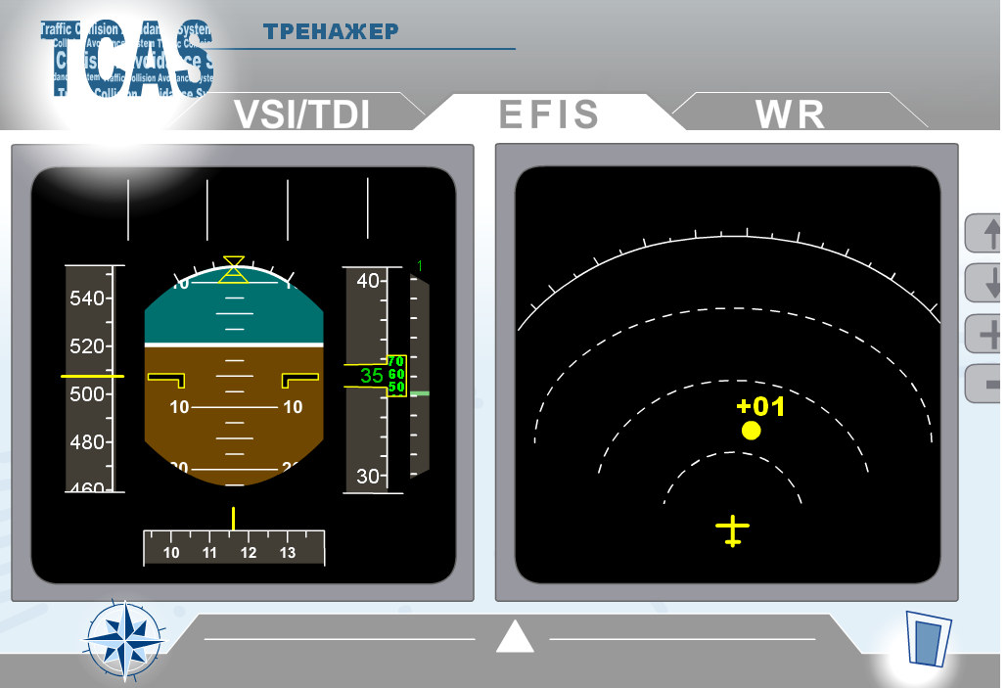  Fig.3. Simulation of EFIS | 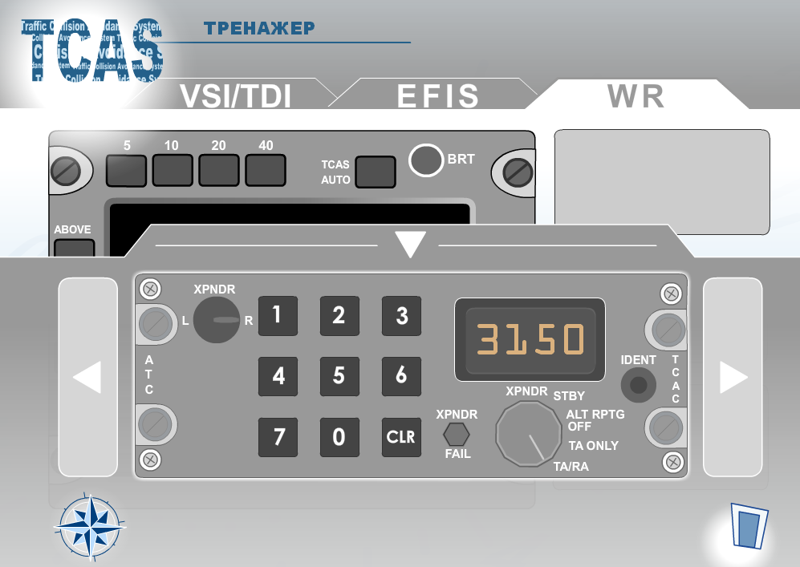  Fig.4. Control panel of TCAS
TCAS system issues through the loud-speaker communication in 14 language cockpit warnings, recommendations or messages, not counting the testing ones. Recommendations to resolve conflict situations can be enhanced, or changed to mild reversible depending on the actions necessary to resolve the conflict.
Conclusion
The electronic simulator of TCAS is directed on learning of the system and acquiring the skills of interaction with the system control and display. During the designing and developing interface program environment of E-learning complex was considered ergonomic features such as rules of applying the optimal placement of controls, color theory and the optimal choice for reading text, as the important part of the creation. Simulation module counter air traffic plays a simple script conflict with the choice of random path. This allows the user to deal with every situation and work out different reactions to different message of TCAS. Interactive interface of e-learning complex allows acquiring skills with TCAS system and working in different versions of failures. One of the main advantages of this system is the access through the Internet, which allows using of it of a great number of people, without the installing the additional software on your computer.
References
- ACSS Training: www.training.acsscustomerservices.com
- Arinc TCAS Training program: www.arinc.com/tcas/training.html
- Overview of ACAS II / TCAS II. – Eurocontrol – 2009. – 32 p.
- Sun flight avionics training: www.electronicflight.com
- Автоматизированная система дистанционного обучения и контроля знаний TCAS 2000 (Change 7): /www.sisadminov.net/tcas
- Електронний навчальний комплекс з вивчення системи попередження зіткнень літаків: www.ANS.nau.edu.ua/tcas
- Introduction to TCAS II Version 7 / Federal Aviation Administration – U.S. department of transportation – 2000. – 45p.

