УДК 531.61.001.32:629.3(045)
UDC 531.61.001.32:629.3(045)

IMPROVEMENTS POWER AGGREGATES CONSTRUCTION ON TRANSPORT

Trofimov I.L., сandidate of engineerings sciences, National aviation university, Kiev, Ukraine
Suliman O.M., National aviation university, College of Slaviansk, Slaviansk, Ukraine
Gorupa V.V., National aviation university, Kiev, Ukraine
Malyovanaya S.U., National aviation university, College of Slaviansk, Slaviansk, Ukraine

УДОСКОНАЛЕННЯ КОНСТРУКЦІЇ ЕНЕРГЕТИЧНИХ АГРЕГАТІВ НА ТРАНСПОРТІ

Трофімов І.Л., Національний авіаційний університет, Київ, Україна
Суліман О.М., Національний авіаційний університет, Слав’янский коледж, Слав’янск, Україна
Горупа В.В., Національний авіаційний університет, Київ, Україна
Мальована С.Ю., Національний авіаційний університет, Слав’янский коледж, Слав’янск, Україна

УСОВЕРШЕНСТВОВАНИЯ КОНСТРУКЦИИ ЭНЕРГЕТИЧЕСКИХ АГРЕГАТОВ НА ТРАНСПОРТЕ

Трофимов И.Л., Национальный авиационный университет, Киев, Украина
Сулиман А.Н., Национальный авиационный университет, Славянский коледж, Славянск, Украина
Горупа В.В., Национальный авиационный университет, Киев, Украина
Малёвана С.Ю., Национальный авиационный университет, Славянский коледж, Славянск, Украина

1. Introduction
There is a big variety of accumulators of power in engineering. Mechanical include spring, rubber, pneumatic, pneumatic- and spring- hydraulically accumulators, power accumulators as the lifted cargo, and at last, flywheel or inertial accumulators. Also exist thermal accumulators, accumulating huge power in a unit of mass, and allocating it as thermal. Each of them is good in its own way and has its area of use. The actual task is development and uses for a drive of working body combined accumulators of power and power assemblies in modern machines [1].
2. Statement of problem
The inertia of rotation showing the most brightly in work of flywheels, it very widely used in engineering in particular in hydraulic drive of self-propelled machines and their equipment which work by live load. Reserved in flywheel the power by a little loads of working member then realize by higher loads. Hydrostatic transmission of machine allows to carry out charging inertial accumulators when driving downhill and then to use reserved energy at movement on horizontal way or on rise. It is difficult to name the machine which hasn’t flywheel or similar detail - a massive pulley, a toothed wheel, a friction. The accumulation ability of flywheels is one thousand times larger then electrostatic, electrodynamics and electrochemical accumulators. But, when required to accumulate some of power and excrete it as electrical then named above electric accumulators are able to turn out more effective. By this the flywheels high-power generators are much more effective, than the battery of condensers or throttles of the same capacity. In particular one of the perspective method of uninterrupted submission, transformation and preservation of any kind of energy is development of new power-plants which on design and by principle of work would spent energy carriers as small as possible would kept autonomy in work, would be ecologically safe without service [2].
The purpose of the work is development of inertial model, flywheel generator for creation and simultaneously accumulations power for hydrostatic drive of machines used in engineering practice.
3. Analysis means of energy accumulation
From mechanical accumulators as engines can be used practically all, but with different efficiency. Spring accumulators are widely applied as clock engines, toys, various devices for giving beginning pulse of movement flywheel. Spring engines accumulate small amount of power in mass unit, in thousand times it is less than flywheels from the same material. The same parameters have also spring-hydraulic accumulators, with that difference, that the energy which has been saved up in spring, is allocated with pressure of working liquid. In this case the work is made by hydraulic engine of this or that type. Electrochemical, pneumatic, pneumatic hydraulic and flywheel accumulators for today are actively applied as engines of machines. The general feature which characteristic for accumulators of these three types is high specific power consumption. Useful energy which has been saved up by these accumulators - hundred thousand joules of energy in kg mass of accumulator. In order to use it as mechanical the electrochemical and pneumatic accumulators or just balloon with compressed gas is necessary to have electric or pneumatic (hydraulic) engine [5].
Usually any engine is not necessary in any engine for flywheel the allocation of energy occurs by shaft rotation of flywheel. The unconditional advantage of flywheel accumulator or engine on its basis is in it. The assignment of flywheel is a bit another in so-called shock action machines where inertia is used for product of mechanical work: in various splitting up and metal cutting assemblies, rolling mills, presses, scissors. During of working course such machines the flywheel take place power slowing down, the dispersal is made by the special engine smoothly, in piston machines all occurs is contrary. In these two cases inertia of flywheel make possible work of the machine - the kinetic energy which has been saved up at dispersal, is used at slowing down.
When it is said about terms of preservation (conservation) of power there are pneumatic accumulators on the foreground pneumatic accumulators act and it is possible to keep the energy of the compressed gas for many years. Electrochemical accumulators concede here to them and flywheels in spite of the fact that laboratory samples allowed the storage of energy for week and months, have to recede on the third plan. But by consideration of such parameter as specific capacity the flywheels again come out on the top with a huge stock. There is no engine or accumulator, capable to develop so big capacities as a flywheel. The capacity developing by a flywheel, is practically boundless and it is limited only by opportunities of transmission. The second place belongs to pneumoaccumulators here, the third - to electrochemical accumulators having, as it is known, not high specific capacity. Analogy to duration charging, dependent on specific capacity of accumulator. Modern flywheel engine has the best parameters on reliability, durability, efficiency and influence of temperatures [9].
The most important ability of that or either engine or accumulator is to recuperate machine`s energy. Here the first place belongs to flywheel though the pneumatic and electromechanical accumulators also are capable to recuperate the power. In accumulators of all three types there are big prospects of growth of useful parameters and in the first place of specific power consumption. The greatest prospects as it is marked above, have flywheels. It is tied in the first place with creation of super flywheels from over-tenacity threadlike materials.
Good prospects of growth of power consumption have the electrochemical accumulators too which have enough high parameters. Prospects of pneumatic accumulators are more modest and they depend basically on creation of over-tenacity and light cylinders from the same threadlike materials.
The approximate data on power consumption of some accumulators with use of materials of D.V. Rabenhorsta are resulted on Fig 1 [10].

Fig. 1. Power consumption of some accumulators of energy
1 - steel shroud; 2 - acid accumulator; 3 - super flywheel from modern materials;
4 - sodium-air accumulator; 5 - perspective super flywheel

These data unequivocally testify to high perspectivity of flywheels engines. And it is doubtless, that many machines of already near future will be led simple, reliable, economic and not polluting of environment - flywheel engine.
The subject of the given research is establishments of appropriateness of interaction of mobile weight with flywheels of the device.
4. Statement of basis material of research
Taking into account a complexity of proceeding processes and physical objects interactions and also the stated task having been worked out the model of experimental installation which can be named "satum flywheel generator of gravitational action - SFGGA". Given power aggregate uses the energy of gravitational power field as a primary pulse for the beginning of work as well as any other mechanical accumulator of power [3], [4] . The principle of the device`s model consist on the basis of fundamental laws of physics (dynamics) - constantly change of energy`s density of the power carrier (mass) due to change of speed and direction of movement at its interaction with flywheels without breaking gravitation`s laws. It is known, that the mass is equivalent to energy. One kg of weight is approximately equal 8,98755*10¹⁶ J of energy [8]. Therefore mass is named - the power carrier.
This device will be working within the action of gravitational field.
Let's consider the bases of method of force calculation and the constructive scheme of model power generator.
Research the scheme of forces which operate on elements of design Fig 2 [5], [6] .

α
F
f

Fig. 2. Scheme of working forces

Calculation is spent basis on formulas:

$\text{mg}=f$; (1)

$\frac{\text{mg}}{F}=\text{sin}α$; (2)

$f=F\text{sin}α$; (3)
$F=\frac{f}{\text{sin}α}=\frac{\text{mg}}{\text{sin}α}$ (4)

where F – force;$α$ – a corner between force and the force of gravitation; f – gravitation force of the earth; m– mass of flywheels; g –acceleration of free drop.
Results of calculations it is brought in Table 1.

Table 1
Force calculation of flywheel
α,  degrees | sin α, | F | α,,  degrees | sin α, | F | α,,  degrees | sin α, | F
30 | 0,5000 | 1,50 | 9 | 0,1564 | 4,80 | 3' | 0,0008 | 938,00
29 | 0,4848 | 1,55 | 8 | 0,1392 | 5,39 | 2' | 0,0005 | 1500,0
28 | 0,4695 | 1,60 | 7 | 0,1219 | 6,50 | 1' = 60" | 0,0002 | 3750,0
27 | 0,4540 | 1,65 | 6 | 0,1045 | 7,18
26 | 0,4384 | 1,73 | 5 | 0,0872 | 8,6 | 50" | 0,0001667 | 4499
25 | 0,4220 | 1,78 | 4 | 0,0698 | 10,74 | 40" | 0,0001334 | 5622
24 | 0,4067 | 1,80 | 3 | 0,0523 | 14,34 | 30" | 0,0001001 | 7492
23 | 0,3907 | 1,92 | 2 | 0,0349 | 21,49 | 20" | 0,000068 | 11029
22 | 0,3746 | 2,00 | 1 - 60' | 0,0175 | 42,86 | 10" | 0,0000335 | 22388
21 | 0,3584 | 2,09 |  |  |  | 9" | 0,00003015 | 24917
20 | 0,3420 | 2,19 | 50' | 0,0145 | 51,70 | 8" | 0,0000268 | 27985
19 | 0,3256 | 2,30 | 40' | 0,0116 | 64,66 | 7" | 0,00002345 | 32051
18 | 0,3090 | 2,43 | 30' | 0,0087 | 86,20 | 6" | 0,0000201 | 37313
17 | 0,2929 | 2,56 | 20' | 0,0058 | 129,30 | 5" | 0,00001675 | 44910
16 | 0,2756 | 2,72 | 10' | 0,0029 | 258,60 | 4" | 0,0000134 | 55970
15 | 0,2888 | 2,90 | 9' | 0,0026 | 283,50 | 3" | 0,0000105 | 71428
14 | 0,2419 | 3,10 | 8' | 0,0023 | 326,10 | 2" | 0,0000067 | 111940
13 | 0,2250 | 3,33 | 7' | 0,0020 | 375,00 | 1" | 0,0000035 | 214285
12 | 0,2079 | 3,60 | 6' | 0,0017 | 441,00
11 | 0,1908 | 3,93 | 5' | 0,0014 | 536,00
10 | 0,1736 | 4,32 | 4' | 0,0011 | 682,00

In accordance to values in Table 1 we build the diagram of the force`s dependence from the angle of position of the stem concerning the top position, a point 0, Fig 3. The stem from starting position (t.0), moves to point 8, downwards (Fig 4). When calculating the constructional scheme of the model the coordinates of passage floating mass from 0 - 8 we design using, formulas:

$a_{n}=a_{1}+d\left(n−1\right)$, mm (5)

$S_{n}=\frac{a_{1}+a_{n}}{2}n$, mm (6)

where a₁ =d=1,16667 mm; n = 8 – quantity of center points of bow; S_{n} – responsible to diameter of circle of rotation mass; a_{n}– center of bow of path of movement mass [5].
Analyzing the diagram of dependence ranges we draw a conclusion that the mechanical force from mass depends on the angle of position of the stem. In accordance to the constructive scheme, Fig 4, the minimal value of force will be in a point 0, and maximal in a point 8. Therefore, the construction of power aggregate provides lags of the stem in a point 8 as it is possible longer at rotation of flywheels that responses to the maximal value of density of power bearer in volume of space. Simultaneously the length of the web will be the greatest too.
And as consequence the values of work also will be maximal. When working the pattern its details carry out complicated motion: the flywheels gyration around their axis and cam shaft with the stem oscillate in horizontal from the centre and back between two flywheels constantly operating on them with the certain force. It is stipulated by the construction when rotation the flywheels takes place compulsory own substitution of web under the action of mass. And the force which operates on flywheels is much more the force of frictional resistance.
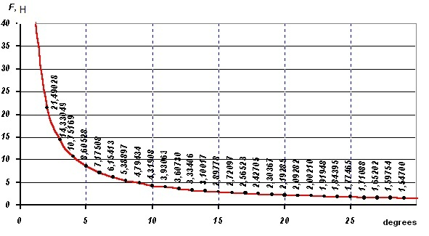

Fig. 3. Diagram of dependence of force from the angle position of the stem

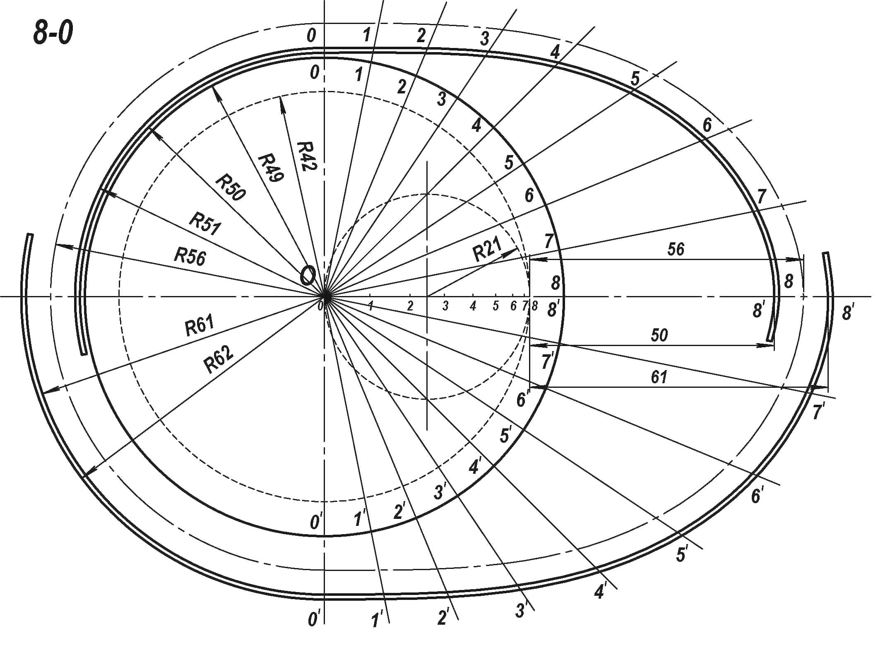

Fig. 4. The constructive scheme of the model of flywheel generator

After calculations, elaboration of drawing and making of details it is created the physical model of the device (Fig 5).
While working the flywheel generator of gravitational action (as a group of interaction physical objects) occurs constantly change of objects motion (speed and direction), therefore takes place constantly change of power`s closeness. This idea is the base of working up the flywheel generator of power gravitational action which in its turn capable and to accumulate the power too [7].
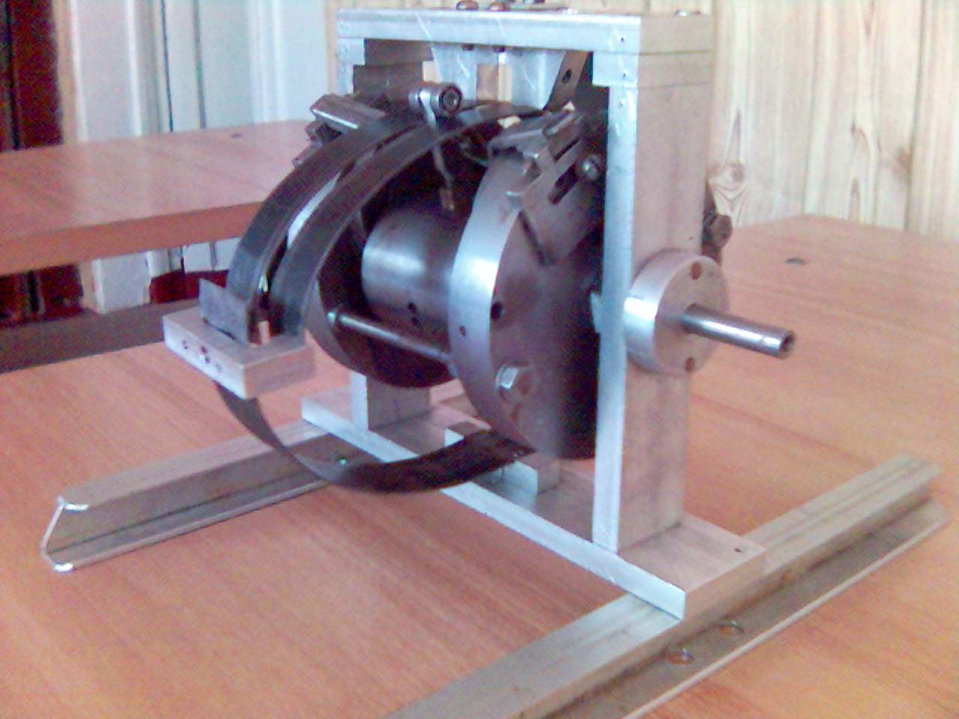

Fig. 5. View of model flywheel generator gravitational action

5. Conclusions
On the basis of observations, accumulation, comparison of analysis of real factors of an environment and various information sources the force calculation has been carried out the pattern of flywheel generator of gravitational action has been worked up and has been stated main principles of interaction energy of mass with flywheels in the gravitational field. The developed model of flywheel engine is not closed there may be continuous movement and processes in it in which energy constantly revives and accumulate. If energy revives without additional expenses we will receive the necessary generator and accumulator of power.

The flywheel generator of energy of gravitational action converts power in that, which it is necessary for us at present moment in the present case.
It is clearly that similar power sources don't solution up to the end all problems of power engineering, but show one of ways of stable get of power without fuel expended as a matter of fact the floating mass is power-bearer. The advantage of flywheel generator is opportunity of constant perfection and accessible construction to realization, the independence from area of use receipt and opportunity of accumulation practically including hydraulic power.

ПЕРЕЛІК ПОСИЛАНЬ
1. Akosta V., Kovan V., Gram B., Bases of modern physics. – Moscow, Prosveshenie, 2001. – 251p.
2. Прохоров А.М. Физическая энциклопедия. – М.: Большая Российская энциклопедия. Т4. Резонансное излучение. – 1994. – с. 313.
3. Бабанов И.М. Теория колебаний. – М.: Наука, 1998. – 245с.
4. Ландау Л.Д., Лившиц В.М. Теоретическая физика. Теория поля. – М.: Наука, 1988. – 189с.
5. Кравец И.А. Управляемый синтез энергии. – Х.: ХГАДТУ, 2001. – 234с.
6. Кравец И.А. Сатумная энергия – это энергия из энергий // Проблемы техники. – 2002 , – №3. – с. 39-52.
7. Шаблиовский В. Вечный двигатель Джона Кили // Волонтёр. – №2, 2005, – с. 4-12.
8. Равдель А.А., Пономарёва А.Г. Краткий справочник физико – химических величин. – Санкт-Петербург.: Химия. – 1993. – с. 47.
9. Гулия Н.В. Маховичные двигатели. – М.: «Транспорт». – 2002. – 148 с.
10. Саликеева С. Н., Галеева Ф. Т. Обзор методов получения альтернативной энергии // Вестник Казан. технолог.ун-та 2012 - № 8., том 15. – с.57-59.

REFERENCES

1. Akosta V., Kovan V., Gram B., Bases of modern physics. – Moscow, Prosveshenie, 2001. – 251p.
2. Prohorov A.M., Physical encyclopedia. – Moscow, Big Russian Encyclopedia.V4. Resonant radiation. – 1994. – p. 313.
3. Banov I.M., Theory of fluctuation. – Moscow, Science, 1998. – p. 245.
4. Landau L.D., Livshitс V.M., Theoretical physics. Theory of field. Moscow, Science, 1988. – p. 189.
5. Kravetc I.A., Controlled synthesis of energy. Kharkov, 2001. – 234p.
6. Kravetc I.A., Satum energy is energy from energy. Problems of technique, 2002, – №3. – p. 39-52.
7. Shabliovskiy V., John Kili’s perpetuum mobile. The Volunteer. – №2, 2005, – p. 4-12.
8. Radvel A.A., Ponamoreva A.G., Brief directory of physical-chemical values. S-P, Chemical, 1993. – p. 47.
9. Gulia N.V. Flywheels engines. – Moscow, Transport, 2002. – 148 p.
10. Salikeeva S. N., Galeeva F. T. The review of the methods in order to receive of alternative energy// Bulletin.Kazan.technolog.University 2012 - № 8., volume15ю – p. 57-59.

РЕФЕРАТ
В этой статье обсуждается проблема создания и использования механических аккумуляторов энергии, а также приводится модель инерционного генератора создания и аккумулирования энергии для гидростатического привода машин используемых в инженерной практике. Проведён анализ средств аккумулирования энергии. Проанализирована проблема использования механических аккумуляторов маховичного типа. Установлено, что основные преимущества маховичных генераторов – выделение энергии путем вращения вала самого же маховика, а также довольно высокие показатели по надежности, долговечности, КПД, влиянию воздействия температур в сравнении с электрохимическими, пневматическими и пневмогидравлическими аккумуляторами энергии. Также маховику принадлежит первенство относительно рекуперации энергии машины и большие перспективы роста удельной энергоемкости. В этой работе основным предметом исследования было установления закономерности взаимодействия подвижной массы с маховиками устройства. Был обоснован и проведен силовой расчет махогенератора. На основании расчетов разработано детальные чертежи и сконструирована физическая модель махогенератора гравитационного действия. Данный энергоагрегат использует энергию гравитационного силового поля, как первичный импульс для начала работы, а так же любого другого механического акумулятора энергии. Разработанная модель маховичного двигателя не является замкнутой, в ней возможны беспрерывные движение и процессы, в котором постоянно возрождается и аккумулируется энергия. Подобные энергетические источники не решают до конца всех проблем энергетики, но показывают один из путей стабильного получения энергии без затраты топлива, поскольку по сути подвижная масса есть энергоносителем. Результаты исследований могут быть применены в машиностроении и транспортной отрасли, в частности, при создании экологического наземного транспорта. Эта работа будет интересна экспертам энергетикам, а также экологам и химмотологам в области создания и рационального использования альтернативных источников энергии.
КЛЮЧЕВЫЕ СЛОВА: ЭНЕРГИЯ, АККУМУЛЯТОР, ЭНЕРГОГЕНЕРАТОР, ГРАВИТАЦИЯ, МАССА, САТУМНАЯ ЭНЕРГИЯ, МАХОВИК.

РЕФЕРАТ

У цій статті обговорюється проблема створення і використання механічних акумуляторів енергії, а також приводиться модель інерційного генератора створення і акумуляції енергії для гідростатичного приводу машин використовуваних в інженерній практиці. Проведений аналіз засобів акумуляції енергії. Проаналізована проблема використання механічних акумуляторів маховикового типа. Встановлено, що основні переваги маховикових генераторів – виділення енергії шляхом обертання валу самого ж маховика, а також досить високі показники з надійності, довговічності, ККД, впливу дії температур порівняно з електрохімічними, пневматичними і пневмогідравлічними акумуляторами енергії. Також маховику належить першість відносно рекуперації енергії машини і великі перспективи зростання питомої енергоємності. У цій роботі основним предметом дослідження було встановлення закономірності взаємодії рухливої маси з маховиками пристрою. Був обґрунтований і проведений силовий розрахунок махогенератора. На підставі розрахунків розроблено детальні креслення і сконструйована фізична модель махогенератора гравітаційної дії. Даний енергоагрегат використовує енергію гравітаційного силового поля, як первинний імпульс для початку роботи, а так само будь-якого іншого механічного акумулятора енергії. Розроблена модель маховикового двигуна не є замкнутою, в ній можливі безперервні рух і процеси, в якому постійно відроджується і акумулюється енергія. Подібні енергетичні джерела не вирішують до кінця всіх проблем енергетики, але показують один із шляхів стабільного отримання енергії без витрати палива, оскільки по суті рухлива маса є енергоносієм. Результати досліджень можуть бути застосовані в машинобудуванні і транспортній галузі, зокрема, при створенні екологічного наземного транспорту. Ця робота буде цікава експертам енергетикам, а також екологам і хіммотологам в області створення і раціонального використання альтернативних джерел енергії.
КЛЮЧОВІ СЛОВА: ЕНЕРГІЯ, АКУМУЛЯТОР, ЕНЕРГОГЕНЕРАТОР, ГРАВІТАЦІЯ, МАСА, САТУМНА ЕНЕРГІЯ, МАХОВИК.

ABSTRACT
This article discusses the problem of creating and using mechanical energy accumulators, as well as a model of the inertial generator for creating and accumulating energy for hydrostatic drive of machines used in engineering practice. The analysis means of accumulation energy is carried out. The problem of using mechanical flywheel batteries is analyzed. It has been established that the main advantages of flywheel generators are energy release by rotating the shaft of the flywheel itself, as well as rather high indicators of reliability, durability, efficiency, the influence of temperature effects in comparison with electrochemical, pneumatic and pneumohydraulic energy accumulators. Also, the flywheel belongs to the priority regarding the recuperation of the energy the machine and the great prospects for the growth of the specific energy intensity. In this work, the main subject of the study was to establish the regularity of the interaction of the mobile mass with the flywheels of the device. The power calculation of the generator was justified and conducted. On the basis of calculations, detailed drawings have been developed and a physical model of the gravity generator has been designed. This power unit uses the energy of the gravitational force field, as the primary impulse to start work, as well as any other mechanical energy accumulator. The developed model of the flywheel engine is not closed, it can be continuous motion and processes, in which the energy is constantly reviving and accumulating. Such energy sources do not solve up to the end of all energy problems, but they show one of the ways of stable energy production without fuel consumption, since in essence the mobile mass is an energy carrier. The results of the research can be applied in engineering and transport industries, in particular, in the development of environmental land transport. This work will be of interest to energy experts, as well as environmentalists and chemotheologists in the field of creation and rational use of alternative energy sources.
KEYWORDS: POWER, ACCUMULATOR, POWER GENERATOR, GRAVITATION, MASS, SATUM POWER, FLYWHEEL

АВТОРИ:
Трофімов Ігор Леонідович - кандидат технічних наук, доцент, доцент кафедри екології Національного авіаційного університету, Е-mail: troffi@ukr.net, ID ORCID: 0000-0001-5539-1166, SPIN-код автора: 8051-5281, контактний тел.: (097)238-28-89, Україна, 03680, Київ, просп. Комарова, 1.begin_of_the_skype_highlightingend_of_the_skype_highlighting
Суліман Олексій Миколайович - завідувач відділення «Авіаційних і економічних спеціальностей», викладач – методист, старший викладач Відокремленого структурного підрозділу Національного авіаційного університету Слов`янський коледж Національного авіаційного університету, Е-mail: san.ttoa@mail.ru, контактний тел.: +38 (098)01-02-085, +38 0502131349, Украина,84100, м. Слов’янськ, вул. К.Маркса, 27.
Горупа Василь Васильович - старший викладач кафедри біотехнологій Національного авіаційного університету, Е-mail: vasilichus@yandex.ru, контактный тел.: +38(050)133-77-26, Україна, 03680, Київ, просп. Комарова, 1.begin_of_the_skype_highlightingend_of_the_skype_highlightingbegin_of_the_skype_highlightingend_of_the_skype_highlighting
Мальована Світлана Юріївна - викладач іноземної мови І категорії Відокремленого структурного підрозділу Національного авіаційного університету Слов`янський коледж Національного авіаційного університету, контактний тел.: +380508884108, Украина,84100, м. Слов’янськ, вул. К.Маркса, 27.

АВТОРЫ:
Трофимов Игорь Леонидович - кандидат технических наук, доцент, доцент кафедры экологии Национального авиационного университета, Е-mail: troffi@ukr.net, ID ORCID: 0000-0001-5539-1166, SPIN-код автора: 8051-5281, контактний тел.: (097)238-28-89, Украина, 03680, Киев, просп. Комарова, 1.
Сулиман Алексей Николаевич - заведующий отделением «Авиационных и экономических специальностей», преподаватель – методист, старший преподаватель Отдельного структурного подразделения Национального авиационного университета Славянский колледж Национального авиационного университета, Е-mail: san.ttoa@mail.ru, контактний тел.: +38 (098)01-02-085, +38 0502131349, Украина, 84100, г. Славянск, ул. К.Маркса,27.
Горупа Василий Василиевич - старший преподаватель кафедры биотехнологий Национального авиационного университета, Е-mail: vasilichus@yandex.ru, контактный тел.: +38(050)133-77-26, Украина, 03680, Киев, просп. Комарова, 1.begin_of_the_skype_highlightingend_of_the_skype_highlighting
Малеваная Светлана Юрьевна - преподаватель иностранного языка І категории Отдельного структурного подразделения Национального авиационного университета Славянский колледж Национального авиационного университета, контактный тел.: +380508884108, Украина, 84100, г. Славянск, ул. К.Маркса,27.

AUTHORS:
Trofimov Igor Leonidovich - сandidate of engineerings sciences, associate professor, associate professor Department of ecology National aviation university, Е-mail: troffi@ukr.net, ID ORCID: 0000-0001-5539-1166, SPIN-cod: 8051-5281, Ukraine, 03680, Kyiv, Kosmonavta Komarova ave.1.
Suliman Aleksey Nikolayevich - head of “Aviation and Economical specialities” department
Teacher-methodologist, senior teacher of Separated Structural Subdivision of National Aviation University Slavyansk College of National Aviation University, Е-mail: san.ttoa@mail.ru, Contact tel.: +38 (098)01-02-085, +38 0502131349, Ukraine, 84100, Slavyansk, Karla Marksa street 27.
Gorupa Vasiliy Vasilievich - senior teacher Department of Biotechnology National aviation university, Е-mail: vasilichus@yandex.ru, Contact tel.: +38(050)133-77-26, Ukraine, 03680, Kyiv, Kosmonavta Komarova ave.1.begin_of_the_skype_highlightingend_of_the_skype_highlighting
Malevanaya Svetlana Yurievna - the first category foreign language teacher of Separated Structural Subdivision of National Aviation University Slavyansk College of National Aviation University, Contact tel.: +380508884108, Ukraine, 84100, Slavyansk, Karla Marksa street 27.

РЕЦЕНЗЕНТИ:
Зайченко Стефан Володимирович, доктор технічних наук, доцент, професор кафедри енергоменеджменту НТУУ «КПІ ім. Ігоря Сікорського», м. Київ, Україна.

REVIEWERS:
Zaychenko Stefan V., PhD, associate professor, professor Department of energyaudit NTUU “KPI Sikorskiy’s Igor name”, Kyiv, Ukraine.

