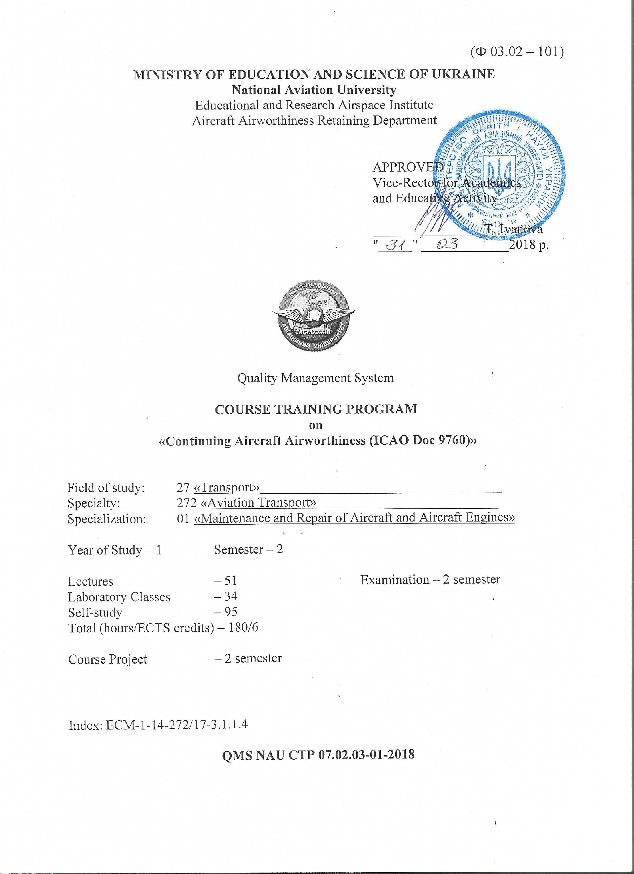
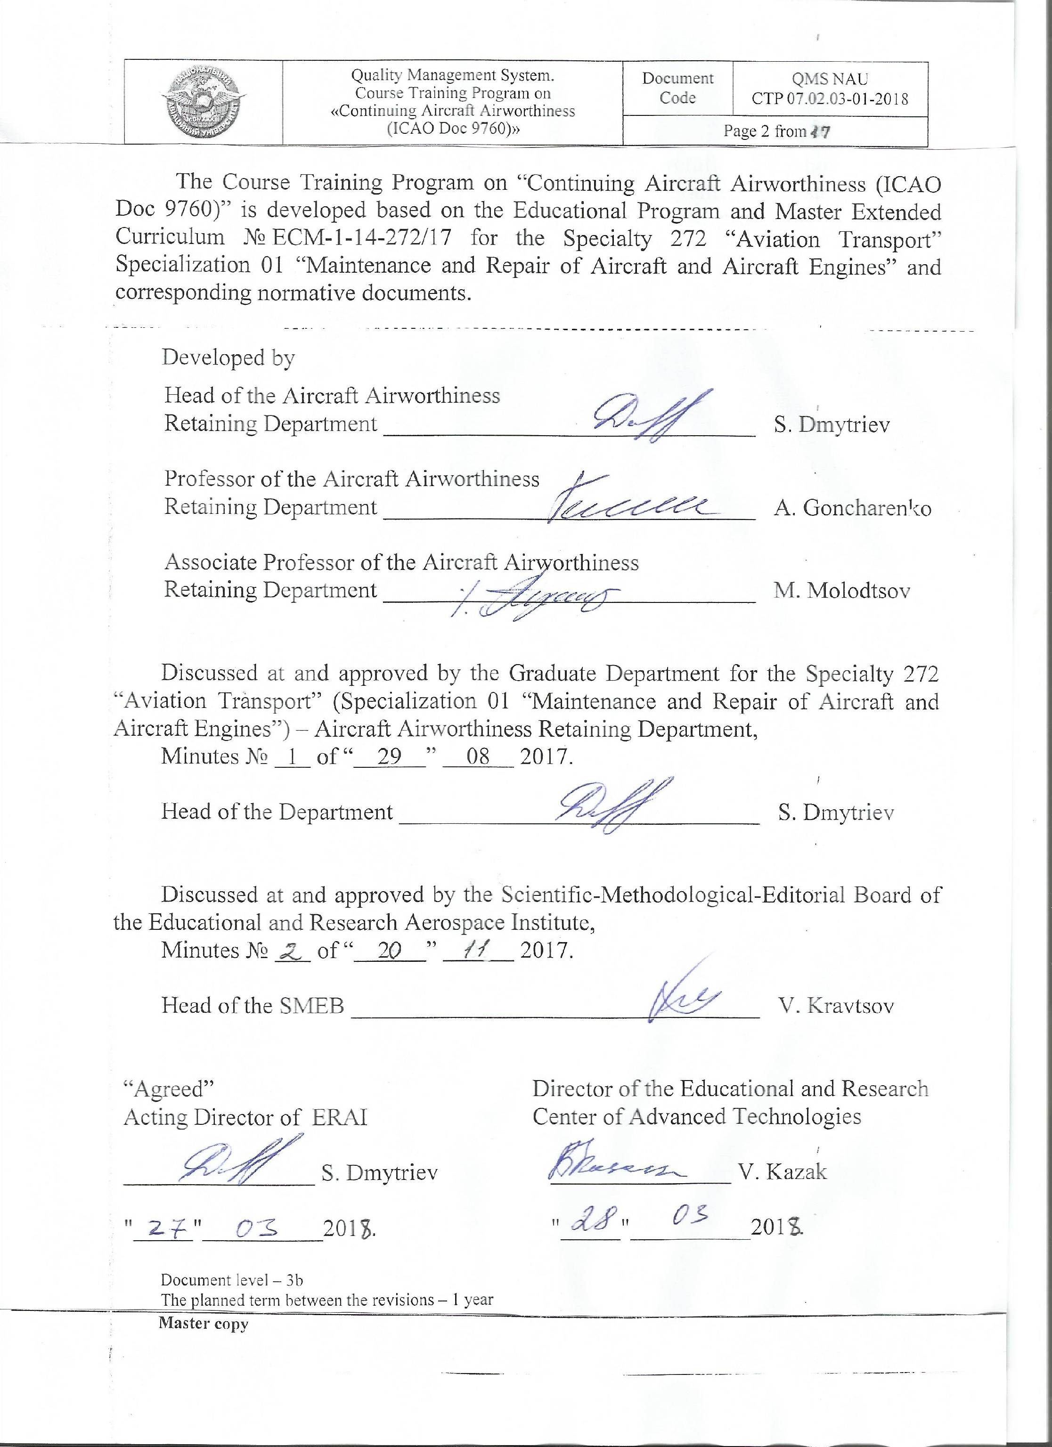

CONTENTS
page
Introduction

1. Explanatory Notes  1.1. Planned Results ……………………………………………………………….  1.2. Subject Program ………………………………….…………………………...  2. Subject Content  2.1. Subject Structure ...............................................................................................  2.2. Lectures, their subject matters and planned hours …………………………….  2.3. Laboratory Classes, their subject matters and planned hours …………………  2.4. Student’s self-study, its content and planned hours …………………………..  2.4.1. Course Project ................................................................................................  3. Teaching-Methodical Materials for the Subject  3.1. Teaching Methods .............................................................................................  3.2. Recommended Literature (major and supplementary)………………………...  3.3. Information Resources on the Internet ………………………………………..  4. Rating System of Knowledge and Skills Assessment  4.1. Check Methods and Scores Accounting Scheme …………………………….. | 4  5  8  9  10  11  11  11  11  12  12

INTRODUCTION

The Course Training Program (CTP) of the discipline is developed based on the "Methodical Recommendations for the Development and Design of the Training Program of an Academic Discipline", approved by the decree № 106 / order, dated July 13, 2017, and the relevant normative documents.
The Course Training Program of the subject “Continuing Aircraft Airworthiness (ІСАО Dос 9760)” reflects the main provisions and requirements of the legal framework of ICAO, aviation legislation of Ukraine, and national aviation regulations (ARs) based on accepted regulations and recommendations of EASA.

1. Explanatory Notes

1.1 Planned Results
The Place of this discipline in the system of professional training of a specialist: this academic discipline is the main profile discipline, which completes theoretical and practical training of students in specialty 272 "Aviation Transport" and specialization 01 "Maintenance and repair of aircraft and aircraft engines". The discipline organically prepares students to solve complex problems at the current level of their solution using advanced methods and means of maintaining the airworthiness of aircraft (A/C) in accordance with the requirements and scopes regulated by the qualification characteristics of a specialist.
The Purpose of teaching the discipline is:
- formation of students' scientific base and practical knowledge in the field of organization and implementation of processes aimed at maintenance, preservation and restoration of A/C airworthiness (A/W);
- mastering the modern methods of management of the implementation of maintenance (M/T) of aeronautical engineering (AE) at all stages of the life cycle - from designing to utilization.
The Tasks of studying the discipline are:
- consolidation of the received knowledge on disciplines: Reliability of AE; Diagnostics and control systems of the A/C technical state (conditions); International and state regulation of A/C A/W; Structure and durability of A/C, A/C engines (A-E); Functional systems of A/C; Flight safety; Aviation security; Design and maintenance of a specific type of A/C and A-E; Maintenance of a specific type of A/C and A-E etc.;
- mastering the practical skills of organization and performance of M/T work, maintenance, preservation and restoration of AE A/W;
- preparation of a student for a choice of an industry branch and the specialty of the practical activity in a new market conditions;
- activation of training and orientation of the students' activity on independent scientific research.
The scope of Competencies to be acquired by a student as a result of the study of the discipline "Maintenance of Airworthiness of Aircraft (ICAO Dos 9760)":
- acquisition of basic knowledge and practical skills for evaluating the operational reliability of A/C by the results of operation and indicators, which are regulated by the AE A/W standards, and preparing the recommendations for developing the measures to maintain specified levels of reliability of AE.
The academic discipline "Maintenance of airworthiness of aircraft (ICAO Dos 9760)" is based on the knowledge of such disciplines as: "Fundamentals of scientific research", "Human factor in operation of aeronautical engineering (circ. ICAO No. 227)", "Structure of a specific type of aircraft, "Design of aviation engine of a specific type of aircraft", "Diagnostics and control systems of the technical condition of aircraft and aircraft engines", and complements each other for such disciplines as "Maintenance of a specific type of aircraft", "Information technologies of ensuring the processes of maintenance of aeronautical engineering", "Technological support of airworthiness of aircraft" and others.

1.2. Subject Program

The educational material of the discipline is structured on a modular basis and consists of two training modules, namely: training Module №1 "Analysis of operating conditions and maintenance of the airframe and functional systems of aircraft" and training Module № 2 "Features of maintenance of piston engines and helicopters. Ensuring the economical effectiveness of air transportation", each of which is a logically complete, relatively independent, integral part of the academic discipline, the mastering of which involves modular check work and analysis of the results of its implementation. A separate third module is a course project, which a student performs in the second semester. The course project is an important part of the consolidating and deepening of the theoretical and practical knowledge and skills acquired by the student in the process of mastering the discipline's educational material.
Module №1 "Analysis of operating conditions and maintenance of the airframe and functional systems of aircraft".
Theme 1. General requirements for maintenance of airworthiness of aircraft.
Content and scientific basis of the discipline, historical background, and connection with other disciplines. Characteristics of operating conditions and operational factors that affect the technical condition of aircraft.
Theme 2. Check of the technical condition of the airplane airframe.
Characteristics of the loads that act on the elements of the structure of the A/C airframe. Classification of the characteristics of failures and damages of structural elements of the glider (airframe). Probable areas of the corrosion of the glider appearing, its causes, means of elimination, methods of providing and protecting parts in operating conditions. The control of and forecasting the technical condition of the glider.
Topic 3. Aircraft airframe maintenance.
M/T of tailoring, glazing, straight joints of parts of the glider. Checking the A/C cockpit air-space for leaks. Features of the A/C M/T after the flight in a turbulent atmosphere. Safety precautions.
Topic 4. Check and maintenance of the workability of the aircraft high-altitude system.
Characteristics of operational factors that affect the performance of the air conditioning system and pressure regulation system. Analysis of the reliability of the elements of the altitude system and the characteristics of the malfunctions by the degree of their impact on the safety of flights. Methods of detection and troubleshooting. Control of the effectiveness of air conditioning and pressure control systems.
Conditions of operation and methods of checking the tightness of the cabins of airplanes. Checking and adjusting the high-altitude system units. Features of the M/T of
the oxygen equipment. Rules of labor protection.
Topic 5. Check of the technical state of the aircraft control system.
Influence of operational factors on the technical state (condition) and effectiveness of control systems. Characteristic failures and damages to cable and rigid control systems.
Topic 6. Aircraft control system maintenance.
Typical work performed at the M/T of the aircraft cable rope and rigid control systems. Inspection and adjustment works with the control systems at the M/T. M/T of the control systems outlet hermetic seals. M/T of the elements of the control systems. M/T of the means of the wing and controlled stabilizer mechanizations.
Theme 7. Operating conditions and design features of the modern aircraft landing gear.
Analysis of operational factors affecting the performance of the landing gear (chassis). Features of operating conditions of the landing gear (chassis) elements and equipment: shock absorbers, pneumatics, brake equipment, hinged (articulated) joints, etc. Characteristics of the processes in the various landing gear elements that are caused by these conditions. Operating features of the design of the modern aircraft landing gear (chassis).
Theme 8. Check of the technical state of the landing gear elements.
Characteristic failures and damages to the landing gear (chassis). Impact of the landing gear malfunctions on flight safety. Methods of detection and troubleshooting of the structural elements of the landing gear (chassis).
Theme 9. Maintenance of the landing gear structural elements.
M/T of the design elements of the landing gear (chassis) kinematics system. M/T of the elements of the landing gear (chassis) wheels. Adjustment work. Landing gear (chassis) performance (workability) monitoring. Rules of labor protection at the M/T of the landing gear (chassis).
Topic 10. Operating conditions and design features of the aircraft hydro-gas systems.
Operational features of the design of the modern aircraft hydro-gas systems. Influence of operational factors on performance and technical condition of the hydro-gas systems. Typical failures of the hydro-gas systems.
Topic 11. Features of the aircraft hydro-gas systems maintenance.
Typical works that are performed at the M/T of the hydro-gas systems. The features of the M/T of the power units of the hydro-gas systems with pumps of various designs.
Topic 12. Check of the technical state of the power plants.
Characteristics of operational factors that affect the durability of power plants. Typical operating failures and damages to aviation power plants.
Topic 13. Power plants maintenance.
M/T of the air-gas duct of the gas-turbine engines (GTD). M/T of the oil and fuel systems. Replacement of A-E. Conservation and de-conservation of A-E. The methods of restoration of characteristics of the GTD.
Topic 14. General characteristics of the process and the main stages of starting the aircraft engine.
General characteristics of the process of starting the A-E. Preparation for the start (launch), start (launch), analysis of startup phases. Causes of the non-start of the A-E, searching for defective elements at the non-start of the A-E. Conditions and peculiarities of starting (launching) the piston engines (PE).
Topic 15. The modes and criteria of warming the different types of aviation engines up.
Warming the A-E up. Modes and criteria for a turbo-reactive engine (TRE) warm-up. Modes and criteria for a turbo-prop engine (TPE) warm-up. Modes and criteria for a PE warm-up.
Topic 16. Checking the operation of, cooling and stopping the various types of aircraft engines.
Checking the work of different types of the A-E in steady and variable modes. Cooling and stopping the different types of the A-E.
Module №2 "Features of maintenance of piston engines and helicopters. Ensuring the economical effectiveness of air transportation".
Topic 1. Features of the piston engines maintenance.
Features of the PE M/T. Basic failures and malfunctions of the cylindrical-piston group. Main work at the M/T. M/T of the ignition systems.
Theme 2. Features of the air propellers maintenance.
Operating features of the air propellers structures (designs). M/T of the air propellers.
Theme 3. Features of the operating conditions of helicopters.
Features of operation in complex natural and climatic conditions: at low and high temperatures, high humidity, dustiness of the atmosphere and solar radiation. Preparation for winter and summer navigation.
Characterization of adjusting work on the carrying propeller and helicopter control system. Features of operation of the helicopters power plants.
Topic 4. Features of the helicopters maintenance.
Features of the helicopters M/T. The helicopter auto-oscillations. The M/T of the helicopter carrying system and transmission. The M/T in the complex natural and climatic conditions.
Theme 5. Annual fund for the operation time of the aircraft.
The main components of the annual fund of the A/C operation time. Types and causes of downtimes.
Topic 6. Ensuring the effectiveness of the use of aircraft.
Characteristics of factors that affect the A/C flight hours. The main directions of the works on improving the effectiveness of the A/C use.
Topic 7. Cost of air transportation.
Cost of air transportation. Main funds of civil aviation, their amortization (depreciation) and the ways to improve their use. Working capital (current assets, turnarounds) and ways to improve their use.
Theme 8. Profitability of air transportation.
Profitability of the civil aviation enterprises works. Ways to ensure the economy of transportation. Conclusions from the course.
Module № 3 Course project
The course project (CP) on the subject is carried out in the second semester, in accordance with the approved in the established order methodological recommendations.
The theme of the CP is "Improvement of the aircraft given functional system maintenance process".
The content of the CP consists of:
- a short technical description of the system;
- evaluations of the functional reliability of the system;
- structural improvements to the system;
- choice of the strategy of the system elements M/T;
- description of the preliminary and pre-flight preparation to the flight by the flight crew members;
- description of the actions in case of the special conditions and cases in flight;
- scientific research elements;
- the list of literature.
2. SUBJECT CONTENT
2.1. Subject Structure
Table 2.1
Thematic plan of the subject
# | Topic title  (thematic section) | Study hours (hours)
# | Topic title  (thematic section) | Total | Lectures | LC | SS

1 |  | 2 |  | 3 |  | 4 |  | 5 |  | 6
2 semester
Module #1 "Analysis of operating conditions and maintenance of the airframe and functional systems of aircraft"
1.1 | General requirements for maintenance of airworthiness of aircraft. |  | 6 |  | 2 |  | 2 |  | 2
1.2 | Check of the technical condition of the airplane airframe. |  | 6 |  | 2 |  | 2 |  | 2
1.3 | Aircraft airframe maintenance. |  | 3 |  | 2 |  | - |  | 1
1.4 | Check and maintenance of the workability of the aircraft high-altitude system. |  | 7 |  | 2 |  | 2 |  | 3
1.5 | Check of the technical state of the aircraft control system. |  | 6 |  | 2 |  | 2 |  | 2
1.6 | Aircraft control system maintenance. |  | 4 |  | 2 |  | - |  | 2
1.7 | Operating conditions and design features of the modern aircraft landing gear. |  | 6 |  | 2 |  | 2 |  | 2
1.8 | Check of the technical state of the landing gear elements. |  | 6 |  | 2 |  | 2 |  | 2
1.9 | Maintenance of the landing gear structural elements. |  | 4 |  | 2 |  | - |  | 2
1.10 | Operating conditions and design features of the aircraft hydro-gas systems. |  | 6 |  | 2 |  | 2 |  | 2
1.11 | Features of the aircraft hydro-gas systems maintenance. |  | 7 |  | 2 |  | 2 |  | 3
1.12 | Check of the technical state of the power plants. |  | 3 |  | 2 |  | - |  | 1
1.13 | Power plants maintenance. |  | 7 |  | 2 |  | 2 |  | 3
1.14 | General characteristics of the process and the main stages of starting the aircraft engine. |  | 3 |  | 2 |  | - |  | 1
1.15 | The modes and criteria of warming the different types of aviation engines up. |  | 6 |  | 2 |  | 2 |  | 2
1.16 | Checking the operation of, cooling and stopping the various types of aircraft engines. |  | 7 |  | 2 |  | 2 |  | 3
1.17 | Module check work № 1 |  | 3 |  | 2 |  | - |  | 1
Total for module № 1 |  |  | 90 |  | 34 |  | 22 |  | 34
Module #2 "Features of maintenance of piston engines and helicopters. Ensuring the economical effectiveness of air transportation"
2.1 | Features of the piston engines maintenance. |  | 6 |  | 2 |  | 2 |  | 2
2.2 | Features of the air propellers maintenance. |  | 6 |  | 2 |  | 2 |  | 2
2.3 | Features of the operating conditions of helicopters. |  | 3 |  | 2 |  | - |  | 1
2.4 | Features of the helicopters maintenance. |  | 6 |  | 2 |  | 2 |  | 2
2.5 | Annual fund for the operation time of the aircraft. |  | 7 |  | 2 |  | 2 |  | 3
2.6 | Ensuring the effectiveness of the use of aircraft. |  | 3 |  | 2 |  | - |  | 1
2.7 | Cost of air transportation. |  | 6 |  | 2 |  | 2 |  | 2
2.8 | Profitability of air transportation. |  | 6 |  | 2 |  | 2 |  | 2
2.9 | Module check work № 2. |  | 2 |  | 1 |  | - |  | 1
Total for module № 2 |  |  | 45 |  | 17 |  | 12 |  | 16
Module #3 "Course project"
3.1 | Carrying out and defense of the course project. |  | 45 |  | - |  | - |  | 45
Total for module № 3 |  |  | 45 |  | - |  | - |  | 45
Total for 2 semester |  |  | 180 |  | 51 |  | 34 |  | 95
Total for educational subject |  |  | 180 |  | 51 |  | 34 |  | 95

2.2. Lectures, their subject matters and planned hours
# | Topic title  (thematic section) | Study hours (hours)
# | Topic title  (thematic section) | Lectures | SS

1 | 2 | 3 | 4
2 semester
Module #1 "Analysis of operating conditions and maintenance of the airframe and functional systems of aircraft"
1.1 | General requirements for maintenance of airworthiness of aircraft. | 2 | 1
1.2 | Check of the technical condition of the airplane airframe. | 2 | 1
1.3 | Aircraft airframe maintenance. | 2 | 1
1.4 | Check and maintenance of the workability of the aircraft high-altitude system. | 2 | 2
1.5 | Check of the technical state of the aircraft control system. | 2 | 1
1.6 | Aircraft control system maintenance. | 2 | 2
1.7 | Operating conditions and design features of the modern aircraft landing gear. | 2 | 1
1.8 | Check of the technical state of the landing gear elements. | 2 | 1
1.9 | Maintenance of the landing gear structural elements. | 2 | 2
1.10 | Operating conditions and design features of the aircraft hydro-gas systems. | 2 | 1
1.11 | Features of the aircraft hydro-gas systems maintenance. | 2 | 2
1.12 | Check of the technical state of the power plants. | 2 | 1
1.13 | Power plants maintenance. | 2 | 2
1.14 | General characteristics of the process and the main stages of starting the aircraft engine. | 2 | 1
1.15 | The modes and criteria of warming the different types of aviation engines up. | 2 | 1
1.16 | Checking the operation of, cooling and stopping the various types of aircraft engines. | 2 | 2
1.17 | Module check work № 1 | 2 | 1
Total for module№ 1 |  | 34 | 23
Module #2 "Features of maintenance of piston engines and helicopters. Ensuring the economical effectiveness of air transportation"
2.1 | Features of the piston engines maintenance. | 2 | 1
2.2 | Features of the air propellers maintenance. | 2 | 1
2.3 | Features of the operating conditions of helicopters. | 2 | 1
2.4 | Features of the helicopters maintenance. | 2 | 1
2.5 | Annual fund for the operation time of the aircraft. | 2 | 2
2.6 | Ensuring the effectiveness of the use of aircraft. | 2 | 1
2.7 | Cost of air transportation. | 2 | 1
2.8 | Profitability of air transportation. | 2 | 1
2.9 | Module check work № 2. | 1 | 1
Total for module № 2 |  | 17 | 10
Total for 2 semester |  | 51 | 33
Total for educational subject |  | 51 | 33

2.3. Laboratory Classes, their subject matters and planned hours
# | Topic title  (thematic section) | Study hours (hours)
# | Topic title  (thematic section) | LC | SS

1 | 2 | 3 |  | 4
2 semester
Module #1 "Analysis of operating conditions and maintenance of the airframe and functional systems of aircraft"
1.1 | Investigation and assessment of the technical state of the control system of the aircraft flaps (on Tu-154). | 2 | 1
1.2 | Investigation of the influence of the turning angle of the mechanism of the limit switches cams on the lack of the flaps control system to stops. | 2 | 1
1.3 | Investigation of the technical state of the aircraft air conditioning system (on Tu-154). | 2 | 1
1.4 | Investigation of the effectiveness of the main units of the air conditioning system at different versions of their loading. | 2 | 1
1.5 | Investigation of the technical state of the aircraft control system (on Tu-154). | 2 | 1
1.6 | Investigation of the dependence of the efforts on the steering wheel of the ailerons control on the magnitude of their deviation. | 2 | 1
1.7 | Investigation of the technical state of the structural elements of the chassis when retracting and extending the chassis on the ground (on Tu-154). | 2 | 1
1.8 | Analysis of the influence of the magnitude of the pressure of nitrogen in the stabilizing shock absorber upon the completeness of the retraction and extension of the chassis. | 2 | 1
1.9 | Investigation of the technical state and performance of the braking devices of the modern aircraft wheels. | 2 | 1
1.10 | Investigation of the technical state of the aircraft hydraulic system when performing the maintenance (on Tu-154). | 2 | 1
1.11 | Inspection-adjustment work in the process of maintenance of the aircraft hydraulic system (on Tu-154). | 2 | 1
Total for module № 1 |  | 22 | 11
Module #2 "Features of maintenance of piston engines and helicopters. Ensuring the economical effectiveness of air transportation"
2.1 | The measurement and adjustment of the hourly fuel consumption of the engine AI-24 on the stand simulator. | 2 | 1
2.2 | Study of the features of the parity characteristics of the indicator of the position of the fuel lever for the limb of the fuel dispensing unit. | 2 | 1
2.3 | Investigation of the technical state of the oil system of the engine НК-8-2У. | 2 | 1
2.4 | Inspection-adjustment works in the process of maintenance of the engine oil system (on the aircraft Tu-154 engine НК-8-2У). | 2 | 1
2.5 | Investigation and assessment of the technical state of aggregates of the high-altitude system of civil aviation aircraft on the stand of high-altitude system (SHS). | 2 | 1
2.6 | Investigation of the influence of the faults of the automatic pressure control system on the parameters of pressure control regimes in the cabin. | 2 | 1
Total for module № 2 |  | 12 | 6
Total for 2 semester |  | 34 | 17
Total for educational subject |  | 34 | 17
2.4. Student’s self-study, its content and planned hours
# | The content of the student’s self-study | SS Study hours (hours)
2 семестр
1. | Mastering the lecture material | 31
2. | Preparation to laboratory classes | 17
3. | Course project completion | 45
4. | Preparation to module check works | 2
Total for educational subject |  | 95
2.4.1. Course Project
The CP on the subject is carried out in the second semester, in accordance with the approved in the established order methodological recommendations in order to consolidate and deepen the theoretical and practical knowledge and skills acquired during the process of mastering the educational material of the subject.
The purpose of the implementation of the CP is to inculcate the students with the practical skills in solving engineering problems in order to maintain airworthiness of aircraft.
The task of the CP is to develop separate elements of the system of maintenance of AE airworthiness on the basis of evaluation of functional significance and operational effectiveness of A/C systems.
The execution, registration and defense of the CP is carried out by the student on an individual basis in accordance with the methodological recommendations.
The time required to complete the CP is up to 45 hours of independent self work.
3. TEACHING-METHODICAL MATERIALS FOR THE SUBJECT
3.1. Teaching Methods
# | Name | Code by the thematic plan | Number
1 | Sheets of main content (SMC) on transparent film | 1.2; 1.3; 1.4; 1.5; 1.6; 1.7; 1.8; 1.9; 1.10; 1.11; 1.14; 2.1; 2.2; 2.3 | 45 SMC in 3 copies (complexes)
2 | Slides (presentations) | 1.1-1.16; 2.1-2.8 | 3 complexes
3 | Examples of course projects | 3.1 | 3 complexes
4 | Complex of state standards | For all themes of lectures and laboratory classes | 1 complex
3.2. Recommended Literature
Major literature
3.2.1. Технічне обслуговування планера і функціональних систем повітряних суден та авіадвигунів: Навчальний посібник / С. О. Дмитрієв, О. С. Тугарінов та ін. За ред. С. О.Дмитрієв. – К.: НАУ, 2004. – 244 с.
3.2.2. С. О. Дмитриев, О. С. Тугаринов и др. Сохранение летной годности воздушных судов и авиадвигателей: Учебное пособие. – К.: НАУ, 2011. – 148 с.
3.2.3. Техническая эксплуатация летательных аппаратов. Учебник для вузов гражданской авиации под ред. проф. Н. Н.Смирнова. – М.: Транспорт, 1990. – 423 с.
3.2.4. Смирнов Н. Н., Ицкович А. А. Обслуживание и ремонт АТ по состоянию. – М.: Транспорт, 1987. – 272 с.
3.2.5. Безопасность полетов: Учебник для ВУЗов/Под ред. Р. В. Сакача./ – М.: Транспорт, 1989. – 239 с.
3.2.6. Комаров А. А. Надежность воздушных судов.–К.: КМУГА, 1996. – 416 с.
3.2.7. Основы летно-технической эксплуатации и безопасности полетов./Под ред. А. И.Пугачева/. – М.: Транспорт, 1984. – 229 с.
3.2.8. Наставление по технической эксплуатации и ремонту авиационной техники в гражданской авиации (НТЭРАТ ГА-83). – М.: Транспорт, 1985.
3.2.9. Черненко Ж. С., Германчук Ф. К. и др. Характеристика сложных климатических условий и особенности технической эксплуатации силовых установок в этих условиях: Учебн. пособие. – К.: КИИГА, 1989. – 108 с.
Supplementary literature
3.2.10. Збереження льотної придатності повітряних суден. Метод. вказ. до вик. курсового проекту/Уклад.: В. Г. Докучаєв, Ю. І. Кордянін, І. М. Новіков та ін. – К.: НАУ, 2002. – 53 с.
3.2.11. Технічна експлуатація літальних апаратів та авіадвигунів: Лабораторні роботи/Уклад.: О. С. Тугарінов, Р. М. Салімов та ін. – К.: НАУ, 2002. – 44 с.
3.2.12. Збереження льотної придатності повітряних суден: Методичні рекомендації до виконання лабораторних робіт /Уклад.: О. С. Тугарінов, М. Ф. Молодцов та ін. – К.: НАУ, 2007. – 66 с.
3.2.13. Поддержание летной годности воздушных судов: лабораторный практикум/Сост.: А. С. Тугаринов, А. И. Богданович и др. – К.: НАУ, 2014. – 124 с.
3.2.14. Збереження льотної придатності повітряних суден: лабораторний практикум/Уклад.: О. С. Тугарінов, О. І.Богданович та ін. – К.: НАУ, 2014. – 116 с.
3.2.15. ІСАО. Приложение 8. Летная годность воздушных судов: Международные стандарты.
3.2.16. Руководство по летной годности (ICAO Doc. 9760).
3.3. Information Resources on the Internet
3.3.1. http://www.aviadocs/net
3.3.2. http://avia.gov.ua
3.3.3. http://www.lib.nau.edu.ua/main/
3.3.4. http://aki.nau.edu.ua/кафедра-збереження-льотної-придатно/
3.3.5. http://er.nau.edu.ua/handle/NAU/9098
4. RATING SYSTEM OF KNOWLEDGE AND SKILLS ASSESSMENT
4.1. Check Methods and Scores Accounting Scheme
Grading different kinds of academic work performed by a student is done in accordance with table 4.1.
Table 4.1
2 semester
Module №1 |  | Module №2 |  | Мах  Grade
Kind of Academic Activities | Мах  Grade | Kind of Academic Activities | Мах  Grade | Мах  Grade
Carrying out and defense of laboratory works (4 × 11) | 44  (total) | Carrying out and defense of laboratory works (4 × 6) | 24  (total)
For getting a permission to carryout Module Test № 1, a student must receive not less than 27,5 values |  | For getting a permission to carryout Module Test № 2, a student must receive not less than 15 values
Module Test №1 | 9 | Module Test №2 | 11
Total for module №1 | 53 | Total for module №2 | 35
Semester examination |  |  |  | 12
Total for 2 semester |  |  |  | 100
Module №3 |  |  |  | Мах  Grade
Kind of Academic Activities |  |  |  | Мах  Grade
Carrying out of course project |  |  |  | 50
Defense of course project |  |  |  | 50
Carrying out and defense of course project |  |  |  | 100
4.2. The carried out types of the executed educational work is set off to the student, if he/she got a positive rating assessment (table 4.2).
Table 4.2
Correspondence between the Grades and the National Scale
Grades |  |  | National Scale
Carrying out and defense of laboratory works | Module Test №1 | Module Test №2 | National Scale
4 | 9 | 10-11 | Excellent
3 | 7-8 | 9 | Good
2,5 | 6 | 7-8 | Satisfactorily
under 2,5 | under 6 | under 7 | Bad
4.3. The sum of ratings assessments, got by student on the separate types of the executed educational work, makes a current module rating assessment which is brought to the list of the module check.
4.4. The sum of the current and checking module ratings assessments makes the final module rating assessment (table 4.3) to which a certain level of an assessment in the national scale corresponds. The final module rating assessment in marks and by the national scale is brought to the list of the module check.
Table 4.3
Correspondence of final module ratings assessments in points to the assessments by the national scale
Module №1 | Module №2 | Assessment by the national scale
48-53 | 32-35 | Відмінно
40-47 | 27-31 | Добре
32-39 | 21-26 | Задовільно
менше 32 | менше 21 | Незадовільно
4.5. The final module rating assessment, obtained by the student in result of the course project completion and defense in grades, of the national scale and the ECTS scale, is recorded to the list of the module check.
4.6. The sum of the final module ratings assessments for the semester in marks makes the final semester module rating assessment which is recounted into the assessment by the national scale (table 4.4).
Table 4.4 Table 4.5
Correspondence between the Semester Module Grades and the National Scale |  |  | Correspondence between the examination/Grades and the National Scale
Semester Grades | National scale |  | Grades | National scale
79-88 | Excellent |  | 11-12 | Excellent
66-78 | Good |  | 9-10 | Good
53-65 | Satisfactorily |  | 7-8 | Satisfactorily
under 53 | Bad |  | under 7 | Bad
4.7. The sum of the final semester module and exam ratings assessments in marks makes the total semester rating assessment which is recounted into marks by the national scale and the scale of ECTS (table 4.6).
4.8. The total semester rating assessment in marks, by the National scale and the scale of ECTS is entered into the Credit-Exam Register and the student’s Training Card and Credit Book.
4.9. The total semester rating grade is put down into the student’s Credit Book and Training Card, for instance, in that manner: 92/Ex/А, 87/Good/В, 79/Good/С, 68/Sat/D, 65/Sat/Е, etc.
4.10. The final module rating grade, got by the student as a result of the course project completion and defense, apart from the register for the module test, is also entered into the student’s training card, credit book, and the Supplement to the diploma, for example, in that style: 92/Ex/А, 87/Good/В, 79/Good/С, 68/Sat/D, 65/Sat/Е, etc.
4.11. The final total rating grade for the subject equals the total semester rating grade. The mentioned final total rating grade is put down into the Supplement to the diploma.

Table 4.6
Correspondence of the Total Semester Grades to the National Scale and the ECTS System
Total Semester Grades | National Scale | ECTS System
Total Semester Grades | National Scale | ECTS Grade | Explanation
90-100 | Excellent | A | Excellent  (excellent performance with insignificant shortcomings)
82 – 89 | Good | B | Very Good  (performance above the average standard with few mistakes)
75 – 81 | Good | C | Good  (good performance altogether with a certain number of significant mistakes)
67 – 74 | Satisfactorily | D | Satisfactorily  (performance meets the average standards)
60 – 66 | Satisfactorily | E | Sufficient  (performance meets the minimal criteria)
35 – 59 | Bad | FX | Bad  (bad performance; a second testing is required)
1 – 34 | Bad | F | Bad  (very bad performance; a student shall retake the course)

5. The forms of quality management system documents
(Ф 03.02 – 01)
АРКУШ ПОШИРЕННЯ ДОКУМЕНТА
№  прим. | Куди передано (підрозділ) | Дата  видачі | П.І.Б. отримувача | Підпис отримувача | Примітки
(Ф 03.02 – 02)
АРКУШ ОЗНАЙОМЛЕННЯ З ДОКУМЕНТОМ
№ пор. | Прізвище ім'я по-батькові | Підпис ознайомленої особи | Дата ознайом-лення | Примітки

(Ф 03.02 – 04)
АРКУШ РЕЄСТРАЦІЇ РЕВІЗІЇ
№ пор. | Прізвище ім'я по-батькові | Дата ревізії | Підпис | Висновок щодо адекватності
(Ф 03.02 – 03)
АРКУШ ОБЛІКУ ЗМІН
№ зміни | № листа (сторінки) |  |  |  | Підпис особи, яка  внесла зміну | Дата внесення зміни | Дата  введення зміни
№ зміни | Зміненого | Заміненого | Нового | Анульо-  ваного | Підпис особи, яка  внесла зміну | Дата внесення зміни | Дата  введення зміни
(Ф 03.02 – 32)
УЗГОДЖЕННЯ ЗМІН
 | Підпис | Ініціали, прізвище | Посада | Дата
Розробник
Узгоджено
Узгоджено
Узгоджено
Узгоджено
Узгоджено

