MINISTRY OF EDUCATION AND SCIENCE OF UKRAINE

National Aviation University

Continuing AIRCRAFT airworthiness

Manual

Kyiv 2014
УДК 629.735.083 (075.8)
ББК 052-082.05я7
C76

Reviewers:
E. Sikorsky – candidate of science (engineering.), head of the department of scientific and technical development and programs of the State enterprise “Ukrainian centre for scientific and methodical support of aeronautical engineering operation” (Kyiv);
A. Andrusevych – candidate of science (engineering.), associate professor, head of Kryvyi Rih College;
I. Gvozdetski – candidate of science (engineering.), associate professor of Aeroengines department of the National Aviation University.

The English language advisor: L. Budko, associate professor of the department of Foreign Languages for Professional Purposes, National Aviation University.

Approved by the methodical and Editorial Board of the National Aviation University (Minutes №5/14 of 12.06.2014).

Authors: S. Dmitriev, O. Tuharinov, Yu. Kazarinov, O. Rugain
C76 Continuing Aircraft Airworthiness: Manual. – К.: NAU, 2014. – 106 p.

The manual contains the description of aircraft functional systems and airframe maintenance. The short overview of the functions, work, design and importance of these systems and units for aircraft flight safety are given in it.
It is designed for the students of specialty 7/8.07010301 “Technical Maintenance and Repair of Aircrafts and Aeroengines”.

Підтримання льотної придатності повітряних суден: навч. посіб. / С. О. Дмитрієв, О. С. Тугарінов, Ю. І. Казарінов, О.В. Ругайн. – К.: НАУ, 2014.– 106 с.
С76

У навчальному посібнику міститься опис питань технічної експлуатації планера і функціональних систем повітряних суден. Розглянуто функції та робота цих систем, характерні відмови і несправності, експлуатаційні чинники, що впливають на безпеку польотів.

Посібник призначений для студентів спеціальності 7/8.07010301 "Виробництво, технічне обслуговування та ремонт повітряних суден і авіадвигунів".

УДК29.735.083(075.8)
ББК 052-082.05я7
- Dmitriev S.O., Tugarinov O.S.,
Kazarinov Yu.I., Rugain O.V, 2014

CONTENTS
PREFACE……………………………………………………………………….  1. ANALISYS OF AIRFRAME OPERATING CONDITIONS.  AIRFRAME MAINTENANCE………………………………………………  1.1. Classification of typical damages and malfunctions of airframe structures in accordance with physics of current processes………………  1.2. Corrosion: the causes of its appearance, consequences of corrosion processes, corrosion prevention and elimination methods………………  1.3. Skin maintenance…………………………………………………….  1.4. Windows maintenance……………………………………………….  1.5. Maintenance of airframe joints…………………………………………  1.6. Features of airframe and landing gear maintenance after flight in turbulent atmosphere and rough landing…………………………………  1.7. Pressurized cabin leakage test……………………………………………  2. HIGH-ALTITUDE SYSTEM MAINTENANCE………………………….  2.1. Air-conditioning system maintenance…………………………………..  2.2. Pressure control system maintenance……………………………………  3. operating conditions AND PROVIDING SERVICEABILITY OF the FLIGHT CONTROL SYSTEMs…………………………………  3.1. Impact of operating conditions on the technical state of flight control systems……………………………………………………………………  3.2. Features of push-pull control linkage components maintenance………..  3.3. Features of cable control linkage maintenance. Cable tension test………  3.4. Check and control procedure in control systems………………………..  3.5. Maintenance of control system pressure seals…………………………..  3.6. Control system parts maintenance………………………………………  3.7. Maintenance of high-lift devices and adjustable horizontal stabilize……  4. OPERATING CONDITIONS AND MAINTENANCE OF THE LANDING GEAR…………………………………………………………….  4.1. Description of operating factors influencing landing gear technical condition………………………………………………………………….  4.2. Tires maintenance………………………………………………………  4.3. Landing-gear shock absorbers maintenance…………………………….  4.4. Operating conditions and maintenance of landing gear primary structure………………………………………………………………….  4.5. Kinematics check of landing gear retraction/extension system…………  4.6. Maintenance of landing gear wheel braking devices…………………….  4.7. Maintenance of wheel casings, their axes and bearings. Wheel replacement rules…………………………………………………………  4.8. Operating causes of “shimmy” phenomenon and ways of their remedies.  5. Maintenance OF AIRCRAFT HYDRAULIC SYSTEM……………..  5.1. Design and operating features of present-day aircraft hydraulic systems  5.2. Factors effecting operational status and serviceability of hydraulic system……………………………………………………………………  5.3. Typical work performed during hydraulic system maintenance………..  5.4. Pipelines maintenance……………………………………………………  5.5. Check methods of the complete system and its units separately for internal leakage…………………………………………………………..  5.6. Checking hydraulic accumulator and pressure snubber nitric cavity for initial nitrogen pressure………………………………………………….  5.7. Maintenance features of hydraulic system power portions equipped with pumps of various construction……………………………………..  6. OPERATING CONDITIONS AND MAINTENANCE OF TURBINE ENGINE POWER PLANT…………………………………………………..  6.1. Improvement of turbine engine maintenance and repair methods………  6.2. Classification of turbine engine typical failures and malfunctions……..  6.3. Turbine engine maintenance…………………………………………….  6.4. Water in fuel……………………………………………………………..  6.5. Aircraft filling with fuels and lubricants ……………………...…………  6.6. Replacement of aircraft engines…………………………………………  6.7. Engine preservation and depreservation…………………………………  6.8. Methods of turbine engine performance restoration……………………  7. startING, warm-up, ground test, cooling and shutdown OF Aircraft ENGINES…………….……………………  7.1. General characteristic of aircraft engines starting  7.2. Stages and monitoring starting process ………………………..………  7.3. Preparation for engine starting…………………………….……………  7.4. Operating factors influence on starting…………………………………  7.5. Typical malfunctions at turbojet engine starting………………………..  7.6. Warm-up of aircraft engines…………………………………………….  7.7. Aircraft engines operational test…………………………………………  8. FEATURES OF RECIPROCATING ENGINES MAINTENANCE……  8.1. Typical failures and defects of cylinder and piston group, their causes and results………………………………………………………………..  8.2. Main maintenance operations……………………………………………  8.3. Ignition system maintenance…………………………………….………  8.4. Propellers maintenance……………………………………………….…  9. ANALISYS OF OPERATION CONDITIONS AND MAINTENANCE OF HELICOPTERS……………………………………………………….…  9.1. Operating factors influence on helicopter self-oscillations (ground resonance and flutter) ……………………………………………………  9.2. Operating conditions and maintenance of helicopter rotor system and transmission………………………………………………………….….  9.3. Description of main rotor and helicopter control system adjustment.….  9.4. Features of helicopter power plants operation………………………….  LITERATURE……………………………………………………………. | 7  8  8  9  11  12  12  13  14  17  17  19  23  23  23  25  27  30  31  31  34  34  34  35  38  39  40  41  42  44  44  46  49  50  51  52  57  57  58  59  66  68  69  70  71  73  73  74  76  76  78  79  81  89  89  90  91  92  94  94  97  99  101  104

LIST OF ABBREVIATIONS

A  AE AEE | ‒ aircraft  ‒ aeronautical equipment; aircraft equipment  ‒ aeronautical (aircraft) and electronic equipment
AEN | ‒ aeronautical engineering; aviation engineering
AES | ‒ aviation engineering service
AMB | ‒ aircraft maintenance base (depot, station)
APU ARP ATC | ‒ auxiliary power unit  ‒ aircraft repair plant  ‒ aviation technology center
CI | ‒ control instrumentation
DC | ‒ department of control
DL | ‒ department of logistics
EAS | ‒ engineering and aviation support
EP | ‒ engineering personnel
ES  FA | ‒ engineering staff (engineers and technicians)  ‒ foreign aircraft
FL  FOC FS  HS  ICS | ‒ fuel and lubricants  ‒ flight operation counsel  ‒ functional system  ‒ hydraulic system  ‒ intercommunication system
LOG  M  MO MP  MR  MS | ‒ logistics  ‒ maintenance  ‒ maintenance organization (aircraft)  ‒ maintenance process  ‒ maintenance regulations  ‒ maintenance system
NTD | ‒ normative and technical documentation
OD | ‒ operational documentation
PCD PDS | ‒ production-control department  ‒ planning and dispatch service
PTD  RI | ‒ production and technical department  ‒ research institute
TDD | ‒ technological and design department
TOASL | ‒ technical operation according to service life
PREFACE

The academic discipline “Continuing Aircraft Airworthiness” is one of the important units of the course “Aircraft maintenance”. Continuing aircraft airworthiness is the task of aircraft maintenance, that is, providing their serviceability and operability, timely readiness for its intended use for minimal man-hours and material inputs.
The manual consists of 9 units: airframe maintenance; high-altitude system maintenance; operating conditions and providing serviceability of the flight control systems; operating conditions and maintenance of the landing gear; maintenance of aircraft hydraulic system; operating conditions and maintenance of turbine engine power plant; starting, warm-up, ground test, cooling and shutdown of aircraft engines; features of reciprocating engines maintenance; analysis of operating conditions and maintenance of helicopters.
Chapters 1 and 2 deal with classification of typical damages and failures of airframe structural elements; causes of corrosion and methods for its prevention and removal; maintenance of skin, windows, airframe joints, airframe and landing gear after flight in the turbulent atmosphere and the rough landing, as well as pressurized cabin leakage test.
In chapters 3-6, 8 and 9 the operating conditions and maintenance of aircraft control systems, landing gear, hydraulic systems of aircraft, turbine engine power plant, reciprocating engines and helicopters are set out. Starting, warm-up, testing, cooling and shutdown of aircraft engines, prediction of engine technical conditions are in chapter 7. To facilitate the understanding of items touched upon, a short overview of the functions, work, design and importance of these systems and units for aircraft flight safety is given.
The manual is designed for the students of major 6.070103 “Aircraft Maintenance” (specialty 7/8.07010301 “Maintenance and Repair of Aircraft and Engines”).
1. ANALISYS OF airframe OPERATING conditions. airframe MAINTENANCE

1.1. Classification of typical damages and malfunctions of airframe structures in accordance with physics of current processes

During aircraft operation their units, aggregates and parts are subjected to constant influence of some factors that affect their operational state.
Typical damages and malfunctions of airframe structural components can be divided (in accordance with the type of aircraft load and physics of processes occurred as a result of a load and exposure to environmental condition) into the next groups:
1. Cracks, deformations and destructions occurred as a result of repeated stress and vibration. As a rule they are fatigue cracks in aircraft skin, ribs, frames, longerones, stress raisers and points of concentrated load (landing gear hinges, wing flaps and so on).
A fatigue crack propagates like a wear in the general case; three zones of crack development can be defined for this process.
1 2 3
T (time operation)
L (crack size)
Fig. 1.1. Typical character of fatigue crack propagation in aircraft skin

The first zone is characterized by high initial speed of crack propagation and decrease of this speed in increments (Fig. 1.1). The stationary crack development is observed in the second zone. The catastrophic crack development following by destruction of airframe structural components starts in the third zone.
2. Cracks, deformations and destructions occurred as a result of excessive overload (rough landing, entering a thunderstorm or turbulence zone, maneuver overloads). These damages are rare, non-local and have common nature.
3. Corrosion damages.
4. Various types of failures occurred as a result of mechanical wear due to long-term exposure by varying load: movable joint/hinge slackening; bolts and rivets slackening; scuffing zones on constructional elements.
5. Malfunctions occurred due to aging components made of organic materials (rubber, plastic, etc).
Such defects propagate slowly and secretly but become visible very rapidly. Appropriate climatic conditions, temperature changes, moisture, atmospheric precipitations, radiation and dust promote development of such defects.
6. Mechanical damages occurred due to negligence during maintenance and commercial operation (damages of floor topping and so on).

1.2. Corrosion: the causes of its appearance, consequences of corrosion processes, corrosion prevention and elimination methods

Harm due to corrosion is: reduction of strength due to reduction of cross-sectional area of structural component; reduction of fatigue strength since the corrosion pit is a stress concentrator; hygroscopicity is attributable for corrosion centers, therefore corrosion develops with a growing rate; a destruction of surface protective oxide film occurs at variable stresses and moisture penetrates through cracks leading to corrosion process acceleration; skin stream-lining deteriorates.
Corrosion causes are: any type of moisture; temperature change through space and time (they promote a moisture condensation on aircraft parts and equipments); salts, acids, bases; dust, dirt; solar radiation; exhaust from engine; coating deterioration.
The most probable places of corrosion damage of internal surfaces are: fuselage parts under the floor (baggage and technical compartments); joints between fuselage hermetic and nonhermetic parts; zones of buffets and toilets; installation sites of accumulators; installation sites of outlet valves of pressure regulation system; sites of contact of metals with hygroscopic materials (heat-and-sound insulation, gaskets, etc.); sites of contact of heterogeneous materials; junctions of a wing with center wing section or a fuselage.
The most probable places of corrosion damage of outer surfaces are: places of dust, dirt and moisture accumulation (landing gear wells, fuselage bottom surface); points of getting acids, alkalis, fuels and lubricants (hereinafter POL, "petroleum, oil, lubricants") on a skin (the bottom surface of wings and engine nacelles); sites with mechanical damages; sites blown by exhaust gases.
Corrosion prevention measures related to aircraft construction: anodization, chroming, nickel-plating (protective coating of materials and metals); application of paint coating (hereinafter PC) on aircraft surfaces; improvement of ventilation under the floor; the rising of air temperature in compartments where the moisture accumulates; installation of special drainage holes and valves for moisture removal.
Operating measures to prevent corrosion are: cleaning dust, dirt and moisture from surfaces periodically; protection of the surfaces from getting acids, alkalis and POL on ones; protection of PC from damages; ventilation of cabins, baggage and technical compartments by opening windows, doors and hatches; regular clearing of drainage valves and openings; booting.
For carrying out these requirements it is necessary: to walk on a skin surface only in soft footwear or using rugs; to use stand, ladders, entrance stairs sheathed by rubber or a cloth in places of their contact with skin surface; don’t put down any parts, tools, etc. on the skin surface; to place the control surfaces, flaps, panels removed from aircraft only on supports or racks, but avoid placing them on bare surface; to delete ice and snow promptly and avoid using mechanical methods but hot water or air (60÷70°С) only; to wash aircraft surfaces regularly; to delete moisture by wipe and by syringe or hot air blowdown if condensate is in inaccessible place; if acid, alkali, mercury are on a skin surface it is need to delete these substances immediately, i.e. wash and wipe the contaminated place and monitor the above mentioned places during one month; the protective covers and aircraft surfaces should be clean when the airplane is covered.
Signs of corrosion:
- white powder-like deposits turned into cavities on parts made of aluminum alloy;
- dirty-white friable deposits on parts made of magnesium alloy;
- red-brown rust on steel parts;
- PC swelling (dark blisters under paint-and-lacquer coating).
Corrosion can be founded visually inside the aircraft; portable x-ray device can be used for inaccessible places.
Corrosion must be removed by soft brushes only (don’t use metal brushes or emery paper). Cleaned place must be covered by PC. Cleaned place must be covered by dense grease if ambient temperature is below 0°C, and must be covered by PC as soon as possible.

1.3. Skin maintenance

Special attention must be paid to: riveted joints; places blown by exhaust gases; places for condensate drain; drainage holes; window, door, access door.
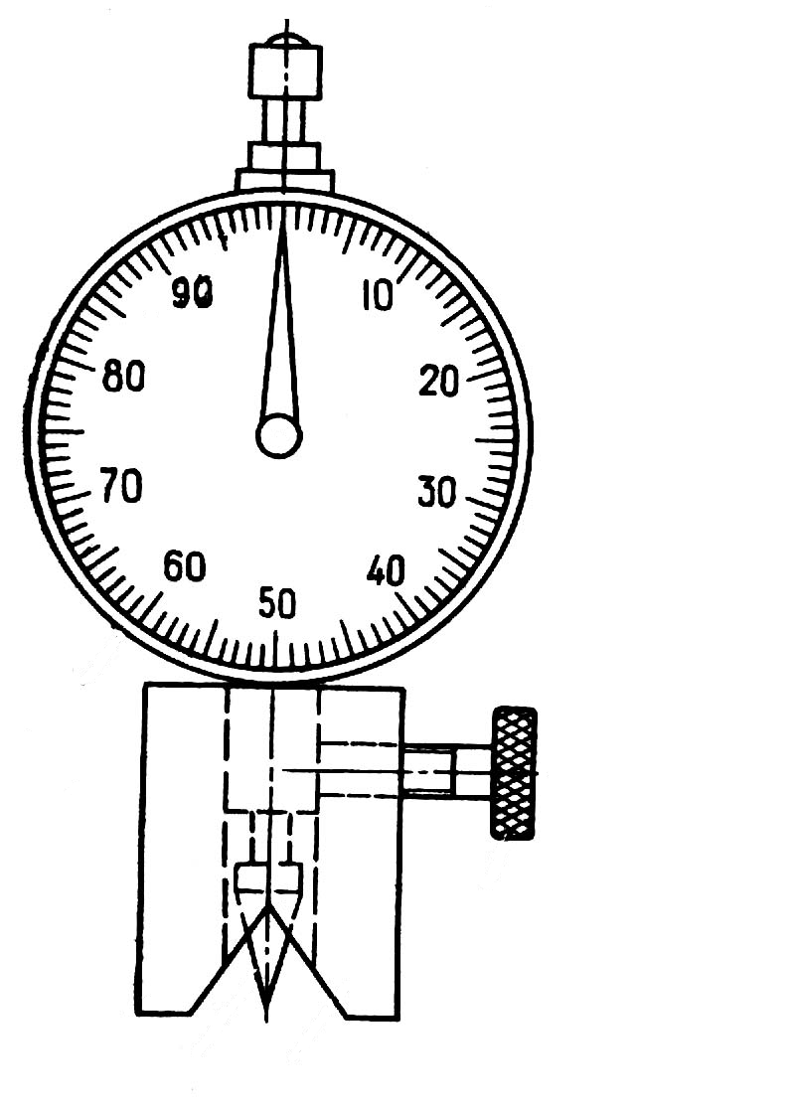
Presence of cracks, indents, nicks, scratches, PC deterioration is possible in these places. Occurrence of not glued zones is possible for cell structure elements; such zones can be discovered by tapping or by method of impedance-acoustical inspection. Scuffing zones can be founded on wing skin in places of wing high-lift devices (Fig. 1.2). A hermetic skin requires an especially careful monitoring. The scratch depth measured by spring indicator mustn’t be more than 0.1÷0.15 mm. If a scratch depth is less than tolerable limit it must be smoothed out and covered by PC; if scratch depth is more than tolerable limit and its length is less 4 mm it must be drilled and new rivet must be set; if scratch length is more than 4 mm the reinforcing plate that flush riveted must be set.
1
2
3
4
Fig. 1.2. Tool for measuring
the depth of scratches:
1 – needle; 2 – indicator;
3 – screw; 4 – base
The loose rivets reduce joint strength and hermeticity.
Signs of riveted loosening: dark zone under head of rivet; an outside bend of countersunk-head rivet edge; PC blistering and peeling around a rivet head.
Such rivets must be tightened (riveted); if it is impossible the rivet must be drilled and new rivet with greater diameter must be set.
Special attention must be given to fatigue cracks. They must be recorded in the logbook of airframe load-carrying elements and their development must be observed; and repeat cracks must be systematized for planning activities to prevent its development.
Dry snow must be removed by hair brushes and frozen snow and ice must be removed by warm water or air (60÷70 °С).

1.4. Windows maintenance

Organic, inorganic (silica-based), usually two- or three-layer (triplex) glasses can be applied for aircraft windows.
Typical failures and damages: cracks, scratches, streaks, nicks; “silvering” of organic glasses, i.e. occurrence of small cracks grid, visible under a certain corner as “silver”; lamination; air bubbles between layers; loosening of glass panel attachment in a framework.
There are tolerable limits for all kinds of malfunctions.
Typical maintenance operations: inspection for defects; elimination of loosening of attachment; replacement of defective glasses; polishing of glasses by special paste using special procedures.
Safety precautions: protect glass from blows; prevent getting solvents, POL and paints on glasses; glasses must be cleaned by soft cloth with neutral soap; cover the airplane with protective covers for protection glasses from radiation, ice and rain; ice must be deleted by warm air or water at temperature 60°C only.

1.5. Maintenance of airframe joints

Airframe joints are: fuselage joints, wing joints (center wing section, inner wing, outer wing), joints of fin and stabilizer with center wing section. They have the reinforced strip with fittings (hollows) equipped by bolted joints. These joints are covered by strips, fillets and detachable noses.
Typical damages and malfunctions: bolted joint and fitting corrosion; nuts loosening of bolted joints; pollution or leakage of lubricant; pollution and damage of threads; the “figure-of-eight” and gapping of bolt heads and nuts; cracks, dents and other damages in strips, fillets and detachable noses.
Typical maintenance operations: inspection for defects; bolts replacement; relubrication; corrosion elimination, tightening bolted joints with needed force moment by torque wrenches (Fig. 1.3.) (wrenches must be calibrated monthly by applying special device). Needed force moment must be set depending on type of bolted joint material, thread diameter, thread size and work conditions (tension and shear bolts, damage to the bolts and nuts). Tightening must be made gradually and in sequence "face-to-face" to prevent swash and overloads.
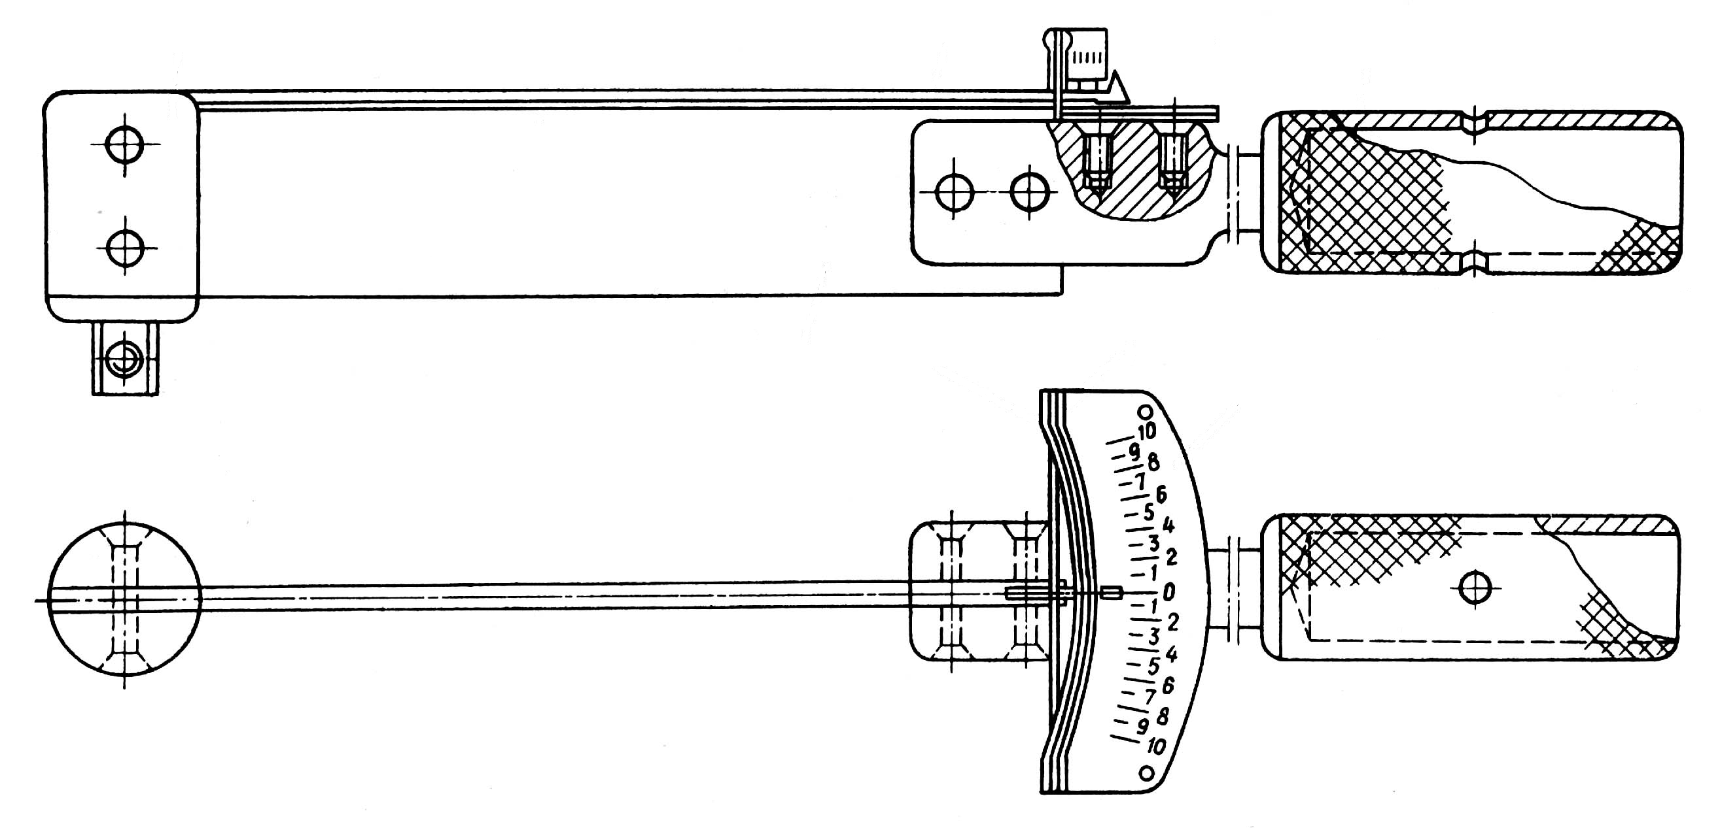
1
2
3
4
5
6
7
Fig. 1.3. Torque wrench with scale of torque pointer:
1 – head, 2 – arrow, 3 – handle, 4 – pin; 5 – rear range,
6 – front range 7 – horizontal scale

Type of locking device must correspond to technical documentation. The bolt and locking device mustn’t be reused in case of bolted joint replacement.

1.6. Features of airframe and landing gear maintenance after flight in turbulent atmosphere and rough landing

At flight in turbulent atmosphere and rough landing the greatest overloads arise in assemblies and parts connected with concentrated masses (landing gear, engines, control surfaces, ailerons, controls elements and wing high-lift devices, attachment fitting). In this connection the special maintenance must be carried out after above mentioned cases. A special attention must be given to above mentioned attachment fitting.
The followed items must be checked: presence of displacement of concentrated masses relative to the attachment fitting; check is carried out by a direct or indirect method, for example, by means of measurement of a gap size between aileron and wing tip, aileron and flaps (Fig. 1.4.); by means of cable tension check, presence of control linkage backlashes and wing high-lift devices eccentricity; by means of check of engines position (engines displacement) in attachment fittings, uplock good condition and serviceability (after the flight in turbulent atmosphere) and downlock good condition and serviceability (after rough landing).

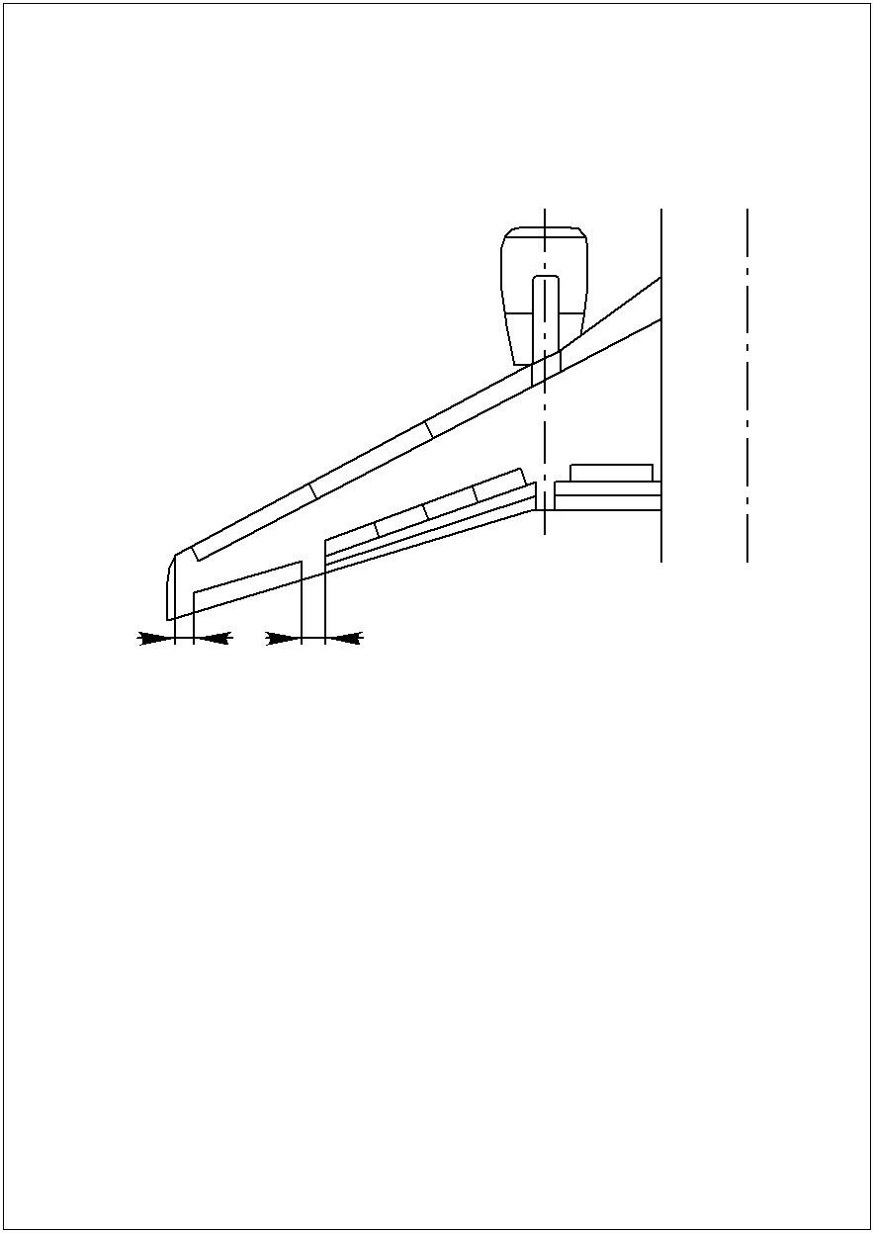
1
2
Fig. 1.4. Scheme of gaps in trailing-edge assembly

The aircraft leveling (i.e. the relative adjustment of the component parts) must be done in special cases. These cases must be recorded in flight log according to crew team reports and monitoring performances data.

1.7. Pressurized cabin leakage test

Cabins are not absolutely tight. Some air leakage (2÷6 kg/m³) is permitted; such leakage is established for ensuring pilot operating ability after rapid depressurization and possibility of aircraft descent to the safe height (not less than 5 000 m). From the engine compressors the air enters the cabin constantly. The part of the cabin air passes through the cabin leakage and the other one leaves the cabin through outlet valves for the regulation of cabin pressure change depending on flight height in accordance with predetermined law. If the leakage level is more than allowable one, such law won’t be satisfied; such situation would be dangerous. Cabin tightness deteriorates during the service as a result of wear, material ageing and fatigue phenomena.
Possible places of aircraft depressurization are: riveted joints; attachment fitting; edging of window, openings, doors, baggage compartments; pressure seals.
Therefore pressurized cabin leakage test is performed periodically, usually as part of overhaul repair, and also after large-scale repair of sealing skin and replacements of three and more windows. The purpose of test is to check actual levels of leakage and to compare the obtained data with allowable values.
There are two methods of pressurized cabin leakage test.
1. Method of leakage compensation.
Principle of method: The gage pressure (given pressure value is similar to operating value) is obtained in the cabin by means of compressor, and then the created pressure is supported by compressor.
Criterion of cabin leakage is air consumption value through the compressor. This method is applied in flight-test center of manufacturing and aircraft overhaul plants, for light aeroplanes and in military aviation.
2. Method of measurement of pressure change speed.
Principle of method: The pressure with value similar to nominal pressure value P_{k} is obtained in the cabin by means of compressor. Thereafter pressurization is stopped and the time of pressure-fall from P_{k} to preset value (0,1kg / sm² usually) is measured.
Obtained time value compares with specified value.
Procedure: the setting-up procedures for compressor and other equipments must be performed; unauthorized persons and useless equipments mustn`t be in the working zone; the cabin pressure regulator must be set up in position "Test"; devices with aneroid capsule must be switched off or removed; the aircraft must be pressurized (i.e. hatches and doors must be closed); the compressor and control devices (manometers, variometres) are connected; the necessary pressure is created and the compressor is switched off; the time of pressure-fall must be measured.
The rate of pressure change must not exceed 10 mm Hg per second (or 0,18 mm Hg per second).
Possible places of leakage: riveted joints; edging of window, openings, doors, pressure seals.
Methods of leakage detection: by aurally check (whistle); by bubbles formation; by means of placing the rubber suction cups (rubber suction cups fall off quickly at leakage); by addition of Freon gas to cabin air and detection of Freon molecules outside of aircraft by means of halogen-sensitive leak detector (method used at repair factories).
Methods of leakage elimination: tightening riveted joints; replacement of the defective rubber strips and pressure seals with new ones.

Self-study check

1. Describe the typical damages and failures of the airframe structural components.
2. Name the causes of corrosion and its negative consequences.
3. List the most likely locations of corrosion damage of internal and external surfaces of the aircraft.
4. What are signs of corrosion of various construction materials, methods of its detection and removal?
5. What constructive activities are used to protect the airframe from corrosion?
6. Name the operational measures to prevent corrosion.
7. List the possible damages of skin and places of their occurrence.
8. What are the signs of loosening rivets and ways of its elimination?
9. Name the typical damages and failures of organic glasses.
10. Name the typical damages and failures of silicate glasses.
11. Describe the typical works for windows maintenance and precautionary measures when these works are performed.
12. Describe the typical damages and failures of airframe joints.
13. Name the typical works for maintenance of airframe joints.
14. Name the features of airframe and landing gear maintenance after flight in turbulent atmosphere and rough landing.
15. What are the causes and possible places of aircraft depressurization?
16. What methods are used for pressurized cabin leakage test?
17. What is the procedure for pressurized cabin leakage test?
18. Name the methods of leakage detection and cabin leakage elimination.
2. HIGH-ALTITUDE SYSTEM MAINTENANCE

High-altitude system is intended for supporting life activity and efficiency of the crew and passengers at high altitude.
High-altitude system is composed of such sub-systems as: air-conditioning sub-system (pressurization, ventilation, heating), pressure control sub-system, oxygen sub-system (oxygen is supplied at decompression or oxygen deficiency), special kitchen equipment, equipment for heating toilets, equipment for heating auxiliary power unit (hereinafter APU), sub-system of ground conditioning.

2.1. Air-conditioning system maintenance

Air-conditioning system is composed of such parts as: pipelines, dampers, valves, non-return valves, pressure regulators, turbo-coolers, radiators, dispensers, mixers, compensators, pipe branches, outlets, silencer.
These parts are exposed by the following factors:
- High temperature. Air temperature may reach 250° ÷ 350 °С when air leaves the engine compressor, and then air temperature is reduced through radiators and coolers. At inlet to the cabin the air temperature is equal to 10 ÷ 60^{о}С.
- High excess air pressure inside equipment and pipelines. Air pressure is 7 ÷ 9 Kg/cm² when taken off from the engine; and then it goes down to 2.5 ÷ 3.5 Kg/cm² in pressure regulator with finally equaling 0.3 ÷ 0.7 Kg/cm² in the cabin (depending on high-altitude system type).
- Vibration induced by operating engines (for the equipment in engine nacelle).
- Repeated load of variable magnitude (for the equipment in the wing).
- Climatic factors: temperature, pressure, atmospheric precipitations.
- Environment conditions: dust, dirt.
- Maintenance and flight operating quality: timeliness and quality of adjustments and inspections; organization of maintenance; accuracy of high-altitude system usage during the flight.

Key maintenance operations:
- Check of the high-altitude system for serviceability on the ground. If it’s not used on the ground the check consists of electric power supply and switching valves, distributors, etc. into extreme positions (open and closed positions), with signal lamps flashing and other indicators actuating. If high-altitude system can be activated on the ground, the check consists of air taken from the engine, air supply in cabin and air temperature/air consumption control by means of appropriate units.
- Check of high-altitude system equipment status. Possible problems: mechanical damages; damages of attachment; air leakage in joints (darkening of leakage points).
- Check of pipelines status.
Prevent the following: cracks, slackening of clamp connections, corrugations; scratches; nicks; scuffings over the limit.
- Check of pipelines tightness.
Methods: by monitoring dark zones in hot air leakage points, by hand touching when high-altitude system is in operation, by pipeline sections pressure test.
Principle of the method: a blind plug is mounted on one tip of the pipeline section and a plug with a connection – on the second one, the air leaves the compressor and passes through the connection. Time of pressure-fall to given value is measured.
- Pressure test of individual joint connecting two pipelines.
Principle of the method: the same as described in previous item but the joint is placed in water bath, presence of the leakage is indicated with air bubbles formation.
- Check of air-to-air radiator (hereinafter AAR) for status and leakage.
The following must be checked: reliability of attachment, joints air-tightness and AAR body air-tightness.
Principle of the method: remove AAR, place plugs on connection, create air pressure, place AAR in water bath. Air bubbles formation indicates the presence of leakage. Air-tightness of AAR can be estimated indirectly by rising temperature of cooling output atmospheric air after mixing with cooled hot air.
- Oil level check and oil change in turbo-cooler. Oil level can be checked by means of sight gage scale. Oil must be added if its level is below graduation mark then oil must be condensated and added again.
- Installation and removal of high-altitude system equipment in cases of its failure.
Notes: spring compensators are installed in compressed state, therefore relevant safety regulations must be observed; ball compensators and non-return valves must be installed in such a way that the arrows on its bodies have the same direction as airflow; non-return valve leafs must be sagged by own weight.

2.2. Pressure control system maintenance

Typical equipment
- Pressure regulators (flight director indicators) are composed of three units: unit of absolute pressure keeping, unit of preset excess pressure keeping, unit of pressure change rate keeping.
- Outlet valves (2 ÷ 5 units, depending on cabin volume) are placed under the floor. The valves are equipped with air filters, which let air leave the cabin.
- Hoses and thin pipes (static, air and control lines).
- Electrical valve for emergency pressure relief.
Typical system malfunctions and their causes:
1. Unpressurized equipment and units.
2. Cleaning air passing ducts (nozzles, calibrated orifices) by the following materials: fibers of sound- and heat-insulating material, hairs from carpet material, dust, gum residue after smoking.
Such malfunctions will be evident in the following divergence of pressure parameters from the norm:
- air pressure reducing in cabin.
Causes: Insufficient cabin air-tightness, malfunction of pressure control system, drop of cabin pressure to zero; fast drop of pressure: cause is loss of cabin air-tightness; slow decrease of pressure: cause is malfunctions of pressure control system; increased air pressure in cabin is dangerous because of additional load on the cabin structure. It’s caused by mal-adjustment of flight director.
3. Increase or decrease in the rate of cabin pressure change (norm is 0.18 Hg mm per second). If pressure change rate is more than normal it results in painful sensations in ears. Typical diagram of dependence between altitude and pressure changes in the cabin of passenger aircraft is given in Fig. 2.1.
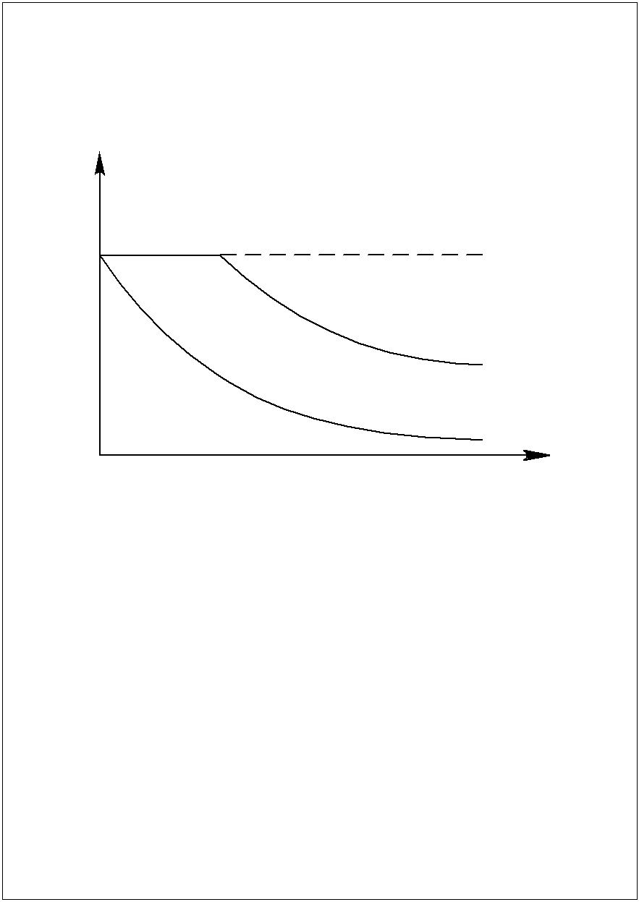
Р, МPa
Н, km
Р = const
ΔР = const
1
2
Fig. 2.1. Typical chart of dependence between
altitude and pressure changes in the cabin of passenger aircraft:
P – pressure; H – flight height; 1 – change of atmospheric pressure;
2 – pressure change in the pressurized cabin

Key maintenance operations:
1. Check of units status: mechanical damages; reliability of attachment; screw locking device integrity; joints air-tightness.
2. Check and correct setting of flight directors units scales.
3. Check of the position of three-way pressure regulator switch (during the flight it must be in position "On").
4. Check of outlet valves: proper bearing of valve dishes to valve seats; surface purity of dishes and seats, with washing them by soft cloth soaked in gasoline, if necessary; purity of air filter through which air from the cabin is fed to the valves. The check is defined by the time of dish lowering from its upper position to the seat. The normal period of this time is supposed to be from 40 to 70 seconds. If it’s more than normal value the filter is contaminated and must be cleaned; if it’s less – the dish rubber diaphragm is torn.
5. Functional check of the system with working engines or APU (along with air-conditioning system).
Principle of the method: cabin is tightened and air is fed into the cabin; correspondence of pressure regulator parameters and parameters of altitude and pressure differential indicator (hereinafter CAPDI) is checked. Deflections from the norm may arise during such check. Probable causes of cabin pressurization absence: windows, doors, hatches are open; emergency air blow-off valve is switched on; outlet valves are defective.
Probable causes of pressure difference raising: pressure regulator (flight director) is switched off; thin pipes system is untight; outlet valves are defective; absolute pressure unit of the regulator is defective.
6. Leak test and check of thin pipes passing ability.
Thin pipes system has three lines:
- static line (feeding of static absolute pressure);
- air lines (feeding of atmospheric consumable pressure);
- pilot lines (signal injection from flight director to outlet valves and feedback).
Tightness testing is carried out by means of portable units with manually operated piston pump or piston pump with electric drive.
Air injection or vacuumization of these lines is carried out through connections mounted in the aircraft. The rate of pressure change measured by means of different devices (manometers, altimeters, speed indicators) is used for tightness testing. Pipeline joints are typical places of leakage.
7. Functional check of the system by means of above mentioned testing portable units.
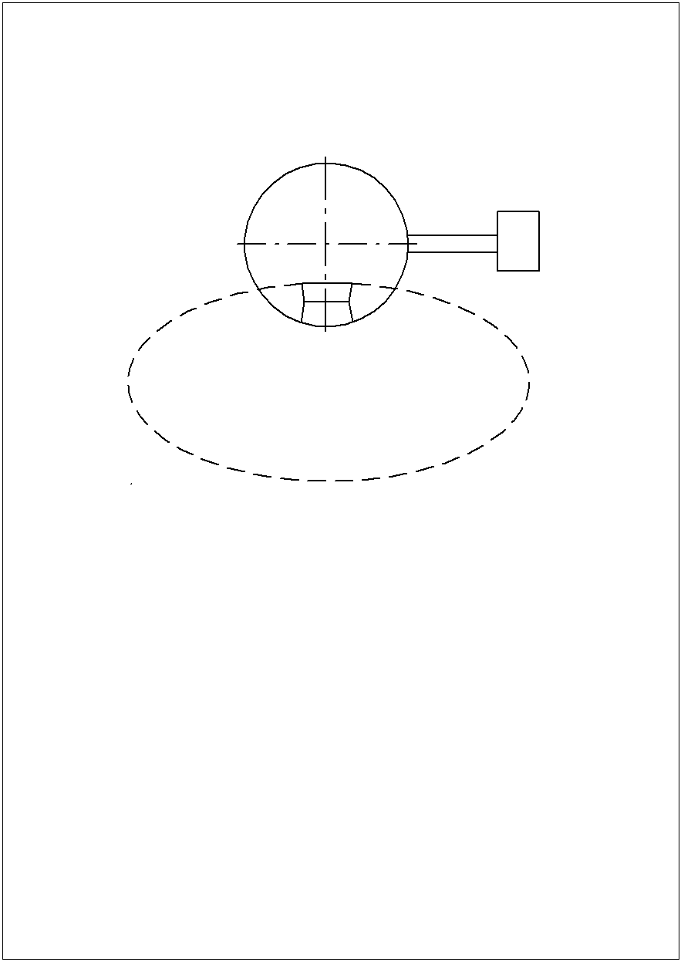
Test aim: check of system operability after changing some system units; check of deflections from the normal pressure parameters. Devices are connected to on-board connections. Height and pressure change speed are checked by means of CAPDI and variometer.
1
2
3
4
Fig. 2.2. Stand scheme of
altitude system:
1 – pressurized aircraft cabin;
2 – team instrument;
3 – the atmosphere;
4 –exhaust valve
8. Functional check of the units taken off from the aircraft by means of special high-altitude system test bench (hereinafter HASTB) (Fig. 2.2.) after specified term of unit's exploitation or in case of impossibility of necessary pressure parameters maintenance on heights. UASTB is composed of two chambers with different pressure values corresponding to different altitudes (“Cabin” chamber and “Atmosphere” chamber); the chambers are connected by means of a valve.
Flight director is connected to “Cabin” chamber. If outlet valve is tested, the flight director must be a reference-class instrument and vice versa. They created pressure differentials between chambers corresponding to different altitudes for this aircraft type. For this purpose air is fed into “Cabin” chamber by means of stationary air supply system, compressor or air cylinder and from “Atmosphere” chamber air is sucked off by vacuum pump. Exact value of pressure changes rule provided by installed units is controlled by means of test bench instruments. If the rule of pressure change is not met, the tested unit is defective and must be changed.

Self-study check

- What are the purpose and structure of the high-altitude system?

- What are the basic units of air conditioning systems (ACS) and factors affecting their technical condition?
- What are the main works done at the ACS maintenance?
- What are the ways of checking the airtightness of the ACS and air-to-air heat exchanger (AAHE) pipeline joints?
- What units are included in the standard pressure control system and what are their typical malfunctions?
- Describe the typical damages and failures of the airframe structural components.
- Describe the typical compression curve with height in the pressurized cabin of a passenger aircraft.
- List the basic works when maintaining the pressure control system.
- What is the essence of the exhaust valves check?
- How is the testing of pressure control system performed?
- Give a diagram of high-altitude system stand; describe the purpose and principle of operation.
- What is the procedure for checking the accessory failures of the pressure control system by means of the high-altitude system stand?
3. operating conditions AND PROVIDING SERVICEABILITY OF the FLIGHT CONTROL SYSTEMs

3.1. Impact of operating conditions on the technical state of flight control systems

In operation the aircraft control system is under the impact of the following groups of factors: static tension/compressive loads resulted from aerodynamic forces and efforts on the control arms; dynamic loads in flight while steering; friction efforts; vibration loads while engines work; atmospheric conditions; factors of maintenance quality and proper operation.
Cracks, corrosion, intolerable wear, indents, scratches, etc. may result from the above mentioned factors.
Control system reliability plays important role in the flight safety therefore it must be maintained properly.

3.2. Features of push-pull control linkage components maintenance

The main components of inflexible wiring: command levers, links, steering linkages, rudder servomechanisms, roller bearings, pressure seals, rudders and its attachment assemblies. Bearings are set inside all joints.
While maintaining inflexible wiring the following check is performed:
- cleanness of links, brackets and rollers (dust, dirt, moisture and oil presence lead to friction and wear increase and corrosion promoting);
- lubricant in assemblies. Used lubricant is removed by a brush and washed off by gasoline then new one is applied. Surfaces of links must be cleaned off lubricant;
- state of links, walking beams, articulated joints and roller bearings. Mechanical failures, play, rivet slackening may appear.
- screw locking device safety, correctness of hinge pins and bolts tightening;
- metallization good condition;
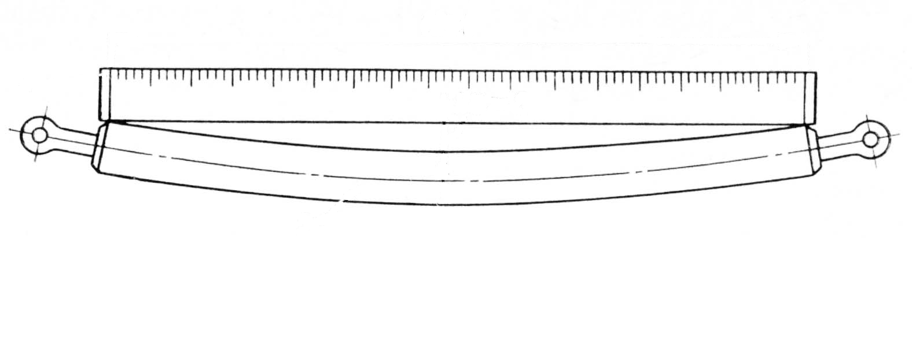
- deflection rods. If the rod deflection exceeds 2 mm over a length of 1 m, such rod must be replaced (Fig. 3.1);
1
2
not more 2 мм
1000

Fig. 3.1. The principle of the rod deflection test:
1 – ruler; 2 – rod

- links wear under rollers (tolerable limits are to 0.5 mm). If the wear exceeds the limit at the first time the link is rotated at 180^{о} at the second time it is replaced (Fig. 3.2, а);
- the gaps between roller bearings and links (standard tolerable limits are 0.1 – 0.6 mm). Gap values are measured by probes, with a link pressed to two rollers and probes inserted between the third roller and the link. If the gap value exceeds tolerable limit it can be adjusted by two methods: a roller replacement by another one with different diameter; one roller rotation around an eccentric on the axis.
While repairing or replacing the link it is necessary to ensure the absence of resonance phenomena (coincidences between the link self-oscillation frequency and forced vibration frequency).
The formula of the first tone frequency of the link oscillation:
$ν=\frac{π}{2l}\sqrt{\frac{\text{ΕΙ}}{m}}$ (Hz),
where: Е – modulus of elasticity; I – moment of inertia; EI – rigidity; m – mass; l – length.
Therefore while replacing or repairing a new link must be of the same material, diameter and wall thickness as the old one. When gaps between the link and bearings change in operation, the links length between supports changes with it i.e. the frequency of links proper oscillation. Therefore it is very important to monitor these gaps values.
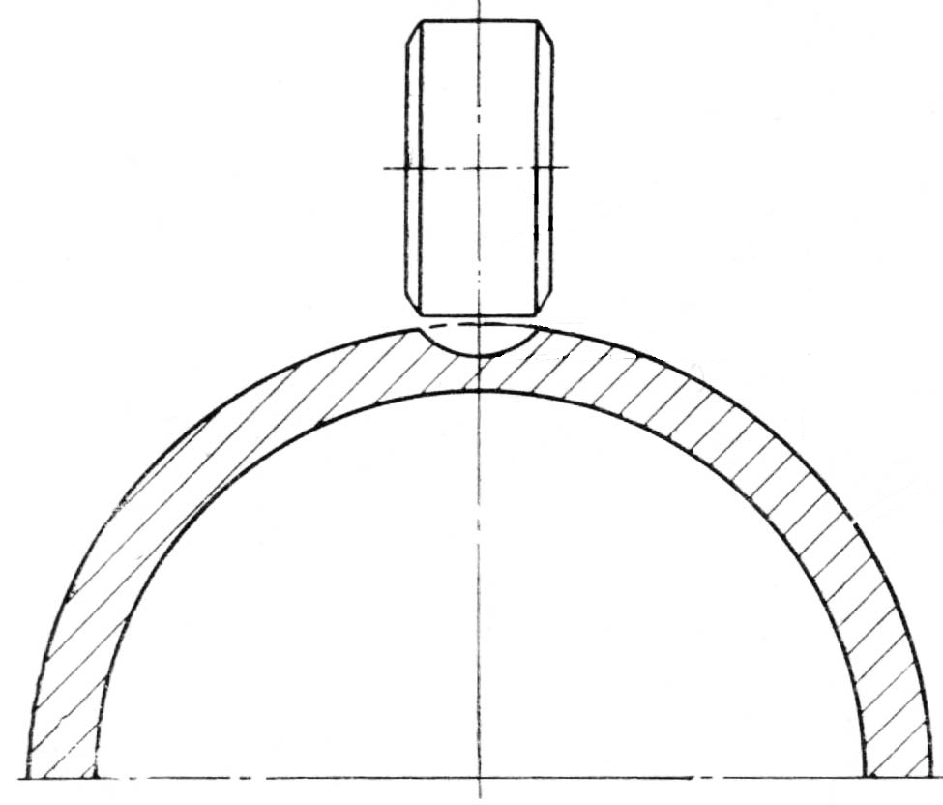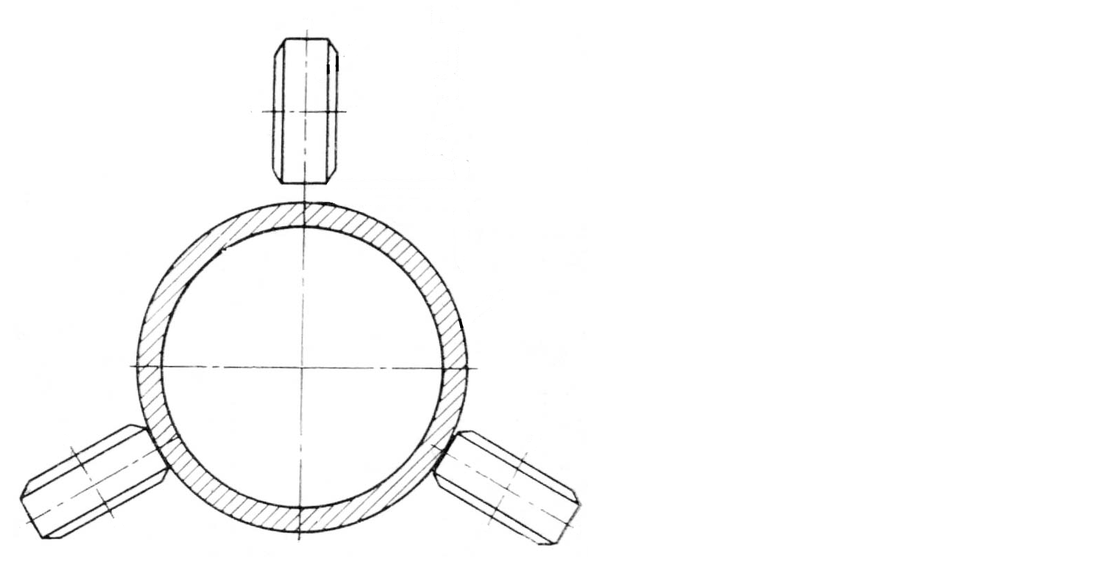
1
2
not more 0,6
Fig. 3.2. Allowable clearances:
a ‒ when rod is worn down with use, b ‒ between the roller and rod;
1 – rod; 2 – roller

а
b
not more 0,3
3.3. Features of cable control linkage maintenance. Cable tension test

Main components: cables, roller bearings with brackets and pressure seals, walking beams.
The following is checked while maintaining cable control: cable cleanness and wear.
Indications of wear: jagged cable – rupture of separate cable strings, attrition – diameter shrinking without breakage of cable strings, fragility is result of cold work hardening and is defined by separate cable strings rupture in removed cable kink. A cable must be replaced if deterioration is intolerable, corrosion – centers of corrosion attack are removed by wipe, if not – cable must be replaced. In addition the following is monitored: lubricant presence, rollers and its brackets attachment, metallization and screw locking device good condition, mechanical failures, wear indications, roller fatigue chipping (particularly its flanges), cables tension. Cable tension slackening in operation results in extension forces, abrupt and wide temperature changes, friction in the wiring.
Cable tension slackening is dangerous because: the slackness leads to impact stresses; controllability is worsening (“lagging” effect); vibrations occur.
Therefore cable tension test is regularly performed. Linear stretch coefficients have the following values: α_{steel} = 12·10⁻⁶ 1/s and
α_{dural} = 21·10⁻⁶ 1/s. Thereby, with temperature changing fuselage length alteration rate is almost two times higher than that of cable length, which means that temperature rise results in cables tension increase and vice versa (Fig. 3.3).
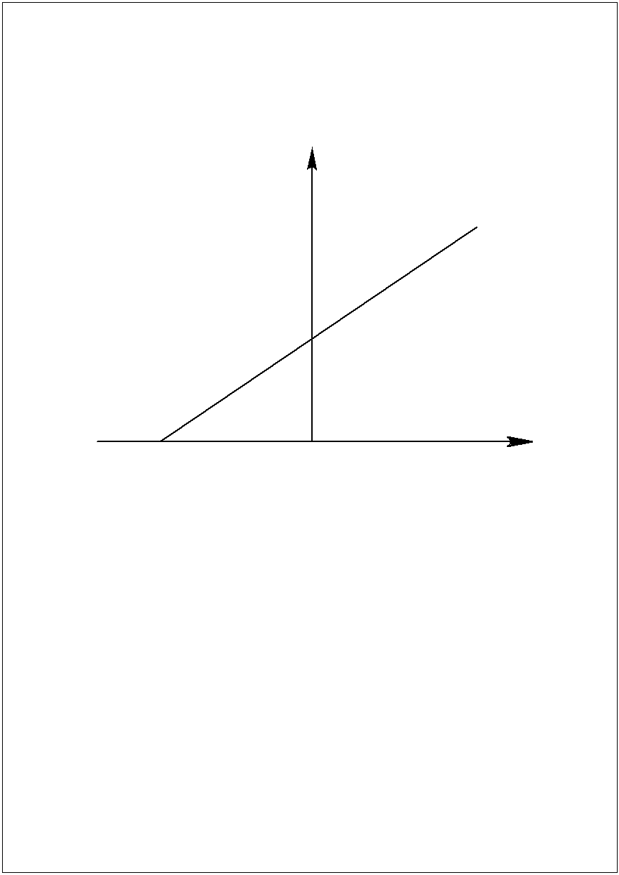
P, кг
–70…–80 ºС
Т, ºС
Fig . 3.3. Standard chart of dependence between cable tension
and temperature

Formula of cable tension calculation for the chart building:
$P=E⋅F\left(α_{\text{dural}}−α_{\text{steel}}\right)\left(t_{\text{test}}−t_{0}\right)$,
where: P – value of cable tension; t_{test} – temperature of tension testing ; t₀ – temperature when cable tension is zero.
To ensure cable tension with any operating temperatures a zero tension should be reached with temperature rate of 70 ÷ 80^{о}С. Tension charts for each cable can be found in technical documents. Cable tension is measured by gripping the cable in tensometer (Fig. 3.4). Result obtained is compared with appropriate chart value defined by given temperature. If the difference exceeds tolerable limit the cable is retorqued by turnbuckle (Fig. 3.5) assemblies (threaded sleeve with a tip).
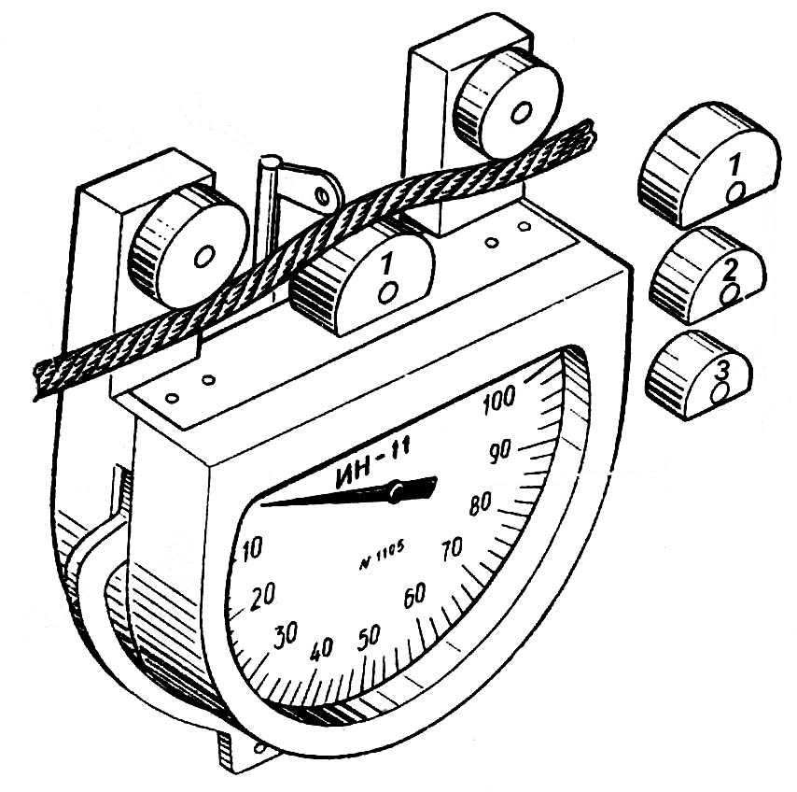
Rotating the sleeve by the rod brings together or moves away cable tips. Some aircraft types are equipped with devices for automatic cable tightening (Fig. 3.6) with temperature changing.
1
2
3
4
5
6

Fig. 3.4. Tensometer for cable tension check:
1 – arm; 2 – cable;
3 – removable detent; 4 – lock lever arrows;
5 – nonremovable detents, 6 – scale

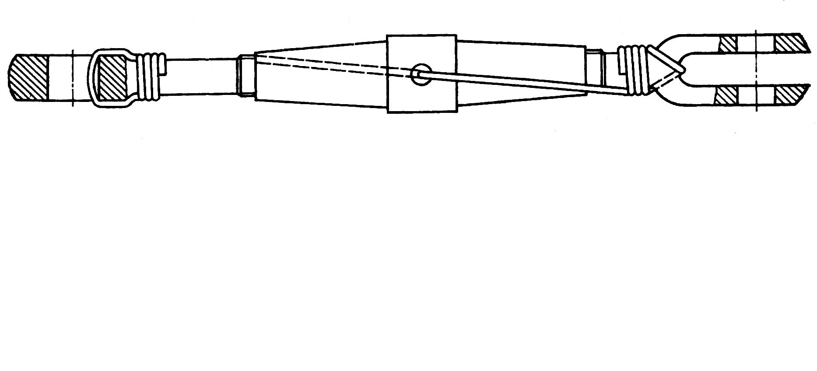
1
2
3
4

Fig. 3.5. Tander to adjust the tension of cables:
1 – tip with left-hand thread; 2 – coupling;
3 – safety wire; 4 – tip with right-hand thread
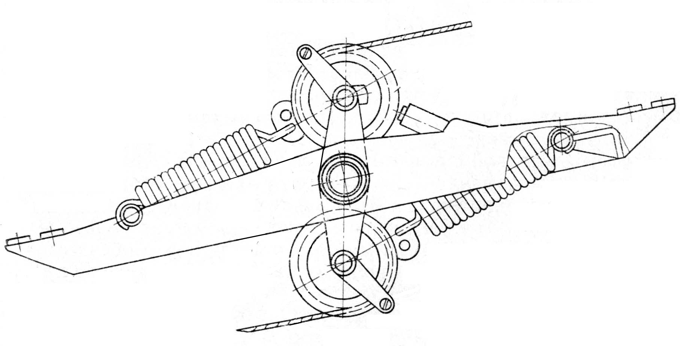
1
2
3
4
5
6
7
8
9
10

Fig. 3.6. Automatic adjustment mechanism cable tension:
1 – spring; 2, 7 – limiting torsos; 3, 8 – wire; 4, 9 – rollers;
5 – emphasis; 6 – body;
10 – rocking

3.4. Check and control procedure in flight control systems

When checking the control system working capacity, the following work is performed:
- 1. Cable tension testing and adjusting,
2. Measurement of friction efforts in the wiring (Fig. 3.7). Friction efforts are specified for both the whole wiring and separate sections. 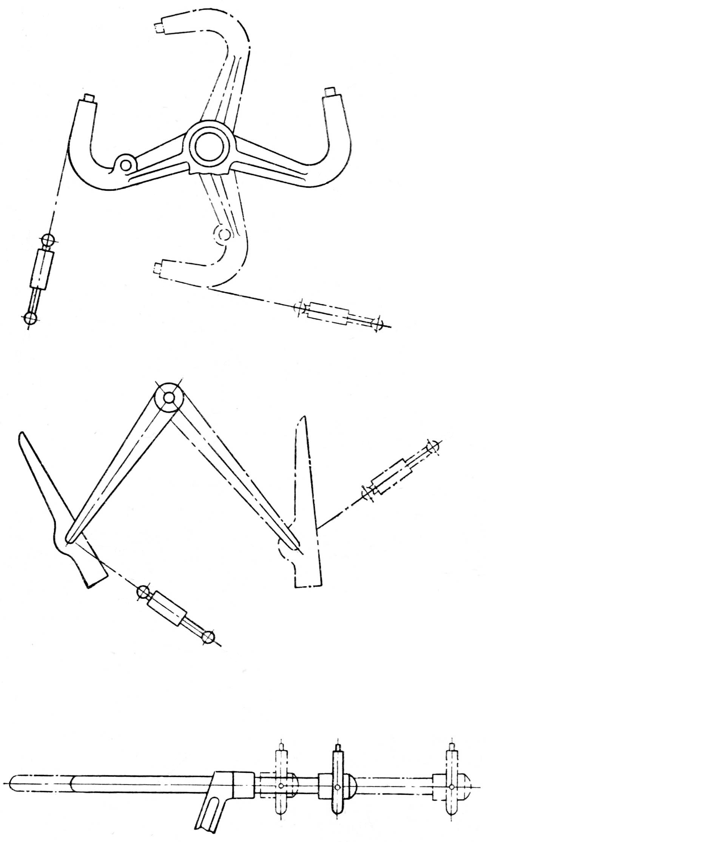 Fig. 3.7. Metering Scheme effort control wiring:
a
b
c
1
2
3
4
a – ailerons, b – rudder, c – the elevator;
1 – dynamometer; 2 – steering wheel; 3 – foot; 4 – helmsman shaft

- Excessive friction indicates possible defects: in cables – cables jumping from rollers, jaggedness, damage or destruction of roller bearings, roller skewing and jamming; in links – links deformation, walking beams jamming (e.g., as a result of bearings destruction), links jamming in the roll guides (e.g., resulted from link’s dent). Friction is measured by the dynamometric device with the spring loader turned off. If the whole wiring friction rate is in excess of tolerable limit the system is divided into sections and separate sections friction is being measured.
3. Moving ability check of control system levers. Movements of the levers must be free, smooth, without slackening and jamming.
4. Test and adjustment of rudders and ailerons deflection correctness and deflection angles value with their correspondence to blocks, control columns and pedals deflections. Neutral and extreme positions are checked. Deflection angles measured by mechanical and optical goniometers (Fig. 3.8 – 3.10).
5. Test of rudders trimming mechanisms, ailerons and flight loaders total reversal time (from one extreme position to the other).
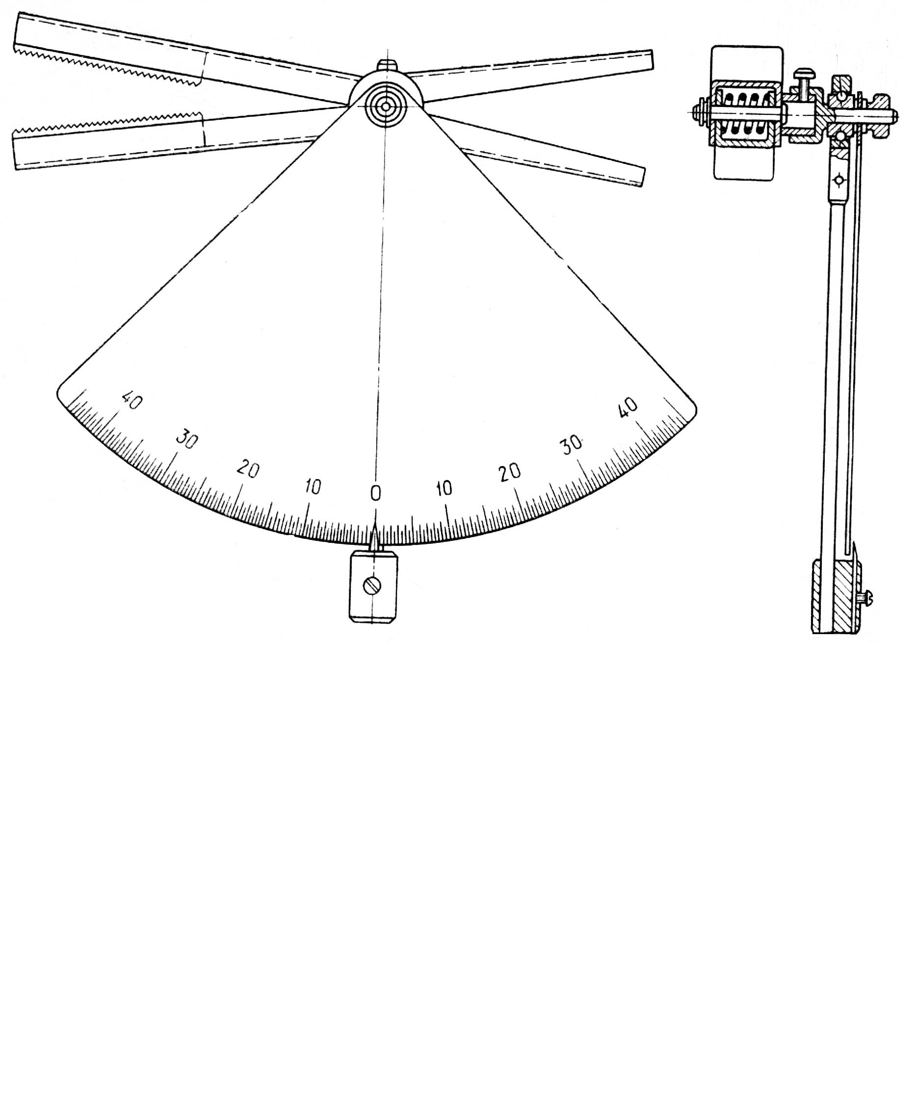
1
1
2
2
3
4
5
6
7
8
9

Fig. 3.8. Protractor to check the aileron deflection and elevator:
1 – plummet; 2 – scale; 3 – lever grip; 4 – sponges;
5 – bush; 6 – screw; 7 – ball; 8 – axis; 9 – nut

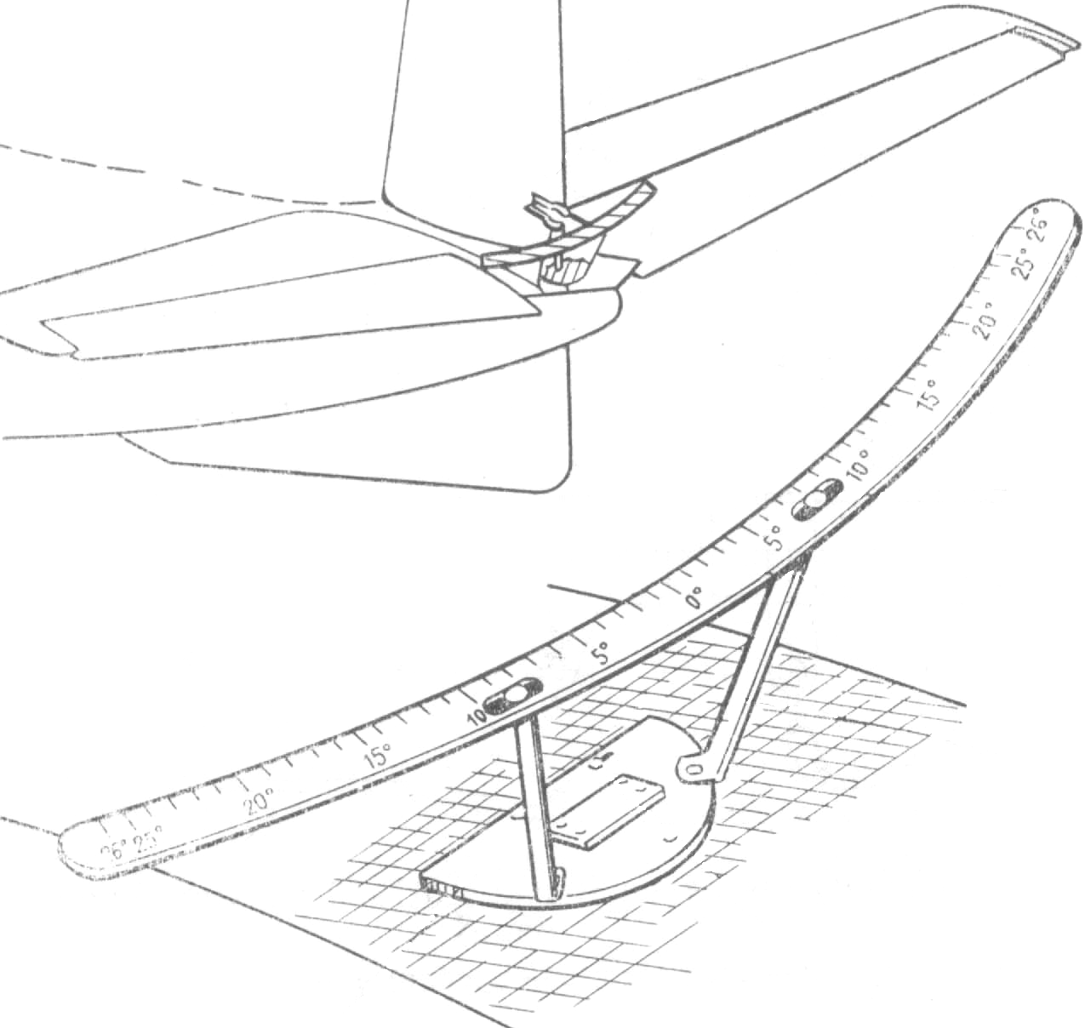
2
1
3
4
5
6
Fig. 3.9. Protractor to check deviations Rudder:
1 – holder; 2 – screw; 3 – bracket;
4 – scale; 5 – slot; 6 – arrowhead

- 6. Measurement of rudders and ailerons gaps at their neutral positions. A special device is mounted near turning rudders and ailerons, with its recording displacement values of rudders and ailerons tips when standard upward and downward efforts are applied to the device by a dynamometer. Gaps values are specified.

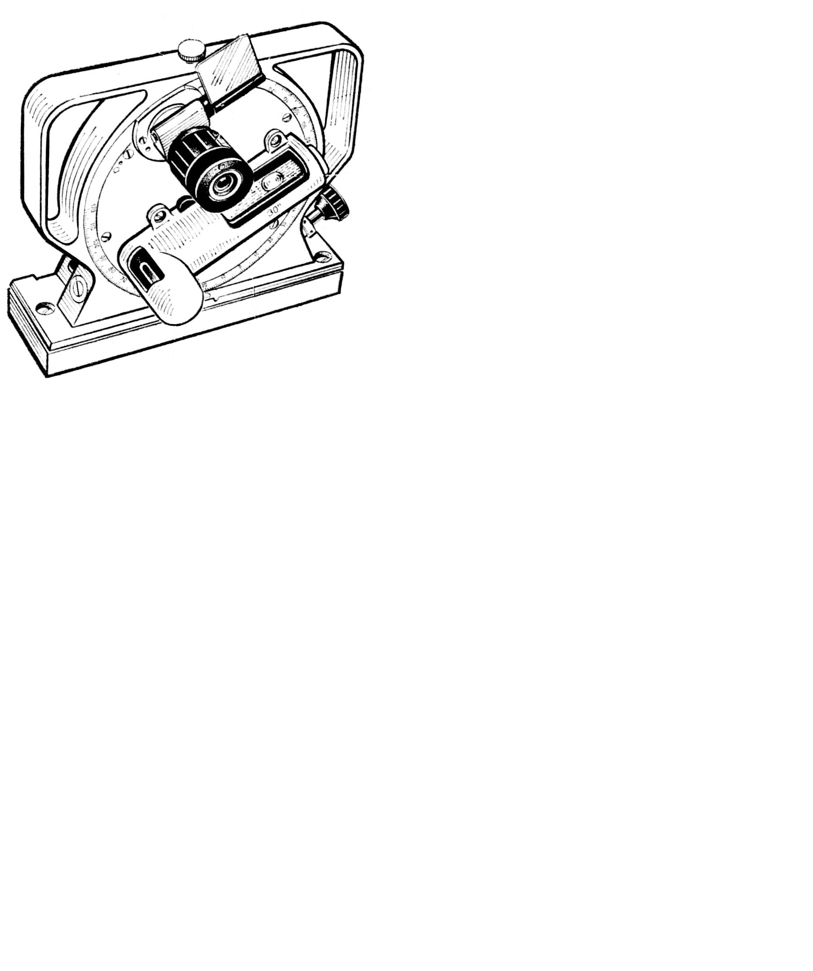
1
2
3
4
5
6
7
8
9
Fig. 3.10. Optical quadrant to check deflection of control surfaces:
1 – mirror; 2 – clamping screw; 3 – microscope; 4 – cover with a scale,
5 – level; 6 – suggestive screw; 7 – body; 8 – warping; 9 – level

3.5. Flight Maintenance of control system pressure seals

Main operations:
1. Check of friction efforts in pressure seals by a dynamometer. To perform it disconnect links and cables on pressure seals and if friction effort exceeds tolerable limit the malfunction must be found and removed.
2. Condition check of cables pressure seals cores made from rubber or coarse calico with possible wearing out, layering and attrition. In such cases the cores are replaced and filled out by lubricant.
3. Check of sliding cylinder mirror in pressure seals. Possible problems: dirt, indents, scratches. The sliding cylinders are wiped, lubricated and checked for their easy sliding.
4. Checking bodies of pressure seal attachment on the frame: bolts gripping, cracks, screw locking devices, PC status, corrosion damages.
5. Relubrication of pressure seals bodies with press-fitting until clean lubricant oozes out from gaps.
6. Condition check of pressure seal rubberized covers.

3.6. Control system parts maintenance

1. Check of command levers state (columns, control panels, pedals, levers, control columns) with possible cracks, corrosion, PC deterioration, deformations, loosening of attachment and disturbance of screw locking devices.
2. Lubricating hinged joints, bearings, cylinder shafts, reducers, drivetrain components, cardan assemblies and lift devices. Technical documentation contains lubrication charts and lists of assemblies and components for lubrication. Lubricant is faced or fed through lubricating boxes by a cylinder or supercharger until clean lubricant oozes out from gaps.
3. Condition check of rudder servos, steering linkages (boosters) and spring loaders. Check of cleanness, good condition, damages, attachment and screw locking devices reliability.
4. Check of steering linkage tightness, oil level in its reducer through oil-sight gage and oil drain/refill.
5. Check of engine control-stick grips (hereinafter ECSG) handleability, movement synchrony and stopping reliability.
6. Measuring value of locking device entry in sockets of rudders and ailerons gust-lock system.

3.7. Maintenance of high-lift devices and adjustable horizontal stabilize

Main operations
- 1. Checking state of skin, fairings, brackets, carriages, reducers, screw hoists, rails, drivetrains, electric actuators and its attachment assemblies. The following is checked: good condition, corrosion damages, cracks, dints, scuffing zones, security of attachment, screw locking devices and state.
- 2. Operation check of wing flap/leading-edge flap retraction-extension system with inspecting tail group shift in extreme positions.
Preliminary works at the testing:
- connection of power supply;
- working pressure buildup with pump station or ground pump unit;
- removing unauthorized facilities;
- establishing communication between cabin and earth.
Time, hydraulic system pressure, movement completeness and smoothness (jerks and jamming absence), movement reserve (distance to extreme stops) and alarm system state are checked while testing wing flap/leading-edge flap retraction-extension system with inspecting tail group shift in extreme position system.
- 3. Checking value of control system elements movement reserve (distance to top or bottom stop). Leading-edge flaps, wing flaps and tail groups are remained in shifted position by water brake (hydraulic clutch) which is turned off with limit switch mechanism. In failure mechanical stops are set on the way of leading-edge flaps, wing flaps and tail groups movement. Distances to the stops are specified. If real value of such distance exceeds specified one it may result in a blow; if less than specified there is a chance of stumbling on the stop before brake actuation. Therefore distance value checking is performed on a regular basis with water brake in down position being unbraked by special key. Then rudder key is inserted in steering linkage reducer and with the key turning control system element is brought up to the stop. The number of the key turns or reducer axis turning angle determines the distance value which is adjusted by the turning of limit switch mechanism tappets.
This distance can be checked by probes in some aircrafts.
- 4. Checking values of gaps between rails and truck rollers in wing flaps support assemblies by probes. Wearing changes these gap values. If gap value exceeds tolerable limits a roller is replaced with another one of different diameter or the eccentric is adjusted by the turning.
- 5. Slackening (“rolling”) check of leading-edge flaps and wing flaps in down position. Upward and downward forces are applied to specified points of trailing edges by dynamometer. Slack is identified by extreme positions of specified points on wing flap shank with special device.

Self-study check

- How do the operating conditions affect the technical condition of the control systems?
- What are the features of the maintenance of the control system hard wiring elements?
- Describe the resonance phenomena in hard wiring of the control system.
- Name the works when caring for cable wiring control system.
- What are the reasons for pull relief of cables and its consequences?
- Draw a typical graph of cable tension depending on temperature and describe it.
- What is the procedure of checking the cable tension?
- Describe the test-regulation works in control systems.
- What is the purpose and procedure for measuring the friction forces in the control wiring?
- What are possible causes of the increase of the circuit friction in rigid conduit wiring and flexible wiring?
- List the basic works when maintaining the pressure seals of the control system.
- List the basic works when maintaining other elements of the control system.
- List the basic works when maintaining wing high-lift device and fully-movable tail.
- Describe the purpose and procedure of checking the failure to reach the stops by both wing high-lift device control system and the flaps.
- What is the purpose of verifying gaps between the rails and flap bogey rollers?
- Explain the essence of the play check in the extention and retracting of flaps or slats.
4. OPERATING CONDITIONS AND MAINTENANCE OF THE LANDING GEAR

4.1. Description of operating factors influencing landing gear technical condition

The following factors influence landing gear technical status:
1. Loads and overloads in the aircraft moving, standing or landing. Its values and directions depend on the aircraft landing performance, movements property, degree of runway irregularities and ruggedness of shock absorption mechanism. When landing on an uneven runway horizontal opposite-to-flight-direction forces affect landing gear in braking and landing with un-spinned wheels. In crosswind landing and turning horizontal side forces affect landing gear.
2. Climatic conditions: moisture, snow, wind, high and low temperatures lead to corrosion, PC destruction, tires ageing, decrease of tire elasticity, tire freezing to ground and its damage.
3. Environment conditions: dust, dirt, sand, large particles, runway/taxiways/stopping places state. Dust gets into bearings, brakes, discs, hinged joints and increases friction and wearing of landing gear parts. Alien objects cause tire indents, scratches and cuts. Runway irregularities lead to landing gear twisting, repeated and variable stresses and strokes resulting in cracks on gears, shock absorbers, axles, brace struts, etc. POL, acids and bases destruct tires.
4. Maintenance and flight service performance: rough landing, hard braking, lubrication and adjustment timeliness and quality.
5. Storage conditions can affect landing gear status (boots must be used).

4.2. Tires maintenance

In addition to above mentioned factors the following affects tire state, operability and durability.
1. Absolute air pressure in the tire. If air pressure exceeds tolerable limit tire amortization properties worsen which results in tire impact loads when landing and moving on bumps. Impact loads entail tire material fatigue, wearing and rupture. The air pressure of below-tolerable limit bring about tire mashing with resulting in cracks and pneumatic tire turning around the hub which leads to inflation valve crush.
2. Pressure difference in pneumatic tires of the same carriage wheels. Tolerable limit for such pressure difference is less than 0.25 Kg/cm². If the difference exceeds this value momentum of vertical axis brings about the tendency of carriage U-turning which may lead to “shimmy” phenomenon with gear and carriage additional loads.
Typical failures and damages: 1) increased wear: the tolerable limit for control well depth is specified (the depth to the second cord layer must be considered as tolerable limit in the absence of such specification); 2) mechanical punctures and cuts: tolerable limits to the second/third cord layer are established; 3) tire material layering near the beads and their blistering, carcass break; 4) pneumatic tire turning around the wheel cylinder and inflation valve crushing; 5) tire leakage in punctures spots; 6) crumpling inflation valve pads; inflation valve leakage.
Key maintenance operations:
– inspection for likely defects (see above);
– checking tire turning by the displacement of red mark on a tire and wheel cylinder;
– testing tire charging pressure with manometer or indirectly by shrinkage. Shrinkage is the difference between horizontal and vertical diameters with taking into account the aircraft mass and outside air temperature (Fig. 4.1),
– disassembly-mounting pneumatics. When you remove a wheel made in special areas with a mechanical device. In conditions of parking with a special puller (Fig. 4.2);
– wheel and tire dismantling and mounting with their cleaning, blowing and testing are performed before autumn/winter and spring/summer navigation seasons.

4.3. Landing-gear shock absorbers maintenance

Landing-gear shock absorbers are used for absorption and dissipation of blows energy experienced by the aircraft when landing and moving on uneven surfaces.

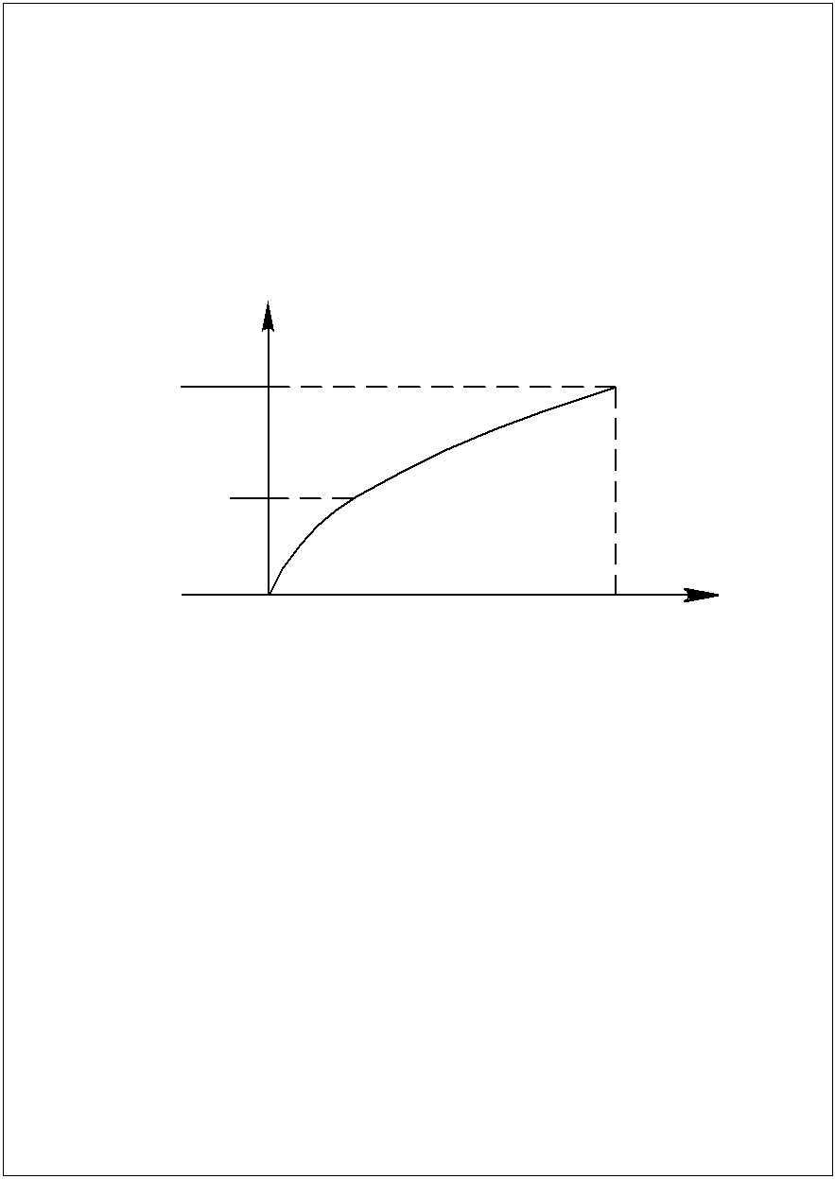  Р_{c max}  Р_{c}, Н  0  δ_{max}  δ  Δ_{st}  Fig. 4.1. Dependence of compression | 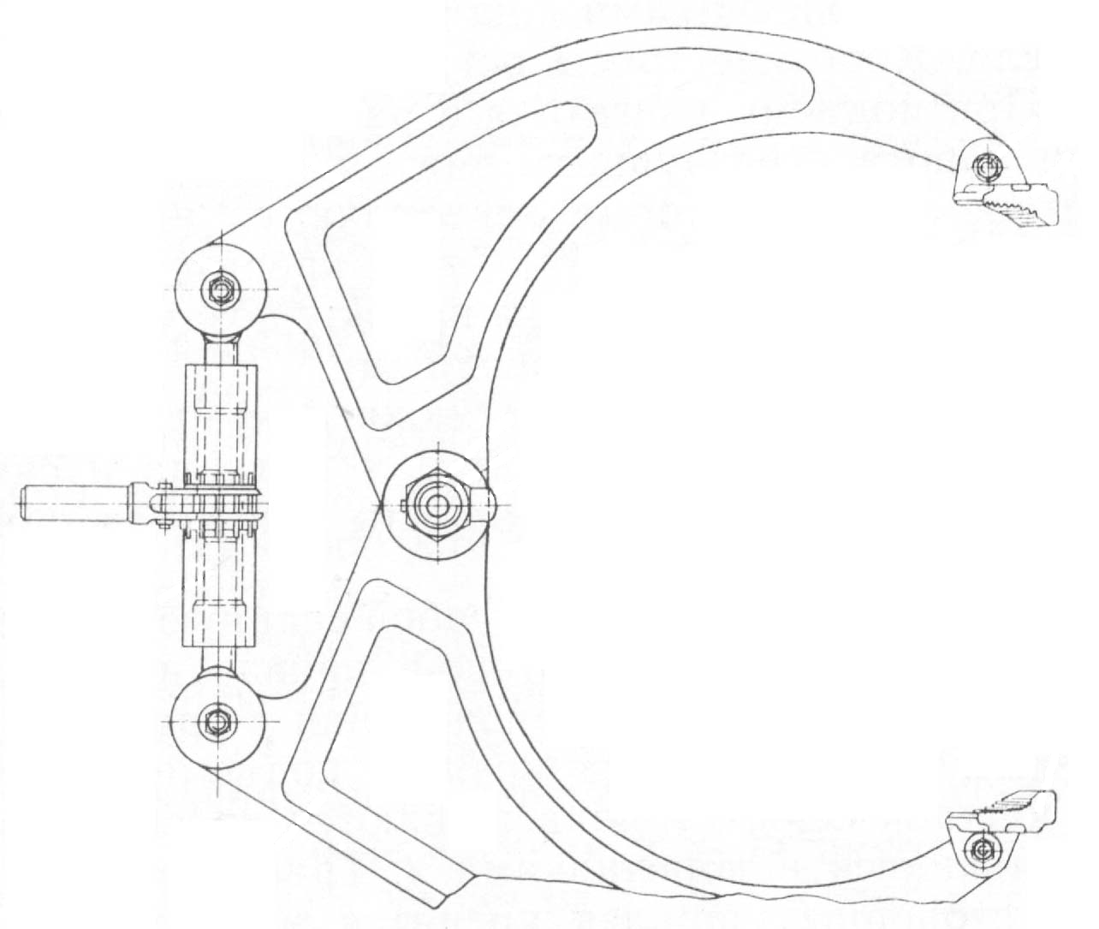  1  2  6  5  4  3
pneumatics from aircraft weight | Fig. 4.2. Tool for removing the wheel tires: 1, 3 – lever; 2 – thunder ratchet; 4 – bolt; 5, 6 – shoe;

As a rule modern aircrafts are equipped with the liquid-and-gas one- or bi- cameral shock absorbers. Their performance figures are influenced by: initial gas (nitrogen) pressure; volume, properties and purity of filling liquid.
The shock absorber must contain the necessary quantity of liquid and pressurized gas for absorption of respective energy. Insufficient gas pressure or liquid quantity brings about shock absorbers too soft response in landing which requires bigger shock strut impact travel than operational for the absorbing of kinetic energy. It can lead to hard hitting of a stopper by the rod while rough landing. If on landing there is excessive nitrogen pressure or liquid quantity the shock absorber response will be hard, i.e. shock strut impact travel will be less and the loading bigger than the operational ones. It can lead to shock absorber residual deformations, increased wear or even destruction.
Typical damages: mechanical damages because of large objects blows while moving; cracks in the places of concentrating tensions generated by shock loads; hinged joints wear; an increased wear of cylinder-piston system especially in axle-box that leads to liquid leakage from a shock absorber; nitrogen leakage through looseness and charging inlet valve with, as a result, the decrease of nitrogen pressure; corrosion.
Key maintenance operations:
1. Inspection for likely defects.
2. Checking nitrogen pressure: indirect test – by inspection of shock strut clamping state (by visible altitude of a rod mirror); direct test – by manometer with the device screwed on charging inlet (Fig. 4.3.). It is important to measure initial pressure when a shock absorber is unloaded (unclenched), i.e. when aircraft is jacked.
The aircraft mass and outer air temperature must be taken into account when performing indirect pressure measurement.
3. Shock absorber resupplying by nitrogen pressure tank when aircraft is jacked.
4. Liquid quantity check and resupplying.
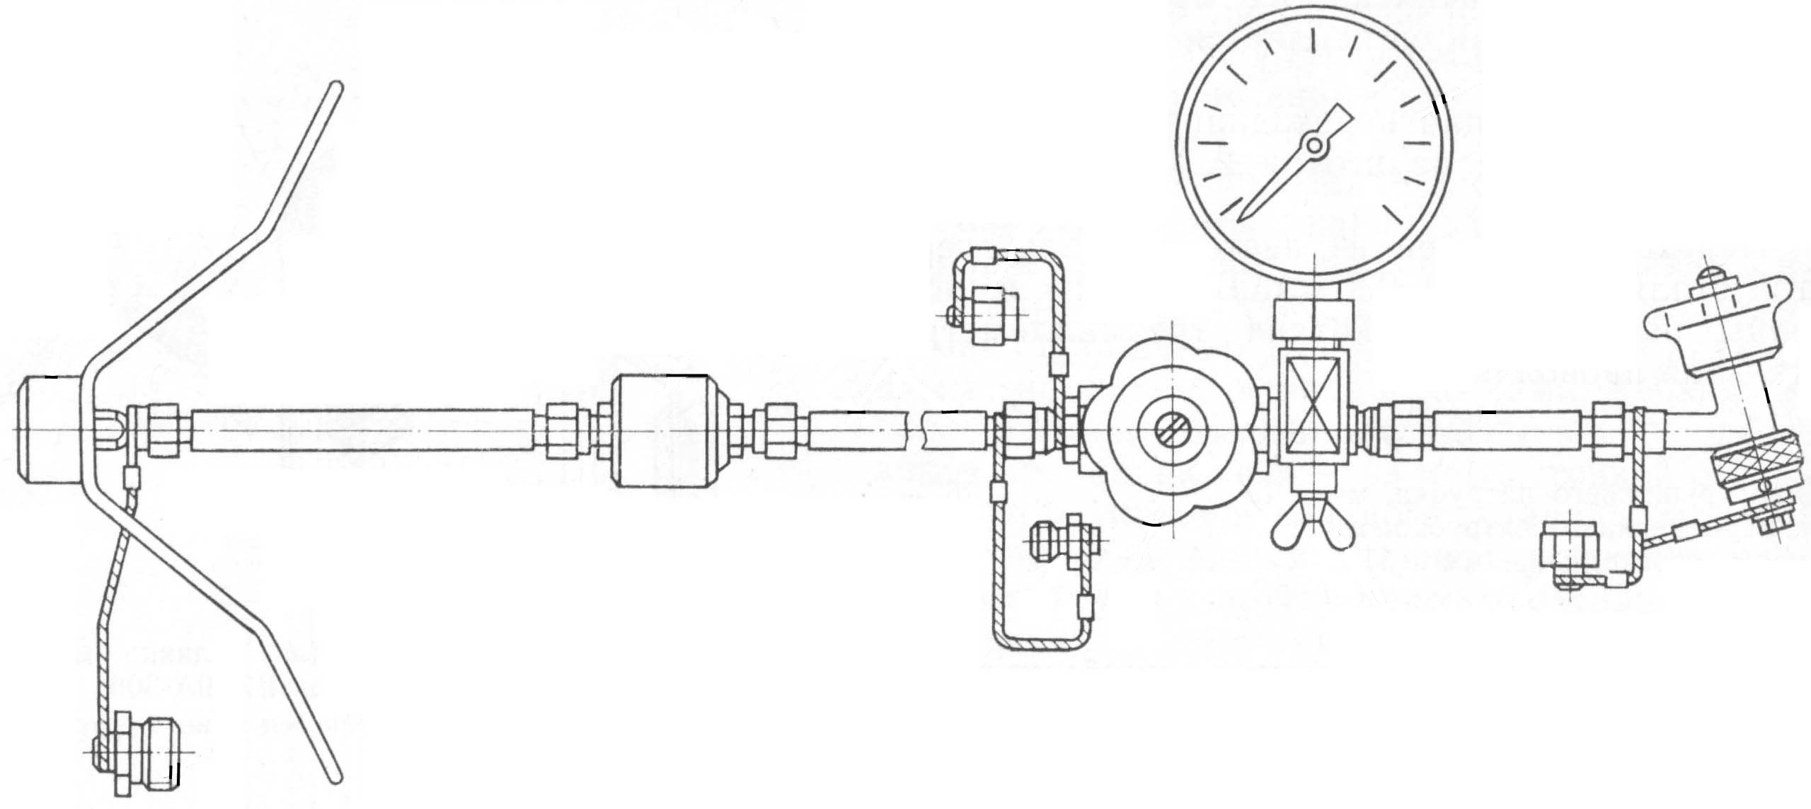
Check and resupplying procedure: 1) preparing an aircraft for the jacking; 2) jacking an aircraft; 3) discharging nitrogen pressure; 4) charging liquid through the charging inlet till its oozing through the inlet opening or the oil tube; 5) lowering an aircraft; 6) settling the liquid with its excess eventual outpouring through the inlet opening or the oil tube; 7) if liquid was not released, its additional charging is required until outpouring; 8) jacking an aircraft; 9) charging with nitrogen to necessary pressure by pressure tank.
1
2
10
9
3
4
8
5
7
12
11
6

Fig. 4.3. Device for charging shock absorber and accumulator:
1, 5, 9, 12 – cap; 2 – tip; 3 – filter; 4 – hose; 6 – gauge; 7 – a device for charging the accumulators and the landing gear shock struts; 8 – tip; 10 – valve; 11 – the stopcock

First charging bottom chamber and then upper one is a feature of resupply process for bicameral shock absorbers.

4.4. Operating conditions and maintenance of landing gear primary structure

The struts, frames and landing gear bogies are the parts of landing gear primary structure.
1. Despite its being made from high-alloy steel shock loads may bring about residual deformations and cracks particularly in the places of tensions concentration (welds, places of thickness change and so on). The cracks are intolerable, therefore such places are checked either visually by optical devices or by nondestructive methods of testing (eddy-current testing, method of magnetic crack detection, crack detection by paints).
2. There are several tens of hinged joints in landing gear composition with specific working conditions: they are exposed to comprehensive shock loads; small values of sliding velocity; move on a small angle.
In addition, they are usually un-tight in the aircrafts. These joints are lubricated with consistent grease which in long operation becomes soiled and oxidized after influence of high loads, dust, moisture and air oxygen. Therefore the grease must be changed on a regular basis. Grease is injected through lubricating boxes with high pressure (15 ÷ 20 МPа) created by oil guns with hydraulic, mechanical, electrical or pneumatic drives. Grease is fed until new pale-yellow lubricant oozes from slots instead of dirty deep-brown one. Hinged joints in modern aircrafts are tight so grease replacement is required only in capital repairs.
3. Hinged joints wear produces gaps and inadmissible slacks which cause shock loads while landing and “shimmy” phenomenon in nose-wheel unit. Therefore slacks testing and their removing must be performed on a regular basis. For checking the aircraft or a separate gear it is placed on hydraulic rams (or on lifting jacks) and loads are applied to the landing gear in certain places by the lever; these loads must be put in various directions specified in aircraft technical documentation, and the total size of slackening is identified by measurement of some specified point displacement. Slackening values are specified. Slackening is eliminated by washers, hubs and balls replacement in hinged joints.
4. Bogie damper located between shock absorber and bogie has the following functions.
  - placing the bogies in horizontal position at landing when landing gear contacting a runway;
  - providing a hard rod with ensuring the completeness of landing gear retraction-extension;
  - playing the role of a shock absorber while moving on uneven surfaces.
If nitrogen pressure in bogie damper is less than the tolerable limit, for example, as a result of leakage through sealing or charging valve these functions can be broken (for example, incomplete landing gear retraction is observed). Therefore pressure is checked and charging is carried out if necessary. Pressure check is carried out by manometer while aircraft jacking and standing with the taking into account of air temperature in the former case, and weight of the aircraft in the latter case.
Bogie damper can be resupplied by nitrogen dresser or nitrogen pressure tank.

4.5. Kinematics check of landing gear retraction/extension system

Such check is carried out in accordance with maintenance schedule while replacing certain units and adjusting. Preliminary works:
- workplace preparation (removing extraneous equipment and persons from stopping place);
- connecting power supply to the aircraft;
- creation of working pressure by vehicular pump station or ground pump unit;
- hydraulic lifts preparation;
- setting communication between cabin and earth;
- aircraft jacking;
- ground-controlled performance of landing gear retraction-extension procedure.
The following items must be followed:
a) in the cabin: retraction-extension time; nominal pressure in hydraulic system; pressure decrease degree; coincidence of landing gear retraction-extension; alarm system status; smoothness (jerks, pushes, noise and jamming absence);
b) on the ground: retraction-extension time; smoothness; completeness of landing gear retraction-extension (locking); automatic-block operation; completeness of closing leafs.
Besides, on the ground additionally landing gear and leafs serviceability is checked with special technology.

4.6. Maintenance of landing gear wheel braking devices

Brake mechanisms serve for dissipation of the moving aircraft kinetic energy while its running, taxiing and engines trial. The brake mechanisms of modern aircrafts can absorb the kinetic energy up to 20÷30 МJ; the capacity of brake mechanisms reaches 10÷16 thousands of horse power; 15000÷25000 Kcal of heat are allocated during one braking procedure; friction zone (places of disks contact) temperature reaches 1000÷1100^{о}С; volume temperature reaches 400÷600^{о}С and 700÷800^{о}С while emergency braking.
The alloyed cast iron (for unrotative disks) and ceramic metal (for rotative disks) were applied in outmoded aircrafts. The beryllium disks and carbon monocrystals disks are applied in modern aircrafts. They have a smaller weight and volume, resistant to higher temperatures; higher wear resistance, and, consequently, a higher endurance.
The following phenomena can be observed during brake mechanisms exploitation: thermal fatigue as a result of thermal cycling; structural and chemical-diffusive transformations with the material oxidation processes.
It results in the intensive disks wear and micro-cracks with the following stresses concentration and gradual turning into large cracks. Temperatures distortion causes disk material distortion, shrinkage and uneven wear.
Main damages of disk brakes: cracks on the disks (sectors); distortion of the disks (sectors); uneven wear; non-uniform engagement of the disks (sectors); frictional materials cementation; loss of brake cylinders tightness; brake release centers destruction.
It is intolerable: opened cracks (through the whole width and thickness of a disk (sector)); fatigue spalling, cracks in a disk face part; disk slits collapse; disks fatigue chipping for the area exceeding the tolerable limit.
It is tolerable: any quantity of small cracks; superficial ring guide scratchs; disks wear within the tolerable limits; disks distortion (if it is not broken when manual wheel spinup).
Key maintenance operations: total disk wear check with indicators, plates, labels; check of braking hydraulic system tightness; wheel removal and dismantling, brake disks inspection for likely defects, brake disks clearing, blowdown and mounting; check of brake disks status on the removed wheel without brake dismantling; check performance ability of parking brake feedback system and landing gear emergency braking system.

4.7. Maintenance of wheel casings, their axes and bearings. Wheel replacement rules

Causes of troubles and wheel parts destruction: maintename conditions (rough landing, landing with a pulling drift, intensive braking); material quality; drawbacks of components manufacturing techniques; MS quality (application of off-grade lubricant, infringement of wheel installation rules).
Typical failures and damages of wheel components: residual deformations and cracks of the wheel housing and wheel flange (demountable and non-removable), cracks, dints, overheat traces (oxide tint) on wheel shafts, naves, drums, bearings; bearing fatigue chipping and increased wear.
Key maintenance operations: likely defects inspection of wheel components; replacement of certain wheel components; wheel dismantling and mounting.
Wheels are mounted with two bearings and fixed on the shaft by nuts. The wheel can be tightened on a shaft excessively or insufficiently.
Excessive tightening results in bearing jamming and wheel overheating. Weak tightening leads to increased slackness and high shock loads with wheel possible damage. To avoid this tightening degree is regulated by mounting length-adjustable spacer sleeve. Its length is calculated with the formula:
$L_{\text{ss}}=L_{\text{br}}+Δl$,
where $L_{\text{br}}−$ distance between bearings races, $ΔL−$ working clearance (0.1÷0.4 mm).
If the spacer sleeve is mounted the wheel nut can be tightened by a wrench completely and the tightening will not be excessive (the wheel rotates freely) or weak (there is no slackness). The spacer sleeve is absent in some wheel systems. In such cases the wheel nut is tightened thoroughly and then turned back on 1/8 turn. The bearing cavities are lubricated by grease. Wheel changing requires the completeness (analogous components must be mounted).

4.8. Operating causes of “shimmy” phenomenon and ways of their remedies

Front landing gear fluctuations around vertical axis in aircraft rolling and running are caused by tire bending and torsion and called “shimmy” phenomenon. These fluctuations depend on aircraft velocity. Particular velocity value V_{sh} entails resonance phenomenon (coincidence of gear self-oscillation frequency and gear forced vibration frequency) with resulting in the fluctuations sharp increase which leads to gear loads accumulating and destruction of this assembly.
Structural preventive measures against ”shimmy” phenomenon:
1. Increasing rigidity by coupled wheels installation.
2. Increasing V_{sh} by wheels forwarding outside the vertical axis limits of the landing gear.
3. Installation of special hydro-dampers with functioning based on effect of liquid pushing through the calibrated orifices. These hydro-dampers simultaneously are used as front wheels rotation cylinders.
But “shimmy” phenomenon is possible in spite of above mentioned preventive measures.
The following promotes this phenomenon: loss of internal or external tightness in damper cylinders; air blocks in damper cylinders; destruction or deformation of damper cylinder shafts, pistons and components; increased slackening in damper cylinder joints; increased slackening of wheel fit on a shaft; reduced pressure in tires; wide difference between right and left wheel tire pressure; uneven tire wear; wide difference between wear degree for different wheels; runway irregularities; wrong landing and braking.
Damper cylinder defects of: dints, indents, slackening, damages of PC state; leakage (defective tightness); air blocks; destruction or deformation of piston shafts; loosening of attachment, disturbance of screw locking devices.
Key maintenance operations: inspection for defects; elimination of malfunctions; functional check of the wheel turning system when aircraft or gear is jacked with the wheel rotating from one extreme position into the other and check time, alarm system workability, turning smoothness and completeness, turning conformity with driving direction of control column and pedal.

Self-study check

- What operational factors affect the technical condition of the chassis?
- Describe the factors affecting the performance and condition of wheel tires.
- What are the maintenance works of wheel tires?
- Describe the purpose and design features of shock absorbers.
- Specify the typical malfunctions of shock absorbers.
- What are the main works done at the shock absorbers maintenance?
- What is the procedure for checking the amount of fluid in the shock absorber and its refill?
- Describe the basic operating conditions and work for the maintenance of the chassis power circuit structural elements.
- How is the maintenance of the chassis ball joints carried out?
- How is the play control of chassis assemblies and its elimination performed?
- What are the procedure for checking the kinematics of the chassis extention and retracting system and the control parameters in the cockpit and on ground?
- Describe the working conditions and the design features of braking devices of the landing gear.
- What are the main acceptable and unacceptable failures of disc brakes?
- What are the maintenance works of the tires of the disc brakes?
- Name the types of failures and malfunctions of wheel parts, their causes and the main works when maintaining.
- What are the characteristics of the wheel suspension on the axle with a spacer?
- What is the phenomenon of "shimmy” and what are the structural measures to prevent this phenomenon?
- What causes the "shimmy” phenomenon during the operation?
- What are the main works done at the hydraulic dampers maintenance?
5. Maintenance OF AIRCRAFT HYDRAULIC SYSTEM

5.1. Design and operating features of present-day aircraft hydraulic systems

Design and operating features of modern aircraft hydraulic systems are the following :
– multifunction system;
– high work pressures (up to 28 МPа (280 kilogram-force/cm²);
– big quantity of assemblies (up to 500) and big length of pipeline system (up to 2000 m);
– big mass (tо 500 Kg);
– reiterative redundancy;
– using other systems (air- and electrical power systems).
Hydraulic system plays an important role for air safety (hereinafter – AS). Therefore, in accordance with airworthiness requirements (hereinafter AR) the probability of hydraulic system fault should be about 10⁻⁷ … 10⁻⁸. At the same time, according to statistical data, hydraulic system faults cause about 20 ÷ 30 % of total number of aircraft systems faults. And it means that careful maintenance and care of aircraft hydraulic system are required.

5.2. Factors effecting operational status and serviceability
of hydraulic system

1. System components loading, i.e. time variation characteristics of pressure, consumption, stress and temperature.
Intricate spectrum of loads influencing hydraulic system components is divided into three groups: static loads – internal constant liquid pressure; repeated static loads – induced by pressure change while actuating unit consumers and pressure control unit, engine behavior changing, etc. which leads to hydraulic shocks; dynamic loads – induced by liquid pulsation, engine vibration etc. Their frequencies and amplitudes are widely ranged. Resonance phenomena are very dangerous.
2. Design features of the system and its components: choice of pumps types, influencing air-tightness with gaps and wear with their depending on sealings design and material, state of shafts surfaces, etc.
3. Properties of a working body and their changes when working (compressibility, temperature expansion, viscosity, chemical stability).
Mineral oil АМG-10 (aviation hydraulic oil with viscosity ν = 10 cSt at t = +50 ^{о}С) is applied with operating temperature ranging from
60 ^{о}С to +60 ^{о}C. Ingredients: petroleum product (92,8 %), organic thickener (7,2 %), antioxidant (0,05 %), dye (0,01 %). Color is red. Fire-hazardous liquid.
Influence of АМG-10 properties on aircraft hydraulic system operability:
- compressibility is only 0,006 % per 1 kg/cm², but mineral oils usually contain up to 6 % of insoluble air and 18 % of steam-and-gas inclusions which sharply increases compressibility, worsens operating speed and leads to shock loads;
- Expansibility. 0.0006 % per 1 ^{о}С value of АМG-10 volume coefficient is small, but in closed spaces oil volumetric expansion can lead to destruction of system components.
- АМG-10 working consistency is specified, but in operation and due to pollution, oxidation, high pressure influence, throttling its viscosity falls to 50 % which brings about increased wear of hydraulic system components.
- Chemical stability and cleanness deteriorates in time which leads to decrease of lubricating properties, wear increase, increase of breakaway force.
In modern aircraft the non-flammable NGG-4 liquid is applied. This is synthetic hydraulic liquid. Base: phosphoric acid esters. Additives: antioxidant, anti-viscous additive, dye. Operating temperatures range from -50 ^{о}С to +250 ^{о}С. Color: blue-violet. Fireproof, toxic liquid requiring special safety precautions
4. Climatic and environment conditions: outside temperature, atmospheric pressure, humidity, dust. These factors promote the corrosion, liquid viscosity changing, gaps increase that leads to increased friction and wear of system components with sealing material elasticity deterioration.
Hydraulic system aggregates operate within temperature values ranging from -70 ^{о}С tо +100 ^{о}С with its possible increasing to +150 ^{о}С in pumps areas, and up to +500 ^{о}С on valve leading edges. Such temperatures entail components thermal deformations which results in gaps changing and plungers jamming. In addition, increased corrosion and cavitation appear. Viscosity decreases with temperature rising which leads to more leakage through sealings and to fall of pump efficiency. Temperature drop result in viscosity increase which leads to hydraulic resistance climbing and to fall of pump efficiency.
5. Maintenance and flight quality.
The adjustments must be carried out, with their quality and timeliness influencing operability of aircraft hydraulic system. Air in system is negative factor which decreases pump efficiency, causes cavitations and leads to flow break. Therefore the system must be protected against air penetration when performing MS. Mounting and dismantling quality plays an important role for system exploitation safety. Possible negative allowances, misalignments, ellipticities and scuffing zones reduce pipeline endurance. Engine behavior influents hydraulic system state since values of vibrational load are determined by engine behavior.

5.3. Typical work performed during hydraulic system maintenance

The system pressure and pressure in hydraulic tanks air pressurization system should be bled without fail before performing any kind of works with hydraulic system aggregates. Pressure releasing for hydraulic system is performed by gradual stop of unit-consumers; releasing pressure for pressurization system is performed by compression-release valve.
1. Checking liquid cleanness.
This test is performed in accordance with maintenance schedule and in the case of supposed liquid pollution. To perform this pressure in hydraulic and pressurization systems it should be released then pour off 1 ÷ 1.5 l of oil from tanks or hydraulic panels through oil takeoff cranes in container and take from the container 100 ÷ 150 cm³ of oil in a flask and send the sample to POL testing laboratory but with its first visual check for presence of metal shaving.
Methods of cleanness test performance in POL testing laboratory: Granulometric method – specified quantity and sizes of particles are determined in oil drop with microscope; gravimetric method – sample is burned with the ash less than 0.008 %; colorimetric method – by color and coloring power changing relative to reference material.
Also viscosity is determined (not less than 7.9 cSt). If oil falls short of specification requirements then the system must be refueled by the new oil and the analysis of oil must be carried out again.
2. Sediment discharge from air traps of hydraulic tanks air pressurization system and liquid discharge from drainage tanks. Liquid quantity must be within normal limits. If exceeding the reason is in redundant filling of hydraulic oil reservoir, excessive oil heating and oil foaming.
3. Checking filter pollution, filter washing and filter tightness.
POL products are polluted by the following materials: alien products getting in oil on filling stations and while mounting and dismantling, check and adjusting (dirt, dust, sand, water, metal particles); products of rubbing parts destruction and products of internal surfaces corrosion; products of POL oxidation and ageing (coke, slag, resin, naphthenes and asphaltenes agglomerates).
Such materials are filtered by coarse mesh filters and micron filters.
Coarse mesh filters. Pore size: 15 ÷ 40 μm. Filtering elements are made from ceramic metal, plastics and cloth. Filters are purified manually by soft brush with solvent.
Micron filters. Pore size: 5 ÷ 15 μm. Such filters generally capture materials of the third group which adhere to surface and their removing is difficult. These filters are made from twill weaved nickel wire. Micron filters are washed by ultrasonic devices (hereinafter USD) consisting of supersonic frequency current generator (20 ÷ 40 KHz). Current is impressed on coil block with inboard rod fabricated from special-property alloy (permalloy). This rod is resized (vibrates) by alteration of electromagnetic field direction. To the rod top a plate is welded. This plate through sealing is built into the bottom of a bath filled with cleansing solution (soap solution, АМG-10, special-property cleansing solution, etc.). Liquid column vibration under the plate brings about cavitation bubbles whose collapse leads to the increase of temperature and pressure which remove adhered particles. Filter washing is performed in two baths (preliminary and finishing ones). Filter rotation improves washing quality. Before and after washing filter cleanness is checked by filter cleanness testing device (hereinafter FCTD) (Fig. 5.1.).

Filters contamination level is evaluated:
– in accordance with filter differential pressure without filter dismantling. The red alarm signal is on if filter differential pressure has critical value.
– after filter dismantling by FCTD.
FCT device is a flange with welded tube and the rod inside. One top of the rod is equipped with a float and the other colored in red.
FCTD flange is connected to filter flange with a blind plug mounted on the other side of the filter. The construction is plunged into the bath with АМG-10 measuring total filling time of filter internal chamber. The end of filling process is identified by the float surfacing (red top of the rod is seen). Longer period defines bigger pollution of filters. To prevent surface tension from influencing duration of filling time the filter first is dipped in АМG-10. With clean filter filling time is ranging from 2 to 5 seconds. Filter contamination depends on its operating time. Also its net is tested and then dried.
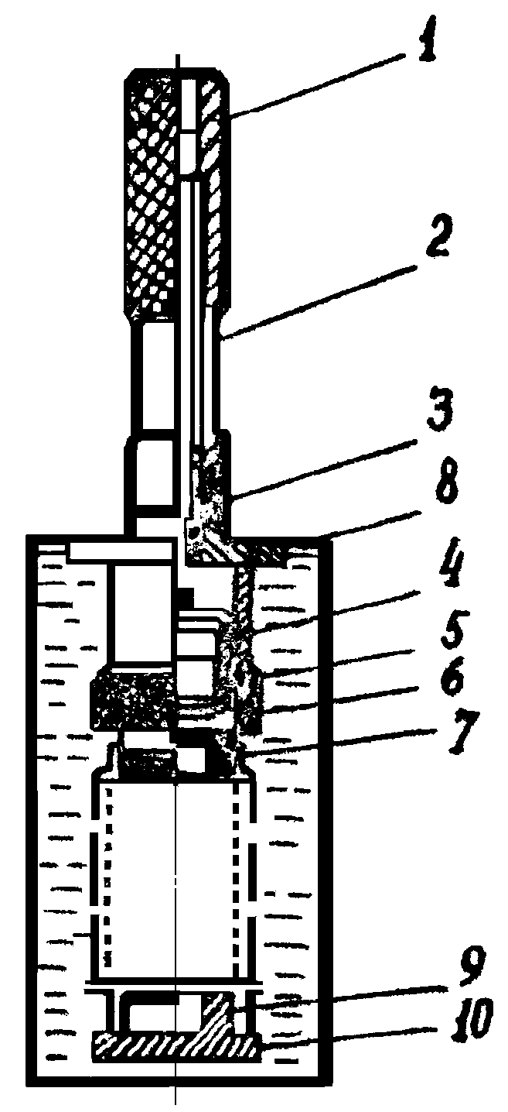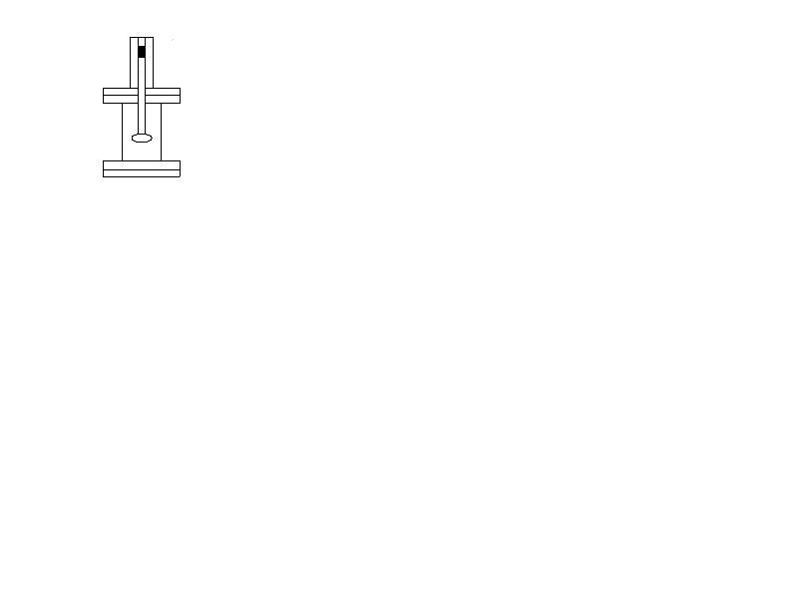
6
7
8
15
9
10
11
12
13
14
а
б
1
2
3
4
5
Fig. 5.1. Check the purity of the filter device:
a – scheme of the device; b – FCTD; 1 – tube; 2 – pin; 3 – flange;
4 – float; 5 – filter; 6 – alarm button 7 – pen, 8, 12, 10 – seals,
9 – float; 10 – body; 11 – adapter; 14 – blind; 15 – flange

4. Hydraulic tank filling with oil.
It is performed if liquid resource is worked off, when filter contamination is intolerable and metal shaving is found in oil. The system pressure and pressure in hydraulic tanks air pressurization system should be bled.
Oil is poured out from all tanks through output cranes and tanks are filled with oil (see oil servicing). It is important to avoid an air penetration into the filling system since air blocks lead to flow break and, as a result, to jerking and pulsing during pump action, to decrease of pump performance and to increased wear of brake system bearings. Therefore special corks for air bleeding-off and cranes for discharge of sediment are opened with unit-consumers working until air-bubbles and foam eliminated from the flow. Leak test for filters and pipelines under pressure is performed after the filling.
5. Checking tightness of hydraulic tanks air pressurization system and serviceability of its safety and pressure-limiting valves.
6. Checking serviceability and tightness of command units.
7. Checking serviceability and operability of hydraulic system unit-consumers. It is carried out in accordance with maintenance schedule while replacing certain units and adjusting.
Preliminary works: removing unauthorized persons and facilities from working zone, preparing working place for the work, creating airborne voltage and pressure in hydraulic system, establishing communication between cabin and earth; actuating unit-consumers according to the commands with monitoring:
a) in the cabin: actuation time; initial pressure in hydraulic system; pressure drop degree; coincidence of actuation; alarm system operability; operating smoothness (without pushes and jamming);
b) on the ground: operating time and velocity; operating smoothness; movement reserve and completeness; external tightness.

5.4. Pipelines maintenance

Factors influencing technical state and operability of pipelines:
1. Possible loads: static loads induced by high constant liquid pressure; vibration loads induced by pressure pulsing from pumps action and engine vibrating; overloads from hydraulic shocks (overpressure) when cranes and unit-consumers turning on/off, pressure control units actuating; liquid overheating from liquid pulsing and hydraulic stresses.
2. Climatic and environment factors: temperature, pressure, atmospheric moisture.
3. Maintenance and flight conditions: choice of engine behaviors and regimes of flight; timeliness and correctness of adjustments; air blocks; installation quality (warps, interferences, ellipticities, misalignments).
Typical failures and damages:
1. Mechanical damages:
- cracks (longitudinal cracks in bending points, cross cracks in beading points and nipple sockets) are intolerable;
- scuffing zones and caulking;
- defective of PC state and deformations (indents, ellipticities, dints, nicks) with corresponding tolerable limits for it.
2. Corrosion with tolerable limits.
3. Pipelines and flanging loosening of attachment.
4. Damages of metallization.
Key maintenance operations:
1. External tightness testing is performed visually when system is pressurized. Moderate tightening of joints nuts is performed in defective tightness.
2. Testing installation, beading and nipple lapping quality.
3. Inspection for likely defects (see above).
4. Pipelines replacement with cracks, leakage appearing and failures tolerable limits overriding. Warps, interferences, ellipticities, misalignments and disregard to curvature radius values are intolerable. Places of contacts should be wrapped with leather or dermatin.
Tolerable limits for gaps: between packaged pipelines: more than 2 mm; between pipelines and frame members: more than 5 mm; between pipelines and actuated parts: more than 10 mm.

5.5. Check methods of the complete system
and its units separately for internal leakage

Internal leakage is defined as liquid flow in units from cavities with high pressure into the cavities with smaller (or zero) one because of faulty sealings.
Test methods:
1. Working pressure is created in the system by vehicular pump station or ground pump unit. Then pressurizing is stopped and time of pressure falls from the nominal to preset value, or vice versa, that is pressure decrease during the preset time (usually one hour) is noted down. If it takes less time than specified a system section with faulty tightness should be first found with following unit(s) identifying. For the searching one of the followed troubleshooting methods for complex systems can be used: method of successive elimination; method of half segmentation (“central point” method); method of minimal effort; method of maximum probability; method of “effort-probability” ratio.
2. The internal leakage in systems with pressure control units can be identified by measuring deviation of this unit actuation frequency from normal value if it is not influenced by any other reason.
3. Leakage of separate units can be checked in laboratory after their dismantling.
4. One of the unit tightness test methods: the return pipeline is disconnected from zero pressure cavity with measuring container placed under the inlet. Degree of leakage is estimated by the quantity of dripped liquid.
5. Leak detectors of various types (ultrasonic, thermo-anemometric) can be used for the testing of separate unit leakage.

5.6. Checking hydraulic accumulator and pressure
snubber nitric cavity for initial nitrogen pressure

Initial pressure is defined as the pressure of discharged hydraulic accumulator when liquid pressure equals zero.
The leakage can be found in charging inlet valve, welds, joints and on the lid.
Four testing methods for the initial pressure checking:
1. With manometer on charging inlet valve of hydraulic accumulator nitrogen cavity.
2. With integral stationary manometer.
3. By indirect method: system is pressurized with its subsequent releasing. Pressure first goes down slowly and then drops sharply to zero. Its value in transition point is the required one.
4. By pump unit actuating for a short period. The pressure first boosts sharply from zero to the required value and then increases slowly.
Checking tightness of hydraulic accumulator/pulsation damper nitrogen cavity is performed when standing an aircraft during a long time or after dismantling of hydraulic accumulator/pulsation damper. Difference between initial pressure and the one after 3 days standing is measured. This difference value is specified.
Possible places of leakage: charging inlet valve; charging inlet welds, welds of housing components.

5.7. Maintenance features of hydraulic system power
portions equipped with pumps of various constructions

Pump output: N=KPQ, where: K – pump factor; P – pressure; Q – pump performance.
There are following types of pumps. 1. Fixed-displacement pumps (Q = const); 2. Variable-displacement pumps (P = const); 3. Self-powered pumps (P = const or Q = const).

5.7.1. Maintenance features of hydraulic system power portions equipped with fixed-delivery pumps

As a rule these are gear pumps characterized by simple design and operating reliability with pressure control unit (PCU) also including in pump system (Fig. 5.2., 5.3). The system operates as follows – with working unit-consumers the PCU permanently feeds liquid from tank into the system. With inactive unit-consumers first hydraulic system is filled with nominal pressure and then PCU switches the liquid delivery from the pump into the tank (blank cycle). In spite of unit-consumers inactive status system pressure falls resulting from internal leakage. With pressure reaching its preset value Р_{min} (usually 170 Kg/сm²) PCU switches the liquid delivery from the pump into the system (working cycle). This procedure is cycling until unit-consumers actuation.
Features of such system maintenance are the following.
hydraulic accumulator
–Р_{max} , Р_{min} check with manometer;
–PCU actuation frequency (time) check;
– finding failures in excessive PCU actuation frequency which is specified in technical conditions.
Isolating causes of increased PCU actuation frequency.
Possible causes: external leakage; reduced nitrogen pressure in the hydraulic accumulator; PCU failure or disarrangement; reduced liquid viscosity; internal leakage.

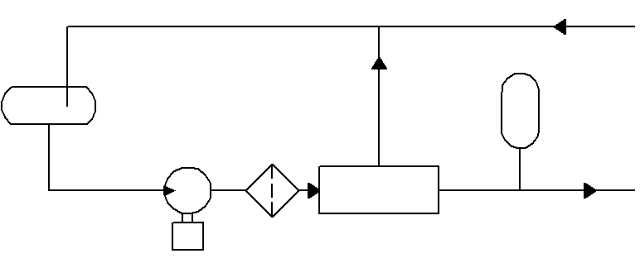
1
2
3
4
5
from system
to system
Fig. 5.2. Scheme of hydraulic system equipped with fixed-displacement pumps
гидроаккумулятор
1 – tank; 2 – pump; 3 – filter; 4 – pressure control unit; 5 – hydraulic accumulator

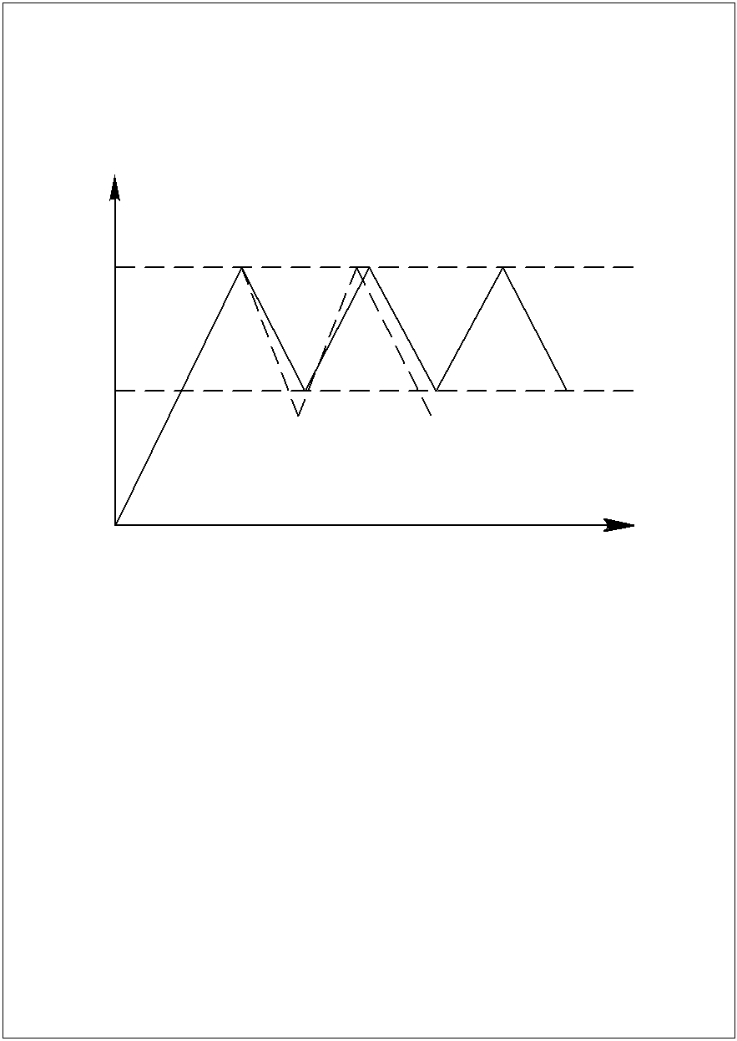
Р, MPa
Р_{max}
Р_{min}
t, h
τ_{nonfault}
τ_{fault}
Fig. 5.3. Flow chart of the pump with PCU:
τ_{nonfault} – PCU actuation frequency without the failure;
τ_{fault} – PCU actuation frequency with the failure.

Often one cause results in another. For example, internal leakage leads to the liquid temperature increase and its viscosity decrease which in turn boosts the internal leakage. The reason of PCU frequent actuation can be found by one of the above mentioned methods (for example, by “effort-probability” ratio). Though external leakage is uncommon they can easily be identified visually so they are first in the list. Internal leakage is the most frequent cause but finding them is very effortful so it closes the list.
Influencing serviceability and operability of hydraulic system by increased PCU actuation frequency.
1. Hydraulic shocks (overpressure) appear and cause substantial mechanical loads which can lead to destruction of filters, pumps and pipelines.
2. With very frequent actuation the pressure becomes pulsing which causes fatigue loads promoting pipelines damage and units wearing.
3. The liquid is heated up that increases internal leakage and decreases pump delivery.

5.7.2. Maintenance features of hydraulic system
components equipped with variable-delivery pumps

As a rule, such systems employs swash plate type plunger (Fig. 5.4) pumps with the swash plate being used for the regulation of pump delivery. With active unit-consumers the pump delivery is maximal. With inactive unit-consumers the pump delivery still doesn’t equal zero but has certain minimum value (approximately 4 L⋅min⁻¹).

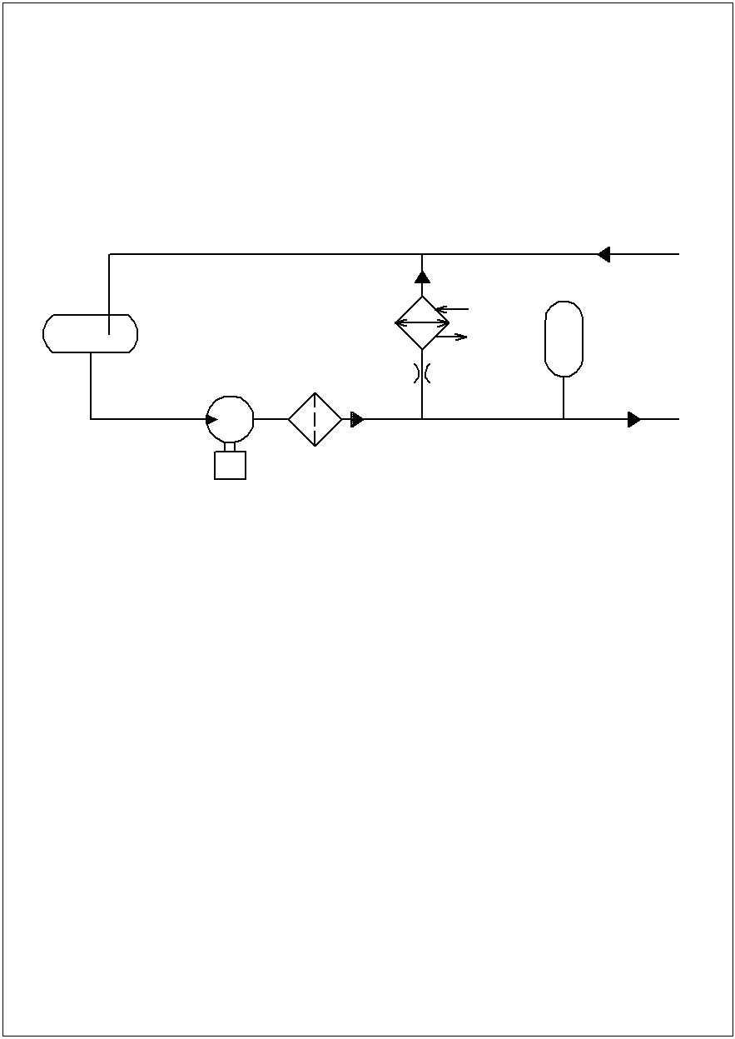
1
2
3
4
5
from system
6
to system
Fig. 5.4. Chart of hydraulic system with variable-displacement pumps
1 – tank; 2 – pump; 3 – filter; 4 – heat exchanger; 5 – throttle; 6 – pulsation damper

With some liquid going into the system for internal leakage replacement and the rest of it into the tank through a steady flow throttle and heat exchanger.
The minimum transmission is necessary to provide the pump lubrication by its own liquid, to reduce pump heating and accelerate pump process stabilization. Steady flow throttle is defined as hydraulic resistance consisting of rings with different diameters packed in housing with a front filtering grid. Liquid is heated in steady flow throttle and cooled off in a heat exchanger – a dural spiral tube.
The pulsation damper is used for plunger pump pulsation leveling and for liquid replacement with active unit-consumers.
Washing net and steady flow throttle grid, inspection for likely defects and replacement of defected units are maintenance features of such hydraulic system.

5.7.3. Maintenance features of hydraulic systems with self-powered pumps

As a rule, such system is an electric driven pump unit used as flight reserve system with check for serviceability of hydraulic system components on the ground.
There are three types of pump units:
1. The pump unit which works constantly up to lock-out (works as variable-displacement pump, it has a steady flow throttle, heat exchanger and pulsation damper).
2. Pump unit which works after unit-consumer engaging with turning off by limit switch at the end of work.
3. The pump unit equipped with a pressure relay works as fixed-displacement pump, i.e. it is engaged by the pressure relay and switched off after creating nominal pressure, with operating cyclically. If pressure due to external leakage decreases below preset value despite the working pump unit the red alarm lamp flashes and if the pressure still decreases despite the crew haven’t switched off the system the pressure relay will switch off a unit after decreasing value reaches certain low point (40 kg/cm²).
Key maintenance operations:
1. Checking pumps delivery by measuring time of hydraulic accumulators charging, i.e. by measuring time of nominal pressure creation in the system (if the time exceeds specified value it may result from the internal or external leakage and pump failures).
2. Checking pumps serviceability and system operability by measuring pressure drop degree when unit-consumers actuating. If pressure is less than specified it may result from the decrease of pump delivery, decrease of nitrogen initial pressure in hydraulic accumulator, internal and external leakage.
3. Check of the pump electric operability in the pump failing (check procedure: switch, pump, wires).
4. Checking serviceability of the system and the pump unit with pressure relay (the third type) by measuring P_{max} and P_{min} actuation frequency and by determining alarm pressure (high actuation frequency of such pump station may result from the same source as in system equipped by PCU (see above)).

Self-study check

- What are the structural and operational features of modern aircraft HS?
- Describe the factors that influence the HS technical condition and performance.
- Give a description of applied hydraulic liquids.
- List the types of work for the HS maintenance.
- What are ways to check the purity of the hydraulic fluid?
- What are the types of POL contamination and methods of filtration and purification?
- Describe the filter monitoring device diagram and the principle of its use.
- What is the principle of filter elements cleaning at the ultrasonic device?
- What is the procedure for checking the health of HS consumers and what are their control settings?
- What factors affect the reliability and technical condition of the HS pipes?
- Name the types of failures and faults of the HS pipelines.
- What are the maintenance works of the tires of the HS pipelines?
- What are the checking methods for internal leakage of HS and its assemblies?
- How is initial pressure of nitrogen in the nitric cavity of the hydraulic accumulator and pulsation dampener verified?
- Give a description of hydraulic pumps varieties.
- Describe the scheme peculiarities and principle of operation of HS with continuous pumps.
- Describe the scheme of the pump operation with PCU.
- What are the characteristics of the HS maintenance with ARV?
- What are the causes of frequent PCU actuation and describe their scanning.
- How do PCU frequent responses affect the HS condition and performance?
- Describe the design and principle of operation of HS with variable pumps.
- What are the characteristics of the HS maintenance with variable displacement pumps?
- What are the types of pumping stations? Describe their purpose and operation.
- List the main types of work for the HS maintenance.
6. OPERATING CONDITIONS AND MAINTENANCE
OF TURBINE ENGINE POWER PLANT

6.1. Improvement of turbine engine maintenance
and repair methods

Rate of scientific and technical progress in aircraft propulsion engineering is very high. Each new engines generation is characterized by raised economic indexes (specific consumption, specific impulse, specific weight) as a result of using more heat-resistant materials, working conditions toughening, complication of engine design and automation. It leads to rise in total engine price. The cost of 1 Kg of traction and 1 Kg of mass increases 10 times and more for each new engines generation. If one takes that TE cost during total operating period (from the manufacturing to the withdrawal from service) is equal to 100 % than new engine cost is 45 %, repairs – 45 % and maintenance – 10 %. Engines deprecation cost makes 50 ÷ 60 % from the whole assignments in civil aviation.
On the other hand, the greater monetary expenses for repair and the big revolving fund are required with small term of overhaul life since for a long time engines are not involved in operating sphere. Here are typical life cycle data for existing engines: operating ratio – 0,6; downtime ratio in expectation for the repair – 0,15 ÷ 0,2; downtime ratio under repair – 0,05 ÷ 0,07; downtime ratio in expectation for the engine installation on the aircraft – 0,15 ÷ 0,2.
As one can see, the term of non-operative engine status is about 40 %, which requires spare engine for each aircraft.
Ways of cost cutting:
1. Raising the term of overhaul life to 10 thousand hours and the term of specified life to 20 thousand hours. But this process requires about 10 years. And besides, increasing engines running time shrinks the probability of their non-failure operation.
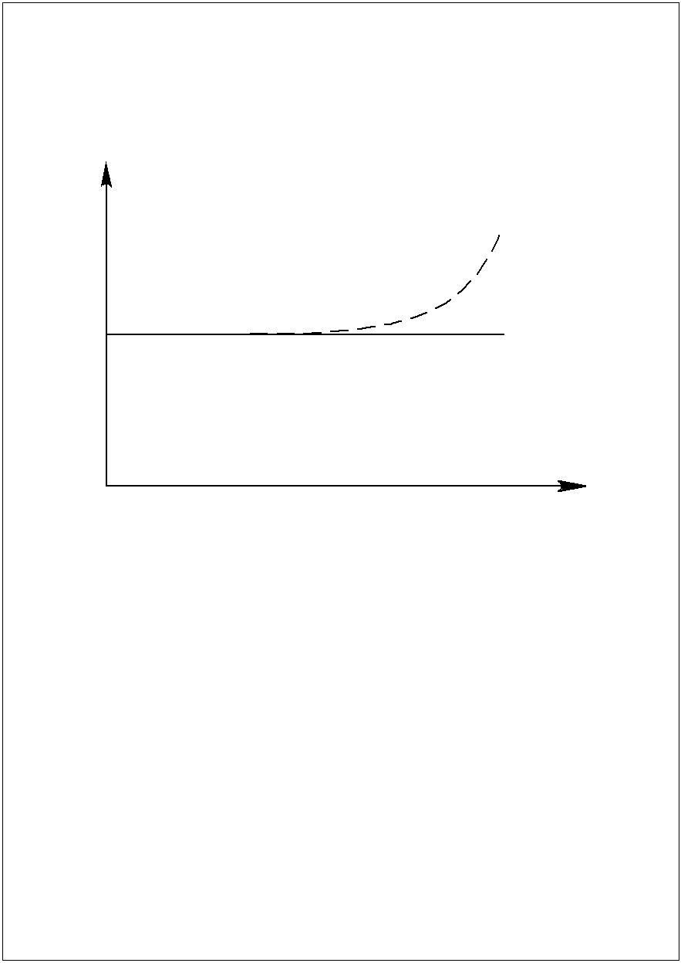
2. Introducing method of maintenance and repair in accordance with engine condition is the most effective way for eliminating contradiction between increase of engine resource and decrease of flight safety. In this case engine reliability is provided by monitoring and troubleshooting (i.e. failure and malfunction predictors) with engine resource being secondary. This method allows supporting the failure rate of engine in flight
1
2
λ
t, h

Fig. 6.1. Typical ratio between failure rate of engine in flight and engine running time

6.2. Classification of turbine engine typical failures
and malfunctions

Design principles uniformity for all GTE types, uniformity of duties and service conditions for all GTE versions result in general failures and damages. We will consider the classification of typical GTE failures and damages according to such signs as: cause; demonstration place; demonstration time.
Causes: abrasive wear of air-gas channel parts as a result of exploitation in dusty conditions; erosive wear as a result of sub-standard fuel application and GTE exploitation in the atmosphere saturated with salts; mechanical damages resulted from foreign matter ingestion; deformation and collapse of GTE parts caused by design features and industrial circumstances; wear of jointed parts which leads to their forms, sizes and weights changes; fatigue failures and damages; units and systems disarrangement as a result of wear, ageing, pollution; engine behaviour disturbance as a result of irregular running.
Demonstration place: elements washed by oil (20÷50 % of failure total number); combustion chamber (2 ÷ 7 %); compressor (2 ÷ 15 %); turbine (0 ÷ 5 %); control system and fuel system (15 ÷ 30 %); start system (2 ÷ 20 %); accessory drives (2 ÷ 10 %).
Such variety of GTE failures demonstration places can be explained by analysing considerable quantity of engine types with different design and special features of their application.
Demonstration time: unexpected; gradual.
Unexpected failures and damages are accompanied by emergency (unexpected) change of parameters and engine technical condition. They are completely obvious and are accompanied by strongly pronounced signs such as sharp changes of instrument readings, unwanted sounds, smoke, etc.
Main causes: Lacks of design and manufacturing technology; poor-quality material; poor-quality monitoring; foreign matter ingestion; gross violation of flight and current rules.
Such failures are shown frequently on initial stage of engine exploitation with the engine design subsequent improving. Statistically approximately 30 % of flight incidents and up to 15 % of preterm engine dismantling are caused by such failures. It’s difficult, almost unfeasible, to predict these events as it is impossible to monitor damages rate.
Gradual failures and damages are accompanied by gradual change of engine parameters caused by the external factors influence and accumulation of damages in various engine parts (wear, fatigue etc.).
Main causes: abrasive wear of engine components; erosive wear of turbine components; turbine rotor blades and compressor blades; wear of bearings; fatigue damages.
These damages can gradually accumulate and reach critical level which result in a failure. Such failures are superviseable and with the data of failure development speed critical level arising can be predicted. However in many cases the tendency of damages accumulation is so mild that it is difficult to find them out. Statistically approximately 70 % of flight incidents and 85 % of preterm engine dismantling resulted from such failures.

6.3. Turbine engine maintenance

The following procedures are performed while GTE maintenance: inspection for defects; test works; adjustment; routine maintenance.
And it is necessary to provide the precautions against ingestion of foreign matter into open cavities.
These are such precautions: installation of input and outlet plugs; installation of screwed plugs or button plugs and corks on the open tips of pipelines and units; tool application in special separation boxes; using special clothes for prevention of foreign matter ingestion interior of the engine; removed parts and the tool should be placed rather on special stands or shelves than on engine and engine nacelle surface.

6.3.1. Compressor maintenance

Typical failures and malfunctions, their causes and results:
1. Dints, indents and cracks from foreign matter ingestion leading to compressor destruction. Stones, large particles of runway surface, ice pieces from the icing of air inlet and input guide wheel blades, birds and hailstones get into the compressor more often. Especially dangerous thing is the icing which leads to increase in input losses, capacity reduction, gases temperature rise, efficiency deterioration, decrease of compressor surge characteristics, vibrations increase, dints occurrence. The plugs are installed and cleanliness of taxiways/stopping places is monitored for the prevention of foreign matter ingestion.
2. Fatigue cracks resulted from raised static and vibration loads leading to compressor destruction. The raised vibration can be caused by decreased compressor surge characteristics.
Causes of such decrease: starter early switch-on; insufficiency of power supply energy; start at the strong cross wind; failure of air bypassing control units; failure of control units for the turning of input guide wheel blades; foreign matter ingestion; increased wear of blades; work modes close to surging boundary; entering turbulent flow.
3. Abrasive wear of blades. It causes more than 30 % of GTE repair incidents. The main reason is the work in dusty runway conditions. Wearing degree of rotor blades exceeds that of nozzle blades; wearing degree of peripheral zones exceeds that of central zone; entrance edge of the blade is worn out more than exit edge of the blade.
4. Deterioration of the ring gaskets providing a gap over rotor blades while working in dusty conditions. It leads to decrease in compressor coefficient of compression, decrease in specific fuel consumption, increase in gases temperature, engine power reduction, and decrease in surge stability factor. Therefore the dust boots are installed on helicopters which aren’t very advantageous since they reduce engine capacity and increase the specific fuel consumption. It entails an important problem – timely detection of abrasive wear.
5. Dust, dirt and salts deposits on blades lead to decrease in output-input ratio, increase in vibration and promotes surge.
Maintenance consists of fault detection and malfunction elimination. There are tolerable limits for dints and indents.
Monitoring methods and facilities:
1. Optical endoscopes are used for detecting indents, dints, cracks.
2. Non-destructive methods for cracks detections (eddy-current testing, ultrasonic method, crack detection with paints).
3. Determining blades wear degree by turning angle of the bar between two blades tails (Fig. 6.2).

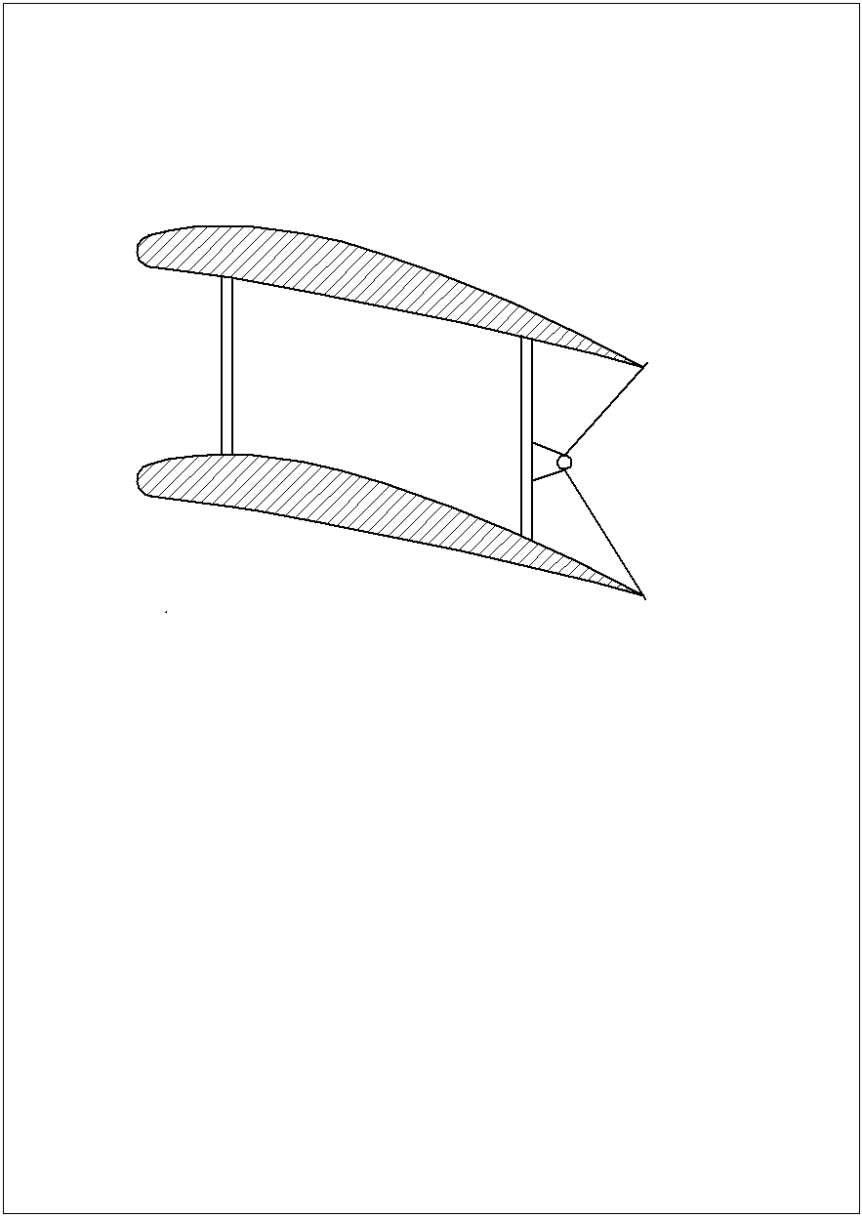
α
Fig. 6.2. Principle of blade wear determination by angle bar

4. Monitoring wear degree by wear testifier. It is a hollow boss with the preset wall thickness which gradually wears out together with blades. The bore in a boss wall indicates intolerable wear degree. (Fig. 6.2)
For vibration and cracks occurrence monitoring they apply a method based on demagnetizing feature of magnetized blade in damage. The eddy-current testing method and method of acoustical emission are used for the same purposes.

6.3.2. Combustion chamber maintenance

Gas pressure forces, vibration forces, inertial forces, a high temperature and uneven heating effect a combustion chamber.
Typical failures and malfunctions, their causes and results:
The first group: cracks, distortion, flame tube and housing burnouts, defects of riveted joints leading to destruction.
Failures are promoted by: poor-quality fuel; working in forced modes; an obstruction of fuel connections; fuel connections burning-out; offset of fuel connections, surge.
The second group: a flame blowout and burning termination leading to engine flameout.
Failures are promoted by: surge; fuel pressure decrease; foreign matter ingestion; reduction of engine behavior on high altitude.
Monitoring methods and facilities: visual inspection of combustion chamber housing; inspection with optical devices (endoscopes and with television image); X-ray inspection; gas analysis of combustion materials, monitoring gas-dynamic properties.
Estimation of fuel connections carburization
It is made by the following two methods:
The first method: The gap between an internal wall of nozzle housing and external surface of sprayer housing is checked. This gap decreases as deposit layer value increase. There is tolerable limit for minimal gap value.
The second method: The temperature of engine stack effluent is calculated as average value for four thermocouples. In accordance with maintenance schedule the estimation of temperature field uniformity is implemented through specified number of hours of work. Each thermocouple is switched off by turn and mean temperature for other three thermocouples is registered. The difference between mean temperatures of four and three thermocouples determines the degree of thermal field non-uniformity. Such degree should be within the range of specified tolerable limits.

6.3.3. Turbine maintenance

The turbine is the most loaded GTE unit.
Typical failures and malfunctions, their causes and results:
The first group. Thermal fatigue cracks on rotor blades and disks leading to their breakage and destruction.
The failures are promoted by: raised vibration; considerable quantity of engine starts and transient behaviors; start or behavior achievement without pre-heating; stopping without pre-cooling; foreign matter ingestion.
Very often thermo fatigue cracks arise in the lock, on entrance and exit edges of blades.
The second group. Melting and distorting rotor and nozzle blades, which entails cracks formation and blades subsequent breakage and destruction.
The failures are promoted by: thermal field non-uniformity; overheating of gases when starting; raised gas temperature resulted from failure of fuel system equipment (FSE); using sub-standard fuel; long-term operation with off-design engine behavior (forced and small modes).
The third group. Turbine rotor blades leading to decrease of radial clearance values, to blades jamming and, as a result, to temperature increase, flame blowout and to break of engine work.
The failures are promoted by: long-term operation with off-design engine behaviour; raised gas temperature resulted from FSE failure; overheating of gases when starting.
The forth group: Erosive and corrosive damage of rotor blades and disks leading to cracks formation and blades destruction.
The failures are promoted by: work in dusty airfield conditions; air saturation by sea salts; using sub-standard fuel.
Signs of turbine units damage: popping-back, bunches of sparks from a jet nozzle, trail of grey smoke, decrease in engine speed, increase in gas temperature behind the turbine.
The status of the turbine in whole can be estimated by the state of turbine last stage. The access to this part is possible and it can be investigated either visually or by non-destructive methods.
Monitoring methods and facilities: optical (endoscopes) – cracks and melting sites are detected; pyrometers – temperature monitoring; vibroacoustic, eddy-current, ultrasonic testing methods – monitoring cracks formation; mechanical method – monitoring turbine rotor blades draw by special plane probes; laser and capacitive methods – monitoring blades draw and vibration degree; probes for charged particles registration – monitoring blades melt.

6.3.4. Maintenance of parts washed by oil

Typical failures and malfunctions, their causes and results: destruction of rotary tables; destruction of accessory drives; destruction of gears.
The failures and damages result from: oil starvation entailed by coke deposits formation in injection holes used for oil supply to rotary tables. It occurs when hot engine is stopped without pre-cooling, as a result the oil doesn’t circulate and coke is formed in injection holes. Transition into raised work mode without engine pre-heating after start leads to friction raise because of increased oil viscosity and decreased bearing gaps.
Signs of above mentioned components destruction: – metal particles on the filters or overheat-chip detector actuation.

6.3.5. Turbine engine oil systems maintenance

Typical failures and malfunctions, their causes and results:
- Oil pressure drop to zero. Result: bearings and gears oil starvation. Causes: discharge pumps or pump drives destruction.
- Decreased oil pressure. Causes: disturbance of oil pressure reducer adjustment; oil pressure reducer failures (sticking of reducer, spring breakage, solid foreign matter ingestion).
- Increased oil pressure. Causes: overtightening of oil pressure reducer spring, jamming of closed reducer, filters clogging, obstruction of nozzle apertures for the bearings and toothings lubricating.
- Oil temperature exceeds tolerable limit. Causes: contamination of air-to-oil cooler surface, worsening radiator blow-off on the ground (cross wind), thermoregulator failure, penetration of hot gases into the engine oil chamber (wear of the seals), insufficient oil quantity.
- Increased oil consumption (decrease in the tank oil level). Causes: seals wear and loss of their elasticity with oil subsequent entering air-gas flow duct; destruction of pipelines; leakage of pipelines joints and units, fuel filler flaps or oil filters; oil slobbering through faulty breathing system.
- Increased oil level as a result of fuel penetration into the tank. Causes: leakage of fuel-oil cooler and oil chambers of fuel metering equipment.
- Oil pollution and ageing.
Signs of above mentioned failures and malfunctions: increasing oil and gases temperature; metal shaving in the filters, magnetic plugs and overheat-chip detectors; increased vibration; oil darkening as a result of pollution; increase or decrease in the tank oil level; smoke in ventilation system and in air pressurization system.

Oil system maintenance key operations:
- Joint tightness check is performed visually (detecting signs of leak).
- Checking equipment state and attachment (tank, radiator, pipelines): cracks, indents, deformations, scuffing zones, loosening of attachment, metallization and screw locking device damages are possible.
- Checking operability of temperature regulators and damper controlling mechanisms (mounted in front of the air-to-oil cooler).
- Checking oil level in tank and oil refill.
- Changing oil in the system when oil resource is worked off or if oil quality is poor.
- Checking oil quality (see "Hydraulic system").
- Tanks and oil radiators washing.
- Checking coke deposits in nozzles and size holes by measurement of nozzle productivity.
- Oil filters checking and washing. Washing coarse mesh filters with solvent (gasoline, kerosene, kresosolvin) by soft brush and micron filters by ultrasonic device. Checking filter cleanness by DTFC (see "Hydraulic system").

6.3.6. Fuel system maintenance

Typical failures and malfunctions, their causes and results:
- Seal failure leads to fuel loss and fire and is promoted by vibrations, deformations, corrosion, low-quality mounting.
- Fuel filters clogging leads to engines cut-off and, as a result, to flight safety hazard. It is promoted by poor-quality fuel, water in fuel, hoarfrost in tanks, fuel oxidation and internal surfaces corrosion.
- Failure of cranes, pumps, signaling devices, manometers which leads to engines cut-off and, as a result, to flight safety hazard. De-energizing of aircraft electrical system is the key cause of such failure.
- Dirtying drainage sockets leads to tanks deformation. It is promoted by dust in the air, dirt on runway, moisture and snow.
Key maintenance operations: leakproofness checking – visually by signs of leaks; full fuelling, refuelling; fuel discharge; sediment discharge; fuel cleanliness testing; filters washing; clearing drainage sockets; checking operability of cranes, pumps, signalling devices.

6.4. Water in fuels

Fuel is hygroscopic, i.e. absorbs moisture. Water in fuel is undesirable as it promotes corrosion of units internal surfaces and can freeze with corking the filters and blocking the fuel delivery to the engine. In fuels water can be found in three states: free, water-fuel emulsion; dissolved form.
Water in the free state can be easily removed as sediment. Dissolved water poses no threat until freezing transforms it into water-fuel emulsion. Water solubility depends on fuel type (in gasoline solubility is higher than in kerosene), on relative humidity, on atmospheric pressure and temperature. The bigger these factors values are, the higher water solubility is.
Fuel temperature decreases considerably during long hauls on cruiser altitude depending on flight velocity, tanks thermal protection, flight time and initial fuel temperature. Fuel temperature can reach –50 °C.
As water solubility falls when temperature decreases water excess is transformed into drops with dimensions of 10 ÷ 40 μm forming water-fuel emulsion. These drops don’t turn into ice at once but remain in liquid overcooled state during some period. The smaller drops size is, the lower overcooling temperature can be. Moving with fuel the drops meet filters grids, pipeline walls in bends (elbows) and crystallize instantly turning into ice which obstruct filters and elbows and stop the fuel access to the engine.
During fuel long-term storage at low temperatures the air moisture crystallizes as hoarfrost on the tank walls and fuel surface and penetrates into the fuel. It also can lead to filter clogging. The bigger free-from-fuel tank surface is, the more hoarfrost is formed. Therefore, it is recommended that during the autumn-winter period while aircraft long standings or storage fuel tanks are completely filled which minimises free surface of the tank. In addition, fuel protects tank rubber parts against quick aging.

Condensate
Dissolved
water
Microdroplets
emulsion
Frosting
Ice crystals
Settling water
Ice
Fig. 6.3. Possible phase transitions of water in the fuel in flight for different combinations of temperature, humidity, sized water droplets

Methods of ice formation prevention in fuel:
1. With stable outside temperature (below –10°C): by freezing out during 3 days minimum with following filtration for the ice removal. It is effortful and costly.
- Cleaning by filter separators. It is also effortful and costly.
- Heating filter elements. It is not highly efficient and fire-hazardous.
- Heating in fuel-oil radiator.
- Water removal from aircraft tanks by warm dry air blowing above fuel surface.
- Cleaning fuel by electrostatic filters. (National Aviation University Patent). This method isn’t applied in aircrafts because of filters’ big mass and volume.
- Adding special additives into fuel is the most effective method. These compounds increase water solubility and form with water mixtures with low freezing temperature. These are “I” (ethyl cellosolve) and “ТGF” (tetrahydrofurfuryl alcohol) liquids. Liquid “I” is used more often – in 85 % of additive application cases and “ТGF” is used in the rest 15 %.
Additive “I” is colorless liquid with weak “etheric” odour; density ranges from 0.93 to 0.95 Kg⋅l⁻¹ at 20 °C. It doesn’t promote corrosion activity. 0.1 ÷ 0.3 % from the volume is added to fuel depending on outside temperature and flight duration. Additive efficiency remains in fuel during 1 year.
The additive is doped into tanks in fuel storages by fuel dressers and dispensers.

6.5. Aircraft filling with fuels and lubricants

The Fuel and Lubricant service and specialized motor pool of aviation enterprise are responsible for quality organization and ensuring aircrafts filling with POL. There are stationary systems of centralized fuelling with underground distribution equipped by outlets in wells on stopping places and mobile dressers. Both systems equipped with filtering and dividing facilities.
Fuel cleanliness testing is performed in cisterns, dressers and tanks after filling. Fuelling can be done by open method – downward through filler neck and by closed one – upward with pressure using the airborne pumps.
Lacks of open method: skills are required; danger of aircraft damage and personnel injuries, possibility of dust, sand, snow penetration into fuel.
Lacks of closed method: fire hazard – aircraft is energized.
Preliminary works before fuelling: dresser is called and arrives; checking fuel certificate, information about fuel type and quality given in this certificate (the certificate must be adopted); checking cleanliness of discharge hoses and filters, checking leads and initial instrumentation indications; checking the dresser ground connection; checking brake-blocks (under aircraft wheels) and aircraft ground connection; checking fuel leak absence under the wings and engine nacelles; checking presence of fire extinguishing tools and their operability; removing unauthorized facilities and people from fuelling aircraft zone; connection of dresser discharge hose with the aircraft fuel-supply tip, and their mutual ground connections checking; dresser and aircraft pumps switching on; fuelling facilities should be placed with the possibility of freely driving from the airplane in case of fire.
The fuelling process and finishing is monitored by: dresser devices; fuelling panel devices, lamps and indicators; devices in the cabin; measured rulers.
Sediment from all groups of tanks should be discharged in 15 minutes after fuelling finished with checking sediment cleanliness and water and extraneous particles presence in it.
Testing methods: fuel stirring in transparent vessel (particles and water will be in the centre); by the device for pollution detection (DPD). DPD is composed of syringe with septum made from special filtered paper with the specified sediment dose being passed through it. A stain formed on the paper is compared to reference stains with defining degree of water and particles pollution; water status is also estimated by potassium permanganate and litmus paper.

6.6. Replacement of aircraft engines

It is made when the engine resource is worked off, if the engine will be remounted on another aircraft, if engine failures can’t be eliminated in exploitation.
Engine replacement is composed of such technological procedures as: inspection for defects, systems cleaning and washing; engine preservation and depreservation; dismantling and mounting operations; adjustment and test works.
Replacement of the aircraft engine (hereinafter AE) is one of the most effortfull and difficult processes. This process is carried out commonly enough therefore the engine must have high operating adaptability i.e. suitability to replacement.
Requirements to operating adaptability are the following:
possibility of simultaneous replacement of the engine and the units established on it without their preliminary dismantling;
presence of quick-disconnect and self-aligning system connections;
arranging system connector sockets in one plane;
unification of propulsion systems i.e. possibility to install any engine in any aircraft hollowing;
convenient access to lifting units;
possibility of preliminary units installation on the engine with special bench instead of installation on the aircraft;
possibility of engine preservation and depreservation on the bench out of the aircraft.
Special work sites equipped with lifting devices, washing units, water-electrical-air communications and installation benches are created in the large aircraft centers for fast engines replacement.
It is important to provide defence of aircraft internal cavities against foreign matter penetration. For this purpose the following is carried out: installation of plugs on input and outlet; installation of screwed or button plugs and corks on the open tips of pipelines and units; tool displacement in special separation box in specified wells; using special clothes with pockets for tools and small parts (to prevent foreign matter penetration into the engine); the parts and tools should be placed on special stands or shelves, but not on the engine or engine nacelle surface.

6.7. Engine preservation and depreservation

This procedure is performed in engine removing from the aircraft and without such removing if the aircraft is on layover more than 1 month.
External and internal preservation is carried out.
The aim of preservation is corrosion prevention.
Procedures of external preservation:
- clearing surface from dust, dirt, POL stains, acids and alkalis;
- installation of plugs on open holes
- lubricating non-protected (without covering) surfaces by technical vaseline or neutral grease such as К-17 (“gun grease”);
- covering by polyethylene film;
- placing into a container.
The essence of internal preservation:
Filling oil and fuel systems with fresh oil. If oil in oil system is pure it is not replaced, if not the oil is discharged and same sort of fresh oil is filled into the system.
Filling fuel system with МК-8 oil (of small viscosity) is performed by either oil dispenser or special plant feeding pressurized oil from tank (1 ÷ 2 Kg⋅cm²).
Oil dispenser or plant hoses are connected with special engine fuel system outlets located behind the fuel system shut-off fire-cock.
Preservation is carried out by several false starts with closed fire-cock and pressurized plant. The oil displaces fuel, fills units and pipelines and covers internal surfaces of air-gas flow duct with thin oil layer. A number of system units don’t work during the false start and aren’t filled with oil (regulator pump, revolutions limiter, air bypassing system, system of input guide wheel blades turning). Therefore they are discharged of fuel and separate cavities are filled with oil using pressure created by oil dispenser or by special plant.
Depreservation is carried out by false starts with opened fire-cock and without oil feeding. The fuel displaces oil and washes off oil film from the internal surfaces of air-gas flow duct. The blowdown by dry motoring is performed for full oil removal from the air-gas flow duct. Used oil and fuel accumulate in special collectors located behind exhaust nozzle.

6.8. Methods of turbine engine performance restoration

The processes of wear, fatigue, ageing, pollution during continuous exploitation lead to change of forms and sizes of air-gas channel parts, to mal-adjustmen of automatic and fuel systems which result in deterioration of GTE characteristics (impulse, temperature, fuel consumption, compression ratio p*_{к}, output-input ratio, etc.).
During exploitation the restoration of GTE characteristics is carried out by the following methods:
- Units and systems adjustment (for example, adjustment of hourly fuel consumption).
- Replacement of certain modules, units and centers.
- Washing GTE air-gas channel.
The following physical phenomena occur when washing:
- a drop blow into the surface and pollution knocking out ;
- chemical influence of solution (erosion);
- liquid adhesive tension around particles and their removal.
Cleansing solution should meet the following requirements: washing efficiency; application convenience; absence of corrosive attack.
2 % solution of “Aerol” washer exactly meets such requirements. Its efficiency is increased by magnetisation.
Plant for air-gas flow duct washing is composed of the following: injector ring for cleansing solution feeding; tanks with compressed air and vessels with washing liquid; sprayers, gates, reducers, manometers, filters, valves, distributors and mixers; storage tank for used cleansing solution.
Optimum interval for the washing is 300 hours.
Self-study check

- Describe the impact of scientific and technological progress in the aircraft engine manufacturing industry on the problem of improving the methods of maintenance and repair of GTE.
- Give classification of failures and malfunctions of the GTE.
- What are the causes of failures and malfunctions of the GTE?
- Specify the places of the manifestation of failures and malfunctions of the GTE.
- Uncover the essence of sudden and gradual failures.
- Name the types of work at GTE maintenance and precautions against any foreign object in the cavities.
- What are the features of the maintenance of modular engines?
- What are the typical malfunctions of compressors, their causes and effects?
- Name the methods of control, monitoring and diagnostic tools for the GTE compressors and typical combustion chamber (CC) faults, their causes and consequences.
- How can you identify the coking of CC injector under operation?
- Describe typical faults of turbines, causes and consequences of these malfunctions.
- What methods and means are used for turbine control and diagnostics?
- Please list the common failures and faults of oil washed parts, the causes, effects and consequences of these failures and malfunctions.
- Please list the characteristic failure or malfunction of oil systems, the causes, the effects and characteristics of these failures and malfunctions.
- List the main types of work for the oil systems maintenance.
- Please list the characteristic failure or malfunction of fuel systems, the causes, the effects and consequences of these failures and malfunctions.
- List the main types of work for the fuel systems maintenance.
- Give a description of state of water in fuel and its impact on the performance of the fuel system.
- What are the ways to prevent the ice formation in the fuel?
- Give the methods of AV refilling with POL. What is the procedure for aircraft fuelling?
- How is the fueling process controlled?
- What are the ways to check the purity of the fuel?
- What is the purpose of the AE preservation and in what cases is it carried out?
- What is the order of the outer conservation?
- Describe the nature and procedure of internal preservation and depreservation.
- What are the ways to restore the operational characteristics of GTE?
- What is the essence of the GTE flow part flushing?
7. startING, warm-up, ground test, cooling
and shutdown OF Aircraft ENGINES

7.1. General characteristic of aviation engines starting

Engine start is a process of engine transfer from rest status in activity status and its transfer in minimal mode of steady operation (idle) by means of start system. Idle is engine operating mode at which any extraneous influences cannot lead to engine cutoff. Idle thrust is equal to 3÷5 % of peak mode thrust. Idle rotation frequency is equal of: for turbojet engine (TJE) – (0,2÷0,4) n_{max}; for turboprop engine (TPE) – (0,7÷0,85) n_{eq}.; for reciprocating engine (RE) – 500 ÷ 600 revolutions per minute (rpm).
Duration of start period is defined by two opposite requirements: the start period must be short as much as possible for fast takeoff; the starting period must be probably maximum for providing normal operating conditions for air-gas flow duct parts.
The "golden mean" is 1 ÷ 1.5 min for one engine.
As starting is important and difficult process only specially trained engineering staff and flight personnel with special permission for starting concrete type engines can be allowed to the starting procedure performing.
Starting process includes such procedures as: rotor spin-up by a starter; starting fluid feeding and its ignition; working fuel feeding; rotor spin-up by a starter and by turbine; idle process stabilization.
Starting intensity is defined by excess of available output over required power. It is created by thermal behavior forcing. The starting mode is off-design and demands the increased attention to temperature of gas behind the turbine (T*_{g}).
Operating requirements to starting systems are the following:
– starting safety at any earth conditions and at any altitude;
– starting autonomy (possibility of starting by means of onboard energy sources);
– the minimal expenditure of energy when starting;
– all-around automation of starting process;
– simplicity, ease, reliability and safety of exploitation and maintenance;
– the starting program must provide the normal operating conditions for air-gas flow duct parts.
Starting systems design is defined by type of trigger (starter).
Electric starter. As a rule, it is a starter-generator, i.e. unit capable to produce an electric energy after start.
Advantages: possibility of all-around automation; design and maintenance simplicity; effortless of provision with electric power; sufficiently high resource.
Lacks: can be applied to engines with relative small power since power increase requires the sharply increase of starter mass and volume.
Energy source: an underground electrical network with an outlet in stopping place; an airfield mobile unit (hereinafter AMU); an auxiliary power-plant (hereinafter APP) generator or working engine generator.
Turbine starter. It is a high-speed GTE with starting from mini-electric starter.
Advantages: can be used for engines with high power.
Lacks: design and maintenance complexity; an insufficient resource; small efficiency.
Energy source: fuel
Air starter. It is a high-speed turbine operates by means of compressed air; the turbine is connected kinematically with engine rotor.
Advantages: design and maintenance simplicity; a high resource; reliability; can be used for engines with any power.
Lacks: difficulty in supply of energy source.
Energy sources: ground sources: compressor, tank with pressurized air; onboard sources: the compressor of auxiliary power-plant or the working engine compressor.

7.2. Stages and monitoring starting process

Starting process may be divided on three stages (Fig. 7.1) depending on the mean of engine rotor spinning-up (starter or turbine).
Fig. 7.1. Stages of GTE start

Let's notice that
М_{res}= М_{t} +М_{com}+М_{fr}+М_{s.d},
where: М_{res} – resisting moment; М_{com} – moment spent for air compression in the compressor; М_{fr} – moment of friction; М_{s.d} – moment spent for accessory drive; М_{t} – turbine moment; М_{sr} – starter moment.
So:
The first stage: from starting process beginning to rotational speed n₁ (in rpm); when rotational speed increases to n₁ the turbine gets into gear.
At this stage М_{acc}= М_{s.d.}+М_{comp}: the rotor spin-up by a starter (trigger) occurs.
Must be monitored: increase of rotor rotational speed; parameters of starter operation: voltage and current strength (if electric starter is used); air pressure in air system (if air starter is used); rotational speed, gases temperature, oil pressure and temperature, fuel pressure (if turbine starter is used).
The second stage: from rotational speed n₁ (in rpm) to rotational speed n₂ (in rpm) (starter is switched off at n₂ rpm ).
At this stage М_{acc}= М_{sr}+ M_{t} – М_{res}: the rotor spin-up by a starter and turbine occurs.
Must be monitored: the above mentioned parameters of starter operation, and the following parameters of engine operation: increase of rotor rotational speed; gas temperature behind the turbine; oil pressure and temperature; fuel pressure; vibration parameter; time of turbine operating starting (time of arising of data about fuel pressure and gases temperature behind the turbine); time of starter switching off (alarm system triggering).
The third stage: from n₂ (in rpm) to n_{idle} (in rpm) (rotational speed at idle). On this stage М_{acc}= М_{t} – М_{res}.
The same engine operating parameters are monitored.
At n_{idle} ⇒ М_{t} = М_{res}; at n_{dm} ⇒ М_{sr} = М_{res}; at n_{к} ⇒ М_{t} = М_{res}. n_{dm} is dry motoring rotational speed.
Duration of each stage depends on the speed-up moment when performing this stage.

7.3. Preparation for engine starting

Aim: prepare an engine to start, provide the equipment serviceability and maintenance staff safety.
Procedures on the earth: prevent foreign matter penetration (for this purpose remove the plugs just before a start); check up the presence of backing blocks under wheels; inspect the standing place, the engine nacelle and wing bottom (be ensured in absent of the POL leaks); check up the presence of fire land extinguishing tools on the standing place and their operability; be sure in the cleanliness of standing place; remove the unauthorized peoples from aircraft zone: such peoples can’t approach more than 10 m in front and more than 50 m behind of aircraft; check up the ground connections; check up the ease of GTE rotor rotation (turn the rotor by means of special wrench), and check up the ease of turboprop engine propeller rotation (turn the propeller by means of starter or the special device); check up the installation of turboprop engine propeller blade of on minimal angle; call the starting facilities and connect them to a board; ensure the land starting facilities from running-down accidents and damages at sudden aircraft breakaway; establish the connection with the cabin.
Procedures in the cabin: ensure that the “landing gear retraction-extension” crane is down and locked; ensure that wheels parking brakes are used; check up the POL quantity by means of cabin indicators; check up the ECSG operating smoothness and return them on previous place (in extreme position); switch on the necessary automatic circuit breakers (hereinafter ACB); switch on the electric sources in position "board"; check up the voltage of all electric sources; check up the serviceable of onboard fire extinguishing facilities.
Procedures on cranking panel: the switch of a choice of temperature limiting mode set in necessary position; the switch “starting on the

earth – starting in air” set in necessary position; the switch “starting – dry motoring” set in necessary position; the switch of engine choice set in necessary position; press the button "start".
Starting occurs automatically.

7.4. Operating factors influence on starting

Low temperature of outer air:
The resisting moment (М_{res}) increases as a result of air density (М_{com}) and friction resistance (M_{fr}) increase; M_{fr} rises due to oil viscosity increase. Besides the fuel volatility deteriorates; it leads to fuel ignition delay and to delay of turbine effective operating start. Fuel viscosity increases that leads to deterioration of fuel dispersion and fuel mixture quality. Starter (both electric and turbine starter) torque moment decreases.
Thereby, the starting conditions are worsened at low temperatures as a result of speedup moment decrease. But it occurs only at the first stage of starting process while, M_{t} < M_{res}. In the sequel the turbine output increases faster than resistance force due to increase of gases weight flow and heat drop; as a result a rotor spin-up occurs more intensively.
For improvement of starting process parameters at low temperature the following is used: powerful starters; heating up of the engine and fuel and oil systems units; if it doesn’t help, the oil must be poured out, warmed up and filled in the system again; hot oil may be added or oil may be dissolved by gasoline (for reciprocating engine, RE hereinafter).
Engine heating up is carried out at the following temperatures: for turbojet engine: below – 40^{о}С; for turboprop engine: below – 25^{о}С; for reciprocating engine: below + 5^{о}С.
High temperature of outer air:
If outer temperature is high than М_{com} and M_{fr} decreases as a result of reduced air density and oil viscosity respectively. Therefore rotor spin-up is greater due to an intensified starter work at the beginning of starting process. But later the engine power decreases more than resisting moment. Therefore the slowdown of rotor spin-up occurs; the range of compressor steady operation decreases and surge is possible for certain values of rotational velocity (surge leads to hot engine speed holdup). Nature of hot engine speed holdup phenomenon: Since air-fuel mixture is reached, temperature increases but rotational velocity is invariable as a result of a surge.
Moisture. Moisture influences fuel in the following way: the filters are blocked by ice crystals (see above), fuel ignition quality decreases. In addition, moisture promotes insulation breakdown, wiring corrosion in joint and seal points. Moisture freezing can occur in movable constructional elements, and freezing of compressor blades to housing can occur also.

7.5. Typical failures at turbojet engine starting

The failures will be considered for individual starting system components:
1. Power supplies:
- voltage or current strength in electric starter is insufficient;
- air pressure in air starter is insufficient as a result of the leakage present.
These factors lead to insufficiency of starter power and to starting delay or failure.
2. Insufficiency of starter power as a result of starter adjustment disturbance and respective worsening the starter characteristics.
3. Malfunction of electric system: a wiring; sparking plugs; ignition coils; starting fluid electromagnetic valves; electrical gears of air chokers can be the likely sites of damage.
These factors lead to brake of starting fluid feeding or absent of this fluent ignition.
4. Mal-adjustmen of automatic system: untimely starter switching off or starter switching off fault; failures while fuel delivery programs are performed; untimely opening and closing of bypassing system valves.
5. Deterioration of compressor, combustion chamber and turbine characteristics as a result of pollution or wear of blades and nozzles. It leads to decrease of rotor spin-up speed, surge and midrange engine speed holdup.
Search algorithms of “effort-probability” type must be created for fast and low-price finding of the reasons of starting fault or starting procedure irregularities.
For example, the reasons of working fuel noninflammation may be the following: absence of fuel pressure before nozzles; ignition system malfunction; starting fluid absence.
Starting procedure must be stopped in the following cases: engine fire; fuel ignition absence in proper time; stop of increase of rotational speed (the engine holdup); gases temperature is higher than normal value steadily; oil pressure absence; oil temperature is higher than normal value; fuel pressure wasn’t appeared; untimely starter switching off or starter switching off failure; decrease of electric starter voltage (air pressure in the case of air starter) below than normal value.
For the termination of starting process during 1st and 2nd stages it is necessary to press the button “Starting termination”, and to block of emergency brake; during 3rd stage it is necessary to block of emergency brake.

7.6. Warm-up of aircraft engines

As “warm-up” is called the process of gradual rising of engine parts and oil temperature when engine working at derating modes. The engine parts and oil should get the temperature close to the operating one during warm-up process. Engine parts warm non-uniformly because of its complex configuration. Therefore, the engine maintenance at operative modes without preliminary warm-up will lead to thermal stresses and, as a result, to arising plastic deformations, distortions and cracks. Besides that, the oil has an increased viscosity in cold engine, and it leads to worsening lubrication process (the “dry friction” arises).

Turbojet engines (TJE) warm-up modes
The design feature: considerable quantity of parts subjecting to gas stream high temperatures. High speed of temperature increase leads to these parts un-uniformly warming. Considerable un-uniformity of gas stream temperature is the reason of it. So, un-uniformity of gas stream temperature reaches 300 °C in combustion chamber (if we will consider the cross-section of combustion chamber).
Besides, the engine parts have different cross-sectional dimensions and, as a result, engine parts arming up are non-uniformly. So, the temperature difference reaches 180 °С at turbine blade height and at its chord. It leads to appearance of thermal deformations, distortions and thermo fatigue cracks. The change of gas stream temperature for different values of rotational speed has the following type (Fig. 7.2). The heat removal from a blade through a tail to a disk is non-uniform also. As a result, temperature is minimal (t_{min}) at rotational speed value n₂ and temperature is maximal (t_{max}) at rotational speed value n₃. But if rotational speed value is equal to n_{tmin}, then the radial clearance in rotor mounting bearings decreases because of heat removal is non-uniform; it leads to increased wear of bearings.
Fig. 7.2. Stages of TJE warm-up
Therefore initial TJE warm-up is performed in the beginning on idle during one – two minutes, and then the mode is smoothly increased to 70 ÷ 80% of nominal mode and final warm-up within 1 minute is performed (Fig. 7.3).
Turboprop engines (TPE hereinafter) warm-up modes
Differences between TPE design and TJE one are the following:
Fig. 7.3. The character of TGE gas stream temperature change in dependence from the rotational speed value
- usage of increased viscosity oils;
- oil is used not only as lubricant, but also as a working substance in system of propeller automatic regulation; it causes some specifics of warm-up process.
At the beginning the warm-up is performed on idle until oil temperature reaches +20 ÷ +40 °С. However the propeller control system doesn’t work at idle and oil in this system units doesn’t circulate and doesn’t warm-up. Therefore it is necessary to raise smoothly (during the 5 ÷ 8 seconds) the engine operating mode to 60 % of nominal mode, then to reduce the engine mode to idle. Such cycle must be performed 2 ÷ 3 times. The oil in system of propeller automatic regulation will circulate and will be warmed up (Fig. 7.4). Reciprocating engines (RE hereinafter) warm-up modes
RE design feature:
– considerable quantity of sliding couplers (cylinder – piston, crankshaft – connecting-rod bearing, piston rings);
– usage of increased viscosity oils.
Therefore the problem of RE warm-up is the increasing of oil temperature for reduction of its viscosity and the smoothly raising the temperature of cylinder – piston group.
Quickly increase of temperature will cause the exhaust valve seats deformation, loss of their tightness, burnout, formation of cracks between cylinder fits and heads.

Fig. 7.4. Stages of TPE warm-up

What mode may be used for RE warm-up? If RE is cold it works at idle unstably. Besides, the pumping action of piston rings leads to oil penetration in combustion chamber. This oil doesn’t burn but settles on spark-plug electrodes that worsen the sparking. Therefore initial warm-up of reciprocating engines is made on speeds above idle, namely 900÷1200 rpm (Fig. 7.5). The engine cowl flaps and flaps and oil cooler folds closed at this. Engine rotation speed increases to 1300 ÷ 1500 rpm after oil temperature increase to 5 °С above initial one. Final warm-up is performed until the oil temperature reachs +40 °С, and cylinder heads temperature reaches +120 °С.

7.7. Aircraft engines operational test
. Fig. 7.5. Stages of RE warm-up

.

Aim: make sure in operability of engine and its systems. Checking is carried out after engine starting and warm-up before flight, after certain forms of MS and after performing of engine repair and adjustments.
Checking is performed on servicing modes in accordance with the special program defined by the schedule of checking. This schedule is the certain sequence of procedures created with taking into account the readiness of systems for check and minimum possible changes of engine operating modes. Schedule co-ordinates: abscissa: – engine operating time; ordinate: engine operating modes.
The monitored operative engine parameters are compared with requirements of specification during checking. The checking is performed on the followed steady operating modes: idle, one from cruising regimes, nominal rating, takeoff regime. Besides, stability of engine work on transient regimes is checked.

7.7.1. Turbojet engines operational test

TJE operating mode is defined by rotor rotational speed; therefore the schedule is plotted in co-ordinates “rpm – operating time”.
If mode is steady the followed parameters are checking: revolutions per minute, gases temperature; fuel pressure; oil pressure and temperature; vibration parameter; air compression ratio in the compressor (р_{k}) (for some types of engines).
For takeoff mode the operating time is limited (8 ÷ 12 seconds depending on engine type). Parameters of a take-off regime depend strongly on outer temperature and air pressure. Therefore, the rating temperature values and rpm are presented in check schedules for take-off mode for different values of outer temperature and air pressure.
Test of engine acceleration
The acceleration is engine ability to go from deferred to raised mode quickly and smoothly. It is estimated by value of time that would be taken. The full acceleration: from idle to takeoff regime. The partial acceleration: for limited range of rotational speed values. The full TJE acceleration is 15 ÷ 17 seconds. ECSG must be moved smoothly (for 1 ÷ 2 seconds) when acceleration checking is performed. It reduces the gases overtemperature and helps to avoid of surge.
TJE cooling and stop.
Cooling is necessary to avoid thermotensions and, as a result, formation of distortions and cracks of engine hot part components. Cooling is performed at rotational speed with minimum gases temperature during 1 ÷ 2 minutes. The lower the temperature of outer air is, the longer the cooling period is.
Stop is performed by a stopping of fuel supply by means of engine shutdown lever (ESL) and "emergency brake". When shutdown is performing the time of run-down (time of its free rotation from the stopping of fuel supply point to a full stop point) is measured. This period duration characterizes a friction process, and, consequently, the condition of bearings, accessory drives, etc. It is necessary also to make sure that unwanted noises and knocks are absent.
Test of engine reverse.
The reverser doors transfer at idle in a back draft position by mean of reverser control lever (RCL); it is confirmed by highlighted messages on indicator panel: “reverser doors” and “reverser lock”. The RCL transfer in the position "reverser switched off" (i.e. engine return to forward thrust) after 5 ÷ 10 sec. Messages on indicator panel go out. Parameters of maximal back draft mode check during previous aircraft run using reverser.

7.7.2. Features of turboprop engines operational test

Two values of rotational speed (“ground idle” and “on-speed” – constant on all modes) are in TPE. Power change occurs as a result of fuel supply change by ECSG and automatic change of blade angle. The regime is defined by ECSG rotation angle which is showed by such device as TPI (throttle position indicator). Therefore, the check schedule is plotted in the following co-ordinates: “TPI degrees” – “operating time”. In addition the rotation speed at idle and on-speed regimes are shown for descriptive reasons.
If TPE mode is steady the following parameters are checking: rotation speed; temperature of gas behind the turbine (T*_{g}); oil pressure and temperature; fuel pressure; vibration parameter.
In addition the following parameters are shown: thrust parameter (P) as pressure in torsiometer; hourly fuel consumption.
The following parameters are checked on transient regimes: feathering system operability; propeller intermediate stop operability; acceleration.
Checking feathering system operability.
The big negative thrust (propeller resistance) arises at engine failure; such negative thrust is very dangerous since the aircraft can enter into a spin. The propeller simultaneously with engine failure is feathered, (i.e. blades are set in feather position – perpendicularly to propeller rotation plane; blade angle (ϕ) is 90^{о}) to minimize negative thrust. In such position the blades resist minimally. Whereas this system is very important for flight safety it is reserved many times.
Feathering can be carried out by such modes:
- if the engine worked at mode above 70 % of nominal mode and switched off the automatic feathering according to torque (M_{tr}) decrease (feathering by torsiometer) performs;
- if negative thrust is arisen the automatic feathering performs.
- if automatic feathering hasn’t occurred the positive (manual) feathering by mean of feathering button is executed;
- in the case of feathering pump default or oil leak the emergency feathering by pressure feed from hydraulic system in propeller cavities for turning of blades in feather position is performed.
Checking feathering system by means of full feathering is unreasonable as engine automatically switches off at full feathering. Indirect checking systems are used.
Checking feathering system operability means the following: checking the operability of feathering pump, supplied the oil in blades turning cavities, checking the turnability of blades towards the increase of blade angle; checking the torque decrease probe; checking the negative thrust probe triggering; checking the wiring and alarm system workability.
Test methods:
1. Checking by means of partial feathering:
At a mode 0,6N press the partial feathering button then feathering pump is actuated. The lamp lights on, the pump feeds oil in blades turning cavities for increase of blade angle (propeller “pitch raising”). As fuel supply doesn’t increase for balancing available power and required power the automation will decrease the propeller rotation frequency. After rotation frequency reduction by 1,5 ÷ 2 % (no more) stop the button pressing. Rotation speed is restored to the equilibrium one. This test enables to make sure that feathering pump is in good condition and blades may be turned.
2. Feathering by torsiometer checking
At a mode 0,7N the switch of feathering by torsiometer checking is turned on and ECSG is set up at reducing mode, simulating the torque falling. The signal lamp must be actuated at this case.
3. Feathering by negative thrust checking:
Checking is performed at ground idle by check switch turning on. The signal lamp of negative thrust probe triggering must be actuated at this case.
Propeller intermediate stop operability checking
At idle and small rotation speed mode (for example, in descent) when blades setting angle is small, the flow over a blade by running air stream and by rotation can become such that thrust will be not driving but negative; it is dangerous for the flight. The aircraft is equipped by special intermediate stop (IS) to avoid it. If necessary, the IS stops the propeller on certain intermediate angle and angle will be not allow to decrease further. So, negative thrust occurrence will be prevented. Besides, the intermediate stop allows quickly reaching the increased engine regime (for example, at repeated approach landing). The propeller is unlatched at landing and the negative thrust is arisen, helping to brake of the aircraft. Whereas this system has a great importance for flight safety, the propeller intermediate stop operability checking is performed before the flight.
Propeller latching is performed automatically at engine throttle retarding. So, at a mode 0,6N the propeller switch is turned on in position “latching propeller”. After that the fuel supply is decreased by means of ECSG for gradual decrease of blade angle. The blades will run against latched in the preset point and a blade angle cannot be decreased more. The automation will decrease the propeller rotation frequency for balancing. The propeller switch is turned on in position “unlatching propeller” after rotation frequency decrease to 200 ÷ 300 rpm. The blades turn on smaller angle and rotation speed increase to equilibrium value.

Test of TPE acceleration
The big weight of rotating details (inertance) is the TPE design special feature. Therefore, at fast forward moving of ECSG the more intensive change of available output in comparison with required power occurs. As a result, the overspeed and overtemperature occur after respective actuation of automation. ECSG must be moved smoothly and slowly (3 ÷ 4 sec) to avoid of it. The full TPE acceleration is worse than TJE acceleration (to 20 sec). Time is fixed when ECSG is transferred from idle position to position of maximum values of thrust parameter (Р_{max}) and fuel pressure before nozzles.
TPE cooling and stop.
Cooling is performing at idle during 2 ÷ 3 minutes. Stop is performing by a stopping of fuel supply by means of electromagnetic shutdown valves. When shutdown is performed the time of run-down is measured.

7.7.3. Features of reciprocating engines operational test

The reciprocating engines are steered by two levers (sectors):
- throttle lever (sector), by means of it the air-fuel mixture supply through engine throttle can be changed;
- propeller lever (sector), by means of it the blade angle can be changed;
The blade angle is minimal when checking and it isn’t changed, therefore the reciprocating engine behavior when checking is defined by rotation speed unequivocally and the check schedule is plotted in co-ordinates “rotary speeds (rpm)” vs “operating time”.
If mode is steady the following parameters are checking: rotation speed (rpm); cylinder heads temperature; oil pressure and temperature; fuel pressure; air-fuel mixture pressure (boost pressure), vibration parameter.
The following parameters are checking at transient regimes: acceleration; ignition system operability; joint operability of propeller and rpm governor; on-speed engine, altitude compensator and feathering system (in the presence of it) operability.
Test of RE acceleration
The RE has the big power surplus and smaller values of rotating parts inertia torque moment. As a result the RE acceleration is high
(1,5 ÷ 2 sec). Engine throttle must be opened by throttle lever smoothly when checking (1.5 ÷ 2 sec). If it is made sharply the mixture will be over-rich and engine hiccupping accompanied with decrease of rotation speed will occur.
Checking ignitiong system operability
RE has two starting magnetos which create a spark in two sparking plugs of each cylinder. It is necessary for ensuring of fuel combustion completeness. When checking is performed at 0,9N mode each magneto is switching off by turn. At this case only one sparking plug will operate instead of two ones in each cylinder, combustion will be incomplete and rotation speed will decrease. If this decrease is no more than 100 rpm the working magneto is in good order and adjusted. If rotation speed decrease is more then 100 rpm the working magneto is unadjusted.
RE cooling and shutdown.
If rotation speed is over idle (namely 800 – 1000 rpm) the engine must operate until the cylinder heads temperature will decrease to
140 ÷ 170 ^{о}С. It this case the engine cowl flaps must be opened for better cooling. But sparking plugs badly cleared from deposit when rotation speed is decreased, therefore it must be annealed before shutdown. For this rotation speed must be increased to 1600 ÷ 1800 rpm and engine must work at this speed during 5 ÷ 10 sec. After that the rotation speed must be decreased to 800 ÷ 1000 rpm again and fuel supply must be switched off. The engine throttle must be opened by throttle lever after termination of flashes in cylinders for clearing cylinders from combustion materials and cylinder walls cooling by pure air. After that the ignition must be switched off, engine throttle and fire cock must be closed.

Self-study check

- Give the general characteristics of the AE startup process.
- What are the operational requirements to start systems?
- Name the trigger systems used in aircraft engines.
- Describe the scheme of the startup stages and characterize it.
- How is the launch control at different stages carried out?
- What is the essence of preparation of engine starting preparation on the ground and in the cockpit?
- Characterize influence of operational factors on the startup process.
- Consider the typical nonoperation at the GTE start.
- What are the features of the PE work flow?
- Give a description of the PE resistance moments.
- What means are used at the PE starting?
- What is a hydraulic shock when running PE?
- What are the characteristics of the PE engine ignition at low ambient temperatures?
- What is the purpose of warming up the engines before starting?
- What are warm-up modes of pure turbojet engine?
- What are warm-up modes of TP?
- What are warm-up modes of PE?
- What are the purpose of the AE functionality check and the principle of the graph plotting?
- Pure turbojet engine operating at steady-state rating.
- Engine operating in transition flight.
- Scan options of TP at steady-state rating.
- Feathering system operation check.
- Testing the intermediate stop of the propeller.
- Scan options of PE at steady-state rating.
- Scan options of PE in transition flight.
- Checking the PE ignition system.
8. FEATURES OF RECIPROCATING ENGINES MAINTENANCE

Reciprocating engine maintenance is more laborious than GTE ones as a result of RE higher complicity.

8.1. Typical failures and defects of cylinder and piston group, their causes and results

1. Cracks in cylinder sleeves and heads (between cylinder fins) arise as a result of: Design and technological defects (substandard material, imperfect manufacturing process); engine overheating; sparking plugs overtightening; hydraulic shocks when starting.
Signs: marks of exhaust gases blow-by on cylinder fins and heads; marks of oil leaks on cylinders and cowls; engine shaking.
2. Nonhermeticity of negative pressure and exhaust systems joints arisen as a result of elasticity loss in the seals and torque retention loss of screws and double-end bolts.
Signs are similar.
3. The increased wear of pistons, piston rings, cylinder sleeves arisen as a result of the following: high content of dust in air; engine and oil overheats; impurity in oil; very small or very big gap between the piston and the cylinder.
Signs: engine shaking; engine power decrease; increased oil consumption; compression decrease (decrease of cylinder leakproofness); raised oil and cylinder heads temperature; oil blowout from breathing system.
4. Exhaust valve head burning-out and rupture may be caused by the following: valve overheat and distortion; valve face destruction; poor-quality gasoline; penetration of solid particles (deposit and metal flakes) under the valve.
Signs: engine shaking; compression decrease, whistle at idle.
5. Intolerable change of gaps between lever rollers and valve rods in gas distribution system arisen as a result of the following: wear of gas distribution system components; valve sagging or lengthening; a weak tightening of valve lever screw.
Signs: engine shaking; engine power decrease.
8.2. Main maintenance operations

1.Monitoring (visual and by means of nondestroying physical methods) the status of piston-cylinder group parts (Fig. 8.1) .
2.Checking the cylinder compression (leakproofness degree).
The compression is worsened by the following: wear of pistons, burnt spots on pistons, wear of cylinder sleeves, valves nonhermeticity.
Check is performed on the warm engine when cylinder heads temperature (t_{ch}) is 10°С to 40°С by means of a manometer equipped by adapter which can be screwed in a bore for a sparking plug. The compression stroke must be achieved by turning propeller blades. The pressure must be 3 Kg⋅cm⁻² or more.
3. Visual inspection of cylinder bearing surface by means of the endoscope type optical device which is entered into a bore for a sparking plug. Checking surface status.
Possible problems: guide scratchs, nicks, increased local wear, burnt spots.
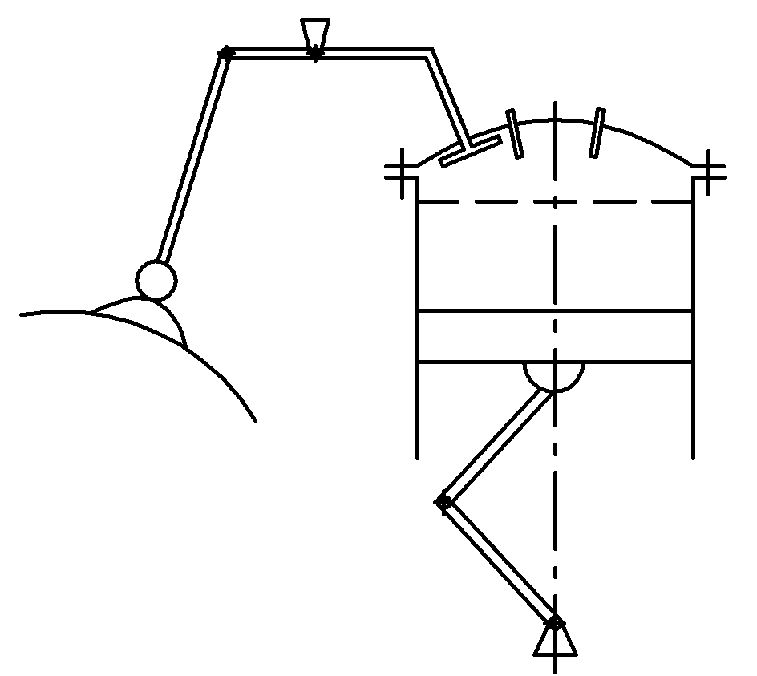
4. Status checking and adjustment of gaps between lever roller and valve rod in gas distribution system. Gap value depends on the temperature. This value is 0.5 mm and 2 mm for cold and heat engine respectively.
1
2
3
4
5
6
7
8
9
α
10

Fig. 8.1. Diagram of RE piston-cylinder group
1 – cam; 2 – pusher;
3 – the adjusting screw; 4 – arm;
5 – valve; 6 – candles; 7 – head
cylinder; 8 – cylinder; 9 – piston;
10 – TDC

If the gap is less then tolerable value the danger of valve nonclosure arises. As a result the filling of cylinders worsens and engine shaking arises. If a gap is more then tolerable value the valve lifting and down movement speed increases and dynamic shock loads arises. As the gap value changes depending on temperature the checking and adjusting are performed at cylinder heads temperature t_{ch} = 10 ÷ 40 °С and with the piston in a top dead centre (TDC). Checking and adjusting are performed by means of the probes and the adjusting screw (on the second level arm) respectively.

8.3. Ignition system maintenance

The cylinder has two starting magnetos and two sparking plugs for ensuring completeness and speed of fuel combustion. If the spark on plugs appears at the moment of full compression (i.e. in the top dead centre (TDC hereinafter)) the combustion of a mixture will not provide the best output-input ratio since a combustion process still will occur at the moment of ВМТ and the gas pressure will not reach the maximum value. Therefore the spark must appear earlier than the piston will reach to ВМТ. This method is called as “ignition advance”; the ignition advance value is measured by an angle between vertical line and connecting rod axis (α), which is 20 ÷ 21^{о}C usually. If α is more than specified value (advanced ignition) the complete fuel combustion will occur before the necessary moment; it leads to decrease of output-input ratio. If α is less than specified value (delayed ignition) the combustion process will not end in the necessary moment that leads to decrease of output-input ratio as well, and afterburning process will occur on an exhaust. Angle α is defined by gaps between magneto anvil contacts since the spark appears in contact breaking moment.
Since while exploitation the gap value changes as e result of wear and mal-adjustmen the gap value is measured periodically by probes. Gap value is adjusted by turning of cams when magneto is removed.
Installation of magneto is performed by means of the special device. After magneto adjusting and installation the correctness of these procedures performance is checked. For that the second magneto is switched off at a certain working mode: as combustion initiates by only one sparking plug the rotation speed must decrease but decreasing value must be no more than 100 rpm. If decrease of speed exceeds this value the adjusting was carried out incorrectly.
Besides, the spark formation and leakproofness are checked for ignition system.

8.4. Propellers maintenance

Propeller blades can be damaged as a result of blow by foreign matter:
- at aircraft movement as a result of foreign matter discard by front aircraft wheels in a plane of propeller rotation;
- at engine running on standing place as a result of “suction” of foreign matter in a plane of propeller rotation;
Any damage on the blade is the stress concentrator. Therefore these damages must be detected carefully.
The following must be absent: any cracks situated in any point; curvature if its value is higher than tolerable one; dints if their sizes are higher than tolerable ones and if distances between them is higher than tolerable one; nicks and dints with any size if their distances from the propeller centre are less than 0.75R; corrosion if corrosion degree is above normal; burnt spots and holes are situated on heating gaskets; layering of heating gasket blades if quantity of such blades is above normal.
Acceptable dints on leading and trailing edges must be leveled smoothly according to the blade profile. If dint is on the end of one blade, it is necessary to level the ends of all blades for saving of propeller balancing. If propeller had strike against an obstacle the commission for making of decision about further exploitation not only the propeller but the engine is created.
Joint of the propeller with gear shaft is carried out by the two following modes:
      - By means of flat flanges with slots (on aircrafts equipped by TJE).
      - By means of slots on gear shaft and propeller female taper (on aircrafts equipped by PE).
Typical propeller failures and damages: unbalance; blades aren’t turned in feather position or aren’t turned from such position; oil leak from propeller hub.
The following procedures must be performed while propeller maintenance: blades and heat elements status checking; checking blades wobbling on control radius; oil leak checking; tightening of flanges mount nuts or splined joint by means of torque-measuring wrench.

Self-study check

- Please list the characteristic failures or malfunctions of the CPG, their causes, the effects and characteristics.
- List and briefly characterize the basic works at PE maintenance.
- What is the essence of the cylinder compression check?
- Procedures for checking and adjusting clearances in the gas distribution system.
- How is the checking of the PE ignition system carried out?
- What is the major damage to the propeller blades and its causes?
- What type of work is done at the Propeller maintenance?
9. ANALISYS OF OPERATING CONDITIONS
AND MAINTENANCE OF HELICOPTERS

Helicopter structural layouts: single-rotor helicopters: with antitorque tail rotor; with aligning arrangement of rotors (light helicopter); twin-rotor tandem-rotor helicopters.
Possibility of vertical and horizontal moving by means of rotor thrust is key feature of helicopter. Systems of lateral-longitudinal control and collective pitch control systems are designed. Usage of these systems allows changing the rotor thrust resultant.
The flight mode can be steady state and transient (the speed vector varies on size and a direction in last case).
Flight regimes: take-off, climb, level flight, descent and landing.
Take-off:
1. No-run takeoff: a vertical unstick, a test hovering, slant trajectory climb with speed increase. Take-off is finished if H = 20 ÷ 25 m.
2. Running take-off (airplane take-off): a take-off run, slant trajectory climb with speed increase (running area is needed).
- Un-run take-off with air cushion use (if altitude is within limits of rotor diameter).
Landing:
- Helicopter-type landing: gliding with loss of speed, hovering in air cushion influence zone (2 ÷ 3 m), vertical descending, landing.
- Aircraft-type landing (running landing): gliding, flareout, flare-up, landing and running.
- Landing at rotor autogyroing regime (special type of landing with dead engine).
Control efficiency and sensitivity, control delay and efforts for command levers moving are the features of helicopter controllability.

9.1. Operating factors influence on helicopter
self-oscillations (ground resonance and flutter)

Some hundreds of various types of vibration are in helicopter. These are the vibration of separate parts and all helicopter induced of a number of sources. There are such sources as load-carrying system, antitorque rotor, power unit, reducers and transmissions, engine cooling systems etc. Oscillations caused by the above mentioned reasons, are called as forced vibrations. Forced vibrations frequency is equal to excitation source frequency. Rotor excitation frequency of rotor, antitorque rotor, transmissions and power plant is 8 ÷ 16 Hz, 10 ÷ 60 Hz, 50 ÷ 160 Hz and of 600 ÷ 1000 Hz respectively. Vibrations from blades of rotor and antitorque rotor are transferred through hubs and air stream thrown off by these blades. This stream causes sign-variable stresses in design elements.
Most often the forced vibrations impact on control system rods. Prevention of rod resonance is especially important. For this purpose it is necessary to know the rod self-resonant frequency; such frequency is proportionate to rod diameter and inversely proportionate to a square of rod length. The inertia dampers (load in rod equipped by rubber shock-absorbers) are applied to elimination of rod resonance.
The forced vibrations aren’t dangerous usually as a result of their amplitudes insignificance. But in certain cases (at infringement of service conditions) they can become dangerous. Vibrations are considered as acceptable if they don’t lead to structural failures and don’t cause of unpleasantness. The more vibration frequency, the less tolerable by human vibration amplitude.
Not only forced vibrations but also self-excited vibrations may occur in helicopters during their exploitation; self-excited vibrations occurrence is considered as alert condition. Three kinds of helicopter self-raised fluctuations may be emphasized: rotorcraft ground resonance, helicopter self-vibrations in flight and flutter-type vibrations. Rotorcraft ground resonance is a result of interaction of two vibrating systems: helicopter and rotor blades. Results of these systems action can be seen especially in the moment of rotor spinup and in the moment of rotor stopping.
Spontaneously arising on the earth and occurring with increasing amplitude vibrations of helicopter are qualified as rotorcraft ground resonance.
If any push (a puff, rough landing, etc.) occurs, the rotor blades self-vibrations in a plane of rotation relative to lag hinges take place. These vibrations cause inertial forces arising in a plane of rotor rotation. Being transferred to a fuselage, they cause vibrations on springy landing gear. Frequency of helicopter shaking forces depends on blade self-vibration frequency for vibrations in a plane of rotation and from rotor angular speed.
Helicopter is shaken most easily when excitation frequency is closed to helicopter self-vibration frequency on springy landing gear. The forces shaking the blades in a plane of rotation are arisen simultaneously with vibrations of helicopter housing. Such bilateral relationship between helicopter housing vibrations and blades vibrations leads to helicopter instability at some value of rotation angular speed, i.e. can be induced starting as a result of any push helicopter vibrations can appear not damped, but increasing.
The key design means against this phenomenon are the following:
- installation of special dampers on lag hinges of rotor blades for damping of blades vibration in rotation plane;
- mounting of a special damping elements in design of landing gear shock-absorbers or a correct choice of hydraulic resistance characteristics of landing gear shock-absorbers for direct and reverse motion.
The following violations of technical operating rules promote the rotorcraft ground resonance occurrence:
- incorrect charging of landing-gear shock absorbers
- incorrect adjusting of lag hinges dampers;
- violations of charging rules and malfunction of landing gear damper special springs;
- incorrect charging of landing gear tires;
- tie-down rules violation;
- sidewind with speed >8 m⋅sec⁻¹;
- violation of engine and helicopter management rules.
The nature of helicopter self-vibrations in flight is similar to nature of rotorcraft ground resonance. These vibrations combine the oscillations of rotor blades relatively lag hinges and springy elements of helicopter hull. Rotor centrifugal force is arisen oscillations of rotor blades. It leads to shaft whipping and deformation of rods of carriage under reducer and hull load-carrying elements.
This phenomenon is observed for twin-rotor tandem-rotor helicopters.
There are two kinds of rotor blade flutter: flexure-torsion flutter and flapping flutter.
Flexure-torsion flutter may be seen in the pure state generally for blades with rigid fastening to hub. Flapping flutter (combination of flapping movements with blade oscillations relatively feathering hinge) may be seen generally for articulated blades. Flutter of both types may be eliminated by means of certain design improvements (rigidity increase, correct blade centering etc.). However the flutter phenomenon can be induced by operating causes: as a result of mass balancing violation and rigidity of construction decrease. Mass balancing violation is characteristic especially for blades with mixed frame structure as a result of applied materials hygroscopicity. Mass balancing is broken generally due to negligent repair of blades.
Decrease of blade rigidity occurs as a result of the latent destructions of construction parts.
Flutter may become visible as occurrence of strong jolting and "fuzziness" of blade rotation cone.
We must remember that such "fuzziness" may be caused by infringement of rotor in-track condition occurred as a result of incorrect adjustment. However in this case it does not depend on rotor rotation frequency.

9.2. Operating conditions and maintenance
of helicopter rotor system and transmission

The technical condition of rotor and transmission changes as a result of the following factors influence: big sign-variable loads; operating factors.
Examples of rotors breakages as a result of service regulations violations:
- Sharp transmission switching on at engine run-up can lead to breakage of blade hull load-carrying elements as a result of blow of blade against revolutions limiters.
- Sharp transmission brake switching on can lead to blade falling out from its limiters and to its blow against a tail boom.
- Negligent removal of blade covers can lead to trimming plates bending and damage that will cause the infringement of rotor in-track condition etc
MS of helicopter load-carrying system includes such procedures as inspection for defects, elimination of malfunctions, adjusting and mounting works.
Failures and defects of rotor hub: corrosion; mechanical damages; damages of screw locking devices; loosening of attachment, failure of blade sagging stoppers; oil leak from feathering hinge seals (charging of these hinges without taking into account of grease temperature expansion phenomenon). Grease level in feathering hinges is monitored.
Inspection for defects carried out for every blade; longerone end sections, brads and rear ends of blade sections are inspected especially carefully. Special access holes are provided for longeron inspection on a blade covering in the most loaded longeron sites.
Longeron damage alarm system is applied to rotor blade status investigation and prevention of through cracks formation in longerons walls.
Principle of operation: The longeron internal cavity is tightened and filled by air under the pressure of 50 KPа. Sensor bellows filled with helium are connected with longeron internal cavity. If pressure decrease is more than tolerable value the bellows either close the electric contacts or move mechanical indicator rod.
System actuation pressure depends on the temperature. It must be taken into account.
If preventive maintenance has been performed for alarm system that is necessary to enter corresponding records in the blade set data card; the records must include the measurement results for the following quantities: air temperature; pressure in a longeron before and after the work performance; pressure of signaling device actuation.
Horizontal, vertical and feathering hinges must be lubricated during exploitation. Prolonged feathering hinge operation without sufficient lubrication leads to the increased wear of hinge mounting bearing fluting and to jamming control lever in flight as a result of unilateral bearing wear.
Helicopter flight safety is defined by operating reliability of its transmission in large degree. In the case of this transmission prolonged operation the carrying out of some procedures is required (transmission lubricating, adjustment and inspection).
It is necessary to pay attention to status of the reducer assemblies used for its fastening to construction, to filled oil quality and quantity, to system tightness and tightness of the reducers during reducers inspection.
It is necessary to pay particular attention to status of the hinges connecting of different parts of transmission, status of the assemblies used for transmission fastening along a tail boom and quality of bearings lubrication during transmission inspection. Access for inspection of tail drive shaft for lubricating this shaft hinged joints are limited and their MS is complicated.

9.3. Description of main rotor and helicopter
control system ajustment

The helicopter control system is nonequivalent to aircraft one and includes the rotor control (change of collective pitch and a cyclic pitch by means of wobble plate), tail rotor control and stabilizer control (for single-rotor helicopter). Spring mechanisms are used for creation of regularity of efforts change on the lever when flight regime changing and for elimination of effort from the lever.
Some helicopters stabilizers are controllable during the flight. Hydraulic or inertial dampers reduce the vibrations directed from the rotor to the control lever.
If it is helicopter jolting then control lever "driving" by cyclic pitch the rotor system adjusting is performed. Such adjusting is performed also after replacement of some rotor system units and in accordance with maintenance schedule. The trimming plates bending and infringement of rotor in-track condition can be induced the above mentioned phenomena.
1. The damper for reducing of rotor blade vibrations relatively vertical hinge can be of two types: frictional and hydraulic. Testing of damper tightening is in the measurement of the of effort necessary for moving blade from front stop to back one and for back moving by means of dynamometer. The effort difference for separate blades must not exceed 5N; the efforts are measured by specified blade radius method.
2. The most labour-consuming is such procedures on elimination of rotor in-track condition defects. If all blades move on a surface of the same cone the movement is performed at rotor in-track condition. As a rule the rotor in-track condition violation at the fixed position of controls is a result of aerodynamic forces inequality for separated blades; this inequality leads to displacement of resultant of rotor thrust and to helicopter jolting.
The blade of aerodynamic characteristics inequality may be eliminated by changing blade setting angle (by means of vertical rod length of blade changing) and angle of trimming plates bending.
There are some methods of definition of rotor in-track condition defect. The "flag" fixed on the end of a special bar is used on light helicopters. "Flag" with a bar is mounted to the moving rotor. The strips painted by various colors are formed in places of contact of blade ends (or brushes fixed on these ends) with paper "flag". Rotor in-track condition degree is estimated by means of dispersion of these strips. Method lacks: possibility of blades damage by the bar, low safety level. Method preference: accuracy, small laboriousness.
Rotor in-track condition on heavy helicopters is defined by photographing the blade ends when its rotating (both on the earth and in flight). The special camera established at an angle to an rotation axis is used. Rotor in-track condition degree is estimated by means of relative position of blade ends represented on a photo. Advantages of a method are possibility of cone monitoring at various speeds of flight.
The estimation of rotor in-track condition may be performed by means of photoelectric cell. Photo cells are installed on each blades and have electric communication with an oscillograph. Photo cell signal generated when lighting bar is passed is reflected on the oscillograph screen. Extent of a mark on the oscillograph screen is defined by length of arch forming between corresponding points of inclined bars.
If rotor in-track condition is defective the ends of different blades pass by a bar at different levels and the length of a trajectory of various blades between bars will differ. As a result of marks in the oscillograph screen will differ also. Method lacks: applied equipment complexity and bulkiness.
Adjustment of helicopter control systems includes: regulating of collective pitch control system; regulating of lateral-longitudinal control system; regulating of antitorque tail rotor and stabilizer control system.
3. Regulating of collective pitch control system is the ascertainment of correspondence of collective pitch control lever position and position of wobble plate slider and rotor blade deviation angles. Correspondence of collective pitch indicator data and wobble plate slider stroke is achieved also.
4. Regulating of lateral-longitudinal control system is performed for achievement of correspondence of position of cyclic pitch control lever with wobble plate tilt angles. The special devices fixing the cyclic in necessary position, devices for angle-meter setting and an optical angle-meter are applied for carrying out this procedure. Regulation is the setting of cyclic pitch control lever in neutral position and fixings it by the special device. Then the position of a rod of hydraulic boosters at lever neutral position is checked (rod position must correspond to specification requirements) and staying of rods of loading electric mechanisms in neutral position. Checking an wobble plate tilt angle in lateral and longitudinal directions is performed at neutral position of cyclic pitch control lever.
The regulating of lever extreme positions (forward-back, to the left-to the right) is performed after checking neutral position. The certain wobble plate tilt angles must correspond to each of these level positions.
5. Regulating of tail rotor control system is performed for achievement of correspondence of control pedal position with antitorque rotor blade erection angles. For this purpose the control pedals are set in neutral position and fixed. The positions of hydraulic booster rod outlet and tail reducer rod outlet are checking. Further the correspondence of pedals position and with antitorque rotor blade erection angles is checking. Regulating of stabilizer control system is the checking correspondence of "pitch-gas" lever position and fin cant angles.

9.4. Features of helicopter power plants operation

As power plants (PP hereinafter) in modern helicopter are used mainly GTE with the free turbine and RE with forced air cooling. PP MS has a certain features caused mainly by design differences (place of engine displacement on helicopter, presence of reducers and transmissions, forced cooling system etc.) and more rigid operating modes.
Installation of engines on helicopter differs from engine installation on aircraft since defined engines position relatively reducer must be provided taking into account the possible hull deformation during the flight.
The engine-reducer coaxiality regulation on helicopters equipped by RE is performed by changing of bolts tightening effort for mounting of the main shaft to engine and reducer flanges. Coaxiality measurement is performed on a flange of flexible clutch by means of the indicator device.
The main helicopter reducer is the most loaded unit of transmission. Therefore when performing transmission MS the special attention must be paid to oil presence in oil system of propulsion reduction gear, the expense of this oil, oil system temperature regime and oil cleanliness. Change of oil condition is the most informative parameter of propulsion reduction gear operability. So, the coke presence in oil indicates about exceeding temperature regime, and shaving presence indicates about the increased wear of reducer parts. The alarm systems informing about shavings appearance are applied in modern helicopter PP. Such system makes possible to know about the beginning of engine and reducer transmission parts destruction.
Application of forced engine cooling system increases requirement to a condition of fan deflectors and air flow duct as well as to a blow-off control system.
Cooling system violation can lead to changing the temperature regime, to local overheats occurrence and to engine failure.
The special attention when inspecting for PP likely defects must be paid to joints condition, screw locking facilities, tightness of communications since helicopter PP operates at increased vibrations.
The exhaust gases penetration on engine input is possible during hovering flight or at PP operation on the earth at windy weather. It can increase air temperature. Such increase occurs as a result of “washing out” of exhaust gases stream by a head wind and the subsequent mixing of gases with air streams from rotor. Therefore the helicopter must be situated against a wind direction during starting and GTE run-up. The same orientation of the helicopter helps to prevent the blows of rotor blades against a tail beam during rotor spin-up.
It is necessary to remember that only specially trained engineering staff and flight personnel with special permission for starting concrete engines can be allowed to the run-up procedure performing since the special skills are needed for run-up execution even for moored helicopter.
Helicopter RE starting is performed at switched off transmission (without load). The position of correction and "pitch-gas" levers must be monitored carefully for prevention of rotation frequency excess. These levers must be in idle position.
Helicopter maintenance on platforms with strong dust content causes the increased wear of turboshaft engine (TSE) air-gas channel and fast decrease of TSE characteristics, engine power reduction, increase of specific fuel consumption, and in certain cases leads to engine inactivation. Therefore the TSE input devices and special wear sensors must be inspected with special carefulness when helicopter operation in the conditions of dusty airfields.

Self-study check

- What are the design and flight operation characteristics of helicopters?
- Forced vibrations of the helicopter from the exciting force.
- What is the phenomenon of helicopter ground resonance?
- What are the causes which contribute to the occurrence of the rotorcraft ground resonance?
- Self-excited oscillations of the helicopter and blade flutter.
- What are the characteristics of the operating conditions of the rotorcraft flight structure and its maintenance?
- List the main types of work for the MR blades maintenance.
- Describe regulation works on MR and the control system for helicopters.
- How are inspection and removal of the MR rotor track carried out?
- What is the point of tracking control of MR and AP of the helicopter?
- What are the characteristics of the helicopter gearboxes and transmissions maintenance?
LITERATURE

- Техническая эксплуатация летательных аппаратов: учебник для вузов /под ред. Н. Н. Смирнова. – М.: Транспорт, 1990. – 432 с.
- Технічне обслуговування планера і функціональних систем ПС та авіадвигунів: [навч. посіб.] / С. О. Дмитрієв, О. С. Тугарінов, Ю. М. Чоха, В. Г. Докучаєв; за ред. С. О. Дмитрієва. – К.: НАУ, 2004. – 244 с.
- Дмитрієв С. О. Особливості експлуатації і технічного обслуговування планера та функціональних систем ПС у складних природно-кліматичних умовах: [курс лекцій] / С. О. Дмитрієв, О. С. Тугарінов, Ю. М. Чоха. – К.: НАУ, 2005. – 140 с.
- Руководство по летной годности. Т.1. Организация и процедуры. – ICAO, 2001. – 96 с.
- Аникин Н. В. Техническая эксплуатация самолетов / Н. В. Аникин, Ю. В. Назаров. – М.: Транспорт, 1984. – 199 с.
- Воробьев В. Г. Техническое обслуживание и ремонт авиационных электросистем и пилотажно-навигационных комплексов: учебн. [для студ. высш. учеб. зав.] / В. Г. Воробьев, В. Д. Константинов. – М.: МГТУ ГА; Университетская книга, 2007. – 472 с.
- Ицкович А. А. Управление процессами технической эксплуатации летательных аппаратов / А. А. Ицкович – М.: МГТУ ГА, 2002. – 144 с. ч. 3.
- Ицкович А. А. Управление эффективностью процесса технической эксплуатации гражданской авиации / А. А. Ицкович, Н. Н. Смирнов. – М.: МИИ ГА, 1993. – 88 с.
- Смирнов Н. Н. Обслуживание и ремонт авиационной техники по состоянию / Н. Н. Смирнов, А. А. Ицкович. – М.: Транспорт, 1980. – 423 с.
10. Смирнов Н. Н. Основы теории технической эксплуатации ЛА / Н. Н.Смирнов – М.: МГТУ ГА, 2001. – 100 с.
11. Константинов В. Д. Методы эксплуатации и стратегии технического обслуживания / В.Д. Константинов. – М.: МГТУ ГА, 1996. – 20 с.
12. Тамаргазін О. А. Системи технічного обслуговування пасажирських літаків: [монографія] / О. А. Тамаргазін. – К.: КМУЦА, 2000. – 268 с.
13. Спільні авіаційні вимоги. JAR-66. Сертифікація персоналу з технічного обслуговування. – ICAO, 2006. – 80 с.
14. Наставление по технической эксплуатации и ремонту авиационной техники в гражданской авиации СССР. Кн. 1. – М.: Воздушн. трансп., 1986. – 368 с.
15. Наставление по производству полетов в гражданской авиации СССР (НПП ГА–85). – М.: Воздушн. трансп., 1985. – 254 с.
16. Хирвич И. Г. Воздушная навигация: [учеб. пособ. для вузов] / И. Г. Хирвич, М. Ф. Миронов, А. М. Белкин. – М.: Транспорт, 1984. – 328 с.
17. Безопасность полетов: учебник для вузов. / под ред. д-ра техн. наук, проф. Р. В. Сакача. – М.: Транспорт, 1989. – 239 с.
18. Руководства по летной эксплуатации конкретных типов воздушных судов.
19. Правила польотів повітряних суден та обслуговування повітряного руху в класифікованому повітряному просторі України: наказ Міністерства транспорту України від 16.04.2003 № 293. – 2003. – 54 с.
Навчальне видання

ДМИТРІЄВ Сергій Олексійович
ТУГАРІНОВ Олександр Степанович
КАЗАРІНОВ Юрій Іванович
РУГАЙН Олександр Володимирович

Підтримання льотної придатності ПОВІТРЯНИХ СУДЕН

Навчальний посібник
(англійською мовою)

Технічний редактор А.І. Лаврінович

Підписано до друку 00.00.09. Формат 60х84/16. Папір офсетний. Офсетний друк. Ум.друк.арк. 6,0. Обл.-вид.акр. 6.0 Тираж 100 пр. Замовлення №____. Вид №___

Видавець і виготівник – Видавництво Національного авіаційного університету
03058. Київ-58, проспект Космонавта Комарова,1
Свідоцтво про внесення до Державного реєстру ДК №977 від 05.07.2002

