(F __- ___)

MINISTRY OF EDUCATION AND SCIENCE OF UKRAINE
National Aviation University
Educational and Scientific Law Institute

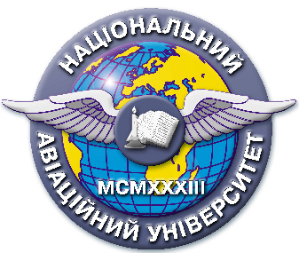

Quality management system

EDUCATIONAL AND METHODICAL COMPLEX
educational discipline
"Organization of Judicial and Law Enforcement Bodies"

for the field of knowledge 08 "Law"
specialty: 081 "Law"

СМЯ НАУ НМК 13.01.03-01-2016

KIEV

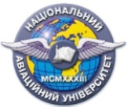 | Quality management system  EDUCATIONAL AND METHODICAL COMPLEX  educational discipline  " Organization of Judicial and Law Enforcement Authorities» | Document Code | QMS NAU CTP  09.01.06-01-2018
 |  | Стор. 2 з 2

Developed by
Associate Professor
of the Department of
Criminal Law and Process N. Malyarchuk

Discussed and approved by the Department of Criminal Law and Process, Minutes № ___ of "___" _______2017.

Head of the Department S. Likhova

Discussed and approved by the Scientific – Methodological – Editorial Board of the Educational and Research Institute Institute of Law, Minutes № ___ of "___" _________ 2017.

Head of the SMEB ____________V. Vyshnevetskii

