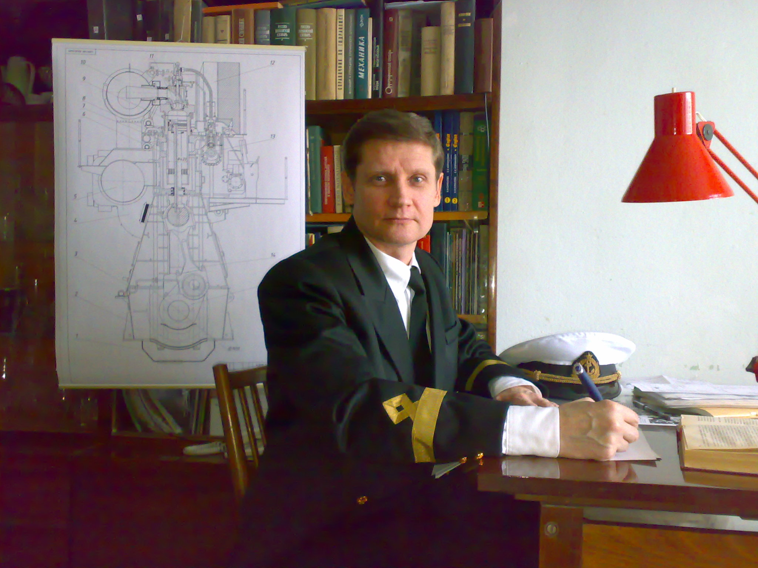
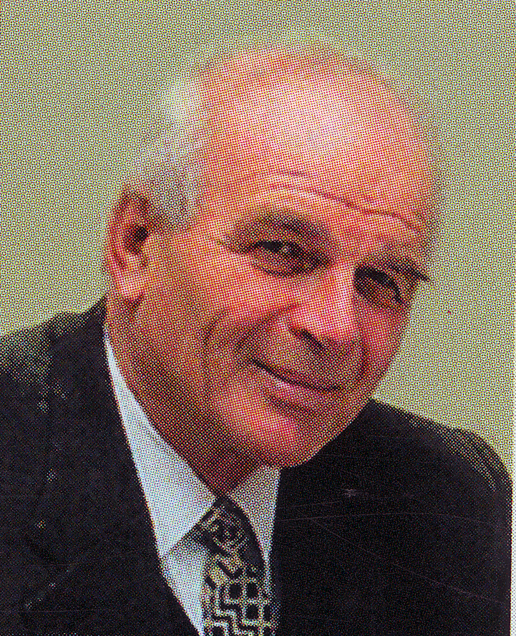

Kasianov Vladimir Aleksandrovich,
Doctor of Engineering Sciences,
Professor

Born in Kharkov in 1935.
Graduated from Nikolayev Shipbuilding Institute in 1959. Doctoral Dissertation defended in 1971.
Area of scientific interests: aerodynamics, statistical mechanics of gases and plasma, control theory, flight dynamics, data processing, identification, organizational systems.
Author of more than 250 scientific publications including 20 monographs and study-books. Graduated 29 Ph. D and
9 Doctors of Science.
Was a member of the Scientific and Technical Board of the USSR Ministry of Civil Aviation, Expert Board of Ukrainian Higher Attestation Commission, is a member of Specialized Boards for Doctoral Dissertations defense. For 22 years was the Head of Theoretical Mechanics Department, worked as a professor of Catholic University in Lublin (Poland), Emeritus Professor of National Aviation University (NAU, Kyiv, Ukraine).
Yacht Master of Open Sea.

Goncharenko Andriy Viktorovich,
Doctor of Engineering Sciences,
Professor

Born in Kherson in 1962.
Graduated from Odessa Institute of Marine Engineers in 1984. Doctoral Dissertation defended in 2016.
Area of scientific interests: safety of active systems, variational principles of power-plants operation in multi-alternative situations, control theory, flight dynamics, data processing, identification, organizational systems.
Author of more than 150 scientific publications including 4 monographs and
25 training-methodical publications among which 17 study guides in English.
Delivered educational subjects in English at five Departments of NAU, was the Head of Ship Power-Plants Department of Kherson State Maritime Academy. Was an associate professor at Kherson Branch of National University of Shipbuilding named after admiral Makarov.
Professor of Aircraft Airworthiness Retaining Department and Mechanics Department of NAU.
andygoncharenco@yahoo.com
skype: andygoncharenco

http://kasianovv.wixsite.com/entropyofpreferences

